Marine Strategy Framework Directive (MSFD)
Common Implementation Strategy

Recommendations for the publication of datasets under MSFD Article 19(3)
ANNEXES

Further information and documentation about TG-DATA and the present document can be found in TG DATA meetings folder on CIRCABC

Contents
Annex I - INSPIRE best practices examples 4
Annex II - INSPIRE metadata specifications 8
a) Datasets and datasets series 8
b) Data services 9
c) Datasets and services 10
Annex III - INSPIRE download services specifications and examples 12
a) ATOM services 12
b) WCS services 13
c) WFS services 14
Annex IV - INSPIRE data specifications (MSFD-relevant) 15
a) Species distribution 15
b) Habitats and biotopes 26
c) Sea Regions 34
d) Oceanographic geographical features 42
Annex V - Examples to be INSPIREd by 43
a) Marine litter using Sea Regions 43
a. Synopsis 43
b. Theme Scope 43
c. Typical Use 43
d. Relation to other INSPIRE Themes 44
e. Source Data Representations 44
f. INSPIRE Data Representations 45
g. Mapping from source to target (MarineContour) 47
h. Conclusions 47
b) Species Distribution using the EEA grid 48
a. Synopsis 48
b. Source Data Representations 48
c. INSPIRE Data Representations 49
d. INSPIRE Theme Scope 50
e. INSPIRE Data Interoperability 52
c) Options to represent nutrients data 55
a. Synopsis 55
b. Theme Scope 55
c. Source Data Representations 59
d. INSPIRE Data Representations 60
e. Mapping from source to target 62
f. INSPIRE view and download 62
Annex VI – EEA grids 63
a) GIS data 63
b) Coordinate reference system and recommended grid resolutions 63
c) Coding system for grid cell identifiers 63
d) INSPIRE compliance 64
e) Link with data models 65
Annex VII –Datasets published by supra-national organisations (selection) 70
a) European Environment Agency 70
b) EMODnet Habitats 71
c) EMODnet Biology 71
d) EMODnet Chemistry 74
e) COPERNICUS (CMEMS) 76
f) HELCOM 80
g) OSPAR 81
h) ICES 84

Annex I - INSPIRE best practices examples
See below some examples of INSPIRE compliant services provided at national and regional level in Europe.
INSPIRE Theme | Geographical coverage | Type of network service | End point location | INSPIRE Metadata | Description
Transport Networks  (Annex 1) | DE  (national) | Download Service: WFS | https://www.geoseaportal.de/wss/service/INSPIRE_TN-W_DS/guest | http://www.geoportal.de/gds/xml.php?uuid=cb07d15c-bef1-43e8-a2ab-17ee3f6a923b | The "Marine data of the BSH for INSPIRE transport networks" describe the shipping network for maritime navigation in the scope of the Federal Maritime and Hydrographic Agency (BSH) as well as their associated infrastructure facilities. The data are stored according to the data specification "D 2.8.1.7 INSPIRE Data Specification on Transport Networks - Guidelines". The data for the Electronic Navigational Chart (ENC) of the BSH as well as data generated especially for INSPIRE in the Nautical Hydrographic Information System (NAUTHIS) of the BSH serve as the data source for this data set. The data are located in the sea and land area of the German Exclusive Economic Zone (EEZ).
Area management/restriction/regulation zones and reporting units  (Annex 3) | UK  (regional) | Download Service: WFS | http://sedsh127.sedsh.gov.uk/arcgis/services/ScotGov/AreaManagement/MapServer/WFSServer? | https://www.spatialdata.gov.scot/geonetwork/srv/spa/xml.metadata.get?id=105 | Marine Planning Zones are defined in the Town and Country Planning (Marine Fish Farming) (Scotland) Order 2007. The Zones designate marine areas for which planning authorities discharge their functions with regard to fish farming developments.  Interesting layer: Marine_Planning_Zones
Environmental monitoring facilities  (Annex 3) | UK  (regional) | Download Service: WFS and others | http://download.geoportal.gov.gi/geoserver/inspire/ows? | ? | Location and operation of environmental monitoring facilities includes observation and measurement of emissions, of the state of environmental media and of other ecosystem parameters (biodiversity, ecological conditions of vegetation, etc.) by or on behalf of public authorities [Directive 2007/2/EC].
Geographical grid system  (Annex1) | ES  (national) | Download Service: SHP | http://centrodedescargas.cnig.es/CentroDescargas/  (Go to the “Información geográfica y de referencia” section) | http://centrodedescargas.cnig.es/CentroDescargas/  (Go to metadata tab) | Official cartographic grids of MTN50 and MTN25.  SGR: ETRS89 or ED50 (according to edition) in the Peninsula, Balearic Islands, Ceuta and Melilla, and REGCAN95 in the Canary Islands. Geographic coordinates length and latitude.
Energy resources  (Annex 3) | DE  (regional) | Download Service: WFS | https://www.geoport-nwm.de/ws/wfs/242f85ab-0e5d-2d1f/Windkraftanlagen_NWM/ows.wfs? | https://www.geoportal-mv.de/geomis/Query/ShowCSWInfo.do?fileIdentifier=225120c9-12e8-4862-b02f-85747bdfc620 | The service wind turbine is the model for point-shaped geometries, which have basic attributes, which they clearly identify as wind power plants from the perspective of the eE-Services project
Natural risk zones  (Annex 3) | PT  (national) | Download Service: WFS | http://sniamb.apambiente.pt:8080/GetOGC/WFS/SNIAmb/Diretiva200760CE? | http://sniamb.apambiente.pt/geoportal/catalog/search/resource/details.page?uuid={C713BD76-07C8-4BC2-8F88-A37508BEA2CB} | Directive 2007/60 / EC on the assessment and management of flood risks requires Member States to draw up flood maps and flood risk maps for different flood scenarios in order to have information, as well as a valuable basis for prioritizing and making technical, financial and policy decisions on flood risk management.
Hydrography  (Annex 1) | PT  (national) | Download Service: WFS | http://sniamb.apambiente.pt:8080/GetOGC/WFS/SNIAmb/AM_RiverBasinDistrict | http://sniamb.apambiente.pt/geoportal/rest/document?id=F2D45C90-B7A2-45B0-BC45-1928C88F451C  http://sniamb.apambiente.pt/geoportal/catalog/search/resource/details.page?uuid=%7B2626B475-6C9E-42C5-B108-DA3137305757%7D | Hydrographic regions of mainland Portugal; OGC service named AM_RiverBasinDistrict.
Protected sites  (Annex 1) | MT  (national) | Download Service: GML | https://msdi.data.gov.mt/geonetwork/srv/eng/catalog.search#/metadata/1b5e8d67-758a-43c5-908b-2c8a6b93556a | https://msdi.data.gov.mt/geonetwork/srv/eng/xml.metadata.get?id=118994 | INSPIRE Compliant Natura 2000 All designated sites in GML format
Geology  (seabed sediments and coastal geomorphology)  (Annex 2) | Europe  (E1) | Download Service: SHP | https://www.eea.europa.eu/data-and-maps/data/geomorphology-geology-erosion-trends-and-coastal-defence-works/ | https://www.eea.europa.eu/data-and-maps/data/geomorphology-geology-erosion-trends-and-coastal-defence-works#tab-metadata | Both a geomorphological and a geological code is assigned to each segment. 20 different geomorphological types (and thus codes) and 13 geological types have been defined. 2) This layer features both erosion trends and the existence of coastal defence works along the coast. 3 codes have been defined to depict erosion trends (stable, erosion, accretion) and 2 codes to depict coastal defence works (presence, absence). Both layers are provided at scale 1:100,000, in vector format, and consists in a segmentation of the EUROSION shoreline.  Geographical coverage note: Romania, Bulgaria, Cyprus, and ultra-peripheral regions are only covered 20%. Also, only EU25 countries with coast are included in the data set.
Elevation (Bathymetry)  (Annex 3) | UK  (regional) | Download Service: WFS | http://www.geostore.com/OGC/OGCInterface;jsessionid=p2HYRYVNAtf2cVUKOukfipnW?SESSIONID=internal&INTERFACE=ENVIRONMENTWFS& | https://data.gov.uk/dataset/areas-of-identified-tidal-stream-resource-defining-boundary-of-policy-tide1-in-the-east-inshore | The dataset sets out areas of identified tidal stream resource that could be harnessed in the future for power generation and as such are protected by policy TIDE1 in the East Inshore and East Offshore marine plans. The areas have been identified using the same parameters that defined The Crown Estates Wave and Tidal Key Resource Areas work but are limited to the East inshore and East offshore marine plan areas. The MMO used UKHO bathymetry data filtered to sites of 5m depth and over and the Atlas of UK Renewable Energy Resource with mean spring peak current filtered to over 1.5metres per second.  Interesting layer: Areas of identified tidal stream resource (TIDE1)

Annex II - INSPIRE metadata specifications

Datasets and datasets series

Element name | INSPIRE multiplicity | INSPIRE obligation / condition / note
Resource title | 1 | Mandatory
Resource abstract | 1 | Mandatory
Resource type | 1 | Mandatory
Resource locator | 0..* | Mandatory if a URL is available to obtain more information on the resources and/or access related services.
Unique resource identifier | 1..* | Mandatory
Resource language | 0..* | Mandatory if the resource includes textual information.
Topic category | 1..* | Mandatory
Keyword value | 1..* | Mandatory
Originating controlled vocabulary | 0..1 | Conditional: Mandatory for each keyword if the keyword value originates from a controlled vocabulary
Geographic bounding box | 1..* | Mandatory
Temporal reference |  | At least one of Temporal extent, Date of publication, Date of last revision or Date of creation must be given
Temporal extent | 0..* | Conditional
Date of publication | 0..* | Conditional
Date of last revision | 0..1 | Conditional
Date of creation | 0..1 | Conditional
Lineage | 1 | Mandatory
Spatial resolution | 0..* | Mandatory if an equivalent scale or a resolution distance can be specified
Conformity | 1..* | Mandatory
Specification | 1 | Mandatory for each conformity statement
Degree | 1 | Mandatory for each conformity statement
Conditions applying to access and use | 1..* | Special values for unknown conditions or no applying conditions may be used
Limitations on public access | 1..* | Special value for no limitations may be used
Responsible organisation | 1..* | Mandatory
Responsible party | 1 | Mandatory for each responsible organisation
Responsible party role | 1 | Mandatory for each responsible organisation
Metadata point of contact | 1..* | Mandatory
Metadata date | 1 | Mandatory
Metadata language | 1 | Mandatory

Data services

Element name | INSPIRE multiplicity | INSPIRE obligation / condition / note
Resource title | 1 | Mandatory
Resource abstract | 1 | Mandatory
Resource type | 1 | Mandatory
Resource locator | 0..* | Conditional, mandatory if linkage to service is available
Coupled resource | 0..* | Conditional, mandatory if linkage to data sets on which the service operates are available.
Spatial data service type | 1 | Mandatory
Keyword value | 1..* | Mandatory
Originating controlled vocabulary | 0..1 | Conditional, mandatory for each keyword if the keyword value originates from a controlled vocabulary
Geographic bounding box | 0..* | Conditional, mandatory for services with an explicit geographic extent.
Temporal reference |  | At least one of Temporal extent, Date of publication, Date of last revision or Date of creation must be given
Temporal extent | 0..* | Conditional
Date of publication | 0..* | Conditional
Date of last revision | 0..1 | Conditional
Date of creation | 0..1 | Conditional
Spatial resolution | 0..* | Mandatory when there is a restriction on the spatial resolution for this service
Conformity | 1..* | Mandatory
Specification | 1 | Mandatory for each conformity statement
Degree | 1 | Mandatory for each conformity statement
Conditions applying to access and use | 1..* | Special values for unknown conditions or no applying conditions may be used
Limitations on public access | 1..* | Special value for no limitations may be used
Responsible organisation | 1..* | Mandatory
Responsible party | 1 | Mandatory for each responsible organisation
Responsible party role | 1 | Mandatory for each responsible organisation
Metadata point of contact | 1..* | Mandatory
Metadata date | 1 | Mandatory
Metadata language | 1 | Mandatory
Category | 0..1 | Conditional, mandatory for an Invocable Spatial Data Service in order to comply with Annex V of [Regulation 1089/2010]
Coordinate Reference System Identifier | 1..* | Mandatory if relevant for an Interoperable Spatial Data Service in order to comply with Annex VI of [Regulation 1089/2010]
Quality of service | 3..* | Mandatory for an Interoperable Spatial Data Service. Three criteria for minimum quality of service shall be given to comply with Annex VI of [Regulation 1089/2010]: Availability, Performance and Capacity
Invocation metadata | 1..* | Mandatory for a Harmonised Spatial Data Service in order to comply with Annex VII of [Regulation 1089/2010]

Datasets and services

Metadata element | Definition | Multiplicity | Condition
Coordinate reference system | Description of the coordinate reference system(s) used in the data set. | 1..*
Temporal reference system | Description of the temporal reference systems used in the dataset. | 0..* | Mandatory, if the spatial data set or one of its feature types contains temporal information that does not refer to the Gregorian Calendar or the Coordinated Universal Time.
Encoding | Description of the computer language construct(s) specifying the representation of data objects in a record, file, message, storage device or transmission channel. | 1..*
Character encoding | The character encoding used in the data set. | 0..* | Mandatory if an encoding is used that is not based on UTF-8.
Spatial representation type | The method used to spatially represent geographic information. | 1..*
Data Quality–Logical consistency–Topological consistency | Correctness of the explicitly encoded topological characteristics of the data set as described by the scope. | 0..* | Mandatory if the data set includes types from the Generic Network Model and does not assure centreline topology (connectivity of centrelines) for the network.

Annex III - INSPIRE download services specifications and examples

In order to be in conformity with Article 11(1) (c) of Directive 2007/2/EC, the download service shall at least provide the operations listed in following table.
Operation | Role
Get Download Service Metadata | Provides all necessary information about the service, the available Spatial Data Sets, and describes the service capabilities.
Get Spatial Data Set | The Get Spatial Data Set operation allows the retrieval of a Spatial Data Set.
Describe Spatial Data Set | This operation returns the description of all the types of Spatial Objects contained in the Spatial Data Set.
Link Download Service | Allows the declaration, by a Public Authority or a Third Party, of the availability of a Download Service for downloading Spatial Data Sets or, where practicable, Spatial Objects, through the Member State’s Download Service while maintaining the downloading capability at the Public Authority or the Third Party location.

ATOM services

Description of  ATOM Services | INSPIRE theme | Access  to the services | Metadata  of services
Download ATOM services of predefined datasets according to the INSPIRE specifications for themes Cadastral Parcels (CP) and Addresses (AD) of Annex I and for the theme buildings (BU) of Annex III. | Cadastral Parcel  (CP) | http://www.catastro.minhap.es/INSPIRE/CadastralParcels/ES.SDGC.CP.atom.xml | http://www.idee.es/csw-inspireidee/srv/spa/csw?SERVICE=CSW&VERSION=2.0.2&REQUEST=GetRecordById&outputSchema= http://www.isotc211.org/2005/gmd&ElementSetName=full&ID=ES_SDGC_CP_ATOM
 | Addresses  (AD) | http://www.catastro.minhap.es/INSPIRE/Addresses/ES.SDGC.AD.atom.xml | http://www.idee.es/csw-inspireidee/srv/spa/csw?SERVICE=CSW&VERSION=2.0.2&REQUEST=GetRecordById&outputSchema= http://www.isotc211.org/2005/gmd&ElementSetName=full&ID=ES_SDGC_AD_ATOM
 | Buildings  (BU) | http://www.catastro.minhap.es/INSPIRE/buildings/ES.SDGC.bu.atom.xml | http://www.idee.es/csw-inspireidee/srv/spa/csw?SERVICE=CSW&VERSION=2.0.2&REQUEST=GetRecordById&outputSchema= http://www.isotc211.org/2005/gmd&ElementSetName=full&ID=ES_SDGC_BU_ATOM
Based on the document “Cadastral Cartography INSPIRE Download atom services”: http://www.catastro.minhap.es/webinspire/documentos/inspire-ATOM_en.pdf

WCS services

WCS | INSPIRE theme | Benefits and Opportunities | Examples
Describe characteristics of real-world phenomena that vary over space and/or time.  Contains sets of values, associated to a spatial and/or temporal domain. | Used in several INSPIRE themes:  - Atmospheric Conditions and meteorological geographical features (AC-MF)  - Oceanographic geographical features (OF)  - Energy resources (ER)  - Elevations (EL)  - Natural risk zones(NZ)  - Orthoimagery (OI)  - Land Use (LU)  - Land Cover (LC) | Provision of raster data directly accessing to the source/original values | - Surfaces  - Grids
 |  | Multi-dimensional or multi-variable grids | - Temperature  - Elevation  - Land cover  - Imagery…
 |  | Advanced download | Queries based on filters that are not trimming and slicing:  - Corridor selection: air temperature along flight corridor  Advanced analyses (server-side):  - Statistical analyses  - Interpolation between point values  - Aggregations  - Time series analyses
 |  | Visualization | For mapping purposes:  - An image coverage as is  - Using interpolation of point clouds  - Using reclassification of range values  - Using styling as defined by the user  - Selecting a style provided by the server
Based on the document “Web Coverage Services (WCS)”: https://geospatialworldforum.org/speaker/SpeakersImages/Jordi%20Escriu2.pdf

WFS services

Description of  WFS Services | INSPIRE theme | Access  to the services
They allow to query the data and to download the geometry* in Geography Markup Language (GML) format. They comply with WFS 1.1.0 standard.  CartoCiudad data can be displayed and queried through various web services created in accordance with the of the Open Geospatial Consortium (OGC) standards, which ensures interoperability. | Building names  (kilometre points) (AD) | http://www.cartociudad.es/wfs-portal/services
 | Thoroughfare (AD) | http://www.cartociudad.es/wfs-vial/services
 | Addresses (AD) | http://www.cartociudad.es/wfs-inspire/direcciones
 | Transport Networks (TN) | http://www.ign.es/wfs-inspire/services/transportes
 | Administrative Units (AU) | http://www.ign.es/wfs-inspire/unidades-administrativas
Based on the document “CartoCiudad Service directory”: http://www.cartociudad.es/portal/en/web/guest/directorio-de-servicios

Annex IV - INSPIRE data specifications (MSFD-relevant)
As described in Section 4.3 of the Recommendations (on Interoperability), there are a number of INSPIRE themes that have been considered relevant in regards to the datasets that have to be published under MSFD Article 19(3). Their data specifications are detailed in this Annex.

Species distribution

The Species distribution types and stereotypes are as follows:
Package | Type | Stereotypes
SpeciesDistribution | DistributionInfoType | «dataType»
 | PopulationSizeType | «dataType»
 | RangeType | «dataType»
 | SpeciesNameType | «dataType»
 | SpeciesDistributionDataSet | «featureType»
 | SpeciesDistributionUnit | «featureType»
 | Article17CountingUnitValue | «codelist»
 | CountingMethodValue | «codelist»
 | CountingUnitValue | «codelist»
 | EuNomenCodeValue | «codelist»
 | EunisSpeciesCodeValue | «codelist»
 | GeneralCountingUnitValue | «codelist»
 | LocalSpeciesNameCodeValue | «codelist»
 | NatureDirectivesCodeValue | «codelist»
 | OccurrenceCategoryValue | «codelist»
 | PopulationTypeValue | «codelist»
 | QualifierValue | «codelist»
 | ReferenceSpeciesCodeValue | «codelist»
 | ReferenceSpeciesSchemeValue | «codelist»
 | ResidencyStatusValue | «codelist»
The data specifications of species distribution are described in the following tables:
SpeciesDistributionDataSet Feature Type
Attribute | Description | Value type | Multiplicity | Voidable/Non-voidable
inspireId | An external object identifier is a unique object identifier published by the responsible body, which may be used by external applications to reference the spatial object. The identifier is an identifier of the spatial object, not an identifier of the real-world phenomenon. | Identifier | 0..1
name | A short descriptive identification name for a specific dataset provided by an institution. EXAMPLE 1 Redlisted_species_Norway EXAMPLE 2 Invasive_alien_species_ Ireland EXAMPLE 3 Articles17_report_Germany | CharacterString | 1 | «voidable»
domainExtent | The geographic extent of the domain of the feature collection. | GM_MultiSurface | 1 | «voidable»
beginLifespanVersion | Date and time at which this version of the spatial object was inserted or changed in the spatial data set.  This date is recorded to enable the generation of change only update files. | DateTime | 1 | «voidable»
endLifespanVersion | Date and time at which this version of the spatial object was superseded or retired in the spatial data set.  This date is recorded to enable the generation of change only update files. | DateTime | 0..1 | «voidable»
Association role | Description | Value type | Multiplicity | Voidable/Non-voidable
member | Individual spatial objects of allowed geometry where a species occurs. | SpeciesDistributionUnit | 1..*
documentBasis | Reference to or citation of a document describing a campaign or a legal act which is the basis for the data set. | DocumentCitation | 0..* | «voidable»

SpeciesDistributionUnit Feature Type
Attribute | Description | Value type | Multiplicity | Voidable/Non-voidable
InspireId | An external object identifier is a unique object identifier published by the responsible body, which may be used by external applications to reference the spatial object. The identifier is an identifier of the spatial object, not an identifier of the real-world phenomenon. | Identifier | 0..1
geometry | The geometry | GM_Object | 0..1
Species name | The authorized ReferenceSpeciesScheme provides reference species list which defines the ReferenceSpeciesName with its scientific name plus author and ReferenceSpeciesId. The LocalSpeciesName provides nomenclatural and taxonomical information about the locally used species name and the taxonomic concepts implied by the use of this name according to a given reference. If omitted the name and concept given by the referenceSpeciesId according to the referenceSpeciesScheme has been used locally. | SpeciesNameType | 1
distribution info | The description of the subject of distribution (occurrences or population), the indication of the count of observations or population size of the particular species, species group or taxon rank and its distribution or isolation within the species distribution unit. | DistributionInfoType | 0..* | «voidable»
begin lifespan version | Date and time at which this version of the spatial object was inserted or changed in the spatial data set.  This date is recorded to enable the generation of change only update files. | DateTime | 1 | «voidable,lifeCycleInfo»
end lifespan version | Date and time at which this version of the spatial object was inserted or changed in the spatial data set. This date is recorded to enable the generation of change only update file. | DateTime | 0..1 | «voidable,lifeCycleInfo»
Association role | Description | Value type | Multiplicity | Voidable/Non-voidable
spatialObject | A reference to another spatial object defining the spatial extent of a distribution unit.  EXAMPLE: A specific administrative area. | AbstractFeature | 0..1 | «voidable,lifeCycleInfo»
Constraint | Natural language | OCL
noGeometry | If geometry has no value, a reference to a spatial object needs to be provided. | inv: self.geometry->isEmpty() implies self.spatialObject->notEmpty()

DistributionInfoType Datatype
Attribute | Description | Value type | Multiplicity | Voidable/Non-voidable
populationSize | A range density (or abundance) value for species occurrence in the individual species distribution units either counted, estimated or calculated based on defined counting units, or using upper and lower bounds. | PopulationSizeType | 0..1 | «voidable»
sensitiveInfo | This can be used to filter out or generalize sensitive data. Generalized representation can be larger spatial objects e.g. grid cells. NOTE A species location e.g. breeding location, of vulnerable, endangered or protected species may by law be excluded from distribution or spatially generalised from detailed locations to lower resolutions in more extensive grid cells to avoid environmental crime. | Boolean | 0..1 | «voidable»
populationType | Kind of species occurrence or population data that are collected. EXAMPLE Permanent, reproducing, concentration or wintering (for migratory species). | PopulationTypeValue | 0..1 | «voidable»
collectedFrom | The starting date for the collection/registration of the primary species occurrence data. | Date | 1 | «voidable»
collectedTo | The last date for the collection/registration of the primary species occurrence data. | Date

PopulationSizeType Datatype
Attribute | Description | Value type | Multiplicity | Voidable/Non-voidable
countingMethod | To obtain a density or abundance estimate the data set provider can either count, estimate or calculate the population abundance. | CountingMethodValue | 1
countingUnit | This parameter defines which species population units that has collected or retrieved. EXAMPLE Colonies, individuals, juvenile, larvae, pairs, shoals, shoots, tufts. | CountingUnitValue | 1
populationSize | A range density (or abundance) value for species occurrence in the individual species distribution units either counted, estimated or calculated based on defined counting units, or using upper and lower bounds. | RangeType | 1

RangeType Datatype
Attribute | Description | Value type | Multiplicity | Voidable/Non-voidable
upperBound | The upper limit of the range. If the value of this attribute is null and lowerBound is populated, this implies that the value is between the lowerBound and infinity. | Integer | 0..1
LowerBound | The lower limit of the range. If the value of this attribute is null and upperBound is populated, this implies that the value is between the upperBound and zero. | Integer | 0..1

SpeciesNameType Datatype
Attribute | Description | Value type | Multiplicity | Voidable/Non-voidable
referenceSpeciesId | In the referenceSpeciesScheme the species IDs are linked to scientific names and corresponding authors using GUIDs | ReferenceSpeciesCodeValue | 1
referenceSpeciesScheme | Code list of accepted PAN-European taxonomical reference lists defining the nomenclature and taxonomical concept of a given species name. This must not be regarded as the ultimate taxonomic truth: this will always change. It serves as a definition of a taxonomic concept described by systematic and synonym relations where other names and there inherent taxonomic concepts can be mapped to. The code list comprises of Eu-Nomen, EUNIS and Natura2000. In these sources harmonized species GUIDs and names are maintained by institutions with an assignment outside INSPIRE and the species names are to be retrieved through webservices using GUIDs. Only one of these list must be used for one taxon. The priority is as follows: 1) EU-Nomen, 2) EUNIS, 3) Natura2000. This implies: if a taxon is listed in EU-Nomen, this reference must be used as first choice. If it is not listed in EU-Nomen, the second choice is EUNIS, if not in EUNIS, Natura2000 can be used. | ReferenceSpeciesSchemeValue | 1
referenceSpeciesName | The authorized ReferenceSpeciesScheme (EU-Nomen, Unis and Nature Directives) provides reference species lists which defines the ReferenceSpeciesName with its scientific name plus author and ReferenceSpeciesId. | CharacterString | 1 | «voidable»
localSpeciesId | The taxonID used in national nomenclature databases. | LocalSpeciesNameCodeValue | 0..1 | «voidable»
localSpeciesScheme | Name of local species classification scheme (bibliographic reference). | CharacterString | 0..1 | «voidable»
localSpeciesName | The LocalSpeciesName provides nomenclatural and taxonomical information about the locally used species name and the taxonomic concepts implied by the use of this name according to a given reference. If omitted the name and concept given by the referenceSpeciesId according to the referenceSpeciesScheme has been used locally. | CharacterString | 0..1 | «voidable»
qualifier | Defines how the local species name conceptually is related to the referenceSpeciesID, either congruent, included in, includes, overlaps or excludes | QualifierValue | 0..1 | «voidable»

Follow the “Identifier” link provided in each of the Code list tables to consult the possible values of the list.

Article17CountingUnitValue Code list
Definition: | The unit used in reporting for Article 17 Report. Expresses counted or estimated number for the abundance within a species distribution unit (e.g. occurrences or the population size).
Description | The values of the list are found here: http://bd.eionet.europa.eu/activities/Natura_2000/Folder_Reference_Portal/Population_units.pdf
Extensibility: | Any
Identifier: | http://inspire.ec.europa.eu/codelist/Article17CountingUnitValue
Values: | The allowed values for this code list comprise the values specified in "http://bd.eionet.europa.eu/activities/Natura_2000/Folder_Reference_Portal/Population_units.pdf" and additional values at any level defined by data providers.

CountingMethodValue Code list
Definition: | Method for producing numbers indicating the abundance of a species within an aggregation unit.
Extensibility: | none
Identifier: | http://inspire.ec.europa.eu/codelist/CountingMethodValue
Values: | The allowed values for this code list comprise only the values specified in Annex C . Annex C includes recommended values that may be used by data providers.

CountingUnitValue Code list
Definition: | The defined unit used to express a counted or estimated number indicating the abundance of a species in a SpeciesDistributionUnit.
Description: | The counting units are defined by specific measures of species occurrence types, life stages, reproductive units or substrate counts. Subclasses for specific domains can be added by member states.
Extensibility: | any
Identifier: | http://inspire.ec.europa.eu/codelist/CountingUnitValue
Values: | The allowed values for this code list comprise any values defined by data providers.

EunisSpeciesCodeValue Code list
Definition: | Reference lists containing Eunis species id's.
Extensibility: | none
Identifier: | http://eunis.eea.europa.eu/
Values: | The allowed values for this code list comprise only the values specified in the reference lists containing the EUNIS species identifiers, as specified in EUNIS Biodiversity database published on the web site of the European Environment Agency.

EuNomenCodeValue Code list
Definition: | Reference lists containing EU-Nomen species id's.
Extensibility: | none
Identifier: | http://www.eu-nomen.eu/portal/
Values: | The allowed values for this code list comprise only the values specified in "Pan-European Species directories Infrastructure available through the EU-Nomen portal".

GeneralCountingUnitValue Code list
Definition: | The unit used to express a counted or estimated number indicating the abundance within a SpeciesAggregationUnit (e.g. ccurrences or the population size).
Extensibility: | any
Identifier: | http://inspire.ec.europa.eu/codelist/GeneralCountingUnitValue
Values | The allowed values for this code list comprise any values defined by data providers. Annex C includes recommended values that may be used by data providers.

LocalSpeciesNameCodeValue Code list
Definition: | Species identifier taken from any local classification scheme.
Extensibility: | any
Identifier: | http://inspire.ec.europa.eu/codelist/LocalSpeciesNameCodeValue
Values: | The allowed values for this code list comprise any values defined by data providers.

NatureDirectivesCodeValue Code list
Definition: | Reference lists containing nature directives species id's.
Description: | In nature directives harmonized species names are given identifiers and the species names are to be connected by using these identifiers.
Extensibility: | none
Identifier: | http://inspire.ec.europa.eu/codelist/NatureDirectivesCodeValue
Values: | The allowed values for this code list comprise only the values specified in "Reference Portal for Natura 2000 as defined in Commission Implementing Decision 2011/484/EU.

OccurrenceCategoryValue Code list
Definition: | The species population density in the SpeciesDistributionUnit.
Description: | A species population density in classes (common, rare, very rare or present) in an individual SpeciesDistributionUnit.
Extensibility: | open
Identifier: | http://inspire.ec.europa.eu/codelist/OccurrenceCategoryValue
Values: | The allowed values for this code list comprise the values specified in Annex C and additional values at any level defined by data providers. Annex C includes recommended values that may be used by data providers.

PopulationTypeValue Code list
Definition: | The permanency of populations, particularly with regard to migratory species within a given species distribution unit.
Description: | These values are used for Natura2000 (revised SDF).
Extensibility: | any
Identifier: | http://inspire.ec.europa.eu/codelist/PopulationTypeValue
Values: | The allowed values for this code list comprise any values defined by data providers.

QualifierValue Code list
Definition: | This value defines the relation between the taxonomic concepts of a local species name and the reference species name given by reference species identifier or by a reference species scheme.
Extensibility: | none
Identifier: | http://inspire.ec.europa.eu/codelist/QualifierValue
Values | The allowed values for this code list comprise only the values specified in Annex C. Annex C includes recommended values that may be used by data providers.

ReferenceSpeciesCodeValue Code list
Definition: | Reference lists containing species identifiers.
Description: | The authorized ReferenceSpeciesScheme provides reference species list which defines the ReferenceSpeciesName with its scientific name plus author and ReferenceSpeciesId. In these ReferenceSpeciesSchemes harmonized species names are given GUIDs and the species names are to be retrieved through webservices using GUIDs. Only one of these list must be used for one taxon. The priority is as follows: 1) EU-Nomen, 2) EUNIS, 3) NatureDirectives. This implies: if a taxon is listed in EU-Nomen, this reference must be used as first choice. If it is not listed in EU-Nomen, the second choice is EUNIS, if not in EUNIS, NatureDirectives can be used.
Extensibility | None
Identifier | The allowed values for this code list comprise only the values of the following code lists :
Values | EuNomenCodeValue  EunisCodeValue (INSPIRE Data specification on Habitats and Biotopes [DS-D2.8.III.18])  NatureDirectiveCodeValue

ReferenceSpeciesSchemeValue Code list
Definition: | Reference lists defining a nomenclatural and taxonomical standard to which local names and taxonomic concepts can be mapped.
Description: | The authorized ReferenceSpeciesScheme provides reference species list which defines the ReferenceSpeciesName with its scientific name plus author and ReferenceSpeciesId. In these ReferenceSpeciesSchemes harmonized species names are given GUIDs and the species names are to be retrieved through webservices using GUIDs. Only one of these list must be used for one taxon. The priority is as follows: 1) EU-Nomen, 2) EUNIS, 3) NatureDirectives. This implies: if a taxon is listed in EU-Nomen, this reference must be used as first choice. If it is not listed in EU-Nomen, the second choice is EUNIS, if not in EUNIS, NatureDirectives can be used.
Extensibility: | none
Identifier: | http://inspire.ec.europa.eu/codelist/ReferenceSpeciesSchemeValue
Values: | The allowed values for this code list comprise only the values specified in Annex C. Annex C includes recommended values that may be used by data providers.

ResidencyStatusValue Code list
Definition: | Category of the residency of the occurrences or estimated population within a given aggregation unit.
Description: | These values are used for Natura2000 (revised SDF). NOTE One or more categories of population may be listed in the dataset, giving population size of e.g. permanent and wintering populations.
Extensibility: | Any
Identifier: | http://inspire.ec.europa.eu/codelist/ResidencyStatusValue
Values: | The allowed values for this code list comprise any values defined by data providers. Annex C includes recommended values that may be used by data providers.

Look for the externally governed code lists and the imported types in the technical guidelines (https://inspire.ec.europa.eu/id/document/tg/sd).

Habitats and biotopes

The Habitats and biotopes types and stereotypes are as follows:
Package | Type | Stereotypes
Habitats and biotopes | Habitat | «featureType»
 | HabitatSpeciesType | «dataType»
 | HabitatTypeCoverType | «dataType»
 | HabitatVegetationType | «dataType»
 | LocalNameType | «dataType»
 | EunisHabitatTypeCodeValue | «codelist»
 | HabitatsDirectiveCodeValue | «codelist»
 | LocalNameCodeValue | «codelist»
 | MarineStrategyFrameworkDirectiveCodeValue | «codelist»
 | QualifierLocalNameValue | «codelist»
 | ReferenceHabitatTypeCodeValue | «codelist»
 | ReferenceHabitatTypeSchemeValue | «codelist»

The data specifications of habitats and biotopes are described in the following tables:
Habitat Feature Type
Attribute | Description | Value type | Multiplicity |  | Voidable/Non-voidable
inspireId | An external object identifier is a unique object identifier published by the responsible body, which may be used by external applications to reference the spatial object. The identifier is an identifier of the spatial object, not an identifier of the real-world phenomenon. | Identifier | 0..1
geometry | Can be polygons, lines or points. Can also support 3-dimensional features. | GM_Object | 1
habitat | Habitats and biotopes may be common in some characteristics on a certain level of detail and may thus be classified as abstract types: e.g. as woodland, pastures, heathland – referring to their vegetation structure - or as running waters, limestone rocks or sand dunes - referring to abiotic features - but also as wintering areas, nesting areas or wandering corridors etc. - referring to relevant phases for the life-cycle of a certain species or ecological guild. These typological classes are usually organised in classification systems (e.g. EUNIS habitat classification). | HabitatTypeCoverType | 1..*
habitatSpecies | List of species which occur in or constitute a certain habitat at the time of mapping. | HabitatSpeciesType | 0..* |  | «voidable»
habitatVegetation | The cover of plants may be common in some characteristics on a certain level of detail and may thus be classified by vegetation science as abstract types. E.g. vegetation may be classified as Tundra or Mediterranean Deciduous Forests – referring to their structure and their bio-geographic formations - or as Nordic vegetation type 5141 Koeleria glauca-Typ or Ranunculetum fluitantis - referring to their floristic composition - or as chamaephytes or hemi-cryptophytes - referring to structural traits etc. Many vegetation type classification systems exist all over Europe. Some of these systems have a deep hierarchical structure. Therefore it is recommended to register the vegetation type scheme which was used. | HabitatVegetationType | 0..* |  | «voidable»
HabitatSpeciesType Datatype
Attribute | Description | Value type | Multiplicity | Voidable/Non-voidable
referenceSpeciesId | Identifier of one of the reference lists given by the referenceSpeciesScheme. | ReferenceSpeciesCodeValue | 1
referenceSpeciesScheme | Closed codelist of accepted PAN-european taxonomical reference lists defining the nomenclature and taxonomical concept of a given species name. This must not be regarded as the ultimate taxonomic truth: this will always change. It serves as a definition of a taxonomic concept described by systematic and synonym relations where other names and there inherent taxonomic concepts can be mapped to. The code list comprises of Eu-Nomen, EUNIS and Natura2000. In these sources harmonized species GUIDs and names are maintained by institutions with an assignment outside INSPIRE and the species names are to be retrieved through webservices using GUIDs. Only one of these list must be used for one taxon. The priority is as follows: 1) EU-Nomen, 2) EUNIS, 3) NatureDirectives. This implies: if a taxon is listed in EU-Nomen, this reference must be used as first choice. If it is not listed in EU-Nomen, the second choice is EUNIS, if not in EUNIS, NatureDirectives can be used. | ReferenceSpeciesSchemeValue | 1
localSpeciesName | The LocalSpeciesName provides nomenclatural and taxonomical information about the locally used species name and the taxonomic concepts implied by the use of this name according to a given reference. If omitted the name and concept given by the referenceSpeciesId according to the referenceSpeciesScheme has been used locally. | LocalNameType | 0..1 | «voidable»

HabitatTypeCoverType Datatype
Attribute | Description | Value type | Multiplicity | Voidable/Non-voidable
referenceHabitatTypeId | Habitat type unique identifier (code) according to one Pan-European classification scheme.  EXAMPLE "1110", "40C0", "95A0", etc., if the referenceHabitatScheme is "habitatsDirective", or "A1.111", "A1.1121", "G1.1111", "X34", etc., if the ReferenceHabitatScheme is "eunis". | ReferenceHabitatTypeCodeValue | 1
referenceHabitatTypeScheme | The list includes at least the classification of the natural habitat types of community interest listed in Annex I of the Habitats Directive, as well as the hierarchic classification of the habitat types of interest for biodiversity and nature protection listed in the EUNIS database, which is maintained by the EEA. | ReferenceHabitatTypeSchemeValue | 1
referenceHabitatTypeName | In the given Pan-European habitat classification systems, the habitat types can be identified by both: a short "identifier" (code) and a name in natural language, which is meant in this attribute. EXAMPLE Habitats Directive habitat type 3260 (code) "Floating vegetation of Ranunculus" or "Chenopodietum rubri of submountainous rivers" (name). | CharacterString | 1 | «voidable»
localHabitatName | Habitat types used in a certain area (e.g. Mediterranean Sea), or in a certain country, or even more restricted in a certain region, county or any other local level. It is strongly recommended to register the local classification scheme from which the local habitat names are taken EXAMPLE Classification of Benthic Marine Habitat Types for the Mediterranean Region, Habitats of Romania, German Biotoptypen, Nordic Vegetation types, UK National Vegetation Classification, etc. | LocalNameType | 0..1 | «voidable»
areaCovered | The surface area should be expressed in square meters. It can be used only in the case that the geometry provided in the Habitat feature represents an area in which more than one habitat type exists in other words a complex of different habitat types. In this case, for each habitat type the surface of the covered area can be provided within this attribute. Since the geometry provided in the Habitat feature can be larger than the total surface of the habitat types listed within that geometry, the total surface of the habitat types can be smaller than the surface of the provided geometry. On the other hand, since some habitat types may overlap (e.g. subterranean caves / habitat type on the surface) or may cover a steep inclination (cliff) the total area of the habitat types can be bigger than the area of the provided geometry. EXAMPLE Within a given habitat geometry of 30.2 hectares there are several habitat types, out of which two are natural habitat types of community interest, ‖91D0‖ covering 22.5 hectares and ‖7110‖ covering 5.3 hectares, thus in total are smaller than the total area. | Area | 0..1 | «voidable»
lengthCovered | The length should be expressed in meters. EXAMPLE Within a given habitat geometry of 300 square meters there are several habitat types. Two natural habitat types of community interest, ‖91F0‖ and ‖9160‖ cover this total area. However, a third natural habitat types of community interest ‖3260‖ is listed, which is a linear feature and thus expressed in meters of its length (e.g. 120 m). | Length | 0..1 | «voidable»
volumeCovered | The volume should be expressed in cubic meters. | Volume | 0..1 | «voidable»

LocalNameType Datatype
Attribute | Description | Value type | Multiplicity | Voidable/Non-voidable
localScheme | Classification scheme, which is used locally and contains all classification types, their codes and/or very often their names in natural language. EXAMPLE "http://www.rac-spa.org/sites/default/files/doc_fsd/lchm_en.pdf", for the Classification of Benthic Marine Habitat Types for the Mediterranean Region or "http://www.lifenatura2000.ro/doc/Habitatele din Romania.pdf", for the Romanian habitats classification. | CharacterString | 1
localNameCode | Natural language name according to a local classification scheme.  EXAMPLE: "Comunitati vest-pontice cu Camphosma annua si Kochia laniflora" for the habitat „R1508" from the Romanian habitat classification or „Biocenosis of abyssal muds" for the habitat „VI.1.1." from the Classification of Benthic Marine Habitat Types for the Mediterranean Region or "Stellario alsines – Montietum rivularis (Franzi 1984)" for a vegetation type. | LocalNameCodeValue | 1
localName | Name according to local classification scheme. It is strongly recommended take all local names from a registered classification scheme. | CharacterString | 1 | «voidable»
qualifierLocalName | The relation between the local name and the corresponding name in the Pan-European schema.  EXAMPLE The local habitat type can be conceptually the same as the related Pan-European habitat type, the relationship then is called ―congruent‖ or the local habitat type may be a subtype of the Pan-European habitat type, therefore the relationship should be "includedIn", etc. | QualifierLocalNameValue | 1 | «voidable»

HabitatVegetationType Datatype
Attribute | Description | Value type | Multiplicity | Voidable/Non-voidable
localVegetationName | For better understanding it is strongly recommended to give the full name of the vegetation type rather than any abbreviation or code used in the local scheme. EXAMPLE "Stellario alsines – Montietum rivularis (Franzi 1984)". | LocalNameType | 1

Follow the “Identifier” link provided in each of the Code list tables to consult the possible values of the list.

EunisHabitatTypeCodeValue Code List
Definition: | EUNIS habitat types classification.
Extensibility: | none
Identifier: | http://inspire.ec.europa.eu/codeList/EunisHabitatTypeCodeValue
Values: | The allowed values for this code list comprise only the values specified in "Classification of habitat types according to the EUNIS Biodiversity database, as specified in the EUNIS habitat type classification published on the web site of the European Environment Agency".

HabitatsDirectiveCodeValue Code List
Definition: | Habitats Directive Annex I habitats.
Extensibility: | none
Identifier: | http://inspire.ec.europa.eu/codeList/HabitatsDirectiveCodeValue
Values: | The allowed values for this code list comprise only the values specified in "Classification of habitat types according to Annex I to Directive 92/43/EEC.

LocalNameCodeValue Code List
Definition: | Identifier taken from any local classification scheme.
Extensibility: | any
Identifier: | http://inspire.ec.europa.eu/codelist/LocalNameCodeValue
Values: | The allowed values for this code list comprise any values defined by data providers.

MarineStrategyFrameworkDirectiveCodeValue Code List
Definition: | Marine Strategy Framework Directive.
Extensibility: | none
Identifier: | http://inspire.ec.europa.eu/codeList/MarineStrategyFrameworkDirectiveCodeValue
Values: | The allowed values for this code list comprise only the values specified in "Classification of habitat types according to table 1 of Annex III to Directive 2008/56/EC".

QualifierLocalNameValue Code List
Definition: | List of values that specify the relation between a locally used name and a name used at the pan-European level.
Extensibility: | none
Identifier: | http://inspire.ec.europa.eu/codeList/QualifierLocalNameValue
Values: | The allowed values for this code list comprise only the values specified in Annex C.

ReferenceHabitatTypeCodeValue Code List
Definition: | Values used in the Pan-European habitat classification schemes.
Extensibility: | none
Identifier: | http://inspire.ec.europa.eu/codelist/ReferenceHabitatTypeCodeValue
Values: | The allowed values for this code list comprise only the values of the following code lists:  EunisCodeValue (INSPIRE Data specification on Habitats and Biotopes [DS-D2.8.III.18])  HabitatsDirectiveCodeValue  MarineStrategyFrameworkDirectiveCodeValue

ReferenceHabitatTypeSchemeValue Code list
Definition: | This value defines which pan-european habitat classification scheme has been used.
Description: | EXAMPLE Eunis
Extensibility: | none
Identifier: | http://inspire.ec.europa.eu/codeList/ReferenceHabitatTypeSchemeValue
Values: | The allowed values for this code list comprise only the values specified in Annex C.

Look for the externally governed code lists and the imported types in the technical guidelines (https://inspire.ec.europa.eu/id/document/tg/hb).

Sea Regions

The Sea regions types and stereotypes are as follows:
Package | Type | Stereotypes
Sea regions | Coastline | «featureType»
 | InterTidalArea | «featureType»
 | MarineCirculationZone | «featureType»
 | MarineContour | «featureType»
 | MarineLayer | «featureType»
 | Sea | «featureType»
 | SeaArea | «featureType»
 | SeaBedArea | «featureType»
 | SeaSurfaceArea | «featureType»
 | Shoreline | «featureType»
 | ShoreSegment | «featureType»
 | MarineExtent | «dataType»
 | MarineIsoline | «dataType»
 | ParameterValuePair | «dataType»
 | SeaAreaTypeClassificationValue | «codelist»
 | SeaBedCoverValue | «codelist»
 | SeaSurfaceClassificationValue | «codelist»
 | ShoreStabilityValue | «codelist»
 | ShoreTypeClassificationValue | «codelist»
 | ZoneTypeValue | «codelist»
The data specifications of Sea regions are described in the following tables:
Coastline Feature Type
Constraint | Natural language | OCL
coastline is special case of shoreline at Mean High Water Level | Coastline is a special case of shoreline at Mean High Water Level. Coastline is the boundary between land and sea to be used for viewing, discovery and general purpose applications where a land/marine boundary is required. Where there is not significant variation in water level, MSL can be used as a substitute for MHW.

InterTidalArea Feature Type
Attribute | Description | Value type | Multiplicity | Voidable/Non-voidable
highWaterLevel | The high water level which was used to define the upper limit of the Intertidal Area, e.g. 'meanHighWater'. | WaterLevelValue | 1
owWaterLevel | The low water level which was used to define the lower limit of the Intertidal Area, e.g. 'meanLowWater'. | WaterLevelValue | 1

MarineCirculationZone Feature Type
Attribute | Description | Value type | Multiplicity | Voidable/Non-voidable
zoneType | The type of the Marine Circulation Zone, e.g. sedimentCell. | ZoneTypeValue | 1
extent | The extent of the Marine Circulation Zone at a particular tidal state Extent of the Marine Circulation Zone. | MarineExtent | 1

MarineContour Feature Type
Attribute | Description | Value type | Multiplicity | Voidable/Non-voidable
isoline | Isoline used to generate the contour. | MarineIsoline | 1..*
phenomenon | The property represented by the isolines (e.g. wave height). | AbstractObservableProperty | 1
validTime | The time at which this contour is representative. | TM_Instant | 1
Association role | Description | Value type | Multiplicity | Voidable/Non-voidable
sourceObservations | Used to link to a collection of underlying observations which were used to define a marine isoline. | ObservationSet | 0..*

MarineLayer Feature Type
Attribute | Description |  | Value type |  | Multiplicity | Voidable/Non-voidable
geometry | Geometry of the marine layer |  | GM_Object |  | 0..1
validTime | Time period for which the marine layer is valid. |  | TM_Period |  | 1
Association role | Description |  | Value type |  | Multiplicity | Voidable/Non-voidable
subLayer | A marine layer may have a sub-layer, for example an Oil Slick may have a main slick with several smaller sub-slicks. |  | MarineLayer |  | 0..*
Constraint | Natural language |  | OCL
geometry should be a GM_Point or GM_Surface | A Marine Layer can be represented as either a surface or a point. The point type geometry reflects the reality that many Marine Layers are identified by point observations. |  | inv:self.geometry.oclIsKindOf(GM_Point) OR self.geometry.oclIsKindOf(GM_Surface).
Sea Feature Type
Attribute |  | Description | Value type | Multiplicity |  | Voidable/Non-voidable
extent |  | The extent of the Sea at Mean High Water | MarineExtent | 1
Constraint |  | Natural language | OCL
extent.waterLevel must be meanHighWater |  | Sea is defined at Mean High Water. This constraint can be relaxed if there is not significant tidal variation in water level | inv: self.extent.waterLevel = 'meanHighWater'

SeaArea Feature Type
Attribute | Description | Value type | Multiplicity | Voidable/Non-voidable
inspireId | "External object identifier of the spatial object".  "An external object identifier is a unique object identifier published by the responsible body, which may be used by external applications to reference the spatial object. The identifier is an identifier of the spatial object, not an identifier of the real-world phenomenon”. | Identifier | 1
seaAreaType | Type of the sea area according to the classifications in the SeaAreaTypeClassificationValue codelist. e.g. Estuary | SeaAreaTypeClassificationValue | 0..1
extent | The extent of the Sea Area at a particular tidal state. | MarineExtent | 1..*
parameterValue | A SeaArea may be attributed with any number of values that are relevant for the sea area polygon as a whole. More detailed observations, such as grids and point data are the subject of the Oceanographic Geographical Features specification. | ParameterValuePair | 0..*
beginLifespanVersion | Date and time at which this version of the spatial object was inserted or changed in the spatial data set. | DateTime | 1 | «voidable,lifeCycleInfo»
endLifespanVersion | Date and time at which this version of the spatial object was superseded or retired in the spatial data set. | DateTime | 0..1 | «voidable,lifeCycleInfo»
Association role | Description | Value type | Multiplicity | Voidable/Non-voidable
subArea | SeaAreas can consist of sub areas. e.g. A SeaArea defining all european seas could be an aggregation of multiple SeaAreas (North Sea, Mediterranean Sea etc) | SeaArea | 0..*

SeaBedArea Feature Type
Attribute | Description | Value type | Multiplicity | Voidable/Non-voidable
surfaceType | Surface type of sea bed. | SeaBedCoverValue | 1..*

SeaSurfaceArea Feature Type
Attribute | Description | Value type | Multiplicity | Voidable/Non-voidable
surfaceType | Surface type of sea area. | SeaSurfaceClassificationValue | 1

Shoreline Feature Type
Attribute | Description | Value type | Multiplicity | Voidable/Non-voidable
segment | A section of shoreline. | ShoreSegment | 1..*
waterLevel | The water level used when defining this shoreline (e.g. meanHighWater) | WaterLevelValue | 1 | «voidable»

ShoreSegment Feature Type
Attribute | Description | Value type | Multiplicity | Voidable/Non-voidable
geometry | The geometry of the ShoreSegment. | GM_Curve | 1
shoreClassification | The primary type of the shore segment, taken from the ShoreTypeClassification codelist. | ShoreTypeClassificationValue | 0..1 | «voidable»
shoreStability | The primary stability type of the shore segment, taken from the ShoreStability codelist. | ShoreStabilityValue | 0..1 | «voidable»

MarineExtent Datatype
Attribute | Description | Value type | Multiplicity | Voidable/Non-voidable
geometry | A GM_MultiSurface is used as at different tidal states, areas of sea may become land-locked and therefore unconnected even though they are still part of the sea. This is primarily a consideration for local scale seas. | GM_MultiSurface | 1
waterLevel | Water level at which the extent is valid. | WaterLevelValue | 0..1

MarineIsoline Datatype
Attribute | Description | Value type | Multiplicity | Voidable/Non-voidable
geometry | Geometry of the isolines. | GM_MultiCurve | 1
value | Values attributed to the isolines. | Measure | 1

ParameterValuePair Datatype
Attribute | Description | Value type | Multiplicity | Voidable/Non-voidable
parameter | A definition of the observed parameter (e.g. mean temperature). | AbstractObservableProperty | 1
value | The value of the observed parameter, e.g. 12 degrees Celsius. | Measure | 1
validTime | The time for which the attributed value is valid. This may be a time instant or a duration. | TM_Object | 1 | «voidable»

Follow the “Identifier” link provided in each of the Code list tables to consult the possible values of the list.

SeaAreaTypeClassificationValue Code list
Definition: | Classification type of the SeaArea, e.g. estuary, openOcean
Extensibility: | any
Identifier: | http://inspire.ec.europa.eu/codelist/SeaAreaTypeClassificationValue
Values: | The allowed values for this code list comprise any values defined by data providers. Annex C includes recommended values that may be used by data providers.

SeaBedCoverValue Code list
Definition: | Types of cover found on sea beds.
Description: | The allowed values for this code list comprise any values defined by data providers. -- Governance -- May be extended by member states
Extensibility: | any
Identifier: | http://inspire.ec.europa.eu/codelist/SeaBedCoverValue
Values: | The allowed values for this code list comprise any values defined by data providers. Annex C includes recommended values that may be used by data providers.

SeaSurfaceClassificationValue Code list
Definition: | Types of sea surface layers found on sea surfaces.
Description: | Codelist for types of sea surface layers found on sea surfaces (.e.g oil, ice etc).
Extensibility: | any
Identifier: | http://inspire.ec.europa.eu/codelist/SeaSurfaceClassificationValue
Values: | The allowed values for this code list comprise any values defined by data providers. Annex C includes recommended values that may be used by data providers.
ShoreStabilityValue Code list
Definition: | Types of the stability of shore segments.
Description: | The allowed values for this code list comprise any values defined by data providers.
Extensibility: | any
Identifier: | http://inspire.ec.europa.eu/codelist/ShoreStabilityValue
Values: | The allowed values for this code list comprise any values defined by data providers. Annex C includes recommended values that may be used by data providers.

ShoreTypeClassificationValue Code list
Definition: | Types of the stability of shore segments.
Description: | The allowed values for this code list comprise any values defined by data providers.
Extensibility: | any
Identifier: | http://inspire.ec.europa.eu/codelist/ShoreStabilityValue
Values: | The allowed values for this code list comprise any values defined by data providers. Annex C includes recommended values that may be used by data providers.

ZoneTypeValue Code list
Definition: | Types of marine circulation zones
Description: | The allowed values for this code list comprise any values defined by data providers.
Extensibility: | any
Identifier:
Values: | The allowed values for this code list comprise any values defined by data providers. Annex C includes recommended values that may be used by data providers.

Look for the externally governed code lists and the imported types in the technical guidelines (https://inspire.ec.europa.eu/id/document/tg/sr).

Oceanographic geographical features

The Oceanographic geographical features types and stereotypes are as follows:
Type | Package | Stereotypes
BODC_P01ParameterUsageValue | Oceanographic geographical features | «codelist»

The data specifications of Oceanographic geographical features are described in the following tables:
Follow the “Identifier” link provided in each of the Code list tables to consult the possible values of the list.

BODC_P01ParameterUsageValue Code list
Name: | BODC P01 Parameter Usage
Description: | Definitions of phenomena observed in oceanography.
Extensibility: | Open
Identifier: | http://vocab.nerc.ac.uk/collection/P01/current
Values: | The allowed values for this code list comprise the values specified in "British Oceanographic Data Centre (BODC) Parameter Usage Vocabulary" and additional values at any level defined by data providers.

Look for the externally governed code lists and the imported types in the technical guidelines (https://inspire.ec.europa.eu/id/document/tg/of).

Annex V - Examples to be INSPIREd by

Marine litter using Sea Regions

Synopsis
This section describes the use of the Sea Regions (SR) theme for representing data on marine litter. The SR theme provides a standard way of describing the marine environment according to its physical and chemical properties. Marine litter can be collected on the beach, seabed or water column. Data on marine litter is typically a count of items; this may be on total number of items with potentially some categorization of litter type (e.g. plastic, metal).
Marine litter is a physical property of the marine environment. It is possible to use the SR data specification for representing marine litter, but other INSPIRE themes could equally be used. This section does not make recommendations as to which theme should be used, only to explain how it could be used and the various advantages and disadvantages.

Theme Scope
The SR data specification defines features of the marine environment according to its physical and chemical characteristics. These features include:
- The sea itself, including the sea surface and sea bed
- The intertidal area
- The shoreline (land-sea interface)
These features may be attributed with properties of phenomenon such as temperature, erosion, wave height, as well as identifiers such as names. One of these phenomena can be marine litter.
Importantly, SR features are not intended to convey details of observation and measurements of the marine environment. This is undertaken within the EF theme. SR datasets are primarily used for background mapping, spatial querying and representation of analysed data.

Typical Use
At the time for drafting the INSPIRE data specification, several uses of the SR data specification were envisaged based on requirements at the time:
- Representing ‘areas of sea’: fundamentally SR specifies how areas of sea should be modelled. This can be for any use. It allows for a hierarchy of seas, e.g. Mediterranean Sea > Aegean Sea. Envisaged use: Defining a set of polygons that represent the marine environment that can be used for background mapping or to support queries of activities in the sea, e.g. “find all windfarms in Southern North Sea”.
- Representing the inter-tidal area: SR provides a standard data model for specifying an inter-tidal area. Envisaged use: Defining a set of polygons for background mapping or to support queries of activities in the inter-tidal area. For example: “Calculate changes in maximum inter-tidal area for the Scheldt Estuary over time”.
- Attributing the land-water boundary: SR provides a standard data model for defining the land:water boundary at any tidal state. This land:water boundary can be segmented ‘as required’ and each of the segments attributed to show ‘shore type’ and ‘coastal stability’. Envisaged use: background mapping and attributing the shoreline as a linear feature, for example pan-European coastal descriptors, based on Corine Coastal Erosion Database.
- Cartographic representations of the marine environment physical and chemical properties: SR provides for defining isolines and contours to define the marine environment. Envisaged use: cartographic representation of physical and chemical properties (e.g. temperature, wave height) of the marine environment. These may be on the sea surface or on the seabed.

Relation to other INSPIRE Themes
SR is related to many other INSPIRE themes, but the most dominant relationships in practice include:
- Elevation (EL): ocean depth is a physical property of the ocean. The depth of the ocean can be assigned as an attribute to a marine Contour Feature. This may be useful for portrayal applications and background mapping, but details of topography should be modelled using the EL data model.
- Area Management, Restriction and Regulation Zones (AM): an area of sea can also be used as a unit for environmental reporting. There is some confusion about which Inspire theme to publish such data under. As a general rule, if any area of sea is only established for the purpose of area management it should be published under the AM theme.
- Administrative Units (AU): an area of sea (and indeed an AM) can also be an Administrative Unit, for example an EEZ. As a general rule, if any area of sea is only established for the purpose of an administration unit it should be published under the AU theme.
- Environmental Monitoring Facilities (EF): properties of a Sea Area are obtained using an observation and measurement network, activity or programme. This may be located in the marine environment.
- Oceanographic Geographical Features (OF): data sets related to the chemical and physical properties of a Sea Area are modelled using the OF theme. OF data sets are always represented as a coverage such as a time series or grid. A SR dataset is often defined by the analysis of an OF data set.

Source Data Representations
For the purpose of this report, a marine litter data set has been taken from the ODIMS website. Table 1 summarises the characteristics of the data set and a portrayal of this data in a desktop GIS is presented in Figure 1.

Table 1 Summary of Marine Litter Datasets published in ODIMS
Source | Data Set (URI) | Description | Data Representation | Notes
OSPAR (ODIMS) | https://odims.ospar.org/layers/geonode:ospar_ia2017_seabed_litter_2017_04/metadata_detail  (see link to WFS in Metadata) | IA2017 Seabed Litter - Total Counts of Litter Items Caught per Trawl | Grid with attributes:  1..2 ID  1..4 LitterCount (govlitter, govlitterk, govplast_1, govprob) | - Unclear what each of the four litter attributes refer to  - If ‘litter count’ unsure why attributes are to 5 decimal places  - 2540 grid cells in total

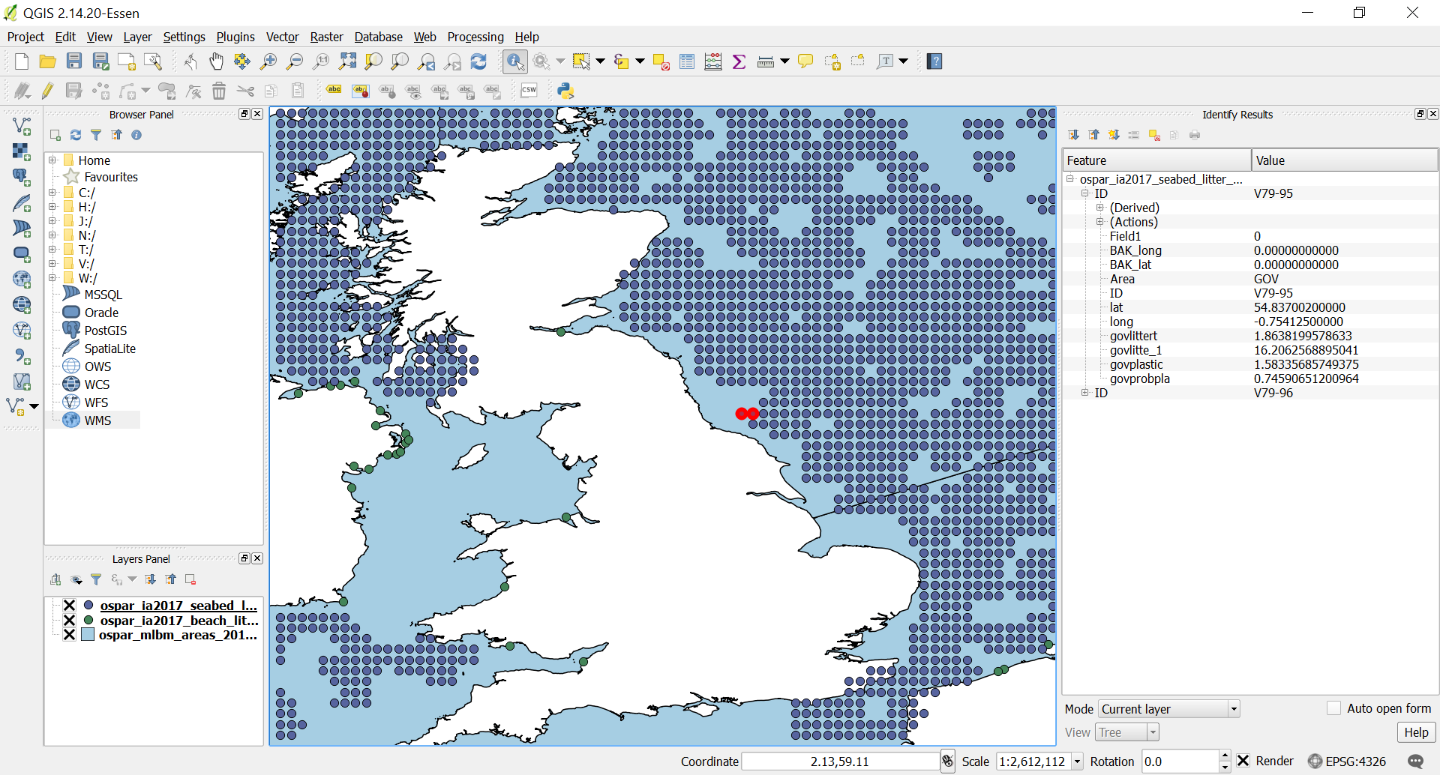
Figure 1 Marine Litter from Trawls (IA2017 Seabed Litter - Total Counts of Litter Items Caught per Trawl)

INSPIRE Data Representations

Marine Litter Viewpoint
In this Section, we consider the relationship between INSPIRE themes that can be used to represent marine litter:
- I want to describe the marine environment. Marine litter is a property of the marine environment I want to communicate. The geometry of the dataset represents the real world. | For this SR should be used.
- I want to describe a numeric dataset of marine litter, associated with the marine environment. The geometry of the dataset may represent the sampling feature used to collect marine data, or a derivation of this (for example a grid created from trawls). | For this OF should be used
- I want to describe the process or programme by which I monitor and observe marine litter (and other parameters) along with the results of this process. The geometry of the dataset represents the sampling feature used to collect marine litter. | For this EF should be used
The marine litter dataset shown in Table 1 doesn’t contain real world geometries and so it can’t be represented as a Sea Region. However, for the purpose of this report we consider how Sea Regions could be used to represent marine litter and any challenges that could be faced.
Using the Shoreline Feature Type for Beach Litter
The Shoreline Feature Type is representation of the land:water interface at any tidal state. Its prime purpose is a reference data layer to support portrayal and querying of data. The shoreline can be segmented and attributed. Currently however only two classification attributes are permitted: ShoreType and ShoreStability. In theory the attribution of each segment could be extended to allow for any attribute to be assigned. This would allow for marine litter, or other values such as visitor number, or specie distribution to be assigned. Alternatively, other specifications such as EF can make reference to the ShoreLine when describing the observation process. A discussion on the Thematic Cluster has been posted to consider this:
https://themes.jrc.ec.europa.eu/discussion/view/177682/ef-and-referencing-other-inspire-themes
Representing beach litter using the Shoreline Feature Type could be portrayed like Figure 2.
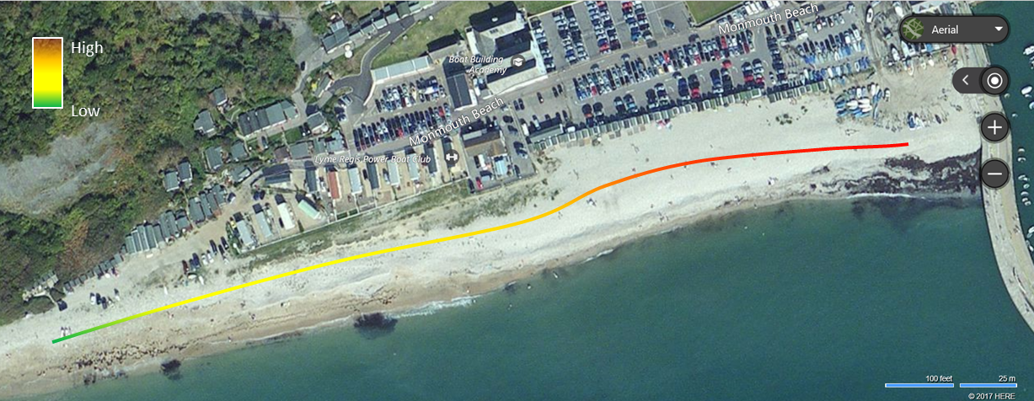
Figure 2 Possible option for using a Shoreline for marine litter
This shows a segmented line with the litter value used to categorize the colour for each segment.
Using the Inter-tidal Area Feature Type for Beach Litter
The inter-tidal Area feature type allows an area between two tidal states to be defined. Its prime purpose is a reference data layer to support portrayal and querying of data. The inter-tidal area can´t be attributed with a value; however, it could define the boundary of measurements from an EF theme dataset to enable litter distribution across an actual beach geometry to be recorded (see Figure 3).
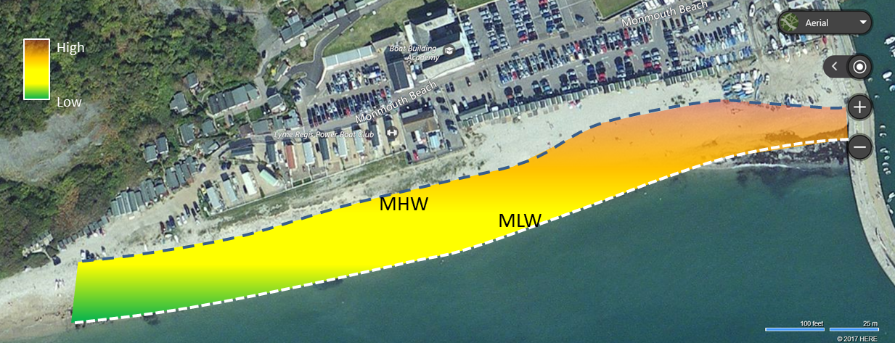
Figure 3 Possible option for using a Shoreline for marine litter
Using the SeaArea Feature Type
The SeaArea feature type allows an area of sea at any tidal states to be defined. Its prime purpose is a reference data layer to support portrayal and querying of data. The SeaArea can be attributed with values, and these could be used for any purpose, but these values are intended to apply to the whole sea area. A SeaArea can be segmented into smaller sub-sea areas, so if it is meaningful to do so, a value such as ‘maximum litter count’ could be applied at the level of a bay or estuary.
Using the MarineContour Feature Type
The marineContour Feature Type can be used to represent any parameter of a SeaArea, including marine litter. There is total flexibility in the way this can be done in INSPIRE. Contours are typically used for portrayal and querying purposes. The ODIMS litter data is represented as attributed points, but this can be converted to contours for representation as MarineContours, as in Figure 4.
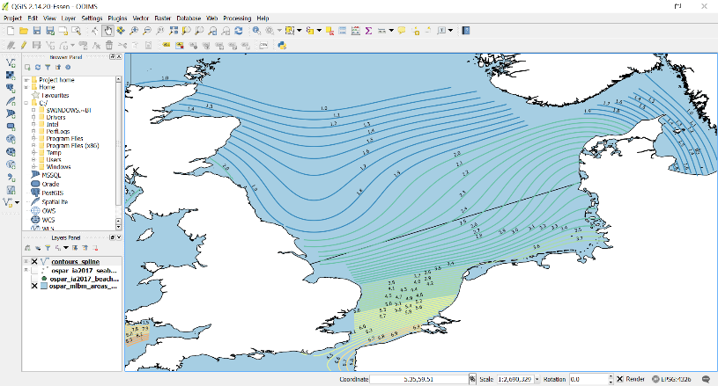
Figure 4 Representing marine litter as MarineContours

Mapping from source to target (MarineContour)
The matching between the INSPIRE MarineContour dataset and a shapefile containing contour data is relatively straight forward. The corresponding matching table is shown in Table 2. The GML was generated using the HALE transformation tool.
Table 2 INSPIRE Matching Table for Marine Contours
Inspire Schema | Source Data (marine litter from trawls)
«featureT ype» MarineContour
+ isoline :MarineIsoline [1..*] | [see datatype]
+ phenomenon :AbstractObservableProperty | Marine Litter
+ validTime :TM_Instant | [No date in source]
«dataT ype» MarineIsoline
+ geometry :GM_MultiCurve | the isoline geometry from the shp file
+ value :Measure | govlittert =1.0,1.1,1.2,1.3….

Conclusions
SR is the best theme to use when the geometry of the data reflects the real world. Attributes can be assigned to SR data sets to present properties of these geometries, but there is a limited range of options for doing this. SR however can provide useful references for other themes; for example detailed measurement data (EF) can be associated with the particular part of the marine environment that is being observed (the particular beach or sea area).
Marine Litter can be represented using the Sea Region theme, but whether this is the best option is a dependent on user requirements to represent Marine Litter.

Species Distribution using the EEA grid

Synopsis
This section describes the use of schemas of the Species Distribution (SD) INSPIRE data theme to map and monitor the EU biogeographical and marine assessments and the data reported by Member States under Article 17 of the Habitats Directive 92/43/EEC through a grid representation.
Article 11 of this Habitats Directive requires Member States to monitor the habitats and species listed in annexes present in their territory. Under Article 17, Member States have to report every six years, according to a standard format, on the conservation status of all targeted species and habitats occurring in each biogeographical region/ marine region present in that Member State territory.
Due to the fact that the dataset holds a big amount of registers, one specie has been selected: Phocoena phocoena specie (code: 1351; http://eunis.eea.europa.eu/species/1510)

Source Data Representations
The data set used for this case study has been downloaded from the European Environment Agency (EEA) internal data repository. There are two data sets for species. The sets are aggregated by conservation status per Member State, and by conservation status at EU-27 level and are provided in ESRI shapefile format.
Tabular data as reported by Member States for the 2007-2012 period includes habitat areas, population sizes, trends, pressures and threats, and conservation status at the national biogeographical level. In addition, it includes conservation status and trends in conservation status at the EU biogeographical level as assessed by the EEA and its ETC on Biological Diversity.
The original metadata format is text that is inserted in the EEA database repository.
The following table shows a summary of the dataset:
Source  Dataset Owners  Dataset Processors | European Environmental Agency (EEA)  Directorate-General for Environment (DG ENV)  European Topic Centre on Biological Diversity (ETC/BD)
Dataset name  Spatial data  Tabular data | Distribution of species and habitat types  Art17_shapefile.zip  Art17_MS_EU27_2015_mdb.zip
Link to the dataset  Spatial data  Tabular data | https://www.eea.europa.eu/data-and-maps/data/article-17-database-habitats-directive-92-43-eec-1/distribution-of-species-zipped-shapefile-vector-polygon/art17-shapefile/at_download/file  https://www.eea.europa.eu/data-and-maps/data/article-17-database-habitats-directive-92-43-eec-1/article-17-database-zipped-ms-access-format/article-17-database-zipped-ms-access-format/at_download/file
Methodology documentation  Name  Download link | art17_EU_dataset_20150611-2.doc  https://www.eea.europa.eu/data-and-maps/data/article-17-database-habitats-directive-92-43-eec-1/
Description | The final European GIS data set contains the conservation status of species and habitat types for each of the biogeographical and marine regions for the European level. These values have been transferred from the tabular data into the spatial data.
Data Representation | Polygons adjusted to the EEA grids.
Field name, definition and table  Many information is provided in the tabular data. The most representative is listed here. | Species distribution data  geometry [From shapefile art17_species_distribution_eu27]  country [Identifies an european level assessment by the EU27 code, Codelist: lu_countries]  region [Biogeographical region or marine region for which the habitat type is taken into account for the European data set / assessments, Codelist: lu_biogeoreg]  assessment_speciescode [Species code corresponding to the assessment_speciesname, Codelist: lu_hd_species]  assessment_speciesname [Name of the species used for the European assessment, Table: data_species_check_list]  conclusion_population [Conclusion for the population state at the biogeographical level (based on method_area), Codelist: lu_assessments]  population_size [Reference to the total size of the population for that biogeographical region, Codelist: lu_population_units]  method_population [Code of the method used to assess the population at the biogeographical level, Codelist: lu_assessments_method]  population_size_unit [Units used for the population size, Codelist: lu_population_units]  presence [Additionnal information such as scientific reserve. Codelist: lu_checklist_presence_categories]  habitat_date [Year or period when data to estimate the habitat surface area were collected. Table: data_species_regions_MS_level]
Access restriction | Unrestricted
Temporal coverage | 2007-2012
Spatial coverage | EU-28
Metadata link | https://www.eea.europa.eu/data-and-maps/data/article-17-database-habitats-directive-92-43-eec-1#tab-metadata

INSPIRE Data Representations
The following table shows the most important INSPIRE elements considered for the mapping process from source to target.
INSPIRE data model considered for Species Distribution theme
inspireID [An external unique object identifier]
geometry [The geometry of each individual spatial object in the collection]
referenceSpeciesId [Identifier of one of the reference lists given by the referenceSpeciesScheme]
referenceSpeciesScheme [Reference list defining a nomenclatural and taxonomical standard]
referenceSpeciesName [The scientific name]
ocurrenceCategory [The species distribution density in the species distribution unit]
residencyStatus [Status of residency regarding nativeness versus introduction and permanency]
populationSize [A range value indicating the counted, estimated or calculated occurrences (upper and lower limit)]
countingMethod [Method of providing a number of the indication of the abundance of a specie]
countingUnit [Species populations units]
populationType [The permanency of populations, regarding to migratory species within the distribution unit]
collectedFrom [Date of the original species occurrence data started]
collectedTo [Date when the collecting of the specie stopped]
beginLifespanVersion [Date and time at which this version of the spatial object was inserted or changed in the dataset]
endLifespanVersion [Date and time at which this version of the spatial object was inserted or changed in the dataset]

INSPIRE Theme Scope
The selection of an INSPIRE theme is straightforward for the selected dataset.
For the Species Distribution (SD) theme, a short definition, the typical uses, and the links and relationships with other INSPIRE themes are briefly outlined below.
This SD theme comprises of the geographical distribution of occurrence of animal and plant species aggregated by grid, region, administrative unit or other analytical unit. Pan-European, national or local mapping initiatives, resulting in spatial data for species in terrestrial and marine environments, e.g. for birds, insects, mammals, amphibians, reptiles, fish or vascular plants.
Digital data sets can be used for:
- Conservation and statistical analysis, as the base of research in ecology and biodiversity: species distribution, quantities, development through time...
- Conservation and management of nature.
- Identifying biotic diversity within biotic regions or countries: geographical distribution, changes over time, combination of species in communities and co-variance with environmental factors and ecological qualities.
- Planning of protection and management of biodiversity in natural, semi-natural and artificial environments.
- Commercial exploitation of economic natural resources such as animals and plants living in natural and semi-natural environments, e.g. fisheries of specific species, both in marine and inland waters, hunting, forestry and sea weed harvesting.
- Natura2000 and other initiatives.
Links to other data themes:
- Geographical grid systems, Habitats and Biotopes, Biogeographical regions and Protected sites.

INSPIRE Data Interoperability
Mapping from source (EEA dataset, right) to target (Species Distribution theme, left)
Type | Attribute  Association role  Constraint | Values / Enumerations | Multiplicity | Voidable / Non-Voidable | Remarks |  | Attribute  Association role  Constraint | Values / Enumerations | Remarks
PopulationSizeType | countingMethod | CountingMethodValue  * counted  * estimated  * calculated | 1 |  | Filled with "estimeted" |  | method_population | 1: Matrix rules used for assessing one or both of the first two sub-conclusions (range, population/area)  2GD: Each subconclusion weighted by area of gridded distribution from GML data  00: Only one MS reported as present
 | countingUnit | CountingUnitValue | 1 |  | Filled with "number of individuals" |  | population_SizeUnit | i: number of individuals
 | populationSize | RangeType | 1 |  | Filled with a numeric interval |  | population_size | Numeric interval
DistributionInfoType | occurrenceCategory | OccurrenceCategoryValue  * common  * rare  * veryRare  * present  * absent | 1 |  | Left empty |  |  |  | Not present
 | residencyStatus | ResidencyStatusValue  * cultivated  * extinct  * introducedEstablished  * introducedImpermanent  * native  * naturallyImpermanent  * probablyExtinct  * re-introducedOrTranslocated | 0..1 | voidable | Filled with “introducedEstablished” and “naturallyImpermanent”. |  | conclusion_population | FV:Favourable  U2: Bad  XX:Unknown
 | populationSize | PopulationSizeType | 0..1 | voidable | Filled with a numeric interval |  | population_size | Numeric interval
 | sensitiveInfo | Boolean  * TRUE  * FALSE | 0..1 | voidable |  |  |  |  | Not present
 | populationType | PopulationTypeValue  * wintering  * reproducing  * concentration  * permanent | 0..1 | voidable | Filled with "permanent" (for 1 ).  Filled with "concentration" (for OCC and SR) |  | presence | 1: The habitat type is present in the region or the species occurs regularly in the region.  OCC: Occasionally occurring species (in some documents also a term vagrant has been used, these two terms are considered here as synonyms). Occasional species are the species which do not have stable and regular occurrence in the biogeographical region or the number of specimens is insignificant. The occasional species should be reported, if possible following the guidance of the Article 17 guidelines.  SR:The status of the species is uncertain, for example there are only occasional records of the species and it is not possible to judge whether it occurs regularly in significant numbers. Basically this criterion should not be used for the species which were known from a biogeographical region and which has recently disappeared. The assessment of conservations status is not expected.  The presence of the habitat type is uncertain; often linked to problems with interpretation of the habitat type. The assessment of conservations status is not expected.
 | collectedFrom | Date | 1 | voidable | Filled with the year.  Only the lower value is taken |  | habitat_date | Interval
 | collectedTo | Date | 1 | voidable | Filled with the year.  Only the upper value is taken |  | habitat_date | Interval
SpeciesNameType | referenceSpeciesId | ReferenceSpeciesCodeValue | 1 |  | Filled with "1351" |  | assessment_speciescode | 1351
 | referenceSpeciesScheme | ReferenceSpeciesSchemeValue  * eunomen  * eunis  * natureDirectives | 1 |  | Filled with "Nature directives"
 | referenceSpeciesName | CharacterString | 1 | voidable | Filled with "Phocoena phocoena" |  | assessment_speciesname | Phocoena phocoena
 | localSpeciesId | LocalSpeciesNameCodeValue | 0..1 | voidable |  |  |  |  | Not present
 | localSpeciesScheme | CharacterString | 0..1 | voidable |  |  |  |  | Not present
 | localSpeciesName | CharacterString | 0..1 | voidable |  |  |  |  | Not present
 | qualifier | QualifierValue  * congruent  * includedIn  * includes  * overlaps  * excludes | 0..1 | voidable |  |  |  |  | Not present
RangeType | upperBound | Integer | 0..1 |  | Filled with the amount.  Only the upper value is taken |  | population_size | Interval
 | lowerBound | Integer | 0..1 |  | Filled with the amount.  Only the lower value is taken |  | population_size | Interval
SpeciesDistributionUnit | inspireId | Identifier | 0..1 |  | Fillled with a unique code |  | inspireID |  | Obtained as "MS"+"Region" + "assessment_speciescode"
 | geometry | GM_Object | 0..1 |  | Filled with "polygon" |  | Geometry | Empty
 | speciesName | SpeciesNameType | 1 |  | Filled with "Phocoena phocoena" |  | assessment_speciesname | Phocoena phocoena
 | distributionInfo | DistributionInfoType | 0..* | voidable |  |  |  |  | Not present
 | beginLifespanVersion | DateTime | 1 | voidable |  |  |  |  | Not present
 | endLifespanVersion | DateTime | 0..1 | voidable |  |  |  |  | Not present

Options to represent nutrients data

Synopsis
This example describes the use of data models from the INSPIRE data themes Environmental Monitoring Facilities (EF), Oceanographic Geographical Features (OF) and from the Observations and Measurements data model, to map nutrients (MSFD Criterion D5C1 “Nutrients concentrations in water”) in the Mediterranean. This use case is developed in collaboration with MEDCIS project and builds on the SeaDataCloud WP8 - Deliverable 8.6 - Part a “Review of data formats, also considering INSPIRE data models (O&M)”.

Theme Scope
This use case relies on three of the INSPIRE Data Specifications elements, namely the Environmental Monitoring Facilities (EF) and the Oceanographic Geographical Features (OF) themes and the Observations and Measurements (O&M) data model.
In the following subsections the main elements of these three INSPIRE concepts are described, with some indications on how they have been used for the development of this exercise.
Observations and Measurements data model (O&M)
Within the INSPIRE Directive, observational data can be included as spatial information together with other theme specific spatial objects using elements defined in the ISO 19156 “Observations and Measurements” data model. In particular, the INSPIRE Deliverable D2.9 “Guidelines for the use of Observations & Measurements and Sensor Web Enablement-related standards in INSPIRE” tailor and specifies various elements of the O&M data model to deliver observations and measurements data for INSPIRE.
The main elements of the O&M data model are shown in Figure 5, where the OM_Observation class in the core of the model, which references additional classes in order to provide contextual metadata relevant to understanding the observation.
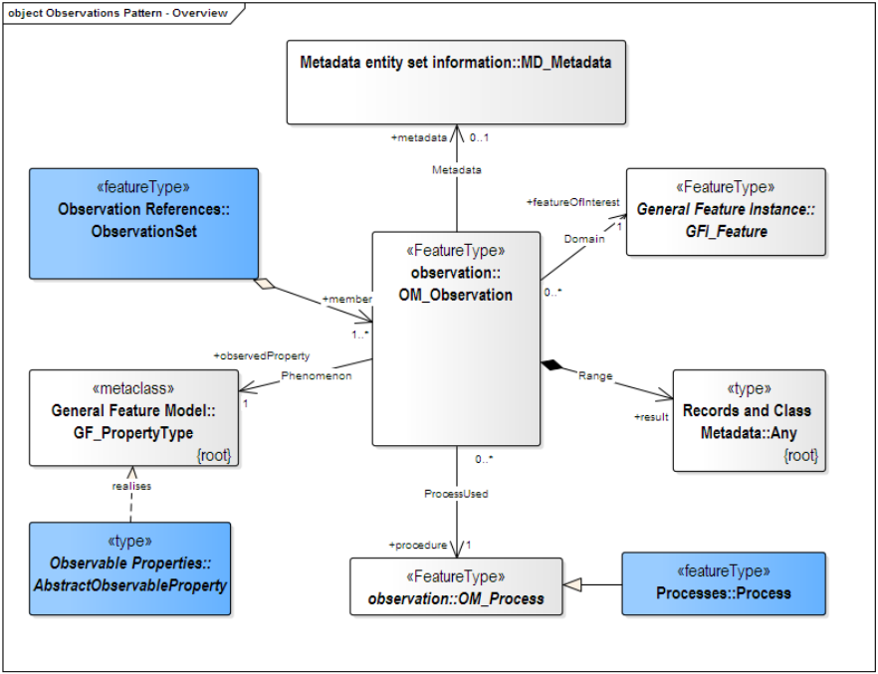
Figure 5 Main classes of the Observations and Measurements data model. The INSPIRE extensions are displayed in blue
The following list provides an overview of the associations linking additional classes to the OM_Observation class:
- metadata: this association allows for the provision of an MD_Metadata object providing additional information on the observation. This object can be provided inline within the Observation, or can be provided as a reference (URI) to an existing external resource.
- observedProperty: this provides a link either to a codelist listing measurement properties such as the parameter codes managed byBritish Oceanographic Data Centre (BODC) by existing SeaDataNet (SDN) data sources, or alternatively a structure based on the AbstractObservableProperty type, allowing for detailed information on complex properties, i.e. statistics.
- procedure: information on the measurement process is essential for understanding how data was assayed, as well as for further processing. As the SensorML standard provided within OGC SWE is quite complex, INSPIRE has introduced the INSPIRE Process type for easy provision of this type of information.
- featureOfInterest: this association links to the spatial object the observation or measurement was taken on. This is often not a real-world object; instead, it is defined based on where the measurement was taken, i.e. describes the location of the water column a profile measurement was taken at, or the trajectory of a vessel.
- result: the actual value(s) provided by the observation. While these are usually encoded within the OM_Observation object, provisions have been foreseen to allow for out-of-band encoding, allowing provision of result data via well established formats such as netCDF.
Based on the type of measurement, several specializations of the base OM_Observation can be applied (see Figure 6), consisting of a set of constraints defining the types to be expected for the associations from the OM_Observation.
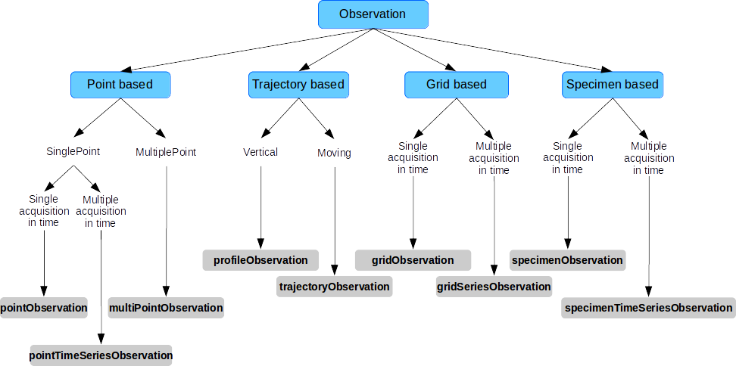
Figure 6 Decision tree to specialised observation type
For this exercise on nutrients data, we selected and developed the profileObservation specialization.
An example of it could be a ship measuring the salinity at varying depths along a water column, the featureOfInterest being a vertical water column at one given ship location. The actual locations of individual measurements along the water column are provided with the result. All measurements are located within the water column with either relative position (from start of water column) or absolute position (i.e. coordinates including the depth). Figure 7 shows a schematic example of such a case.
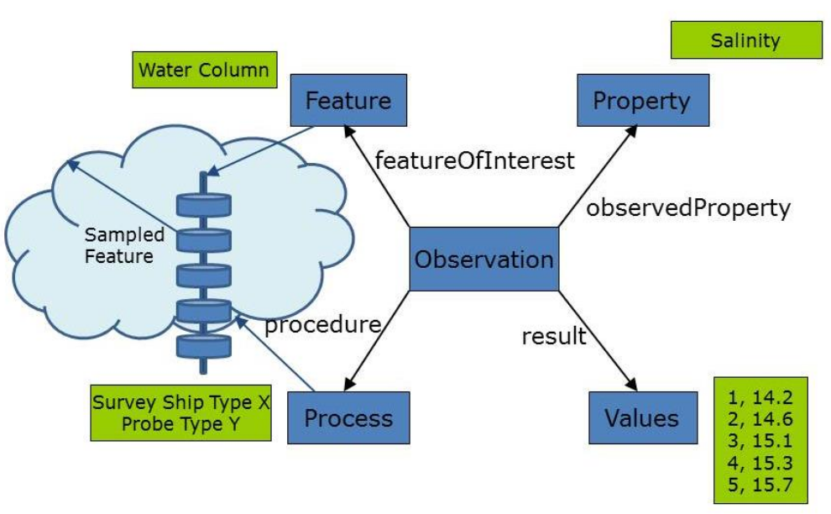
Figure 7 Profile observation schematic example

Environmental Monitoring Facilities (EF)
The Environmental monitoring facilities (EF) theme is defined within the INSPIRE Directive as follows:
Location and operation of environmental monitoring facilities includes observation and measurement of emissions, of the state of environmental media and of other ecosystem parameters (biodiversity, ecological conditions of vegetation, etc.) by or on behalf of public authorities.
This scope includes two main aspects: the environmental monitoring facility as a spatial object and observations and measurements linked to the environmental monitoring facility.
Figure 8 shows the main objects part of the EF data model:
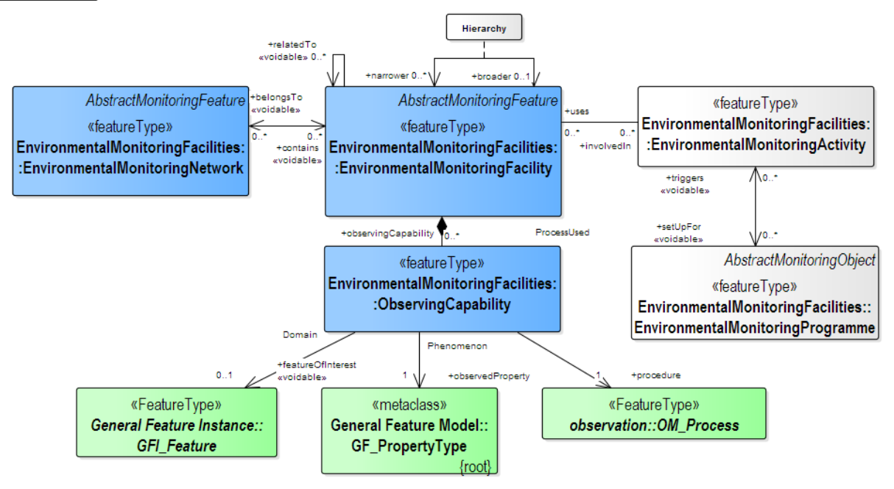
Figure 8 Simplified overview of the EF class structure (from SeaDataCloud WP8 - Deliverable 8.6 - Part a: “Review of data formats, also considering INSPIRE data models (O&M)”)
In this example, developed for nutrients data, we use the class EnvironmentalMonitoringFacility, which provides data on the platform at which the data provided was assayed, together with relevant information on the measurement process.
Oceanografic Geographical Features (OF)
The Oceanographic Geographical Features (OF) theme is defined within the INSPIRE Directive as follows: Physical conditions of oceans (currents, salinity, wave heights, etc.).
Oceanographic Geographical Features, in the contexts on INSPIRE, are typically presented as a set of point data or gridded data from a satellite. Other common data types in oceanography could be vertical profiles through ocean depth or trajectory on the ocean surface.
In order to support the specific requirements ensuing from these different measurement types, the OF data model strongly relies on the specialized observations made available from the O&M data model extensions available within INSPIRE. The following observation types have been defined within the OF data model:
Among these, the ProfileObservation has been used to describe nutrients data.
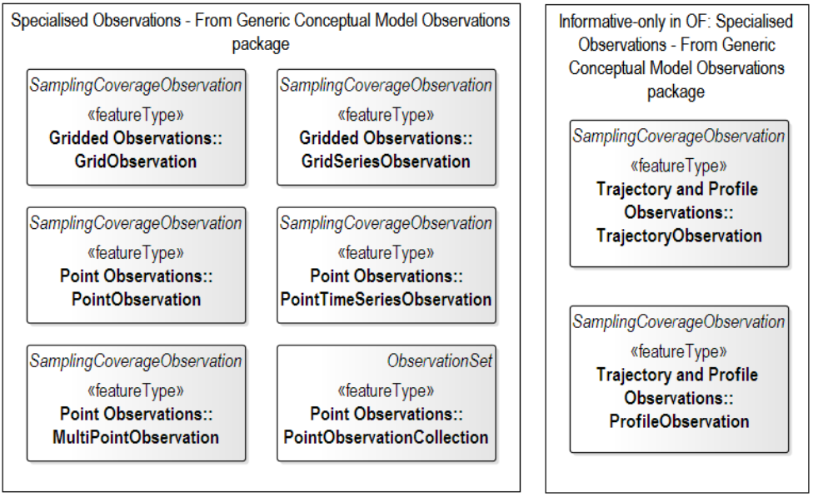
Figure 9 Specialised observations defined in OF data model

Source Data Representations
The data used for this case study were provided by Croatian Institute of Oceanography and Fisheries (IOF). The original metadata format is the Common Data Index (CDI), while data are provided in Ocean Data View (ODV) format. The CDI provides an ISO19115 - ISO19139 based index to individual data sets. The information collected in the CDI answers questions as who, what, where, how, when data were acquired:
- Dataset Originator (Chief scientist/Contact name)
- Dataset name
- Cruise reference (e.g. Name/ start date/ end date)
- Project
- Abstract
- Platform type (ship/float/…)
- Start Date (es. 1999-12-19 15:00:00)
- End Date (es. 1999-12-25 17:00:00)
- Parameters + units
- Data type (CTD/ADCP/Water Bottle…)
- Access restriction (e.g. restricted or unrestricted)
- Latitude/Longitude

Some of these information elements are described using standard vocabularies, consisting of lists of standardised terms that cover a broad spectrum of disciplines of relevance to the oceanographic and wider community. These vocabularies are managed and hosted by the British Oceanographic Data Centre (BODC) by means of the NERC Vocabulary Server (NVS2.0).
More details on the source dataset are included in the table below:
Source | Data Set (URI) | Description | Data Representation
Institute of Oceanography and Fisheries (IOF) - Croatia | http://seadatanet.maris2.nl/v_cdi_v3/print_ajax.asp?screen=0&n_code=2581516 | National monitoring dataset chemistry - OC07 | Data profile of Chlorophyll a [microg/l], Oxygen [micromol/l], Nitrate [micromol/l], Nitrite [micromol/l], Phosphate [micromol/l], pH [pH units], Secchi disk [m], Silicate [micromol/l], Total Ammonium [micromol/l], Total Inorganic Nitrogen [micromol/l], Total Nitrogen [micromol/l], Total Phosphorus [micromol/l], Temperature [degrees Celsius], Salinity [PSU]

For the purposes of this exercise, examples have been developed using Nitrite and Phosphate data.

INSPIRE Data Representations
In this case study, we adopted the solution developed and proposed in the SeaDataCloud project to deliver data in a INSPIRE compliant way. In detail, we use as guideline the SeaDataCloud WP8 - Deliverable 8.6 - Part a “Review of data formats, also considering INSPIRE data models (O&M)”, adapting its content to the current use case focused on nutrients data.
The INSPIRE data models EF, OF and the O&M based observational model have been designed in a complementary manner. The same information objects provided by the Environmental Monitoring Facility as metadata on potential observations stemming from this facility are reused in order to provide contextual metadata for the individual observations provided by this facility. Thus, information on the observed property as well as measurement location and process need only be provided once with the facility data, and can then be referenced by all observations stemming from this facility.
In Figure 10 the classes displayed in blue stem from the EF theme, describing the facility (the Environmental Monitoring Facility class is used to represent both the platform as well as the sampling point level). The classes displayed in green are the area of overlap, so those classed relevant to both EF and OF data. The class in red at the bottom is the basic O&M Observation; this observation references the same classes from the overlap area, describing the observed property, measurement location and process.

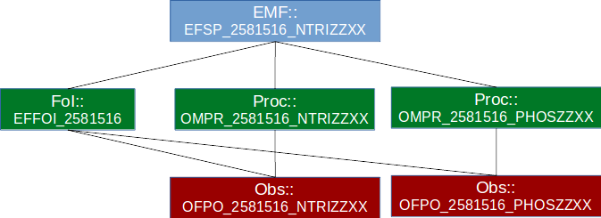
Figure 10 Relationship between objects from different INSPIRE theme
Figure 11 illustrates the relationships between the individual GML objects. The objects displayed in blue stem from the INSPIRE Theme EF, the objects displayed in red stem from the specialized observations utilized for the INSPIRE Theme OF. The green objects are the area of overlap, utilized by both INSPIRE Themes.
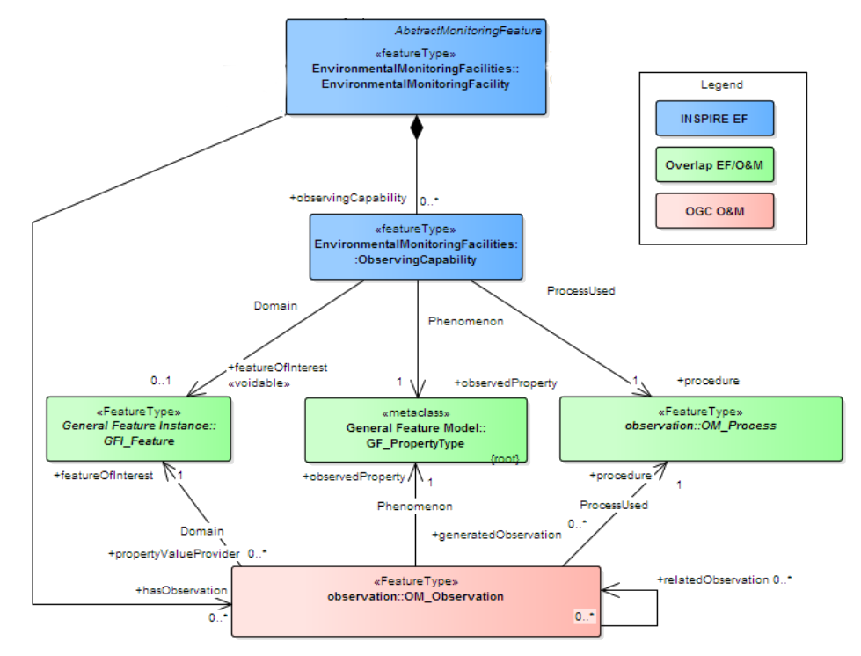
Figure 11 Connections between EF, OF and O&M
The classes used as guidelines in this work are:
- Environmental Monitoring Facility (EMF): this class provide information about platform at which the data are connected and the measurement process.
- Feature of Interest (Foi): this element describes the physical object that acquires data. It describes the location (geographic coordinates) of acquisition.
- Procedure (Proc): this class identifies how the measurement was performed.
- Observed Property (Obs): this element includes all the relevant information on what was measured.
The mapping between SeaDataCloud metadata and INSPIRE elements was done using as source of metadata the Common Data Index (CDI) and ODV for data. The INSPIRE data models have been designed in a complementary manner and are interconnected between them. Among the different types of observations that can be described with O&M standards and further specialised in the OF data model (see Figure 6), we decide, based on the nutrients data used for testing, to adopt the ProfileObservation as XML profile.
As synthesized in Figure 15, the Environmental Monitoring Facility in our case is described as a single Sampling Point, where the Feature of Interest in the water column (at 4 depths: 0, 5, 10 and 18 m) at that specific location. The process relates with two different parameter analysed, Nitrites and Phosphate, producing as results two Observations.

Mapping from source to target
The mapping between the source data and the target EF, OF and O&M schemas has been developed using the matching tables for the EF theme, as improved by SeaDataCloud and uploaded in the INSPIRE Thematic Clusters platform: https://themes.jrc.ec.europa.eu/file/view/170503/inspire-ef-matching-table. The matching tables are available at the following link:
http://nodc.ogs.trieste.it/INSPIRE_compliant/INSPIREmatching_MEDCIS.xlsx

INSPIRE view and download
A complete version of XML files are downloadable at the following link: http://nodc.ogs.trieste.it/INSPIRE_compliant
At the moment, the INSPIRE profiles are only in testing, and they are not yet available by any services. The project MEDCIS will continue developing this example in the coming months.

Annex VI – EEA grids
The use of grids under INSPIRE is introduced in Section 4.3.2 of the Recommendations, where a subsection on Pan-European grids is also included. EEA’s reference grids are enhanced to be used for the publication of datasets under MSFD Article 19(3), in order to progress towards harmonisation.

GIS data
The European Environmental Agency (EEA) reference grids are available in EEA’s website Data and maps section. They are based on the recommendations from the 1st European Workshop on Reference Grids in 2003 and later INSPIRE geographical grid systems. For each country, three vector polygon grid shape files, 1, 10 and 100 km are available. The grids cover at least country borders (plus 15km buffer) and, where applicable, marine Exclusive Economic Zones (plus 15km buffer). The extent of the grid into the marine area does not reflect the extent of the territorial waters.
The reference Grid_ETRS89-LAEA is available for the following countries: Albania, Austria, Belgium, Bosnia and Herzegovina, Bulgaria, Croatia, Cyprus, Czech Republic, Denmark, Estonia, Finland, France, Greece, Hungary, Iceland, Ireland, Italy, Latvia, Liechtenstein, Lithuania, Luxembourg, Macedonia (FYR), Malta, Montenegro, Netherlands, Norway, Poland, Portugal, Romania, Serbia, Slovakia, Slovenia, Spain, Sweden, Switzerland, Turkey and United Kingdom.

Coordinate reference system and recommended grid resolutions
The coordinate reference system (CRS) is ETRS89-LAEA Europe, also known in the EPSG Geodetic Parameter Dataset under the identifier: EPSG:3035. The Geodetic Datum is the European Terrestrial Reference System 1989 (EPSG:6258). The Lambert Azimuthal Equal Area (LAEA) projection is centred at 10°E, 52°N. Coordinates are based on a false Easting of 4321000 meters, and a false Northing of 3210000 meters.
Being based on an equal area projection, the EEA reference grid is suitable for generalising data, statistical mapping and analytical work whenever a true area representation is required. Recommended grid resolutions are 100 m, 1 km, 10 km and 100 km. Alternatively, 25 m or 250 m resolution can be used for analysis purposes, where the standard 100 m or 1 km grid cell size is not appropriate.

Coding system for grid cell identifiers
As it is explained in the eea_reference_grid_v1.pdf document, the objective of the coding system is to generate unique identifiers for each cell, for any of the recommended resolutions. The cell code is a text string, composed of cell size and cell coordinates. Cell codes start with a cell size prefix. The cell size is denoted in meter (m) for cell sizes below 1000 m and kilometre (km) for cell sizes from 1000 m and above. Examples: a 100 meter cell has an identifier starting with “100m”, the identifier of a 10000 meter cell starts with “10km”.
The coordinate part of the cell code reflects the distance of the lower left grid cell corner from the false origin of the CRS. In order to reduce the length of the string, Easting (E) and Northing (N) values are divided by 10^n (n is the number of zeros in the cell size value). Example for a cell size of 10000 meters: The number of zeros in the cell size value is 4. The resulting divider for Easting and Northing values is 10^4 = 10000.

INSPIRE compliance
The requirements for the EEA Reference grids to be INSPIRE compliant are marked with a check:

xml metadata links provided for the following grid resolutions: 1 km , 10 km and 100 km .
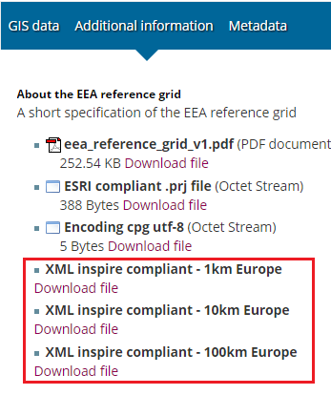

Network services for downloading vector data for the reference grids available.
The downloading links are available at the EEA web page.
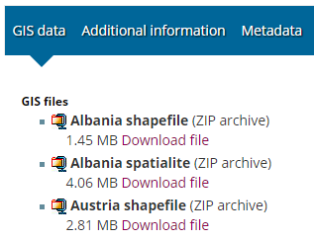

Requirement 3 for the Grid_ETRS89-LAEA is accomplished.
“etrs_1989_laea_l52_m10.prj” file provided with the defined coordinate reference system.
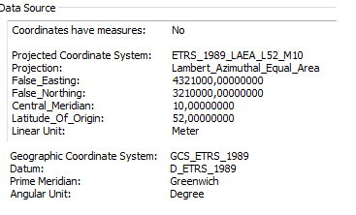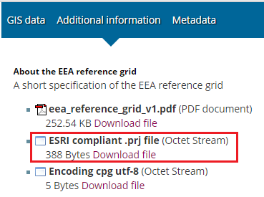

Requirement 4 for the Grid_ETRS89-LAEA is accomplished.
A coding system is needed to identify the cell size and the position of the lower left corner.

Link with data models
This section introduces the idea of linking or using the EEA grids as the geographical objects to be used for the modelling of themes such as habitats and biotopes or species distribution. This is presented as an option, since there is no formal consensus on how those data should be presented.
Most of the content has been taken from the “INSPIRE thematic cluster” forum.
Why it would be necessary to use the EEA reference grids to report the vector and raster data?
  - It would be recommendable to minimize coordinate reference system transformations of the data sets as possible, in order to preserve their quality.
  - Even in the case where data is made available in the same coordinate reference system, when combining raster georeferenced data from different sources (coverages), limits of pixels usually do not match in X,Y coordinates. In order to get the proper alignment it is necessary to establish additional rules, such as the origin of a common geographic grid or its orientation.
As a consequence, problems of alignment between raster files (coverages) based on the “GRID_ETRS89-GRS80zn_res” at the same resolution level (grid coverage cell size) disappear. Remaining misalignments correspond only to the difference in absolute positioning and consistency of the data being combined.
The problem consists in the fact that marine habitats are typically captured according to the WGS84 (EPSG:4326). A global geographic coordinate system that allows locating any point on the Earth by means of three given units. The World Geodetic System (WGS) is a standard for use in cartography, geodesy, and navigation including GPS. And therefore a transformation is need to the EEA grids.
At this respect the Range Tool, available for public download, was used for MS to report data under the articles 12 (Birds Directive) and 17 (Habitats Directive).
What mainly does the tool to adjust vector (points, polylines and polygons) and raster data (grids) to the EEA grid cells corners?
  - Creates dissolved gridded distribution and rage of the input data, adjusted to the EEA reference grids corners, at different resolutions.
  - Create polygons/multipart polygons based on the input data based on the EEA grids by merging adjacent grid-cells, so these polygons have the vertices in the grid cell corners.
  - If input data is provided in LAEA5210 ETRS89 projection, the same as the EEA reference grids, then the number of vertices of the reported areas can be minimized by only putting those that are the extremities, but in the case of reprojecting the geometry in another projection, then only these vertices will be reprojected (and not the complete list of vertices) so for long distances such as the marine areas, the shape and the area will not be correct.
  - In the case the reported areas are going to be reprojected afterwards, then the best is to generate the polygons with the vertices in all EEA grid cells, so once reprojected, the area and the shape will still be quite correct.
Figure 12 shows with brown polylines the reported input vector data for species distribution areas with code 1013. The tool obtain this input vector data as a distribution gridded output. The cells match the cells of the EEA reference grid in the country (dark green cells).
The range (the extension of a group of input data) is obtained as well as grid data (light green). These cells also match the EEA reference grids cells.
For more information see the User Manual for Range Tool.
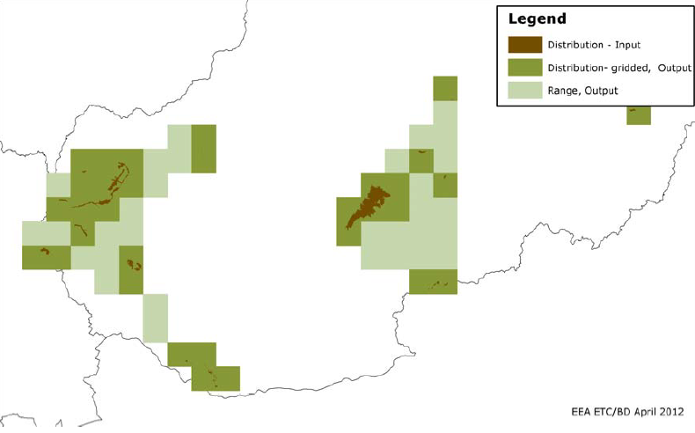
Figure 12 Example of Range Tool results
The following test has been realized. It has been loaded into a GIS software the web map server for Article 17 (Article17/Article17_Distribution_WM (MapServer) . This service provides the polygons for Ranges, Distributions and Biogeographical Regions.
If visualizing only the “Species Distribution” layer inside the Distributions group from the WMS, and loading to the GIS software the EEA Reference Grid_ETRS89-LAEA with cell size 100 km and 10 km, it is possible to check which Member States have reported the data taking into account the INSPIRE grids.
Figure 13 shows how France MS has reported the species distribution under Article 17 by using the EEA grid (in yellow color). The blue dashed areas (reported areas) when covering 100 km width, adjust their vertices to the 100 km EEA grid.

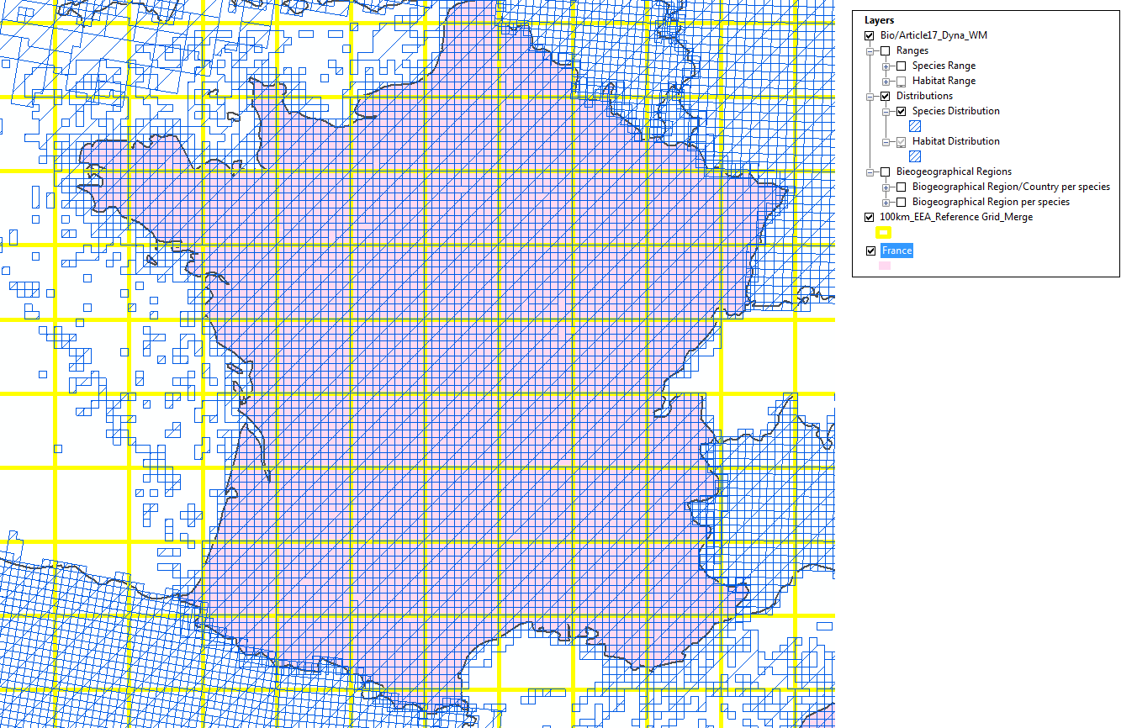
Figure 13 100 km reported species distribution in France adjusted to the 100 km cell size EEA Reference Grid
In the case of overlaying the 10 km cell size EEA Reference Grid (in red color in the image) and the French reported species distributions (blue dashed areas), the cells match exactly with those from the reference Grid (see Figure 14 and Figure 15).
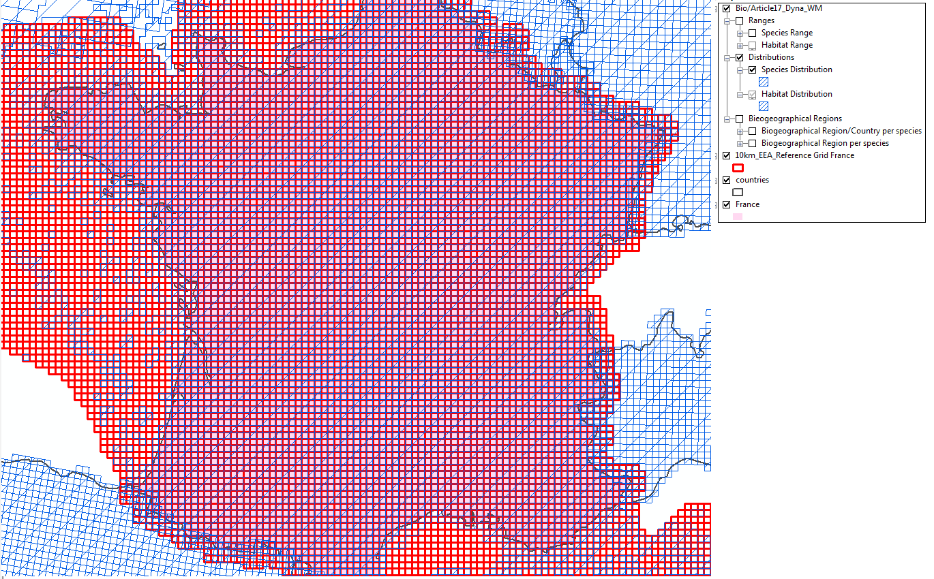
Figure 14 10 km reported species distribution in France adjusted to the 10 km cell size EEA Reference Grid

Figure 15 Detail of Figure 1
Figure 16 shows how Spain MS has reported the species distribution (blue dashed areas) under Article 17 but cells doesn´t match the EEA Reference grid (in yellow color).
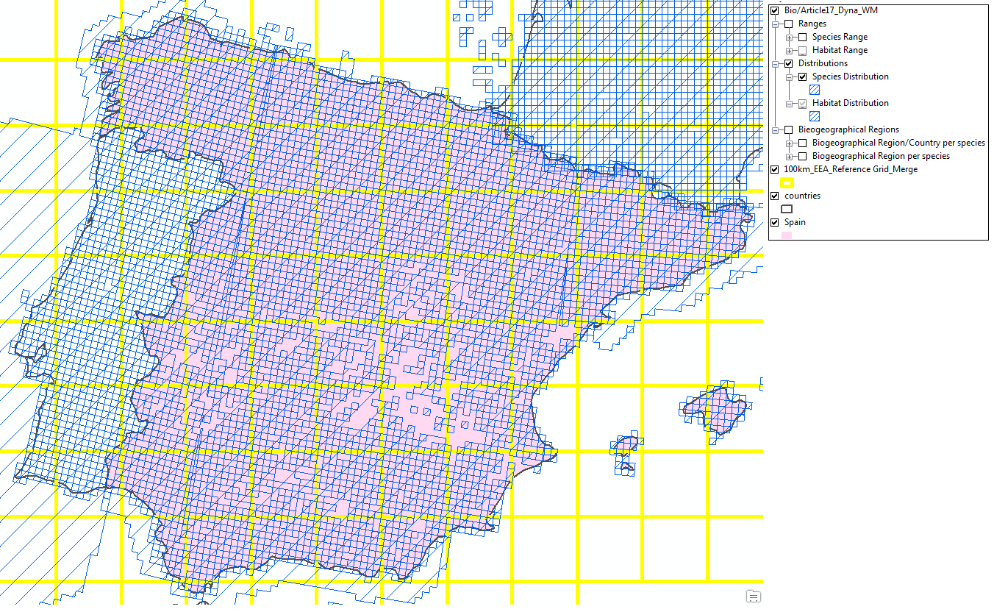
Figure 16 100 km reported species distribution in Spain are not adjusted to the 100 km cell size EEA Reference Grid
Figure 17 shows how the 10 km cell size EEA Reference Grid (in red color in the image) and the Spanish reported species distributions (blue dashed areas), doesn´t match.
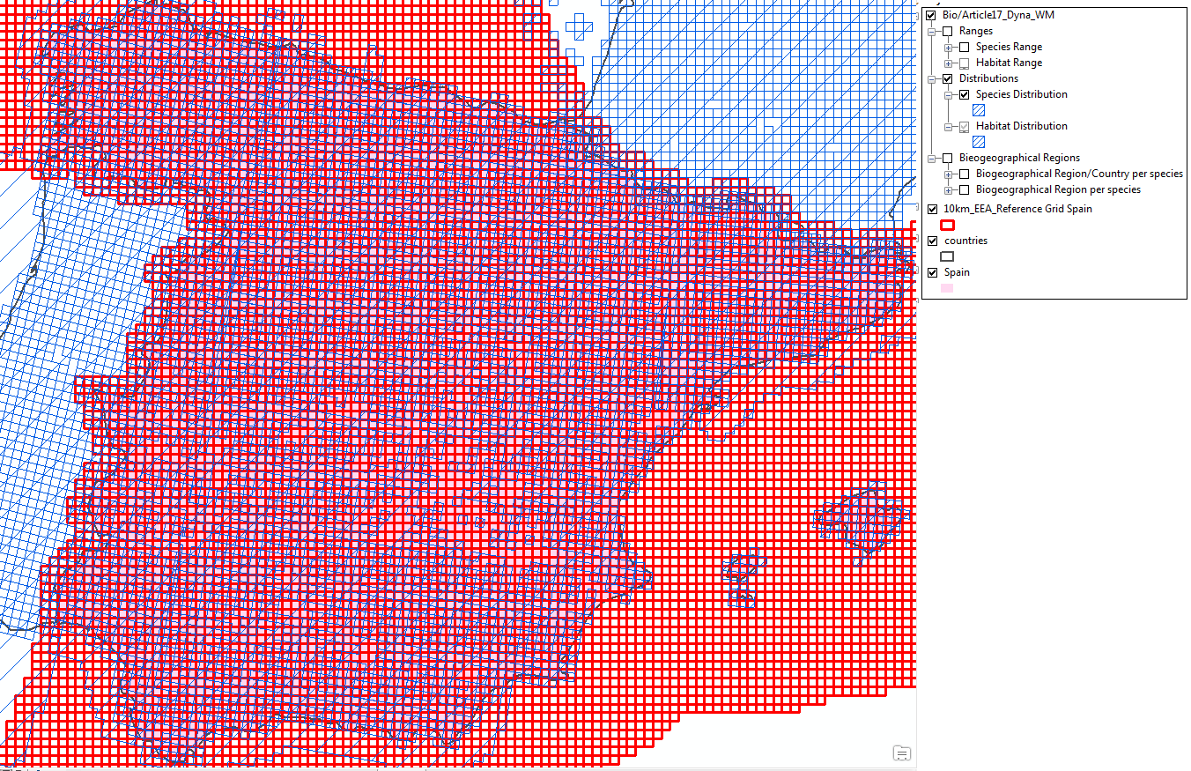
Figure 17 10 km reported species distribution in Spain are not adjusted to the 10 km cell size EEA Reference Grid

Annex VII –Datasets published by supra-national organisations (selection)
In the present Annex, a subset of datasets published by different supra-national organisations is presented as mentioned in Section 5 of the Recommendations, with a brief analysis on whether they are INSPIRE compliant or not.

European Environment Agency
Marine litter on beaches (D10)
INSPIRE
Metadata: partially compliant
Network Discovery and View: partially compliant (planned 2018)
Network Download: partially compliant (direct access)
Description: marine litter data collected in beaches through the Marine LitterWatch (MLW) mobile app or entered from MLW website.

Format: query tool that allows download in XML, csv, pdf, html, Excel, tiff, Word

Link to data: https://www.eea.europa.eu/data-and-maps/data/marine-litter

Link to metadata: https://www.eea.europa.eu/data-and-maps/data/marine-litter#tab-metadata

Publication of services: http://discomap.eea.europa.eu/Services.aspx?agsID=36&fID=6129

Data products:
Data viewer: https://www.eea.europa.eu/themes/coast_sea/marine-litterwatch/data-and-results/marine-litterwatch-data-viewer-1

EMODnet Habitats
EMODnet broad-scale seabed habitat map for Europe (D1, D6)
INSPIRE
Metadata: partially compliant
Network Discovery and View: compliant
Network Download: partially compliant (predefined access)
Format: ESRI shape file, also see http://www.emodnet-seabedhabitats.eu/DEF
Link to data: check box selection
http://www.emodnet-seabedhabitats.eu/default.aspx?page=1953&linkid=1
Link to metadata:
http://gis.ices.dk/geonetwork/srv/eng/catalog.search#/metadata/d23d0516-6ff4-4fb8-bf78-c11991cef78b
Services: WMS maps

EMODnet Biology
Gridded abundance maps of the benthic species from the North Sea (D1)
INSPIRE
Metadata: partially compliant
Network Discovery and View: compliant
Network Download: partially compliant
Format: NetCDF, raster images
Link to data: (per species, 19 in total)
http://www.emodnet-biology.eu/project/documents/Data-products/Benthos/NSBS---gridded-abundance-products/
query driven download available
http://www.emodnet-biology.eu/toolbox/en/download/occurrence/explore
Link to metadata:
http://www.emodnet-biology.eu/data-catalog?module=dataset&dasid=5452 see also
http://www.emodnet.eu/geonetwork/emodnet/eng/catalog.search#/metadata/5f239d08b31d32c7c22efbe51f5aba7fe14b7332
Services: WMS gridded maps

Gridded abundance maps of (10) marine birds from the North Sea (D1)
INSPIRE
Metadata: partially compliant
Network Discovery and View: compliant
Network Download: partially compliant
Format: NetCDF, raster images
Link to data: (per species, 10 in total)
http://emodnet-biology.eu/project/documents/Data-products/Birds/Alca-torda---gridded-abundance-product/
query driven download available
http://www.emodnet-biology.eu/toolbox/en/download/occurrence/explore
Link to metadata:
http://www.emodnet-biology.eu/data-catalog?module=dataset&dasid=5454
Services: WMS gridded maps

Gridded abundance maps of commercial fish species from the North Sea (D1, D3)
INSPIRE
Metadata: partially compliant
Network Discovery and View: compliant
Network Download: partially compliant
Format: NetCDF, raster images
Link to data: (per species, 6 in total)
http://emodnet-biology.eu/project/documents/Data-products/Fish/Clupea-harengus---gridded-abundance-product/
query driven download available
http://www.emodnet-biology.eu/toolbox/en/download/occurrence/explore
Link to metadata:
http://www.emodnet-biology.eu/data-catalog?module=dataset&dasid=5456
Services: WMS gridded maps

Gridded abundance maps of marine mammals from the North Sea (D1)
INSPIRE
Metadata: partially compliant
Network Discovery and View: compliant
Network Download: partially compliant
Format: NetCDF, raster images
Link to data: (per species, 8 in total)
http://emodnet-biology.eu/project/documents/Data-products/Mammals/Dolphin---gridded-abundance-product/
query driven download available
http://www.emodnet-biology.eu/toolbox/en/download/occurrence/explore
Link to metadata:
http://www.emodnet-biology.eu/data-catalog?module=dataset&dasid=5457
Services: WMS gridded maps

OOPS - Copepods: ICES Operational Oceanographic Products and Services - Gridded Copepod abundance data in NE Atlantic (D1)
INSPIRE
Metadata: partially compliant
Network Discovery and View: compliant
Network Download: partially compliant
Format: NetCDF, raster images
Link to data: (per species, size group, ratio, 43 in total)
http://emodnet-biology.eu/project/documents/Data-products/Plankton/Calanus-finmarchicus---gridded-abundance-product/
query driven download available
http://www.emodnet-biology.eu/toolbox/en/download/occurrence/explore
Link to metadata:
http://www.emodnet-biology.eu/data-catalog?module=dataset&dasid=5438
Services: WMS gridded maps

EMODnet Chemistry

Nitrate/Phosphate/Ammomium/Dissolved gasses/Chlorophyll a concentrations by regional sea basin (D5)
INSPIRE
Metadata: compliant
Network Discovery and View: compliant
Network Download: partially compliant (direct access)
Format: netCDF (products), ODV (csv) for input data
Link to data: specific data product dataset embedded on metadata, generic data search
http://emodnet-chemistry.maris2.nl/v_cdi_v3/search.asp or by region on table on
http://www.emodnet-chemistry.eu/index.html
Link to metadata:
http://sextant.ifremer.fr/en/web/emodnet_chemistry/catalogue#/metadata/4b65b074-19a2-11e5-95c0-8056f28224bb
Services: WMS products available attached to metadata
Data products:
Catalogue of data products:
http://sextant.ifremer.fr/en/web/emodnet_chemistry/catalogue#/search?sortBy=popularity&from=1&to=20

Contaminants (grouped by Fertilizers, Heavy metals, Hyrdrocarbons, PCB’s, Anti-foulants) by regional sea basin (D8)
INSPIRE
Metadata: compliant
Network Discovery and View: compliant
Network Download: partially compliant (direct access)
Format: ODV (csv) for input data
Link to data: by region on table on
http://www.emodnet-chemistry.eu/index.html
Link to metadata:
Metadata is provided per data record i.e. one regional subset of datasets can contain thousands of metadata records
Services: WMS products available attached to metadata
Data products:
Map search and download tool:
http://emodnet-chemistry.maris2.nl/v_cdi_v3/result.asp?formname=search&v0_30=CPSD,CPWC&v1_30=parameters_p02&v2_30=4&v0_23=1,10,11,12,13,141,198,39,40,41,42,8,9&v1_23=sea_area_c19&v2_23=115
Note: Marine litter (D10) data download and data products are planned but not yet available

COPERNICUS (CMEMS)

Nutrients/Oxygen/Chlorophyll a modelled and observed concentrations globally or by regions (D5)
INSPIRE
Metadata: compliant
Network Discovery and View: compliant
Network Download: partially compliant (direct access)
Format: NetCDF (products)
Link to data:
Data is available through FTP (summary) or through a subsetter service (by geographic area, time, depth and variable)
Global dataset:
http://marine.copernicus.eu/services-portfolio/access-to-products/?option=com_csw&view=details&product_id=GLOBAL_ANALYSIS_FORECAST_BIO_001_014
http://marine.copernicus.eu/services-portfolio/access-to-products/?option=com_csw&view=details&product_id=GLOBAL_REANALYSIS_BIO_001_018
http://marine.copernicus.eu/services-portfolio/access-to-products/?option=com_csw&view=details&product_id=OCEANCOLOUR_GLO_CHL_L4_NRT_OBSERVATIONS_009_033
http://marine.copernicus.eu/services-portfolio/access-to-products/?option=com_csw&view=details&product_id=OCEANCOLOUR_GLO_CHL_L4_REP_OBSERVATIONS_009_082
http://marine.copernicus.eu/services-portfolio/access-to-products/?option=com_csw&view=details&product_id=INSITU_GLO_NRT_OBSERVATIONS_013_030
Link to metadata:
http://cmems-resources.cls.fr/?option=com_csw&view=details&tab=info&product_id= GLOBAL_ANALYSIS_FORECAST_BIO_001_014&format=xml
http://cmems-resources.cls.fr/?option=com_csw&view=details&tab=info&product_id= GLOBAL_REANALYSIS_BIO_001_018&format=xml
http://cmems-resources.cls.fr/?option=com_csw&view=details&tab=info&product_id= OCEANCOLOUR_GLO_CHL_L4_NRT_OBSERVATIONS_009_033&format=xml
http://cmems-resources.cls.fr/?option=com_csw&view=details&tab=info&product_id= OCEANCOLOUR_GLO_CHL_L4_REP_OBSERVATIONS_009_082&format=xml
http://cmems-resources.cls.fr/?option=com_csw&view=details&tab=info&product_id= INSITU_GLO_NRT_OBSERVATIONS_013_030&format=xml
View service (WMS) available per product.
http://nrtcmems.mercator-ocean.fr/thredds/wms/dataset-global-analysis-forecast-bio-001-014
http://nrtcmems.mercator-ocean.fr/thredds/wms/dataset-global-reanalysis-bio-001-018
http://nrtcmems.mercator-ocean.fr/thredds/wms/dataset-oceancolour-glo-chl-l4-nrt-observations-009-033
http://nrtcmems.mercator-ocean.fr/thredds/wms/dataset-oceancolour-glo-chl-l4-rep-observations-009-082
http://nrtcmems.mercator-ocean.fr/thredds/wms/dataset-insitu-glo-nrt-observations-013-030
Catalogue of data products:
http://marine.copernicus.eu/wp-content/uploads/catalogue-cmems.pdf
http://marine.copernicus.eu/services-portfolio/access-to-products/

Hydrographic conditions products globally or by regions (D1, D7, D8, D10, D11)
INSPIRE
Metadata: compliant
Network Discovery and View: compliant
Network Download: partially compliant (direct access)
Format: NetCDF (products)
Link to data:
Data is available through FTP (summary) or through a subsetter service (by geographic area, time, depth and variable)
Global dataset:
http://marine.copernicus.eu/services-portfolio/access-to-products/?option=com_csw&view=details&product_id=GLOBAL_ANALYSIS_FORECAST_PHY_001_024
http://marine.copernicus.eu/services-portfolio/access-to-products/?option=com_csw&view=details&product_id=GLOBAL_REANALYSIS_PHY_001_025
http://marine.copernicus.eu/services-portfolio/access-to-products/?option=com_csw&view=details&product_id=GLOBAL_ANALYSIS_FORECAST_WAV_001_023
http://marine.copernicus.eu/services-portfolio/access-to-products/?option=com_csw&view=details&product_id=GLOBAL_ANALYSIS_PHYS_001_020
http://marine.copernicus.eu/services-portfolio/access-to-products/?option=com_csw&view=details&product_id=GLOBAL_REP_PHY_001_021
http://marine.copernicus.eu/services-portfolio/access-to-products/?option=com_csw&view=details&product_id=INSITU_GLO_NRT_OBSERVATIONS_013_030
Link to metadata:
http://cmems-resources.cls.fr/?option=com_csw&view=details&tab=info&product_id= GLOBAL_ANALYSIS_FORECAST_PHY_001_024&format=xml
http://cmems-resources.cls.fr/?option=com_csw&view=details&tab=info&product_id= GLOBAL_REANALYSIS_PHY_001_025&format=xml
http://cmems-resources.cls.fr/?option=com_csw&view=details&tab=info&product_id= GLOBAL_ANALYSIS_FORECAST_WAV_001_023&format=xml
http://cmems-resources.cls.fr/?option=com_csw&view=details&tab=info&product_id= GLOBAL_ANALYSIS_PHY_001_020&format=xml
http://cmems-resources.cls.fr/?option=com_csw&view=details&tab=info&product_id= GLOBAL_REP_PHY_001_021&format=xml
http://cmems-resources.cls.fr/?option=com_csw&view=details&tab=info&product_id= INSITU_GLO_NRT_OBSERVATIONS_013_030&format=xml
View service (WMS) available per product.
http://nrtcmems.mercator-ocean.fr/thredds/wms/dataset-global-analysis-forecast-phy-001-024
http://nrtcmems.mercator-ocean.fr/thredds/wms/dataset-global-reanalysis-phy-001-025
http://nrtcmems.mercator-ocean.fr/thredds/wms/dataset-global-analysis-forecast-wav-001-023
http://nrtcmems.mercator-ocean.fr/thredds/wms/dataset-global-analysis-phys-001-020
http://nrtcmems.mercator-ocean.fr/thredds/wms/dataset-global-rep-phy-001-021
http://nrtcmems.mercator-ocean.fr/thredds/wms/dataset-insitu-glo-nrt-observations-013-030
Catalogue of data products:
http://marine.copernicus.eu/wp-content/uploads/catalogue-cmems.pdf
http://marine.copernicus.eu/services-portfolio/access-to-products/

HELCOM
Some of the indicator datasets presented here, full list at http://helcom.fi/baltic-sea-trends/indicators/
Distribution of Baltic Seals (D1)
INSPIRE
Metadata: compliant
Network Discovery and View: compliant
Network Download: partially compliant (Predefined access)
Format: Excel
Link to data: (3 species)
http://helcom.fi/Documents/Baltic%20sea%20trends/Data%20and%20maps/Biodiversity/BALSAM_GreySeal.xlsx
http://helcom.fi/Documents/Baltic%20sea%20trends/Data%20and%20maps/Biodiversity/BALSAM_HarbourSeal.xlsx
http://helcom.fi/Documents/Baltic%20sea%20trends/Data%20and%20maps/Biodiversity/BALSAM_RingedSeal.xlsx
Link to metadata:
http://metadata.helcom.fi/geonetwork/srv/eng/catalog.search#/metadata/01b92d9d-ceaa-4dfa-a281-53a6a3b9d4ba
http://metadata.helcom.fi/geonetwork/srv/eng/catalog.search#/metadata/e1266843-a481-478b-8fe9-fc727c13997d
http://metadata.helcom.fi/geonetwork/srv/eng/catalog.search#/metadata/53753abf-f164-40b5-9325-6b0605b0c0ab

Trends in arrival of new non-indigenous species (D2)
INSPIRE
Metadata: compliant
Network Discovery and View: compliant
Network Download: partially compliant (Predefined access)
Format: Shp
Link to data: Embedded link in metadata
Link to metadata:
http://metadata.helcom.fi/geonetwork/srv/eng/catalog.search#/metadata/e0816467-c550-40cc-a215-2bcd8e196e62

Abundance of waterbirds in the wintering season (D1)
INSPIRE
Metadata: compliant
Network Discovery and View: compliant
Network Download: partially compliant (Predefined access)
Format: Shp
Link to data: Embedded link in metadata
Link to metadata:
http://metadata.helcom.fi/geonetwork/srv/eng/catalog.search#/metadata/6014538b-5a78-42c9-a9b2-b070f52492c3

OSPAR
All (ca. 50) Intermediate Assessment datasets are catalogued in https://odims.ospar.org/odims_data_files/#collapse_dstream_6. Some of the relevant datasets are included below.
Abundance and Distribution of Coastal Bottlenose Dolphins (D1)
INSPIRE
Metadata: compliant
Network Discovery and View: Partially compliant
Network Download: partially compliant (Predefined access)
Format: Excel
Link to data:
https://odims-cloudfront.ospar.org/ospar_abundance_bnd_2017_02-other-IA2017_Abundance_BND_SnapshotData.zip
Link to metadata:
https://odims-cloudfront.ospar.org/ospar_abundance_bnd_2017_02-metadata.xml

Beach Litter (D10)
INSPIRE
Metadata: compliant
Network Discovery and View: Partially compliant
Network Download: partially compliant (Predefined access)
Format: Excel
Link to data:
https://odims-cloudfront.ospar.org/ospar_ia2017_beach_litter_2017_02-other-IA2017_Beach_Litter_Snapshot.zip
Link to metadata:
https://odims-cloudfront.ospar.org/ospar_ia2017_beach_litter_2017_02-metadata.xml

Concentration of Chlorophyll a (D5)
INSPIRE
Metadata: compliant
Network Discovery and View: Partially compliant
Network Download: partially compliant (Predefined access)
Format: Excel
Link to data:
https://odims-cloudfront.ospar.org/ospar_ia2017_conc_chlora_2017_01-other-IA2017_Chlorophyll_Snapshot.zip
Link to metadata:
https://odims-cloudfront.ospar.org/ospar_ia2017_conc_chlora_2017_01-metadata.xml

Marine bird abundance (D1)
INSPIRE
Metadata: compliant
Network Discovery and View: Partially compliant
Network Download: partially compliant (Predefined access)
Format: Excel
Link to data:
https://odims-cloudfront.ospar.org/ospar_marine_bird_abundance_2017_02-other-IA2017_Marine_Bird_Abundance_SnapshotData.zip
Link to metadata:
https://odims-cloudfront.ospar.org/ospar_marine_bird_abundance_2017_02-metadata.xml

Trends in New Records of Non-Indigenous Species Introduced by Human Activities (D2)
INSPIRE
Metadata: compliant
Network Discovery and View: Partially compliant
Network Download: partially compliant (Predefined access)
Format: Excel
Link to data:
https://odims-cloudfront.ospar.org/ospar_trends_nis_2017_02-other-IA2017_Trends_in_NIS_Introduced_by_Human_Activities_SnapshotData.zip
Link to metadata:
https://odims-cloudfront.ospar.org/ospar_trends_nis_2017_02-metadata.xml

Plastic Particles in Fulmar Stomachs (D8, D10)
INSPIRE
Metadata: compliant
Network Discovery and View: Partially compliant
Network Download: partially compliant (Predefined access)
Format: shp, Excel
Link to data: one file per year
https://odims-cloudfront.ospar.org/ospar_plastic_fulmars_2013_01-other-OSPAR_Plastic_Particles_Fulmars_2013.xlsx
Link to metadata:
https://odims-cloudfront.ospar.org/ospar_plastic_fulmars_2013_01-metadata.xml
Services:
Data products:

ICES

Fish stock population and status assessments in NE Atlantic and Baltic (D3)
INSPIRE
Metadata: compliant
Network Discovery and View: Partially compliant
Network Download: partially compliant (direct access)
Format: XML, png, html
Link to data: http://standardgraphs.ices.dk/stockList.aspx
Link to metadata:
http://gis.ices.dk/geonetwork/srv/eng/catalog.search#/metadata/f5992b7d-b9da-40d4-81b9-d6db9e87e759
Services: http://gis.ices.dk/geonetwork/srv/eng/catalog.search#/search?facet.q=type%2Fservice&resultType=details&any=stock&fast=index&_content_type=json&from=1&to=20&sortBy=relevance
Data products:
Plots and Data for each assessed stock, for example http://standardgraphs.ices.dk/ViewCharts.aspx?key=8728
See also web services for extended products

Impulsive noise events in NE Atlantic and Baltic (D11)
INSPIRE
Metadata: compliant
Network Discovery and View: Partially compliant
Network Download: partially compliant (direct access)
Format: shp (Shape files), png and xls
Link to data:
http://geodata.ices.dk/geoserver/SQL/ows?service=WFS&version=1.0.0&request=GetFeature&typeName=SQL:lyNoiseEventFullLayer&maxFeatures=100000&outputFormat=excel
Link to metadata:
http://gis.ices.dk/geonetwork/srv/eng/catalog.search#/metadata/bc5a443e-4dad-47f4-8203-19c0b44c3883
Services: http://underwaternoise.ices.dk/webservices.aspx
Data products:
Map viewer: http://underwaternoise.ices.dk/map.aspx
Pulse block days indicator: http://underwaternoise.ices.dk/map.aspx ‘Indicator’ functions on right hand menu

Vulnerable Marine Ecosystems, observations of Vulnerable Marine Ecosystem (VME) indicators and habitats in the North Atlantic (D1, D6, D7)
INSPIRE
Metadata: compliant
Network Discovery and View: Partially compliant
Network Download: partially compliant (direct access)
Format: csv
Link to data: http://vme.ices.dk/download.aspx
Link to metadata: http://gis.ices.dk/geonetwork/srv/eng/catalog.search#/metadata/50051026-435d-4554-9692-4cb2f62ab5f9
Services: http://vme.ices.dk/webservices.aspx
Data products:
Map viewer: http://vme.ices.dk/map.aspx
VME Weighting Algorithm: http://vme.ices.dk/map.aspx see right hand menu

Oceanographic dataset for North Atlantic, temp/sal, oxygen, phosphates, nitrates, Chl a, secchi (D5)
INSPIRE
Metadata: compliant
Network Discovery and View: Partially compliant
Network Download: partially compliant (direct access)
Format: csv (odv standard)
Link to data: http://ocean.ices.dk/HydChem/HydChem.aspx?plot=yes
Link to metadata:
http://gis.ices.dk/geonetwork/srv/eng/catalog.search#/metadata/2D135511-B51F-4C69-9D15-A2BB564AC017
Services: http://ocean.ices.dk/webservices/hydchem.asmx
Data products:
Map plots: http://ocean.ices.dk/data/maps/maps.htm
HELCOM oceanographic data tool:
http://ocean.ices.dk/Helcom/Helcom.aspx?Mode=1
Map viewer: http://vme.ices.dk/map.aspx
Ocean climate: http://ocean.ices.dk/iroc/

DOME (Marine Environment) in the NE Atlantic and Baltic including contaminants, biological effects and biological communities (D1, D2, D5, D7, D8, D10)
INSPIRE
Metadata: compliant
Network Discovery and View: Partially compliant
Network Download: partially compliant (direct access)
Format: csv (tab separated)
Link to data:
http://dome.ices.dk/views/index.aspx and http://dome.ices.dk/browse/index.aspx
Link to metadata:
http://gis.ices.dk/geonetwork/srv/eng/catalog.search#/metadata/76336a61-d257-4637-8811-c7f509078547
Services: http://dome.ices.dk/Webservices/index.aspx
Data products:
Thematic views for RSC’s: http://dome.ices.dk/views/index.aspx
Monitoring stations:
http://www.ices.dk/marine-data/tools/Pages/Station-dictionary.aspx
Map viewer: http://ecosystemdata.ices.dk/ (part of main data map portal)

Biodiversity – seabirds and seals abundance and distribution in NE Atlantic (D1, D4)
INSPIRE
Metadata: compliant
Network Discovery and View: Partially compliant
Network Download: partially compliant (Predefined access)
Format: XML, Excel (csv)
Link to data: overview at http://biodiversity.ices.dk/accessions.aspx but output on OSPAR.OAP https://oap.ospar.org/en/ospar-assessments/intermediate-assessment-2017/biodiversity-status/marine-birds/bird-abundance/
Link to metadata: https://oap.ospar.org/en/ospar-assessments/intermediate-assessment-2017/biodiversity-status/marine-birds/bird-abundance/#collapse-assessment-metadata-155088
Services:
Data products:
Indicator factsheet https://oap.ospar.org/en/ospar-assessments/intermediate-assessment-2017/biodiversity-status/marine-birds/bird-abundance/

Database of Trawl surveys (DATRAS) in the NE Atlantic and Baltic (D3, D10)
INSPIRE
Metadata: compliant
Network Discovery and View: Partially compliant
Network Download: partially compliant (direct access)
Format: csv
Link to data: https://datras.ices.dk/Data_products/Download/Download_Data_public.aspx
Link to metadata:
Fish age structure, biodiversity
http://gis.ices.dk/geonetwork/srv/eng/catalog.search#/metadata/68a3376b-c85c-4b4e-a6b8-8ebea73bb427
Marine litter
http://gis.ices.dk/geonetwork/srv/eng/catalog.search#/metadata/54158c0b-398a-4001-a9c7-2f4becc8e148
Services: https://datras.ices.dk/WebServices/Webservices.aspx
Data products:
12 calculated products (indices, CPUE etc):
https://datras.ices.dk/Data_products/Download/Download_Data_public.aspx
Distribution maps:
http://ecosystemdata.ices.dk/Map/index.aspx?Action=AddLayer&DataSet=657&Param=135740&LatN=&LatS=&LonE=&LonW=&Sdate=&Edate=
Marine litter data products (Litter detailed data, and litter assessment output)
https://datras.ices.dk/Data_products/Download/Download_Data_public.aspx

although it could be modified to accept ‘parameterValue’like the SeaArea Feature Type.
The SeaRegion could be the EF SampleFeature or FeatureOfInterest in the Observation and Measurements Process.
parameterValue :ParameterValuePair [0..*]
http://vocab.nerc.ac.uk/collection/P01/current/MLITCNTW/ is used in the example in Figure 6. This is not correct, but an exact match could not be found in the BODC parameter dictionary.
https://inspire.ec.europa.eu/id/document/tg/d2.9-o%26m-swe
https://www.eea.europa.eu/data-and-maps/data/eea-reference-grids-2
www.vliz.be/vmdcdata/marbound
http://epsg-registry.org/
http://sdi.eea.europa.eu/catalogue/srv/eng/xml_iso19139?uuid=d9d4684e-0a8d-496c-8be8-110f4b9465f6
http://sdi.eea.europa.eu/catalogue/srv/eng/xml_iso19139?uuid=074b8e76-5e49-467c-aa30-ed013afd41a9
http://sdi.eea.europa.eu/catalogue/srv/eng/xml_iso19139?uuid=a373b065-66d8-45ae-86af-6618cc6792cb
https://themes.jrc.ec.europa.eu/discussion/view/159833/using-eea-reporting-grids
https:// bd.eionet.europa.eu/activities/Reporting/Article_17/Reporting_Tool/Reporting_Tool_Software
https://bd.eionet.europa.eu/activities/Reporting_Tool/Documents/Range_Tool_User_Manual_18092012.pdf
http://bio.discomap.eea.europa.eu/arcgis/rest/services/Article17/Article17_Distribution_WM/MapServer
https://marinelitterwatch.discomap.eea.europa.eu/

