Customer | DG ENV
Document | MSFD Art. 11 Web Forms User Manual
About | This document contains the User Manual for the  MSFD Art. 11 web forms.

Ver. | DATE | AUTHOR | DESCRIPTION
V1 | 15/01/2020 | Jose Asensio | Generation of the document

Table of Contents

1 Introduction 3
1.1 Purpose 3
1.2 Definitions, acronyms and abbreviation 3
1.3 Overview 3
2 Web forms 4
2.1 Access to web forms 4
2.2 Web forms structure 5
2.3 Web forms validation 6
2.4 Web forms HTML view 6
2.5 Web forms merge tool 7

Introduction

Purpose
The purpose of this document is to provide a user guide for the end users of the Marine Strategy Framework Directive (MSFD) web forms.

Definitions, acronyms and abbreviation
This section provides the reader of the document with an overview of terms used throughout this document and will help to properly understand the MSFD web forms.

EEA | European Environment Agency
EIONET | European Environment Information and Observation Network
HTML | Hypertext Markup Language
MSFD | Marine Strategy Framework Directive
XML | Extensible Mark-up Language

Overview
This document is aimed at providing support for the reporting of the MSFD. The EEA provides us the EIONET platform where the web forms will be allocated. By now they are deployed in the testing environment (http://webq2test.eionet.europa.eu), there we can find the five web forms (one per each schema).

Web forms

Access to web forms
Accessing the web forms URL (http://webq2test.eionet.europa.eu) we have two options:
- Create new session file
- Upload session file
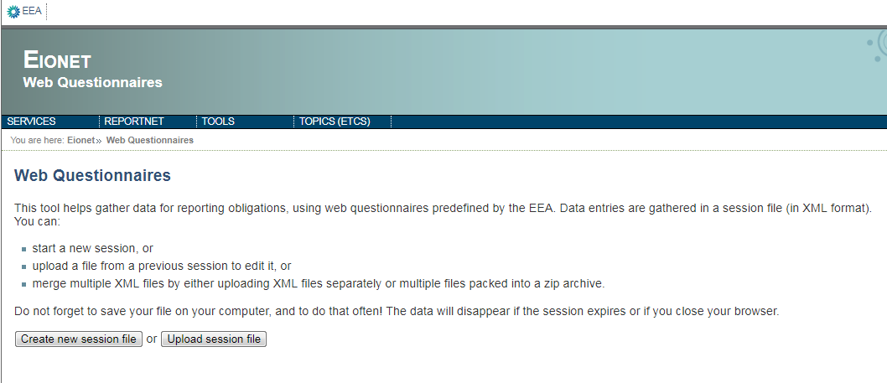
Clicking in the button Create new session file we have to choose one of the five web forms that we need to fill for the reporting of the MSFD;
- MSFD Article 11 Strategies
- MSFD Article 11 Programmes
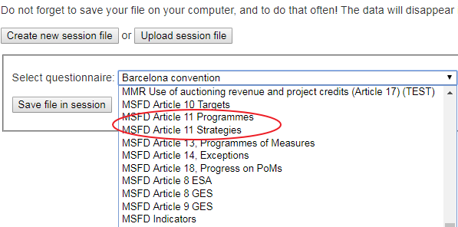
With the option Upload session file, we can upload a XML file to work with it. This XML file could be a prefilled file provide by us or a file that we downloaded and we want to follow the work with it.
Both options will allow us to open the web form clicking in the action provided by the file.
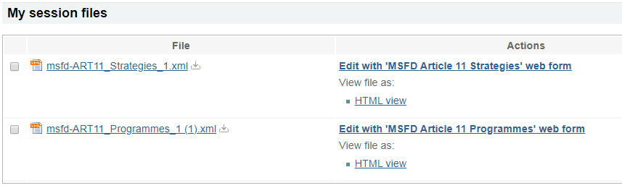

Web forms structure
The web forms have a common section called Reporter Information where we have to insert the data of the reporter.
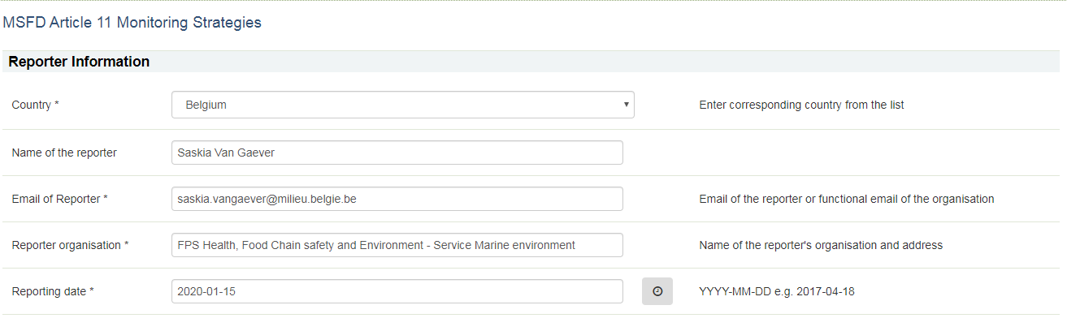

MSFD Article 11 Strategies
Below the Reporter Information section there is another section called Metadata where all the data related to each Responsible Competent Authority can be filled. The mandatory fields are marked with an asterisk and the section can be removed or copied.
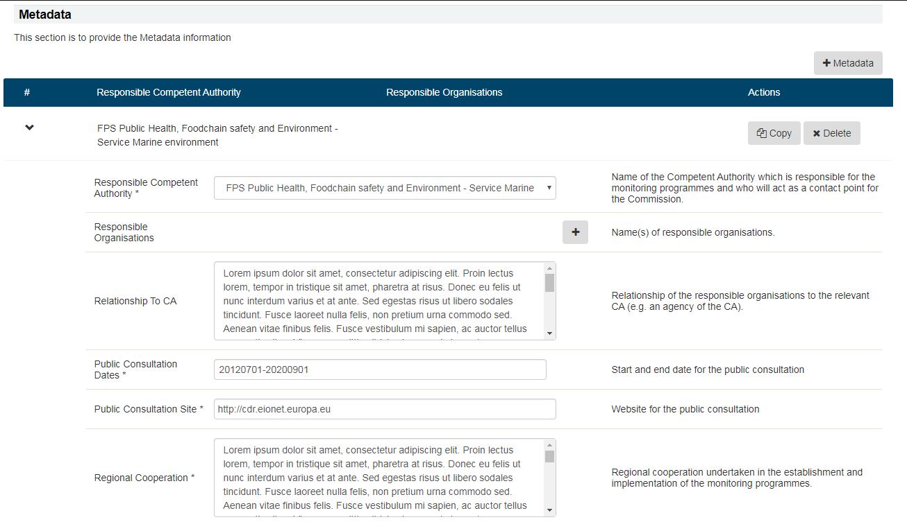
In the Metadata section, there is a sub-section called Monitoring Strategies where can be added the strategy for each Descriptor linked to the Responsible Competent Authority. The mandatory fields are marked with an asterisk and the sub-section can be removed or copied.
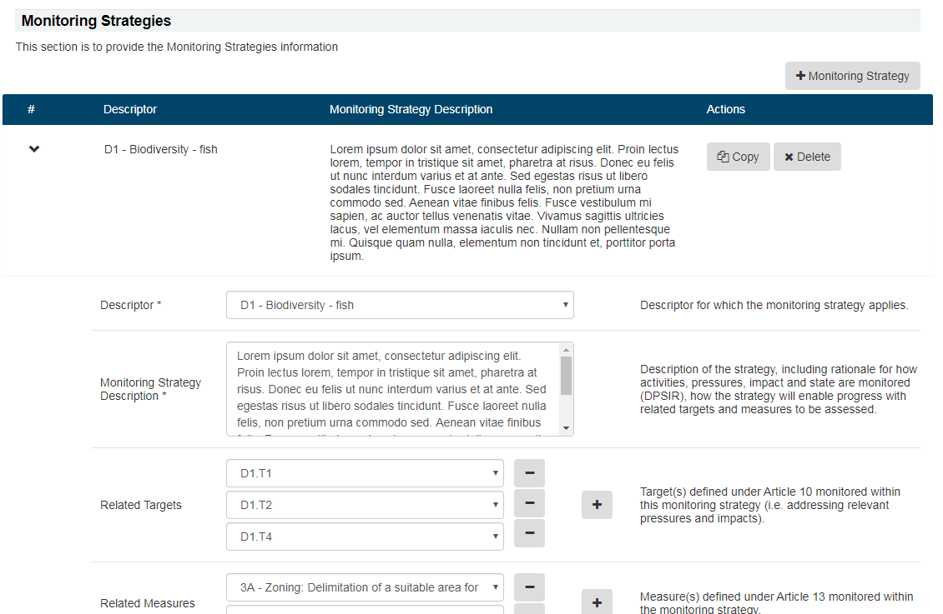

MSFD Article 11 Programmes
Below the Reporter Information section there is another section called Monitoring Programmes where all the data related to each Monitoring Programme can be filled. The mandatory fields are marked with an asterisk and the section can be removed or copied.
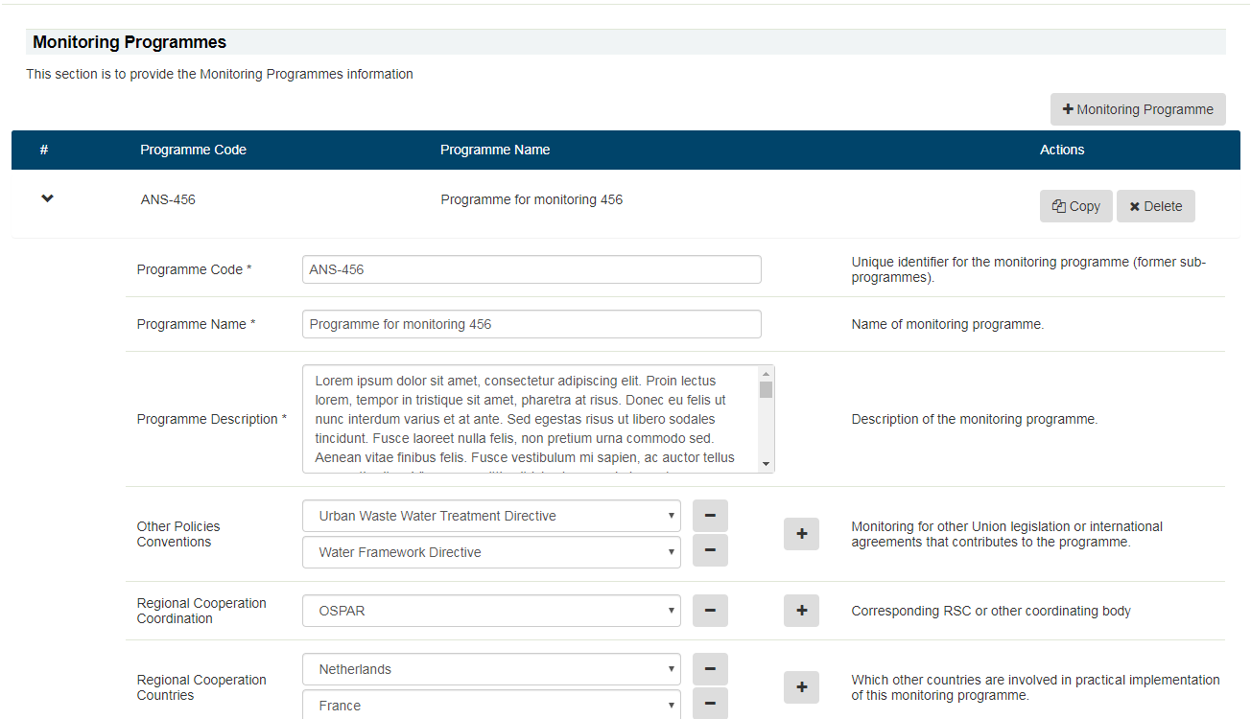

In the Monitoring Programmes section, there is a sub-section called Features where can be added features linked to the Monitoring Programme. Each feature has a sub-section called Elements and each element has a sub-section called GES Criteria. The mandatory fields are marked with an asterisk and the sub-section can be removed or copied.

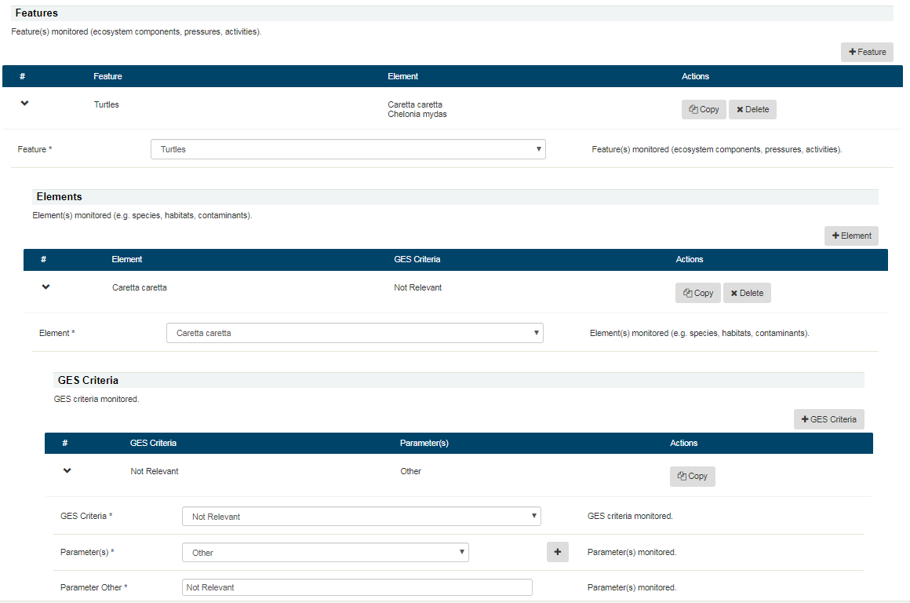

Web forms validation
To facilitate the full fill of the web forms we have implemented a validation. This validation allows the user to check if the mandatory fields are properly filled. The validation can be enabled and disabled using the button at the bottom of the page.
When the validation is enabled, we can check where the error is.
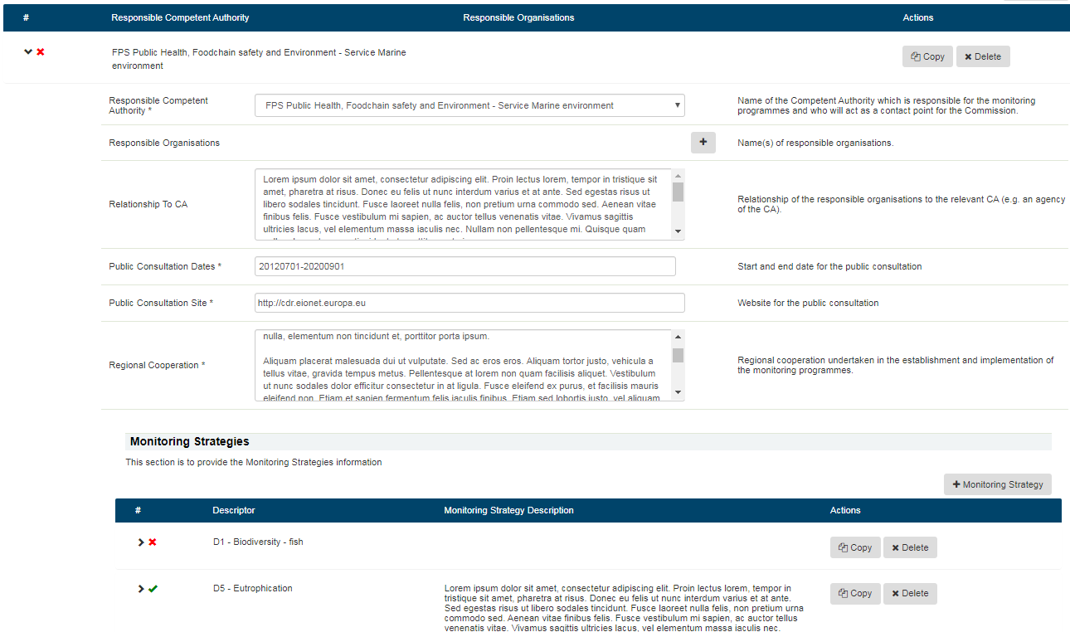
Knowing it we can navigate to the class that give us the error and solve it.
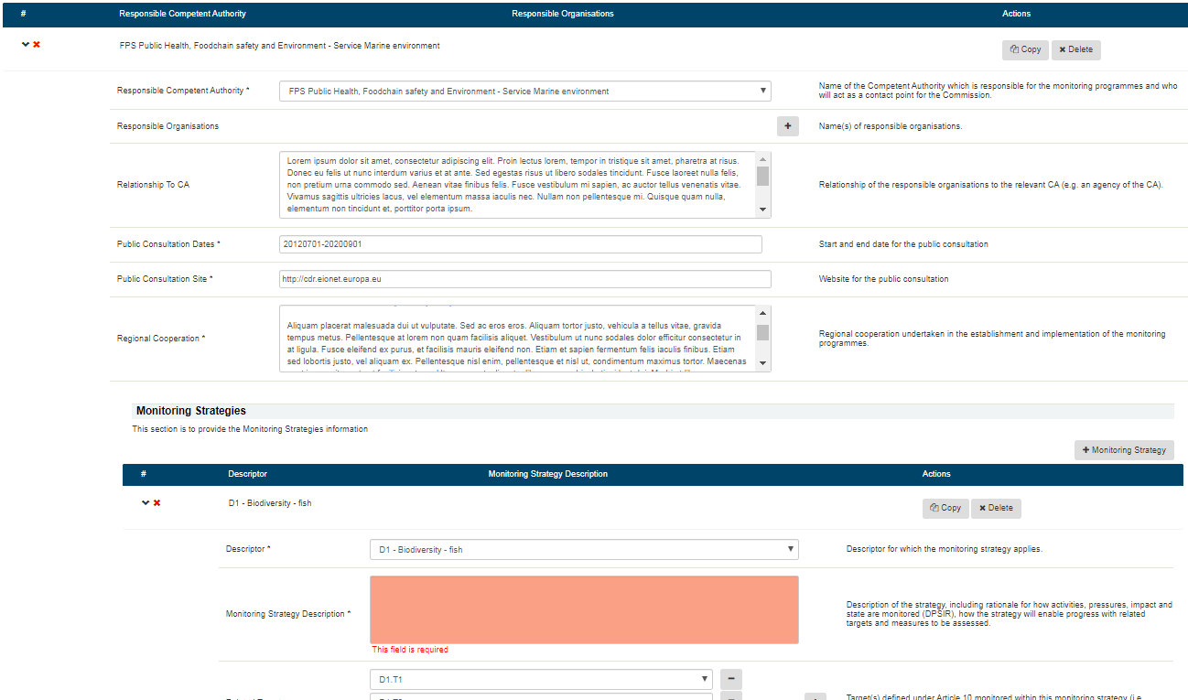

Web forms HTML view
To make the web forms more readable, we have developed a HTML view that can be printed, the option is in the main page of the web forms platform.
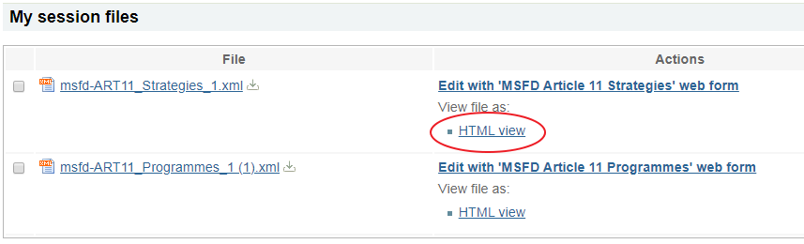
This link will open a new page with the data filled in the web form.
