Here you can find answers to **F**requently **A**sked **Q**uestions

**Question to the SDF**

**SDF - 1. SITE IDENTIFICATION**

**SDF - 2. SITE LOCATION**

**SDF - 4. SITE DESCRIPTION**

**Question to the Natura 2000 software**

* IP address - remote version
* How to add the port 3306 as exception?
* How to edit data manually?
* How to delete all information edited in the Software?
* Should data be re-imported when a new software version is available?

**SDF - 1. SITE IDENTIFICATION**

**1.6 Respondent**

**What is meaning of the different fields for the Address?**

For enter an Address you have two choices:

a) Inspire compliant (recommended),

b) unstructured

The address can either be added as Inspire conform address **or** in the unstructured field for addresses, but not as a mixture out of both.



a) To enter the information on Address into the database, we highly recommend to follow the Inspire Standard. The fields in the database template and xml schema for Address are the following:

adminUnit : Administrative Unit Name (for example the name of the municipality)

thoroughfare : Thoroughfare Name (for example the street name)

locatorDesignator: Address locator (e.g. house number)

postCode : Postal Descriptor (for example the postcode)

postName : Postal Descriptor (for example the postname)

addressArea : Address Area Name (for example the name of the town

locatorName : text associated to a property (e.g. estate, or name of a part of a building)

Further explanation and **examples for the several European countries** can be found here :

<http://inspire.jrc.ec.europa.eu/documents/Data_Specifications/INSPIRE_DataSpecification_AD_v3.0.pdf>

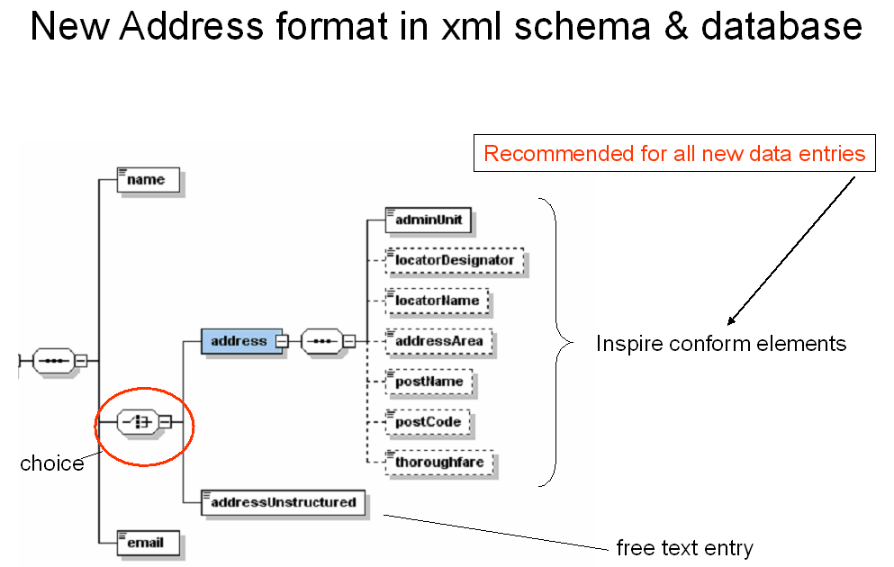

Fig. : Visual presentation of the XML Schema part for the Address (The dotted line around an element means, that it is possible to leave it empty.)

b) For existing entries of Addresses, which are not jet structured like described above, you can put the Address string in the field ‘addressUnstructured’.

**SDF - 2. SITE LOCATION**

**2.1 Site centre location**

**How do I convert coordinates from degrees, minutes, seconds (dms) to decimal degrees (dd)?**

Each degree is divided into sixty minutes; each minute is divided into sixty seconds

Examples: **40 degrees, 20 minutes, 50 seconds** (40° 20’ 50’’)

Here we have 40 full degrees, 20 minutes - each 1/60 of a degree, and 50 seconds - each 1/60 of 1/60 of a degree. Work that out and you will get a decimal number of degrees

40 + (20 * 1/60) + (50 * 1/60 * 1/60) = **40.34722**

**SDF - 4. SITE DESCRIPTION**

**4.1 Threats, pressures and activities with impact on the site**

**Why does the software not import all the data on threats and pressures?**

As the code list for the threats and pressures has been revised considerably for the new SDF, the transfer of the information on threats and pressures can not simply be done automatically in all of the cases.

For codes for threats and pressures having a 1 to 1 relationship between the previous code and the new one (see [list of threats and pressures](http://bd.eionet.europa.eu/activities/Natura_2000/Folder_Reference_Portal/Ref_threats_pressures_FINAL_20110330.xls), column ‘G’ in the sheet ‘database version new list’), the import process works correctly. However old_codes with the extension pp (=pro parte) and cases where two old codes correspond to the same new one need manual editing as well as of course the assignment of new categories of threats and pressures.

The example below illustrates, where automation is not possible and manual editing is required.

1) code is followed by ‘pp’ meaning ‘pro parte’ (e.g. new code H02 is linked to old code 701pp)

2) two old codes correspond to the same new one (e.g. new code G05 is linked to old codes 690 & 790)

3) situations listed above are combined (e.g. new code J02.06 is linked to old codes 853pp,810pp)

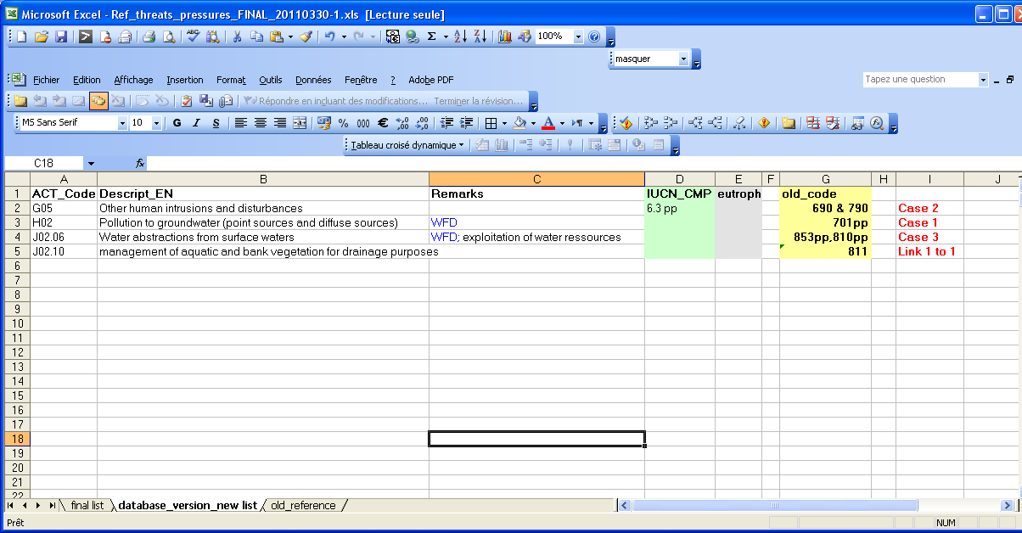

Fig. View of the reference table for threats and pressures illustrating the explained above situations (in red).

**How to deal with impacts defined as ‘neutral’ (old code: 0) in the previous SDF?**

Impacts or activities, which can have positive as well as negative impacts on the site should be listed in both categories (one entry in positive impacts and one entry in negative impacts). This interpretation might not be adequate for all situations. Therefore Member States should make their own correct interpretation of the existing values and edit the values transferred by means of the software manually if required.

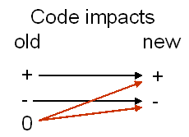

**What is the meaning of ‘pp’ in the old code for threats and pressures?**

pp stands for ‘pro parte’ and indicates that the old category for threats and pressures is only partial the same as the new one.

**How to find the IP address of the host for the remote version?**

If you install the remote version take care, that the IP address for the host is the one from the computer where the MySQL data base is installed (server). Whereas the Natura 2000 software might be installed on your computer (client).

To find the IP address, see the captures below, the last one showing the host address (IP address)

step 1: click on ‘Run’

step 2: write cmd

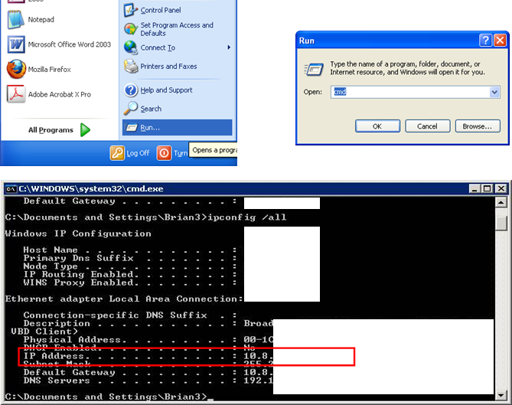

step 3: write ipconfig /all



**How to add the port 3306 as exception to the windows firewall settings?**

Go to control panel, network connections. Select 'change windows firewall settings'. Click on Exceptions tab and click on Add Port button. Type in MySQL for the name of the port and 3306 for the port number. Select tcp and ok.

**I have edited data manually in the new database (mdb) and want to import the mdb back in the MySQL database, so that I can continue to edit data with the software?**

The first step is to export (into an mdb format) the database through the software application (using the SDF export editor). Then users can edit data manually in the mdb.

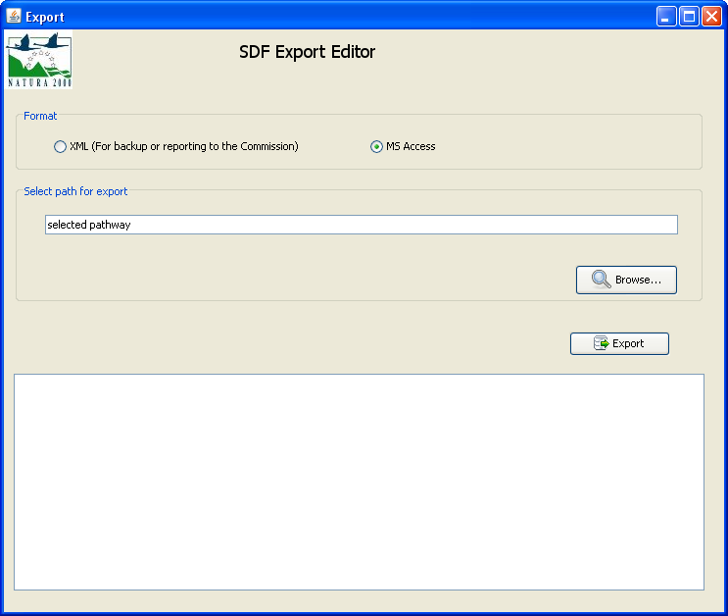 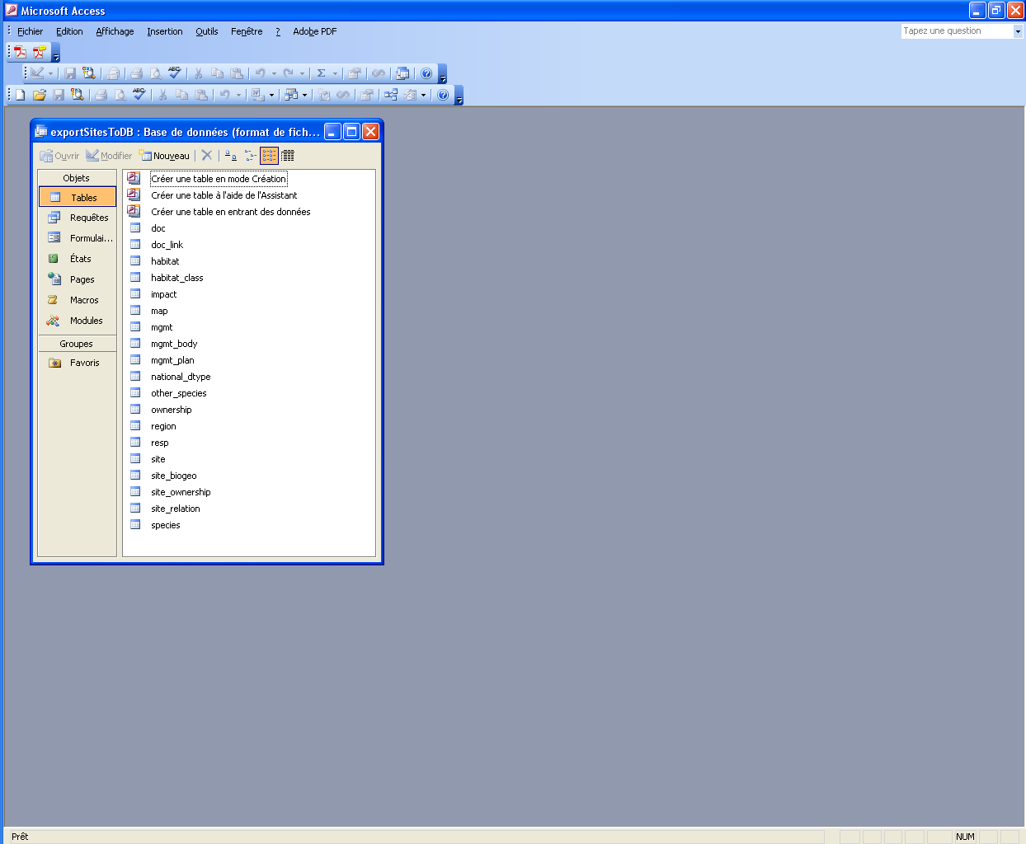

Before importing the mdb back in the MySQL database, sites existing both in the mdb and MySQL databases have to be removed from the MySQL database (more explanations here)

After using the SDF import editor (new SDF), users can continue to edit data with the software application.

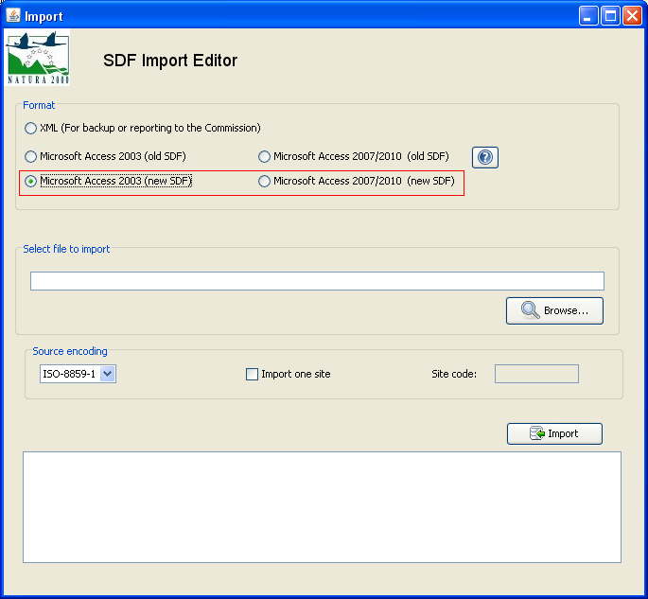

**How to delete information edited in the software?**

To delete **part** of information, the software application allows users to filter data (see the section 4.1.1 of the User Manual)

To delete **all** information, there are two solutions:

- using the software functionality ‘delete all sites’ (it can be very time consuming when a huge amount of data have been edited)

- drop down the schema from MySQL Workbench. Open the MySQL Workbench software, select the database connection in the window “open connection to start querying”, then click right on the natura2000 database as shown below.

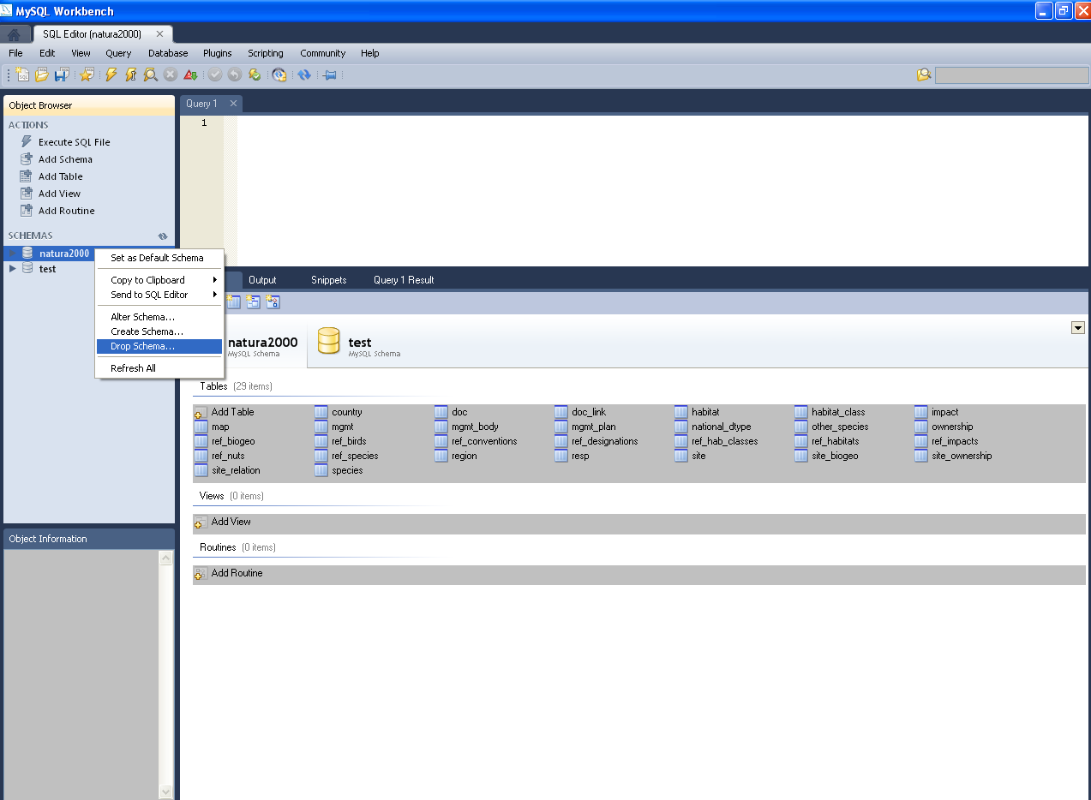

**I have already imported data using a previous version of the software. Should data be re-imported when a new software version is available?**

The recommendation will be to re-import the data, as some bugs from the import process have been fixed (e.g. calculation of the habitat coverage, the conversion of the coordinates). The data already imported with the previous version will not be affected with the new software version. However, in order to re-import, the imported data need to be deleted in advance using the software capability of deletion.