WISE GIS Guidance

Guidance on the reporting of spatial data to WISE

Version 6.0.6

2016-04-29



Contents

[Quick Start 1](#_Toc449037925)

[WISE Reporting obligations 2](#_Toc449037926)

[WFD reporting 2](#_Toc449037927)

[WISE SoE reporting 2](#_Toc449037928)

[Data content 3](#_Toc449037929)

[River basin districts and sub-units 3](#_Toc449037930)

[Definitions 3](#_Toc449037931)

[Reporting river basin districts and sub-units 3](#_Toc449037932)

[Constraints and quality control 3](#_Toc449037933)

[Special case: reporting river basins under WISE SoE 4](#_Toc449037934)

[Surface water bodies 5](#_Toc449037935)

[Definitions 5](#_Toc449037936)

[Reporting surface water bodies 6](#_Toc449037937)

[Reporting surface water bodies using the SurfaceWaterBody data set 7](#_Toc449037938)

[Reporting surface water bodies using the SurfaceWaterBodyLine data set 8](#_Toc449037939)

[Constraints and quality control 9](#_Toc449037940)

[Special case: reporting coastal waters 9](#_Toc449037941)

[Special case: reporting units for territorial waters 9](#_Toc449037942)

[Special case: reporting surface water bodies under WISE SoE 10](#_Toc449037943)

[Reporting surface water body centrelines 12](#_Toc449037944)

[Constraints and quality control 15](#_Toc449037945)

[Groundwater bodies 16](#_Toc449037946)

[Definitions 16](#_Toc449037947)

[Reporting groundwater bodies using the GroundWaterBody data set 16](#_Toc449037948)

[Constraints and quality control 16](#_Toc449037949)

[Special case: reporting groundwater bodies under WISE SoE 17](#_Toc449037950)

[Reporting horizons using the GroundWaterBodyHorizon data set 17](#_Toc449037951)

[Constraints and quality control 17](#_Toc449037952)

[Monitoring sites 18](#_Toc449037953)

[Definitions 18](#_Toc449037954)

[Reporting monitoring sites using the MonitoringSite data set 18](#_Toc449037955)

[Constraints and quality control 18](#_Toc449037956)

[Special case: reporting monitoring sites under WISE SoE 18](#_Toc449037957)

[Protected areas 20](#_Toc449037958)

[Data quality 21](#_Toc449037959)

[Coordinate reference systems 24](#_Toc449037960)

[Projection metadata files (.prj) 24](#_Toc449037961)

[Metadata 25](#_Toc449037962)

[INSPIRE metadata requirements for specific themes 25](#_Toc449037963)

[WISE reporting guidance for specific metadata elements 26](#_Toc449037964)

[Data exchange 27](#_Toc449037965)

[Character encoding 27](#_Toc449037966)

[File formats 27](#_Toc449037967)

[GML format 27](#_Toc449037968)

[Shapefile format 27](#_Toc449037969)

[File naming convention 28](#_Toc449037970)

[Data submission 29](#_Toc449037971)

[Resubmissions and updates 29](#_Toc449037972)

[Data policy 30](#_Toc449037973)

[Data storage 30](#_Toc449037974)

[Data usage 30](#_Toc449037975)

[Data distribution 30](#_Toc449037976)

[WISE spatial data set and INSPIRE themes 32](#_Toc449037977)

[INSPIRE Area Management/Restriction/Regulation Zones and Reporting Units 32](#_Toc449037978)

[Introduction 32](#_Toc449037979)

[Overview 32](#_Toc449037980)

[Required data elements 33](#_Toc449037981)

[Voidable data elements 34](#_Toc449037982)

[Multiplicity of the data elements 34](#_Toc449037983)

[Reporting the geometry 34](#_Toc449037984)

[Reporting inspireId and thematicId 35](#_Toc449037985)

[Life-cycle information 36](#_Toc449037986)

[Reporting predecessors and successors 36](#_Toc449037987)

[Reporting geographical names 38](#_Toc449037988)

[Reporting the designationPeriod 38](#_Toc449037989)

[Reporting zoneType and specialisedZoneType 39](#_Toc449037990)

[Reporting the legalBasis information 40](#_Toc449037991)

[Reporting relatedZone information 40](#_Toc449037992)

[Data elements specific to WISE 41](#_Toc449037993)

[INSPIRE Environmental Monitoring Facilities 42](#_Toc449037994)

[Introduction 42](#_Toc449037995)

[Overview 42](#_Toc449037996)

[Required data elements 43](#_Toc449037997)

[Voidable data elements 43](#_Toc449037998)

[Multiplicity of the data elements 43](#_Toc449037999)

[Reporting the geometry 43](#_Toc449038000)

[Reporting inspireId and thematicId 44](#_Toc449038001)

[Life-cycle information 45](#_Toc449038002)

[Reporting predecessors and successors 45](#_Toc449038003)

[Reporting geographical names 46](#_Toc449038004)

[Reporting the operationalActivityPeriod 46](#_Toc449038005)

[Reporting the featureOfInterest 47](#_Toc449038006)

[Reporting relatedTo information 47](#_Toc449038007)

[Reporting mediaMonitored information 48](#_Toc449038008)

[Reporting monitoring purpose information 48](#_Toc449038009)

[Data elements specific to WISE 49](#_Toc449038010)

[Identifier management 50](#_Toc449038011)

[Overview 50](#_Toc449038012)

[Using thematic identifiers 51](#_Toc449038013)

[What is a thematic identifier? 51](#_Toc449038014)

[Using thematic identifiers to identify WISE monitoring sites, water bodies, etc. 52](#_Toc449038015)

[Using thematic identifiers to relate two objects with different types 53](#_Toc449038016)

[Using thematic identifiers to relate WFD and EIONET monitoring site codes 54](#_Toc449038017)

[Using INSPIRE identifiers 55](#_Toc449038018)

[Relationship between inspireId and thematicId 56](#_Toc449038019)

[Special case: Using hydrographic identifiers 57](#_Toc449038020)

[Using identifiers in the WISE spatial data reporting 58](#_Toc449038021)

[Reporting the identifier for spatial objects 58](#_Toc449038022)

[Linking spatial objects 60](#_Toc449038023)

[Life-cycle management 62](#_Toc449038024)

[Overview 62](#_Toc449038025)

[Life-cycle information 63](#_Toc449038026)

[Creation 64](#_Toc449038027)

[Aggregation 65](#_Toc449038028)

[Splitting 65](#_Toc449038029)

[Combined aggregation and splitting 66](#_Toc449038030)

[Changes in the spatial extent 66](#_Toc449038031)

[Changes in the identifier of an object 67](#_Toc449038032)

[Changes in the geometry 67](#_Toc449038033)

[No changes 68](#_Toc449038034)

[Deletion 68](#_Toc449038035)

[Special case: constraints and quality control 68](#_Toc449038036)

[Special case: invalid objects 69](#_Toc449038037)

[Quick reference card 70](#_Toc449038038)

[Note on the WISE register 71](#_Toc449038039)

[About the status of a concept 74](#_Toc449038040)

[References 76](#_Toc449038041)

List of Figures

Figure 1. Reporting of river basins for two hypothetical countries: XZ reporting under WFD and WISE SoE; and ZZ reporting only under WISE SoE. 4

Figure 2. Surface water bodies represented by different geometries. 6

Figure 3. Polygon geometries to be included in the SurfaceWaterBody data set. 7

Figure 4. Geometry and thematic identifier in the SurfaceWaterBody data set (see also Figure 3). 7

Figure 5. Polyline geometries to be included in the SurfaceWaterBodyLine data set. 8

Figure 6. Geometry and thematic identifier in the SurfaceWaterBodyLine data set (see also Figure 5). 8

Figure 7. Illustrative delineation of territorial waters for reporting purposes. 10

Figure 8. Reporting territorial waters and adjacent sub-units in the SurfaceWaterBody data set (see also Figure 7). 10

Figure 9. Reporting of surface water bodies for two hypothetical countries: XZ reporting under WFD and WISE SoE; and ZZ reporting only under WISE SoE. 11

Figure 10. Representation of the hydrographic network. 12

Figure 11. Surface water body centreline example: virtual segment not under classification. 14

Figure 12. Surface water body centreline example: virtual segment to connect tributary. 15

Figure 13. Reporting of monitoring sites for two hypothetical countries: XZ reporting under WFD and WISE SoE; and ZZ reporting only under WISE SoE. 19

Figure 14. Conditions for use of data sets of country boundaries in the scope of the WFD related reporting obligations. 23

Figure 15. Reporting dates in the metadata files (example). 26

Figure 16. Class diagram for the INSPIRE AM theme (informative only). 33

Figure 17. INSPIRE Identifier data type (informative only). 35

Figure 18. INSPIRE ThematicIdentifier data type (informative only). 35

Figure 19. Class diagram INSPIRE SU theme (informative only). 36

Figure 20. INSPIRE GeographicalName data type (informative only). 38

Figure 21. TM\_Period data type (informative only). 38

Figure 22. INSPIRE LegislationCitation (informative only). 40

Figure 23. Class diagram for the INSPIRE EF theme (informative only). 42

Figure 24. INSPIRE Identifier data type (informative only). 44

Figure 25. INSPIRE ThematicIdentifier data type (informative only). 44

Figure 26. INSPIRE GeographicalName data type (informative only). 46

Figure 27. TM\_Period data type (informative only). 46

Figure 28. INSPIRE ThematicIdentifier data type (informative only). 51

Figure 29. Overview of the relationships between different WISE spatial object types. 53

Figure 30. INSPIRE Identifier data type (informative only). 55

Figure 31. INSPIRE HydroIdentifier data type (informative only). 57

Figure 32. Reporting the identifier of monitoring sites. 58

Figure 33. Reporting the identifier of groundwater bodies. 59

Figure 34. Linking sub-units to River Basin Districts using the relatedZone elements. 60

Figure 35. Linking groundwater bodies to river districts using the relatedZone elements. 61

Figure 36. Linking surface water bodies to sub-units using the relatedZone elements. 61

Figure 37. Valid options for the wiseEvolutionType element. 63

Figure 38. SpatialUnit register. 71

Figure 39. Information about the identifier of a river basin district. 72

Figure 40. Information about the identifier of a river basin district sub-unit. 72

Figure 41. Information about the identifier of a river basin district that replaces previously reported identifiers. 72

Figure 42. Information about the identifier of a river basin district that has been replaced by a new identifier. 73

Figure 43. Information about the identifier of a river basin district that replaces an invalid identifier. 73

Figure 44. Information about an 'invalid' identifier previously used for a river basin district. 73

Figure 45. Status. 74

List of Tables

Table 1. Definitions relevant for the RiverBasinDistrict and the SubUnit data sets. 3

Table 2. Definitions relevant for the SurfaceWaterBody, SurfaceWaterBodyLine and SurfaceWaterBodyCentreline data sets. 5

Table 3. Representation of the hydrographic network in the SurfaceWaterBodyCentreline data set (see also Figure 10). 13

Table 4. Representation of the hydrographic network in the SurfaceWaterBodyCentreline data set (see also Figure 11). 14

Table 5. Representation of the hydrographic network in the SurfaceWaterBodyCentreline data set (see also Figure 12). 15

Table 6. Definitions relevant for the GroundWaterBody and GroundWaterBodyHorizon data set. 16

Table 7. Definitions relevant to the MonitoringSite data set. 18

Table 8. Reporting of EIONET monitoring sites in the WFD reporting. 18

Table 9. Spatial quality control tests where a spatial tolerance value is applied 22

Table 10. WISE reporting guidance for specific metadata elements. 26

Table 11. Reporting dates in the metadata files (see also Figure 15). 26

Table 12. File naming convention. 28

Table 13. Geometry types for each WISE spatial data set. 34

Table 14. Valid zoneType and specialisedZoneType values for each WISE spatial data set. 39

Table 15. Allowed geometry types for the MonitoringSite spatial data set. 43

Table 16. Monitoring purpose of monitoring sites (PurposeOfCollection code list). 48

Table 17. Valid identifier schemes in the different WISE spatial object types. 52

Table 18. Description of the relationships between different WISE spatial object types. 53

Table 19. Using consistent identifier schemes to relate different WISE objects. 54

Table 20. Reporting the WFD and the EIONET identifier for monitoring sites. 54

# Quick Start

1. The following WISE reference spatial data sets are required:

* River basin districts
* River basin district sub-units
* Surface water bodies
* Groundwater bodies
* Monitoring sites
* Protected areas

1. The geometry of surface water bodies must be reported using polygons or polylines (as appropriate for a given water body). If applicable, separate files must be provided for each geometry type.
2. The geometry of protected areas must be reported as polygons, polylines or points (as appropriate for a given protected area). If applicable, separate files must be provided for each geometry type.
3. Two additional data sets allow the reporting of:

* The centrelines of surface water bodies, forming a hydrographic network;
* The delineation of horizons, for groundwater bodies that have different horizons.

1. The quality of the data sets must be evaluated by the Data Providers before the submission. Attention must be paid to the spatial alignment across national and international borders for the purpose of producing a harmonised European level dataset. Reference data sets are available to support this alignment.
2. The coordinate reference system for spatial data must be ETRS89-GRS80 or ETRS89-LAEA.   
   For areas outside the scope of ETRS89, WGS 84 must be used.
3. Metadata must be provided for each spatial data file, according to the INSPIRE metadata profile.
4. The spatial data files must be submitted as valid GML files, conformant with the schemas available in the Data Dictionary schemas (<http://dd.eionet.europa.eu/schemasets/browse/>).
5. The spatial data files may be prepared as *shapefiles*. The *shapefile* templates available in the resources page (<http://cdr.eionet.europa.eu/help/>) must be used. The *shapefiles* must be converted to GML using the conversion tools available in the same page. The GML files must then be uploaded to the appropriate envelope in Reportnet CDR.
6. The spatial data files must follow the naming convention defined in this document.
7. Spatial data must be submitted as complete national datasets (i.e. in a single national data set and not separated per river basin district).
8. For the 2016 Water Framework Directive reporting, submissions to Reportnet must be completed no later than 22nd March 2016.

# WISE Reporting obligations

## WFD reporting

For Data Providers reporting under the Water Framework Directive, this document is Annex 5 to the WFD Reporting Guidance 2016. It provides a short guidance in the preparation and reporting of spatial data.

The following Annexes of the WFD Reporting Guidance are also relevant to the reporting of spatial data:

* + Annex 4: Groundwater bodies and horizon assignment.
  + Annex 6: Reporting on the River Basin Management Plans – a user manual.

The GML schemas, *shapefile* templates and supporting documents required for the WFD reporting are available in Reportnet via <http://cdr.eionet.europa.eu/help/WFD>.

If you need assistance on issues not addressed in this document please contact the WFD helpdesk at [wfd.helpdesk@eionet.europa.eu](mailto:wfd.helpdesk@eionet.europa.eu).

In accordance with the WISE reporting arrangements, Member States may update the data submitted to WISE at any time. Member States should ensure that the latest, correct information is available in WISE since that will be used for compliance checking and publication.

The quality, accuracy and validation of the information and data in WISE is the responsibility of the Member States. Quality assurance and control processes will be carried out by the WISE partners. The Commission, the EEA or its contracted partners may contact the Member State in case there is an indication that any of the data may be erroneous or misleading. This may lead to a resubmission request to the Member State.

## WISE SoE reporting

For Data Providers not reporting under the Water Framework Directive, but reporting under WISE SoE, the same guidelines defined for WFD Reporting are to be followed. If applicable, exceptions or particular cases are described under the different sections of the GIS guidance.

Only the information not reported via the WFD Reporting is required (e.g. EIONET monitoring sites that are not WFD monitoring sites). Information on Protected Areas is not required under WISE SoE.

Please refer to the information available in <http://cdr.eionet.europa.eu/help/WISE_SoE/wise5>.

If you need assistance on issues not addressed in this document please contact the WISE SoE helpdesk at [wisesoe.helpdesk@eionet.europa.eu](mailto:wfd.helpdesk@eionet.europa.eu).

# Data content

This section provides an overview of the content of the different WISE spatial data sets and of the constraints and requirements applicable to the spatial objects and their relationships. Examples are provided to clarify some specific situations.

## River basin districts and sub-units

### Definitions

Table . Definitions relevant for the RiverBasinDistrict and the SubUnit data sets.

|  |  |  |
| --- | --- | --- |
| Concept | Definition | Related data sets |
| River basin district | The area of land and sea, made up of one or more neighbouring river basins together with their associated groundwaters and coastal waters, which is the main unit for management of river basins. | RiverBasinDistrict, SubUnit |
| River basin | The area of land from which all surface run-off flows through a sequence of streams, rivers and, possibly, lakes into the sea at a single river mouth, estuary or delta. | RiverBasinDistrict, SubUnit |
| Sub-basin | The area of land from which all surface run-off flows through a series of streams, rivers and, possibly, lakes to a particular point in a water course (normally a lake or a river confluence). | SubUnit |
| Sub-unit | [Operational definition. Not in the WFD] Reporting unit. River basin districts larger than 50000 square kilometre should be divided into comparable sub-units with an area between 5000 and 50000 square kilometre. The sub-units should be created using river basins (if more than one river basin exists in the RBD), set of contiguous river basins, or sub-basins, for example. If the RBD area is less than 50000 square kilometre, the RBD itself should be used as a sub-unit. | SubUnit |

### Reporting river basin districts and sub-units

River basin districts are reported in the RiverBasinDistrict data set.

Sub-units are reported in the SubUnit data set.

### Constraints and quality control

1. The RiverBasinDistrict data set must form a complete tessellation of the national territory to the limit of the coastal waters (i.e. 1 nautical mile for the territorial waters baseline).
2. Each sub-unit must be assigned to one and only river basin district.
3. Each sub-unit polygon must be contained by its river basin district polygon.
4. The SubUnit data set must form a complete tessellation with the same spatial coverage of the RiverBasinDistrict data set.

Note 1: In a tessellation, the polygons must fill the plane with no gaps, overlaps or self-intersecting boundaries.

Note 2: In the spatial data set, if a given river basin district has not been divided into sub-units, Data Providers are requested to report the geometry of the river basin district as a sub-unit. This facilitates the data processing and quality control of the delivered spatial data set.

Note 3: For more information on sub-units see the "Report on sub-units – version 5, 31 January 2008. Paper prepared for the meeting of the CIS Working Group Reporting." <https://circabc.europa.eu/w/browse/4b0e9c5d-f5b0-410e-a721-7ae90c8ef844>

### Special case: reporting river basins under WISE SoE

For Data Providers not reporting under the Water Framework Directive, a RiverBasinDistrict data set and a SubUnit data set is requested under WISE - Spatial Data (WISE-5).

These data sets will provide the necessary spatial reference for the data reported in the WISE SoE - Emissions (WISE-1) and the WISE SoE - Water Quantity (WISE-3) data flows, and will also allow European-wide comparisons to be made, using a similar structure to that available for EU Member States and Norway.

In this context, river basin districts should be interpreted as reporting units created from contiguous sets of river basins (and sub-units should be defined according to criteria similar to those proposed in the WFD).

Figure 1 illustrates the reporting of the RiverBasinDistrict spatial reference data set required for WFD and WISE SoE: in practice, only the thematic identifier scheme changes. Please refer to the section on “Identifier management” for further information.

Figure . Reporting of river basins for two hypothetical countries: XZ reporting under WFD and WISE SoE; and ZZ reporting only under WISE SoE.

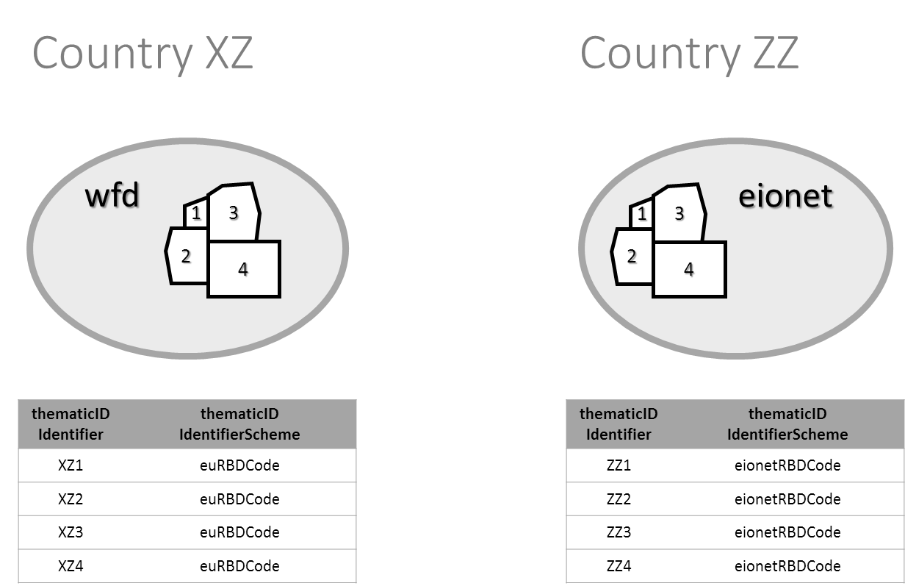

## Surface water bodies

### Definitions

Table . Definitions relevant for the SurfaceWaterBody, SurfaceWaterBodyLine and SurfaceWaterBodyCentreline data sets.

| Concept | Definition | Related data sets |
| --- | --- | --- |
| Surface water body | Body of surface water means a discrete and significant element of surface water such as a lake, a reservoir, a stream, river or canal, part of a stream, river or canal, a transitional water or a stretch of coastal water. | SurfaceWaterBody, SurfaceWaterBodyLine, SurfaceWaterBodyCentreline |
| Surface water | Inland waters, except groundwater; transitional waters and coastal waters, except in respect of chemical status for which it shall also include territorial waters. | SurfaceWaterBody, SurfaceWaterBodyLine, SurfaceWaterBodyCentreline |
| Inland water | All standing or flowing water on the surface of the land, and all groundwater on the landward side of the baseline from which the breadth of territorial waters is measured. | SurfaceWaterBody, SurfaceWaterBodyLine, SurfaceWaterBodyCentreline, GroundWaterBody, GroundWaterBodyHorizon |
| Territorial sea | The territorial waters, or territorial sea as defined by the 1982 United Nations Convention on the Law of the Sea, extend up to a limit not exceeding 12 nautical miles (22.2 km), measured from the baseline. The normal baseline is the low-water line along the coast. |  |
| Territorial waters | [Operational definition. Not in WFD.] *Reporting unit*. The zone between the limit of the coastal water bodies and the limit of the territorial sea, can be geometrically subdivided in polygons according to proximity to the adjacent coastal sub-unit (i.e. creating a Voronoi partition) or using any alternative delineation provided by the national competent authorities. Each reporting unit must be assigned to an adjacent sub-unit for the purpose of reporting the chemical status of the territorial waters under the Water Framework Directive. | SurfaceWaterBody |
| Coastal water | Surface water on the landward side of a line, every point of which is at a distance of one nautical mile on the seaward side from the nearest point of the baseline from which the breadth of territorial waters is measured, extending where appropriate up to the outer limit of transitional waters. | SurfaceWaterBody |
| Transitional waters | Bodies of surface water in the vicinity of river mouths which are partly saline in character as a result of their proximity to coastal waters but which are substantially influenced by freshwater flows. | SurfaceWaterBody, SurfaceWaterBodyLine, SurfaceWaterBodyCentreline |
| River | Body of inland water flowing for the most part on the surface of the land but which may flow underground for part of its course. | SurfaceWaterBody, SurfaceWaterBodyLine, SurfaceWaterBodyCentreline |
| Lake | Body of standing inland surface water. | SurfaceWaterBody, SurfaceWaterBodyLine, SurfaceWaterBodyCentreline |
| Artificial water body | Body of surface water created by human activity. | SurfaceWaterBody, SurfaceWaterBodyLine, SurfaceWaterBodyCentreline |
| Heavily modified water body | Body of surface water which as a result of physical alterations by human activity is substantially changed in character, as designated by the Member State in accordance with the provisions of Annex II of the Water Framework Directive. | SurfaceWaterBody, SurfaceWaterBodyLine, SurfaceWaterBodyCentreline |

### Reporting surface water bodies

The diagram in will be used in the examples.

Figure . Surface water bodies represented by different geometries.

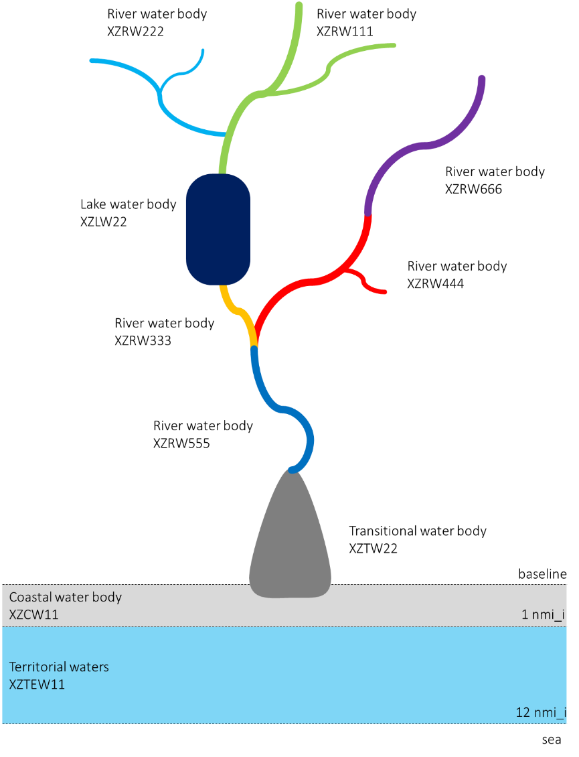

### Reporting surface water bodies using the SurfaceWaterBody data set

If the reference geometry of the surface water body is a polygon, then the surface water body must be reported in the SurfaceWaterBody data set.

Note that the reference geometry for rivers may also be a polygon. For example, the WFD reporting guidance recommends that reservoirs formed by damming rivers (i.e. heavily modified rivers) should be reported as river water bodies.

Figure . Polygon geometries to be included in the SurfaceWaterBody data set.

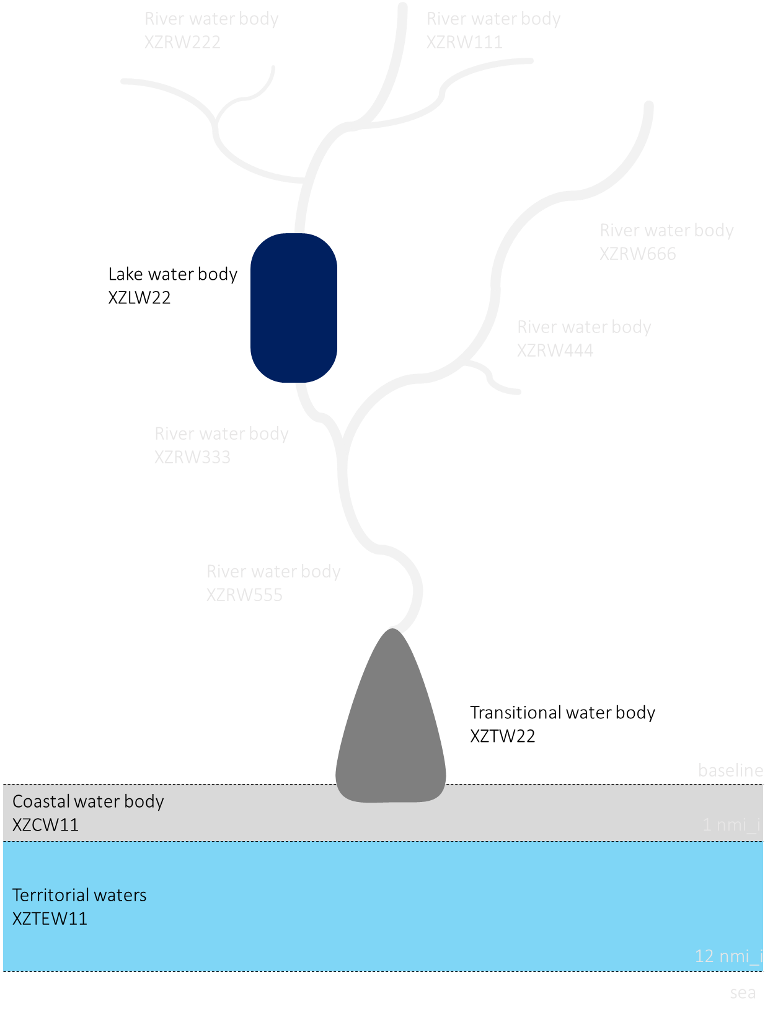

Figure . Geometry and thematic identifier in the SurfaceWaterBody data set (see also ).

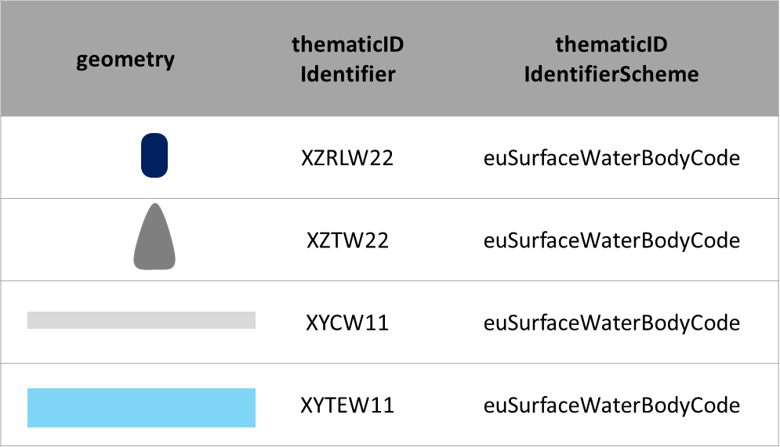

### Reporting surface water bodies using the SurfaceWaterBodyLine data set

If the reference geometry of the surface water body is linear, then the surface water body must be reported in the SurfaceWaterBodyLine data set.

Figure . Polyline geometries to be included in the SurfaceWaterBodyLine data set.

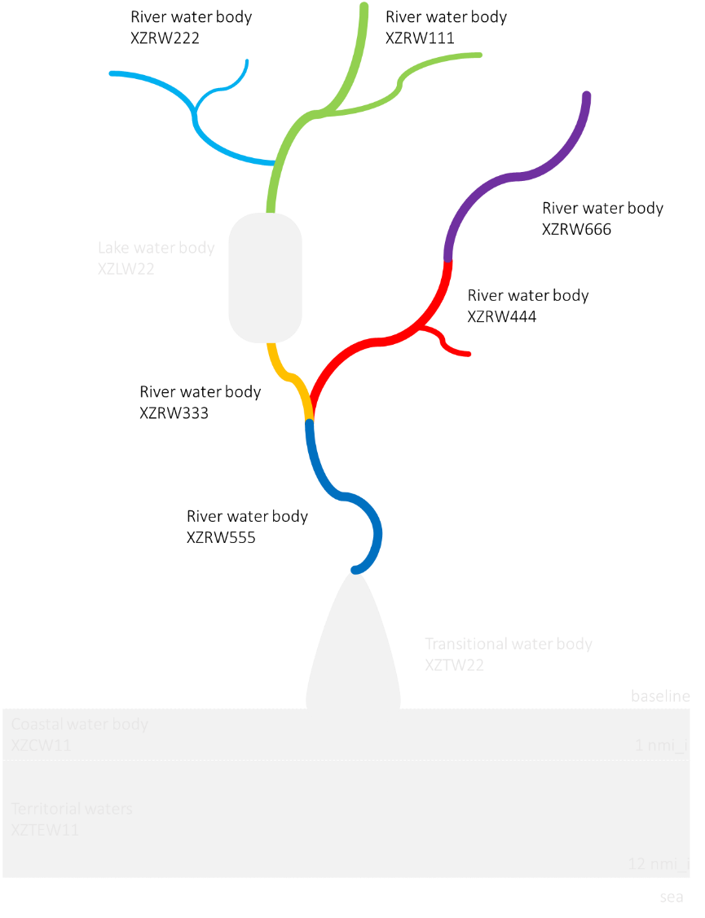

Figure . Geometry and thematic identifier in the SurfaceWaterBodyLine data set (see also ).

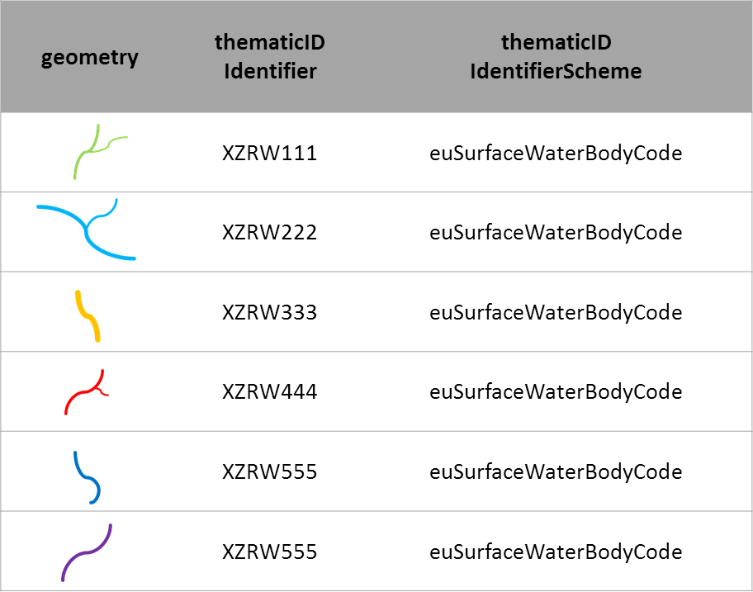

### Constraints and quality control

1. Each surface water body must be assigned to one and only sub-unit.
2. Surface water bodies must not overlap each other. This requirement applies regardless of the reference geometry:  polygons must not overlap each over, line segments must not overlap each other (a node must exist at intersections) and finally lines and polygons cannot overlap each other. Adjacent water bodies must touch each other at vertices or nodes along a common boundary.
3. Each surface water body, with the exception of territorial waters, must overlap or be contained by its sub-unit polygon.
4. Each surface water body, with the exception of coastal and territorial waters, must be contained by the river basin district polygon.
5. If the coastal water body is contained by the sub-unit, the common boundary between coastal waters and adjacent territorial waters must coincide with the seaward limit of the sub-unit.

### Special case: reporting coastal waters

Coastal waters are represented by polygons and must be reported in the SurfaceWaterBody data set.

Coastal waters must be assigned to a sub-unit. This may involve the splitting of stretches of coastal water that might otherwise be considered as single water bodies. When assigning a stretch of coastal water to a River Basin District, the objective is to ensure that coastal waters are assigned to the closest possible or the most appropriate natural management unit and to minimise any unnecessary splitting of coastal stretches.

To ensure consistency in the approach, the following principles should be applied:

* + Where possible, existing boundaries should be used. Examples are ecoregions defined in the WFD and regions defined in the Marine Conventions;
  + The boundaries between two adjacent types should be used wherever possible to minimise unnecessary splitting of the coastline;
  + In the general case, the coastline should be split at open coast areas rather than through natural management units such as bays or inlets. However, specific situations may exist where the splitting of natural units for management purposes cannot be avoided.

### Special case: reporting units for territorial waters

Territorial waters are treated as surface water bodies for reporting purposes only. Territorial waters are represented by polygons and must be reported in the SurfaceWaterBody data set.

The delineation of reporting units in the territorial waters zone, and their assignment to an adjacent sub-unit for reporting purposes, can be done by the competent national authorities according to the criteria best fitting the specific conditions of their territorial sea.

illustrates a simple geometric procedure whereby the territorial waters are subdivided in polygons according to their proximity to the adjacent coastal sub-unit (i.e. creating a Voronoi partition). Each reporting unit is then assigned to the adjacent sub-unit with which it shares the longest border. Note the omission of a reporting unit adjacent to the small XZSU22 sub-unit. This omission illustrates the possibility of merging neighbouring units (preferably only if the sub-units belong to the same RBD): the resulting XZTEW21 unit should be assigned to sub-unit XZSU21 (unless local conditions advice otherwise).

Figure . Illustrative delineation of territorial waters for reporting purposes.

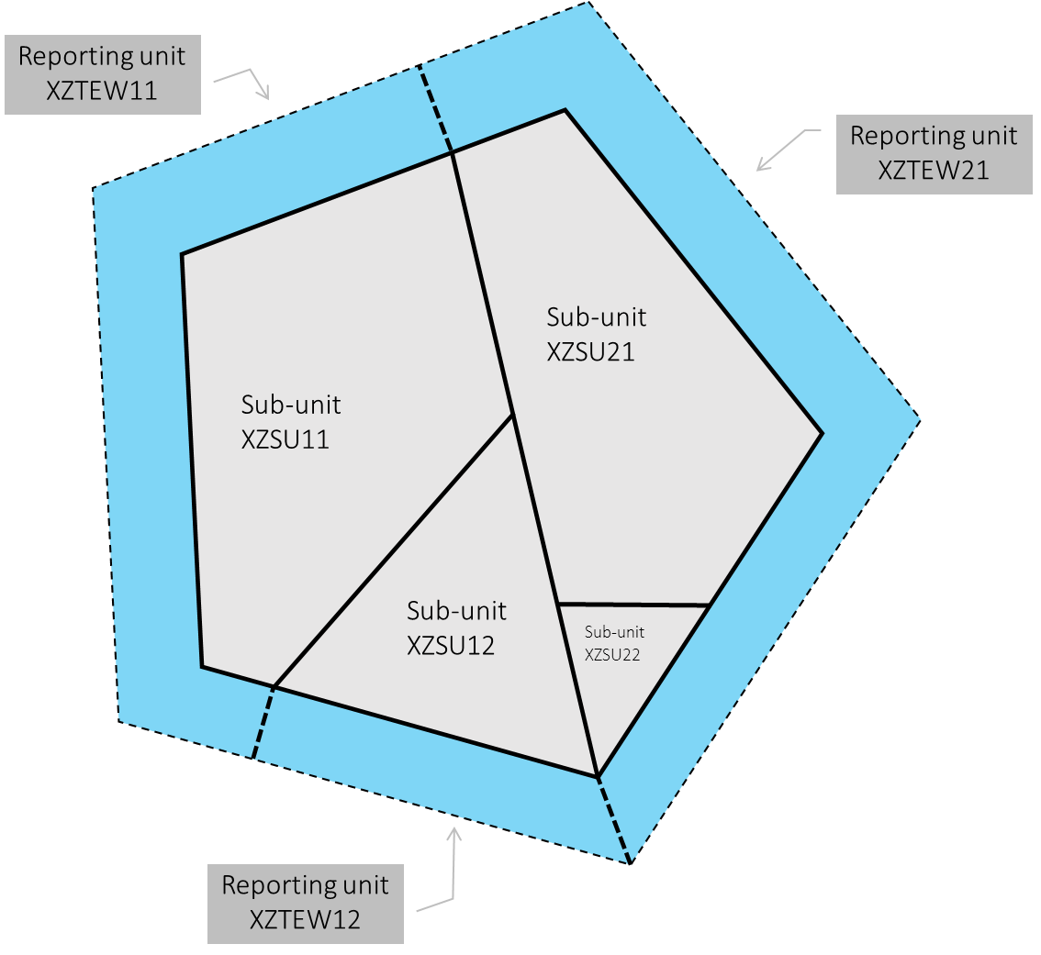

Figure . Reporting territorial waters and adjacent sub-units in the SurfaceWaterBody data set (see also ).

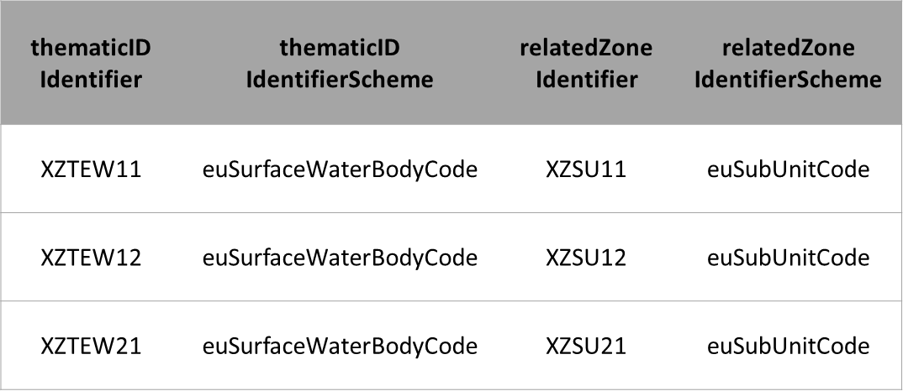

### Special case: reporting surface water bodies under WISE SoE

Example 1: Under the Water Framework Directive, countries may have defined a minimum catchment area in km² for a river to be delineated as a water body in the RBMP, or a minimum surface area in km² for a lake to be delineated as a water body in the RBMP. This means that water bodies below the minimum threshold are not delineated as WFD surface water bodies, and are not reported under the WFD data flow.

If (and only if) some of these smaller water bodies are being monitored and time series information is being reported under the WISE SoE - Water Quality (WISE-4) or the WISE SoE - Water Quantity (WISE-3) data flows, then the Data Providers are requested to report their geometry. The term EIONET water body refers to this specific case.

Example 2: Under the Water Framework Directive, countries may have delineated a given surface water body such that it includes different reservoirs for which inflow, outflow or stock volume is reported under the WISE SoE - Water Quantity (WISE-3) data flow. In this situation, each reservoir should be given an EIONET identifier and reported under WISE-5.

Similarly, countries not reporting under WFD are requested to provide the delineation of EIONET water bodies, to provide the necessary spatial reference for the data reported in the WISE SoE - Water Quality (WISE-4) or WISE SoE - Water Quantity (WISE-3) data flows. Data Providers are also encouraged to report the geometry of the national water bodies (even if not monitored by EIONET monitoring sites) to allow an overview of the completeness of the spatial coverage of the EIONET data at national and European level.

Figure 9 illustrates the reporting of water bodies data under WFD and under WISE SoE: in practice, only the thematic identifier scheme changes. Please refer to the section on “Identifier management” for further information.

Figure . Reporting of surface water bodies for two hypothetical countries: XZ reporting under WFD and WISE SoE; and ZZ reporting only under WISE SoE.

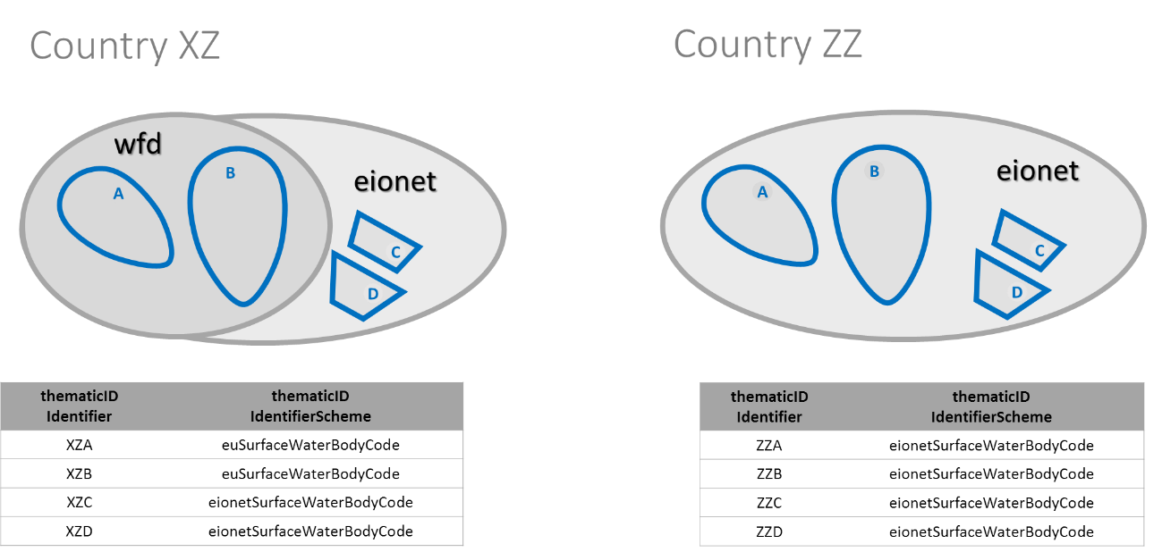

### Reporting surface water body centrelines

In the scope of the WFD reporting, a representation of the centrelines of surface water bodies is requested. This hydrographic network must be reported in the SurfaceWaterBodyCentreline data set.

The centreline of each surface water bodies must be split into segments, such that each segment belongs to one and only one hydrographic feature.

The hydrographic code and the geographical name of the hydrographic feature must be reported.

Figure . Representation of the hydrographic network.

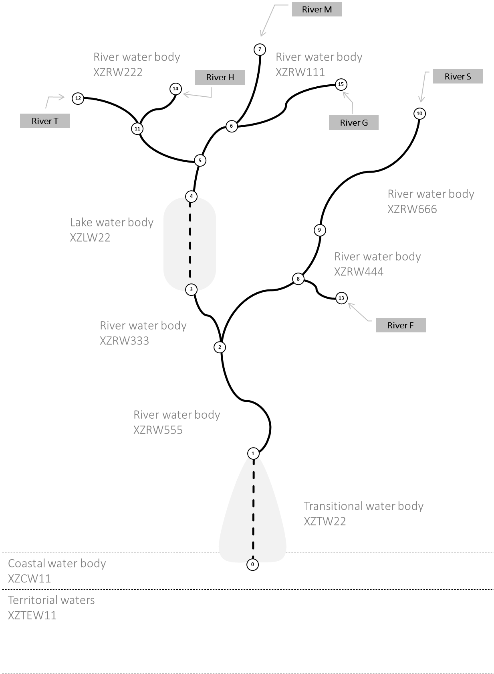

Each segment must be classified according to its type, using the **continua** element value:

* + realSurfaceWaterSegment
  + realUndergroundSegment
  + virtualSegmentLake
  + virtualSegmentToConnectTributary
  + virtualSegmentTransitionalWater
  + virtualSegmentCoastalWater
  + virtualSegmentTerritorialWater
  + virtualSegmentNotUnderOtherClassification

In the example in , let it be assumed that:

* + "River M" is the main river, flowing from node 7 to node 0;
  + "River S" is a tributary of river M, flowing from node 10 to node 2;
  + "River T" is a tributary of river M, flowing from node 12 to node 5;
  + "River G" is a tributary of river M, flowing from node 15 to node 6;
  + "River F" is a tributary of river S, flowing from node 13 to node 8;
  + "River H" is a tributary of river T, flowing from node 14 to node 11.

Let it also be assumed that the hydrographic identifier of each centreline segment is simply the number of its initial node.

Table 3 presents the hydrographic network as it would be described in the SurfaceWaterBodyCentreline data set.

Table . Representation of the hydrographic network in the SurfaceWaterBodyCentreline data set (see also ).

|  |  |  |  |  |
| --- | --- | --- | --- | --- |
| thematicIdIdentifier | thematicIdIdentifierScheme | hydroIdLocalId | geographicalNameText | continua |
| XZTW22 | euSurfaceWaterBodyCode | 1 | River M | virtualSegmentTransitionalWater |
| XZRW555 | euSurfaceWaterBodyCode | 2 | River M | realSurfaceWaterSegment |
| XZRW333 | euSurfaceWaterBodyCode | 3 | River M | realSurfaceWaterSegment |
| XZLW22 | euSurfaceWaterBodyCode | 4 | River M | virtualSegmentLake |
| XZRW111 | euSurfaceWaterBodyCode | 5 | River M | realSurfaceWaterSegment |
| XZRW111 | euSurfaceWaterBodyCode | 6 | River M | realSurfaceWaterSegment |
| XZRW111 | euSurfaceWaterBodyCode | 7 | River M | realSurfaceWaterSegment |
| XZRW444 | euSurfaceWaterBodyCode | 8 | River S | realSurfaceWaterSegment |
| XZRW444 | euSurfaceWaterBodyCode | 9 | River S | realSurfaceWaterSegment |
| XZRW666 | euSurfaceWaterBodyCode | 10 | River S | realSurfaceWaterSegment |
| XZRW222 | euSurfaceWaterBodyCode | 11 | River T | realSurfaceWaterSegment |
| XZRW222 | euSurfaceWaterBodyCode | 12 | River T | realSurfaceWaterSegment |
| XZRW444 | euSurfaceWaterBodyCode | 13 | River F | realSurfaceWaterSegment |
| XZRW122 | euSurfaceWaterBodyCode | 14 | River H | realSurfaceWaterSegment |
| XZRW111 | euSurfaceWaterBodyCode | 15 | River G | realSurfaceWaterSegment |

Figure 11 illustrates the case where a virtual segment is required to reestablish the connectivity of the network. In the example, the lake water body XZLW1 is a reservoir represented by a polygon geometry and reported in the SurfaceWaterBody dataset. The river water bodies XZRW1 and XZRW2 are represented by polyline geometries and reported in the SurfaceWaterBodyLine dataset.

Figure . Surface water body centreline example: virtual segment not under classification.

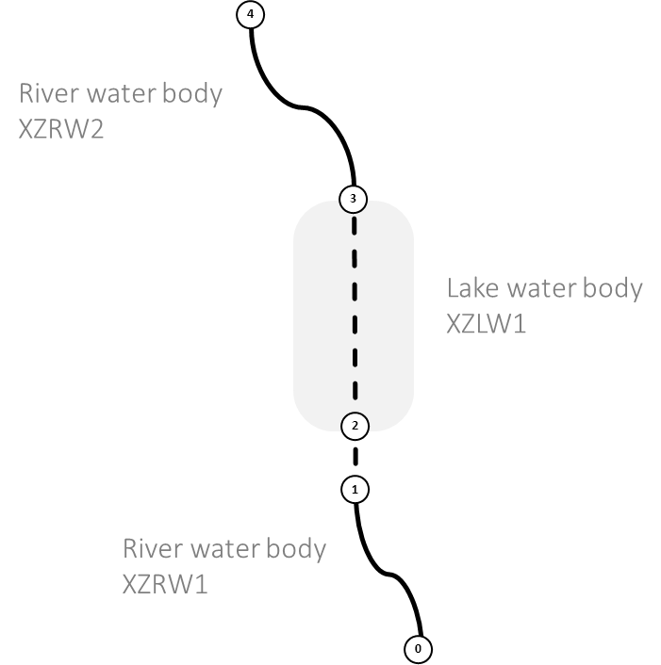

Depending on the scale and the level of detail of the information, there may be a discontinuity between the geometry of the reservoir and the geometry of the downstream river, e.g. due to the presence of a dam.

In this case, the small virtual segment between node 1 and node 2 can be used to reestablish the connectivity, although that segment is not contained by either or the water bodies.

Table 4 presents the relevant attributes for the centrelines. Note the absence of the water body identifier and identifier scheme when the segment is classified as 'virtualSegmentNotUnderOtherClassification'. Note also that these two elements must be present when the **continua** takes any other value.

Table . Representation of the hydrographic network in the SurfaceWaterBodyCentreline data set (see also Figure 11).

|  |  |  |  |
| --- | --- | --- | --- |
| thematicIdIdentifier | thematicIdIdentifierScheme | hydroIdLocalId | continua |
| XZRW1 | euSurfaceWaterBodyCode | 1 | realSurfaceWaterSegment |
|  |  | 2 | virtualSegmentNotUnderOtherClassification |
| XZLW1 | euSurfaceWaterBodyCode | 3 | virtualSegmentLake |
| XZRW2 | euSurfaceWaterBodyCode | 4 | realSurfaceWaterSegment |

If the segment is a real hydrographic feature connecting WFD surface water bodies, but that does not belong to any WFD surface water body, do not report the thematicIdIdentifier and provide the value 'realSurfaceWaterSegment' (or 'realUndergroundSegment', if applicable) in the **continua** element.

Figure 12 illustrates a different situation. The river water body XZRW2 is represented by a polygon geometry and is reported in the SurfaceWaterBody dataset. The river water bodies XZRW1, XZRW3 and XZRW4 are represented by polyline geometries and are reported in the SurfaceWaterBodyLine dataset.

Figure . Surface water body centreline example: virtual segment to connect tributary.

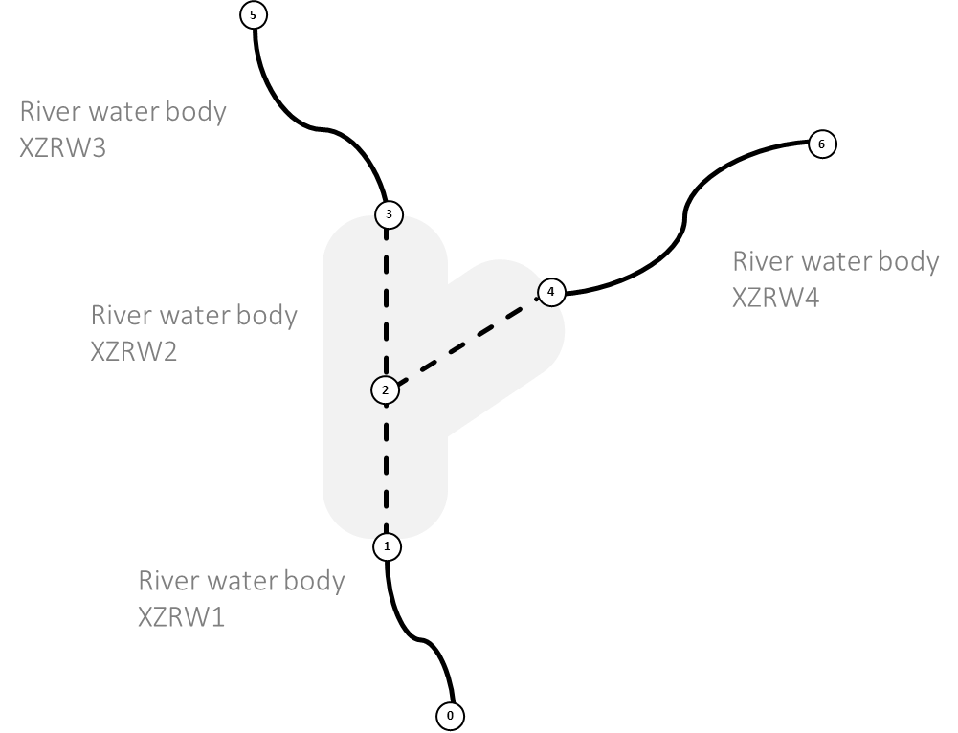

When reporting the centrelines, a connection must be established between the different rivers, using virtual segments within the river water body XZRW2. Table 5 presents the relevant attributes for the centrelines.

Table . Representation of the hydrographic network in the SurfaceWaterBodyCentreline data set (see also Figure 12).

|  |  |  |  |
| --- | --- | --- | --- |
| thematicIdIdentifier | thematicIdIdentifierScheme | hydroIdLocalId | continua |
| XZRW1 | euSurfaceWaterBodyCode | 1 | realSurfaceWaterSegment |
| XZRW2 | euSurfaceWaterBodyCode | 2 | virtualSegmentToConnectTributary |
| XZRW2 | euSurfaceWaterBodyCode | 3 | virtualSegmentToConnectTributary |
| XZRW2 | euSurfaceWaterBodyCode | 4 | virtualSegmentToConnectTributary |
| XZRW3 | euSurfaceWaterBodyCode | 5 | realSurfaceWaterSegment |
| XZRW4 | euSurfaceWaterBodyCode | 6 | realSurfaceWaterSegment |

### Constraints and quality control

In the SurfaceWaterBodyLine data set, each geometry may be composed of multiple parts.

In the SurfaceWaterBodyCentreline data set, the geometry of each segment must represented by one line string (i.e. a sequence of line segments). Each geometry must have only one part.

From a geometric and topological point of view, the data quality requirements described in section 10.2 "Data capture for Network" of the INSPIRE Data Specification on Hydrography v3.1 are directly applicable to the SurfaceWaterBodyCentreline data set (with the exception of sections 10.2.8 and 10.2.9).

Please refer to the INSPIRE Data Specification on Hydrography v3.1 for a complete description (<http://inspire.ec.europa.eu/documents/Data_Specifications/INSPIRE_DataSpecification_HY_v3.1.pdf>).

## Groundwater bodies

### Definitions

Table . Definitions relevant for the GroundWaterBody and GroundWaterBodyHorizon data set.

|  |  |  |
| --- | --- | --- |
| Concept | Definition | Related data sets |
| Groundwater body | ‘Body of groundwater’ means a distinct volume of groundwater within an aquifer or aquifers. | GroundWaterBody, GroundWaterBodyHorizon |
| Groundwater | All water which is below the surface of the ground in the saturation zone and in direct contact with the ground or subsoil. | GroundWaterBody, GroundWaterBodyHorizon |
| Aquifer | Subsurface layer or layers of rock or other geological strata of sufficient porosity and permeability to allow either a significant flow of groundwater or the abstraction of significant quantities of groundwater. | GroundWaterBody, GroundWaterBodyHorizon |

### Reporting groundwater bodies using the GroundWaterBody data set

Groundwater bodies are represented by 2D polygon geometries (where the outer boundary is the horizontal projection of the extent of the groundwater body). Groundwater bodies are reported in the GroundWaterBody data set.

The geometry of a body of groundwater may overlap the geometry of more than one RBD in the national territory. However, one groundwater body must be assigned to one and only one river basin district. If the different parts are managed separately (e.g. require different measures or have different competent authorities) then this cannot be treated as a single water body and needs to be split (not necessarily along the geographical borders of the RBD but rather according to the different identification of measures). Please note that reporting the same water body twice, with the same geometry and different measures, in two different RBDs, is not possible.

The **horizons** element identifies the different horizons in the groundwater body – the different horizons must be reported as a comma-separated list of integer values. For example:

* + If the groundwater body belongs to horizon 1, simply report '1'.
  + If the groundwater body belongs to horizon 2 and 3, report '2,3'.   
    In this situation, the geometry of the part belonging to horizon 2 and the geometry of the part belong to horizon 3 must be reported in the GroundWaterBodyHorizon data set.

Please refer to Annex 4 in the WFD Reporting Guidance for further information on the delineation of groundwater bodies.

### Constraints and quality control

1. Each groundwater body must be assigned to one and only River Basin District.
2. The groundwater body polygon must be contained by or overlap the River Basin District polygon.
3. The groundwater body polygon must be completely contained on the national territory.
4. Groundwater bodies may overlap each other (if at different depths).

### Special case: reporting groundwater bodies under WISE SoE

Note that the GroundWaterBodyHorizon data set is not required under WISE SoE.   
Only the GroundWaterBody data set is required, even if a given groundwater body has more than one horizon.

The principles described for surface water bodies are applicable to the reporting of groundwater bodies under WISE SoE. Please refer to the section “Special case: reporting surface water bodies under WISE SoE” (cf. page 10) for further information.

### Reporting horizons using the GroundWaterBodyHorizon data set

If, and only if, a groundwater body has different horizons, then the GroundWaterBodyHorizon data set must be used to report the spatial delineation of each horizon. Please refer to Annex 4 in the WFD Reporting Guidance for further information on the spatial delineation of groundwater horizons.

The **horizon** element identifies each of the horizons of a groundwater body, using a simple integer numeration (in the sense of the numerical position of the groundwater body starting with the first horizon from the surface).

Data Providers not reporting under WFD are not required to provide this data set.

### Constraints and quality control

1. The GroundWaterBodyHorizon data set must contain all the groundwater bodies that belong to two or more horizons.
2. In the GroundWaterBodyHorizon data set, at least two different parts must be reported for each groundwater body.
3. Each part of a given groundwater body must belong to a different horizon.
4. The geometry of each part of a given groundwater body may contain one or more spatially disjoint polygons.
5. The geometries of each part of a given groundwater body must not overlap.
6. The spatial union of the geometries of the each part of a given groundwater (in the GroundWaterBodyHorizon data set) must be equal to the geometry of the groundwater body (as reported in the GroundWaterBody data set).
7. For each part, the value in the **horizon** element (in the GroundWaterBodyHorizon data set) must match one of the values provided in the **horizons** element of the corresponding groundwater body (in the GroundWaterBody data set).

## Monitoring sites

### Definitions

Table . Definitions relevant to the MonitoringSite data set.

|  |  |  |
| --- | --- | --- |
| Concept | Definition | Related data sets |
| Monitoring site | [Operational definition. Not in the WFD]  Data Providers reporting under WFD are requested to report monitoring sites established for the following monitoring purposes listed in Table 16 (cf. page 48).  Data Providers reporting under WISE SoE are requested to report monitoring sites included in the EIONET WISE SoE network (if the monitoring site is not also a WFD monitoring site). | MonitoringSite |

### Reporting monitoring sites using the MonitoringSite data set

All monitoring sites are reported in the MonitoringSite data set: this includes both surface water monitoring sites and groundwater monitoring sites.

The location of a monitoring site is always reported as a (representative) point.

### Constraints and quality control

* 1. Each monitoring site must be assigned to one and only water body.
  2. If the water body is represented by a polygon (i.e. if it is represented in the SurfaceWaterBody or GroundWaterBody data set), then the monitoring site representative point must be contained within the water body polygon.
  3. If the water body is represented by a polyline (i.e. if it is represented in the SurfaceWaterBodyLine data set), then the monitoring site representative point should be within a 200 metre distance of the water body geometry.

### Special case: reporting monitoring sites under WISE SoE

For Data Providers reporting under the Water Framework Directive, the monitoring sites currently reported under WISE SoE - Water Quality (WISE-4) or WISE SoE - Water Quantity (WISE-3) will most probably also be included in one or more of the WFD monitoring programmes (and hence be reported under the WFD data flow). In exceptional cases, monitoring sites may exist that were only reported under WISE SoE (e.g. see the section “Special case: reporting surface water bodies under WISE SoE”).

Table 6 illustrates the reporting (under WFD only) of a WFD monitoring site that is also an EIONET site and that had a different code in the WISE-4 or WISE-3 reporting. The monitoring site is reported only once (under WFD). It is not necessary to report it again in WISE-5.

Table . Reporting of EIONET monitoring sites in the WFD reporting.

|  |  |  |  |
| --- | --- | --- | --- |
| thematicIdIdentifier | thematicIdIdentifierScheme | relatedToIdentifier | relatedToIdentifierScheme |
| XZMS1 | euMonitoringSiteCode | XZ5671-OLD-EIONET-CODE | eionetMonitoringSiteCode |

Figure 13 illustrates the reporting of the monitoring site reference data required for WFD and WISE SoE: in practice, only the thematic identifier scheme changes.

Please refer to the section on “Identifier management” for further information.

Figure . Reporting of monitoring sites for two hypothetical countries: XZ reporting under WFD and WISE SoE; and ZZ reporting only under WISE SoE.

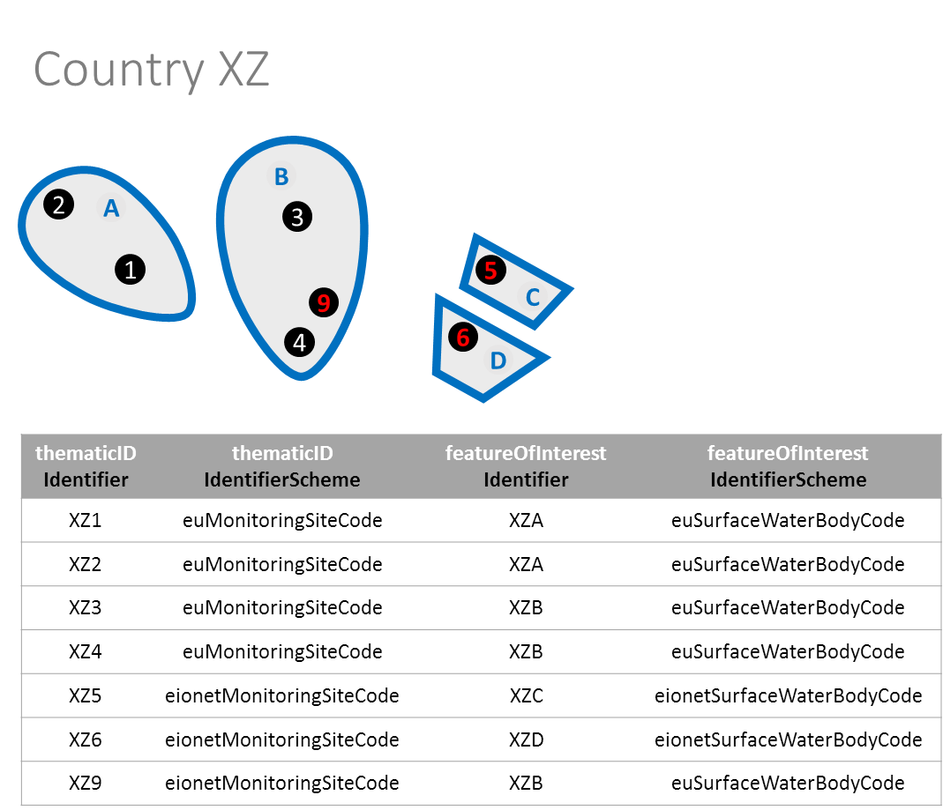

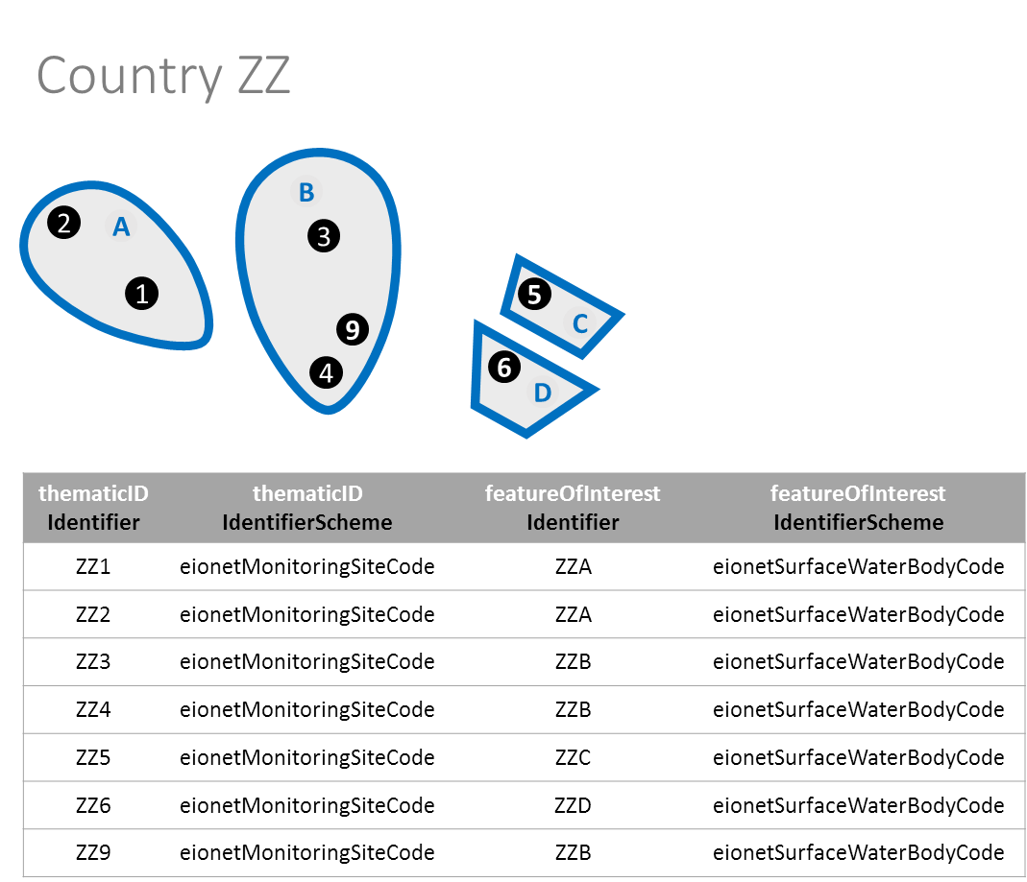

## Protected areas

Protected areas must be represented by polygon, polyline or point geometries: use the ProtectedArea data set, the ProtectedAreaLine data set or the ProtectedAreaPoint data set accordingly.

Each type of protected area is identified using the **zoneType** value. The values 'nitrateVulnerableZone', 'sensitiveArea', 'bathingWaters' and 'drinkingWaterProtectionArea' identify areas designated under the Nitrates Directive, Urban Waste Water Treatment Directive, Bathing Waters Directive or Drinking Water Directive, respectively.

For other protected areas, the **zoneType** element is 'designatedWaters' and the **specialisedZoneType** element is used to further distinguish different types: 'shellfishDesignatedWater', 'freshwaterFishDesignatedWater' or 'otherProtectedArea'.

Note that areas protected under the Habitats or Birds directive are not reported in the WISE spatial data sets. Please refer to the "Clarification on the reporting of spatial data for protected areas" document in the [CDR help](http://cdr.eionet.europa.eu/help/WFD/WFD_521_2016) pages.

Data Providers reporting under WISE-5 do not report the Protected Areas data sets.

# Data quality

Data providers are recommended not to simplify or generalise the spatial data reported to WISE.

The accuracy of the data should be documented in the metadata so that any further processing done in the production of the European reference data sets can respect the accuracy of the original data source.

Considering both WISE needs and the practical constraints of data availability, it is recommended that to report data with positional accuracy acceptable for cartographic representation at the 1:100000 scale or larger. The positional accuracy should always be kept as high as possible and ideally be similar to the national operational data sets.

Geodetic coordinates must be expressed in decimal degree, with a minimum recommended precision of 5 decimal places. Projected coordinates must be expressed in metre, with a minimum recommended precision of 1 decimal places. See the section on “Coordinate reference systems” for further information.

The quality of the data sets must be evaluated by the Data Providers before the submission.

For each dataset, the sections on "Constraints and quality control" express a number of requirements on the topology and/or spatial relationships between different types of spatial units. However, and to keep the model as simple as possible, topology is handled implicitly rather than explicitly. There is therefore a prerequisite for "implicit topology", i.e. the data provided should be sufficiently clean to support automated topological construction based on the reported geometry.

Reporting of fully consistent geometries across different datasets can be difficult due to inherent limitations in the original data sources or to discrepancies between the different data sources. For this reason, a spatial tolerance factor was introduced in some of the quality control checks.

For the tests listed in Table 9, if the test fails but the issue detected is within the spatial tolerance value, then the quality control raises an 'WARNING' but not a 'BLOCKER' (i.e. the data delivery can be released).

Data Providers are advised to check the WARNING and correct errors or systematic misalignments.

Attention must be paid to the spatial alignment across national and international borders for the purpose of producing a harmonised European level data set. Reference data sets are made available to support this alignment. Country boundaries are available at the [WISE restricted access area](http://forum.eionet.europa.eu/x_wise-reporting/library/restricted_distribution/). Note that access is restricted to authorised [Water Framework Directive Data Reporters](http://rod.eionet.europa.eu/contacts?roleId=extranet-wfd-data) and subject to use conditions (Figure 14).

The EEA coastline for analysis is available at <http://www.eea.europa.eu/data-and-maps/data/eea-coastline-for-analysis-1> and may be used, subject to the constraints expressed in its metadata (<http://www.eea.europa.eu/data-and-maps/data/eea-coastline-for-analysis-1#tab-metadata>).

Table . Spatial quality control tests where a spatial tolerance value is applied

| Test | Source dataset | Target dataset | Message | Spatial tolerance |
| --- | --- | --- | --- | --- |
| SS03 | SubUnit | RiverBasinDistrict | The geometry of the subunit must be within the geometry of the associated river basin district. | If all the parts of the source geometry that are not within the target geometry have an area of less than 625 square metre, then only a 'WARNING' is raised. |
| SS04B | SurfaceWaterBody | RiverBasinDistrict | The geometry of the surface water body (except for territorial waters) must be within the geometry of the associated river basin district. | If all the parts of the source geometry that are not within the target geometry have an area of less than 625 square metre, then only a 'WARNING' is raised. |
| SS05B | SurfaceWaterBodyLine | RiverBasinDistrict | The geometry of the surface water body must be covered by the geometry of the associated river basin district. | If all the parts of the source geometry that are not covered by the target geometry have a length of less than 25 square metre, then only a 'WARNING' is raised. |
| SS08B | MonitoringSite | RiverBasinDistrict | The geometry of the monitoring site must not be disjoint of the geometry of the surface water body's river basin district (except for territorial waters). | If the distance between the source geometry and the target geometry is less than 25 metre, then only a 'WARNING' is raised. |
| SS10 | RiverBasinDistrict | RiverBasinDistrict | The geometry of the river basin districts must not overlap each other. | If all the parts of the source geometry that overlap the target geometry have an area of less than 625 square metre, then only a 'WARNING' is raised. |
| SS11 | SubUnit | SubUnit | The geometry of the subunits must not overlap each other. | If all the parts of the source geometry that overlap the target geometry have an area of less than 625 square metre, then only a 'WARNING' is raised. |
| SS12 | SurfaceWaterBody | SurfaceWaterBody | The geometry of polygon surface water bodies must not overlap each other. | If all the parts of the source geometry that overlap the target geometry have an area of less than 625 square metre, then only a 'WARNING' is raised. |
| SS13 | SurfaceWaterBody | SurfaceWaterBodyLine | The geometry of polygon surface water bodies and the geometry of line surface water bodies must be disjoint or only touch at the boundary. | If all the parts of the geometry that are not disjoint have a length of less than 25 square metre, then only a 'WARNING' is raised. |
| SS14 | SurfaceWaterBodyLine | SurfaceWaterBody | The geometry of polygon surface water bodies and the geometry of line surface water bodies must be disjoint or only touch at the boundary. | If all the parts of the geometry that are not disjoint have a length of less than 25 square metre, then only a 'WARNING' is raised. |
| SS15 | SurfaceWaterBodyLine | SurfaceWaterBodyLine | The geometry of line surface water bodies must not overlap each other. | If all the parts of the geometry that are not disjoint have a length of less than 25 square metre, then only a 'WARNING' is raised. |
| SS16 | GroundWaterBody | GroundWaterBody | Groundwater bodies at the same depth must not overlap. | If all the parts of the source geometry that overlap the target geometry have an area of less than 625 square metre, then only a 'WARNING' is raised. |
| SS17 | GroundWaterBodyHorizon | GroundWaterBody | The spatial union of the geometries of the different horizons must be equal to the geometry of the groundwater body. | If all the parts of the source geometry that are not equal to the target geometry have an area of less than 625 square metre, then only a 'WARNING' is raised. |
| SS18 | SurfaceWaterBodyCentreline | SurfaceWaterBody | The geometry of a virtual line must be covered by the geometry of the polygon surface water body. | If all the parts of the geometry that are not covered have a length of less than 25 square metre, then only a 'WARNING' is raised. |

Figure . Conditions for use of data sets of country boundaries in the scope of the WFD related reporting obligations.



# Coordinate reference systems

The spatial data sets must be provided in one of the following coordinate reference systems (CRS):

* + ETRS89-GRS80 (urn:ogc:def:crs:EPSG::4258)
  + ETRS89-LAEA (urn:ogc:def:crs:EPSG::3035)
  + WGS 84 (urn:ogc:def:crs:EPSG::4326)

The geometry of spatial objects should be reported in the ETRS89-GRS80 geodetic coordinate system (urn:ogc:def:crs:EPSG::4258).  For areas outside the scope of ETRS89, such as overseas territories, WGS 84 (urn:ogc:def:crs:EPSG::4326) must be used.

The geometry of spatial objects may also be reported in the ETRS89-LAEA projected coordinate system (urn:ogc:def:crs:EPSG::3035). Again, an exception applies for areas outside the scope of ETRS89, where the geodetic coordinate system WGS 84 (urn:ogc:def:crs:EPSG::4326) must be used.

Note that for the quality control procedures applied to the spatial data, the ETRS89-LAEA projected coordinate system will be used.

## Projection metadata files (.prj)

Valid projection metadata files (.prj) for the *shapefile* format are provided below:

* + For ETRS89-GRS80 (urn:ogc:def:crs:EPSG::4258)

GEOGCS["ETRS89",DATUM["D\_ETRS\_1989",SPHEROID["GRS\_1980",6378137.0,298.257222101]],PRIMEM["Greenwich",0.0],UNIT["Degree",0.0174532925199433]]

* + For ETRS89-LAEA (urn:ogc:def:crs:EPSG::3035)

PROJCS["ETRS\_1989\_LAEA",GEOGCS["GCS\_ETRS\_1989",DATUM["D\_ETRS\_1989",SPHEROID["GRS\_1980",6378137.0,298.257222101]],PRIMEM["Greenwich",0.0],UNIT["Degree",0.0174532925199433]],PROJECTION["Lambert\_Azimuthal\_Equal\_Area"],PARAMETER["False\_Easting",4321000.0],PARAMETER["False\_Northing",3210000.0],PARAMETER["Central\_Meridian",10.0],PARAMETER["Latitude\_Of\_Origin",52.0],UNIT["Meter",1.0]]

* + For WGS 84 (urn:ogc:def:crs:EPSG::4326)

GEOGCS["GCS\_WGS\_1984",DATUM["D\_WGS\_1984",SPHEROID["WGS\_1984",6378137.0,298.257223563]],PRIMEM["Greenwich",0.0],UNIT["Degree",0.0174532925199433]]

# Metadata

A metadata file must be provided for each spatial data file. As defined in the “CIS Guidance Document No. 22”:

Since the majority of WISE datasets and services will fall under the scope of INSPIRE, this guidance recommends the adoption of a profile which extends the INSPIRE metadata to include all those additional elements already agreed by the WISE community. This guidance recommends the use of INSPIRE terminology for element names wherever possible, thus ensuring compatibility with metadata created in other environmental policy areas.

The content and structure of the metadata file must be in conformance to the “INSPIRE Metadata Implementing Rules: Technical Guidelines based on EN ISO 19115 and EN ISO 19119”:

The use of these guidelines to create INSPIRE metadata ensures that the metadata is not in conflict with ISO 19115.

However, full conformance to ISO 19115 implies the provision of additional metadata elements which are not required by the INSPIRE Implementing Rule on Metadata. Additional metadata elements are required by the INSPIRE Implementing Rules for the Interoperability of Spatial Datasets and Services. An overview list of these additional elements is provided in Annex B.

In practice, this means that the INSPIRE metadata requirements must be met (including the metadata elements for interoperability defined in Annex B of the INSPIRE Metadata Implementing Rules). Conformance with ISO 19115 is encouraged but not strictly required. A specific WISE metadata profile is no longer required.

The authoring and editing of metadata files can be done in a number of ways including the use of a metadata editor capable of exporting an XML file conformant to the ISO 19139 schema. See, for example, the editor and the validator available at the INSPIRE Geoportal (<http://inspire-geoportal.ec.europa.eu>).

## INSPIRE metadata requirements for specific themes

The INSPIRE Data Specification on Area Management/Restriction/Regulation Zones and Reporting Units sets specific requirements for the metadata: see section 8 (Dataset-level metadata) of the specification document.

These requirements must be followed for the RiverBasinDistrict, SubUnit, SurfaceWaterBody, SurfaceWaterBodyLine, GroundWaterBody, ProtectedArea, ProtectedAreaLine, ProtectedAreaPoint data sets.

Note 1: Currently no such requirements exist for the MonitoringSite data set.

## WISE reporting guidance for specific metadata elements

Table . WISE reporting guidance for specific metadata elements.

|  |  |
| --- | --- |
| Metadata element | Reporting guidance |
| 2.1 Topic category | Select at least option 012 (inlandWaters). This element is required. |
| 3.1 Keyword value | Select the appropriate keywords from the WISE metadata keywords list (<http://converters.eionet.europa.eu/xmlfile/WISE_metadata_keywords_1.xml>) and identify the corresponding vocabulary. This element is required. |
| 5.1 Temporal extent | Provide the period covered by the spatial data reported.  The period should be defined by the planning period for which the real-world entities are expected to be valid. This element is required. |
| 5.2 Date of publication | Provide the date of the reporting deadline of the period specified with Metadata element 5.1. This element is required. |
| 5.3 Date of last revision | Provide the date of the last submitted update to the data set. This element is required. |
| 8.2. Limitations on public access | Limitations on public access, if any, must be clearly stated in the metadata. If no restrictions are stated, Category 3 will be applied (see the Data policy section, below). Note that, for safety or security reasons, Data Providers may flag that the location of some monitoring sites (e.g. drinking water abstractions) must not be published. These restrictions are set at record-level and are always applied, regardless of the classification of the data set. |

Figure . Reporting dates in the metadata files (example).

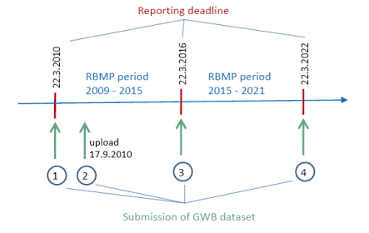

Table . Reporting dates in the metadata files (see also ).

|  |  |  |  |
| --- | --- | --- | --- |
| Submission | Temporal extent | Date of publication | Date of last revision |
| 1 | From 2010-03-22 to 2016-03-22 | 2010-03-22 | 2010-03-22 |
| 2 | From 2010-03-22 to 2016-03-22 | 2010-03-22 | 2010-09-17 |
| 3 | From 2016-03-22 to 2022-03-22 | 2016-03-22 | 2016-03-22 |
| 4 | From 2022-03-22 to 2028-03-22 | 2022-03-22 | 2022-03-22 |

# Data exchange

## Character encoding

The character encoding for all data and metadata files must be UTF-8.

## File formats

The spatial data sets must be reported using **GML** files.

Data Providers may prepare the data using the *shapefile* format. *Shapefile* templates are available, and a *shapefile* to GML conversion tool is also provided (see below).

The GML files resulting from this conversion must be uploaded to the delivery envelope in CDR.   
The *shapefiles* must not be uploaded to the delivery envelope.

Some restrictions were adopted in the schemas to allow a similar description of the data sets regardless of the file format (GML or *shapefile*). For example, each type of geometry is reported in a separate data file (due to the limitations of the *shapefile* format).

See the CDR help page for further information (<http://cdr.eionet.europa.eu/help/WFD/WFD_521_2016>).

(For countries reporting only under WISE SoE, see <http://cdr.eionet.europa.eu/help/WISE_SoE/wise5>.)

## GML format

The schemas are available in the Data Dictionary (<http://dd.eionet.europa.eu/schemaset/WFD2016/view>).

## Shapefile format

*Shapefile* templates are provided in the CDR help page. The templates must be used when preparing the data and using the conversion tools to from *shapefile* to GML.

*Shapefiles* must have the three structural files (\*.shp, \*.shx and \*.dbf) and the \*.prj and \*.cpg files.   
*Shapefiles* without the \*.prj projection file (or with an incorrect definition of the coordinate system) will not be processed by the conversion tools. The \*.cpg file is also mandatory as it is explicitly identifies the character encoding used in the \*.dbf file. Remember that the mandatory encoding is UTF-8.

*Shapefiles* with different fields in the attribute table will not be processed. This includes: additional fields, different field names or different field types. Note that the field names in a *shapefile* must have a maximum of 10 characters, so a "short" version of the GML names was defined for the *shapefile* templates (see the "Quick Reference Card" in page 70).

The DBF format used in the *shapefile* attribute table does not support NULL values (i.e. there is no difference between a NULL string and an empty string, or between a NULL value and a zero value). Also the structure of the table is fixed for all records (i.e. even if an optional attribute is not provided or is not applicable to a given record). To circumvent these limitations, Data Providers are requested to explicitly provide the conventional null values depending on the field type:

* Use '**NotApplicable**' for string fields;
* Use **-9999** for numeric fields;
* Use **9999-12-31** for date fields.

The DBF format has a maximum length of 254 characters for string fields. Be aware of this limitation.

## File naming convention

The filenames of the spatial data sets must follow the following naming convention:

[DataSetType]\_[CountryCode]\_[Date]

Table . File naming convention.

|  |  |
| --- | --- |
| Code | Description |
| [DataSetType] | Identification of the content of the data set.   * RiverBasinDistrict * SubUnit * SurfaceWaterBody, for polygonal geometries * SurfaceWaterBodyLine, for linear geometries * GroundWaterBody * MonitoringSite * ProtectedArea, for polygonal geometries * ProtectedAreaLine, for linear geometries * ProtectedAreaPoint, for point geometries * SurfaceWaterBodyCentreline * GroundWaterBodyHorizon |
| [CountryCode] | Use the two-letter ISO code of the country ([ISO 3166 alpha-2](http://www.iso.org/iso/country_codes.htm)), except for Greece and the United Kingdom, for which the abbreviations EL and UK must be used.  Spatial data is reported in national data sets, to guarantee the geometric consistency of the spatial objects and avoid the rejection of data set due to inconsistencies between partial deliveries. Partial deliveries are not accepted. |
| [Date] | Submission date in the format YYYYMMDD |

Examples:

* RiverBasinDistrict\_XZ\_20160101
* SubUnit\_XZ\_20160101
* SurfaceWaterBody\_XZ\_20160101
* SurfaceWaterBodyLine\_XZ\_20160101
* GroundWaterBody\_XZ\_20160101
* MonitoringSite\_XZ\_20160101
* ProtectedArea\_XZ\_20160101
* ProtectedAreaLine\_XZ\_20160101
* ProtectedAreaPoint\_XZ\_20160101
* SurfaceWaterBodyCentreline\_XZ\_20160101
* GroundWaterBodyHorizon\_XZ\_20160101

The file extension depends on the file format.

* xml (for the metadata file)
* gml (for the spatial data file)

## Data submission

Data must be uploaded in the Reportnet Central Data Repository (CDR).

Data Providers reporting under WFD are referred to the instructions provided in the Annex 6 of the WFD Reporting Guidance 2016. Collections have already been created in CDR for the reporting of spatial data:

* http://cdr.eionet.europa.eu/*{country\_code}***/eu/wfd2016/spatial/**

Data Providers reporting under WISE SoE are referred to the WISE SoE Reportnet Guidance. Collections have already been created in CDR for the reporting of spatial data:

* http://cdr.eionet.europa.eu/*{country\_code}***/eea/wise\_soe/wise5/**

## Resubmissions and updates

If data is resubmitted or updated, then complete data sets have to be uploaded.

Incomplete spatial data sets will not pass the referential integrity quality control and thus cannot be further processed.

# Data policy

Under the "WISE Reporting Arrangements", Member States have agreed on the conditions applicable to spatial data (see Annex 1 of the WISE Reporting Arrangements). For ease of reference, an extract of the current agreement (dated 2007-03-01) is transcribed below. The agreement may be subject to future changes.

## Data storage

The European Commission (EC) and the European Environmental Agency (EEA) will store the geographic datasets on servers managed and accessible by the staff of the EC and the EEA. DG Environment will distribute parts or the entire datasets within the Commission, the EEA and to contractors, these last for the sole purpose of activities executed for the Commission and/or the EEA and limited to the duration of those activities.

## Data usage

The Commission and the EEA are authorised to use the geographic data in the context of environmental policy definition, implementation, assessment and analysis:

* + As geographic reference, i.e. creating a geographical context for other data;
  + For the production of maps, publications, posters, presentations, web sites and any other electronic publication on the Internet. Electronic publication will be in the form of image maps;
  + For spatial and statistical analysis;
  + For deriving new geographic datasets by applying data manipulation procedures, e.g. combining different geographic datasets, generalisation procedures including smoothing and dropping of spatial features, adding new attribute information;
  + For inclusion of the geographic data in other applications provided that it will not possible to extract the original geographic data.

## Data distribution

The Commission and the EEA are authorized to distribute geographic data, if

* + The source is acknowledged and,
  + The data is not used for commercial purpose – unless approved by the provider - and,
  + The data provider has not explicitly restricted their dissemination beyond what specified at point 2

[…]Distribution media of geographic data are paper publications, electronic publications, offline distribution on physical supports (e.g. CD-ROMs) and online distribution via the Internet services. Geographic data may be distributed as feature services on the Internet or vector data on physical support, only if data distribution conditions are met as specified in the metadata.

The metadata related to the geographic data and the derived geographic data will be distributed via a data catalogue service within the Commission, the EEA and to the public without any restrictions.

An acknowledgement of source including statement on legal constraints on access and use of geographic data, where appropriate, will be supplied with geographic data and derived products as part of the metadata information or as an accompanying document. […]

Categories for distribution of geographic data and derived products as part [of the] metadata element on data constraints:

* + Category 1: Internal use within Commission and EEA, publication as maps on paper or in electronic format as image maps.
  + Category 2: Distribution of derived data and products under predefined conditions with the aim of decreasing the spatial accuracy or resolution of the geographic data.
  + Category 3: Distribution of original data electronically as feature service or on physical support.

# WISE spatial data set and INSPIRE themes

## INSPIRE Area Management/Restriction/Regulation Zones and Reporting Units

### Introduction

This section provides information about the relationship between the WISE spatial data sets and the INSPIRE AM theme (Annex III - Area Management/Restriction/Regulation Zones and Reporting Units).

This section provides information about the conceptual mapping between the elements in the WISE spatial data model and the elements in the INSPIRE AM data model. It also explains the basic differences between the schemas used in WISE and in INSPIRE.

### Overview

The INSPIRE AM theme has a broad thematic scope: areas managed, regulated or used for reporting at international, European, national, regional and local levels, established in accordance with *specific legislative requirements* to deliver specific environmental objectives related to any environmental media (air, soil, water and biota).

It explicitly excludes areas established to manage, regulate and restrict activities to conserve nature, biodiversity and cultural heritage (only), which are covered under the INSPIRE PS theme (Annex I Protected Sites). However, areas with multiple environmental objectives that include nature and biodiversity conservation fall in the scope of the AM theme.

The following WISE spatial data sets are in the scope of the INSPIRE AM theme:

* River Basin Districts
* Sub-units
* Surface Water Bodies
* Groundwater Bodies
* Protected Areas

For informative purposes only, shows the part of the AM data model which is relevant for the WISE spatial data reporting.

Figure . Class diagram for the INSPIRE AM theme (informative only).



### Required data elements

In the current WISE spatial data reporting, not all elements in the INSPIRE AM data model are requested:

* + The environmentalDomaindata element does not have to be reported, because it would have the fixed value 'Water' for all spatial data sets and objects.
  + The competentAuthority data element does not have to be reported, because:
* In the scope of the WFD reporting, the information on the River Basin District competent authorities is reported in the "non-spatial" XML files.
* In the scope of the WFD reporting, this type of information is not requested for surface water bodies, groundwater bodies or protected areas.
* In the scope of the WISE SoE reporting, information on competent authorities is not required.
  + The **legalBasis** data elements are only requested for Protected Areas.

Important notes:

1. Data Providers implementing the INSPIRE Directive are still required include the above data elements in their INSPIRE visualisation and download services. The simplification adopted in WISE merely reflects the fact that not everything is strictly needed in the context of a specific reporting obligation (although it may be needed for other purposes).
2. Data Providers implementing the INSPIRE Directive are still required to use the INSPIRE schemas.   
   The flat schemas presently adopted in WISE are not compliant with INSPIRE requirements.

### Voidable data elements

In the current WISE spatial data reporting, the INSPIRE «voidable» stereotype is not used:

* + WISE data elements with multiplicity 1..1 are required and must be provided.
  + WISE data elements with multiplicity 0..1 are treated as conditional: if the information exists or is applicable, it must be provided.

Requesting further information associated with «voidable» characteristics (such as the *VoidReasonValue*) was presently deemed unnecessary.

### Multiplicity of the data elements

Some INSPIRE data elements and associations can have many instances (i.e. multiplicity 0..\* or 1..\*).

In the WISE spatial data sets, data elements typically have a maximum of one instance (i.e. multiplicity 0..1 or 1..1). This change was required by the "flat" structure in the current WISE spatial data files.

The restriction in multiplicity was applied to the zoneType, thematicId, name, relatedZone and legalBasis elements.

### Reporting the geometry

The INSPIRE AM theme does not restrict the type of geometry of spatial objects.

However in the WISE spatial data sets, a decision was taken to keep different types of geometry in separate data files. This allows the use of *shapefile format* (that does not support different types of geometry in the same file), if a Data Provider is not able to directly produce the GML files.

Also, in the current spatial data files, only 2D geometries are used (see ).

Table . Geometry types for each WISE spatial data set.

|  |  |  |
| --- | --- | --- |
| Spatial data set | Geometry (GML) | Geometry (shapefile) |
| RiverBasinDistrict | GM\_MultiSurface | Polygon |
| SubUnit | GM\_MultiSurface | Polygon |
| SurfaceWaterBody | GM\_MultiSurface | Polygon |
| SurfaceWaterBodyLine | GM\_MultiCurve | Polyline |
| GroundWaterBody | GM\_MultiSurface | Polygon |
| ProtectedArea | GM\_MultiSurface | Polygon |
| ProtectedAreaLine | GM\_MultiCurve | Polyline |
| ProtectedAreaPoint | GM\_MultiPoint | Point |

### Reporting inspireId and thematicId

The flattened structure of the current WISE spatial data files required the "flattening" of INSPIRE complex data elements or data types.

The INSPIRE inspireId data element has a complex data type: Identifier.

In the WISE spatial data sets, it must be provided using 3 separate data elements:

* **inspireIdLocalId**;
* **inspireIdNamespace**;
* **inspireIdVersionId**.

Figure . INSPIRE Identifier data type (informative only).

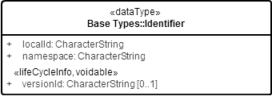

The INSPIRE thematicId data element also has a complex data type: ThematicIdentifier.

In the WISE spatial data sets, itmust be provided using 2 separate data elements:

* **thematicIdIdentifier**;
* **thematicIdIdentifierScheme**.

Figure . INSPIRE ThematicIdentifier data type (informative only).

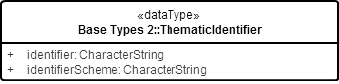

For reporting purposes, the thematic identifier is very important: it is required to join the spatial data with other reported thematic information. Please refer to the section on “Identifier management” for further information.

### Life-cycle information

Life-cycle information at spatial object level is reported using the **beginLifespanVersion** and **endLifespanVersion** elements. Dates must be reported using the ISO 8601 extended format:

* + YYYY-MM-DD, for days;
  + YYYY-MM, for months;
  + YYYY, for years.

(If necessary, or convenient, time values can be reported. The ISO 8601 extended format for UTC time should be used.)

### Reporting predecessors and successors

The need to manage life-cycle information in the WISE spatial data sets is identified in CIS Guidance Document No. 22 (2009):

"Depending on the data, the reporting obligations and the intended use of the data, it will be necessary to establish a system that manages temporal changes of non-hydrological features including the identification of predecessors and successors.

Changes will occur from one reporting period to another (submission of datasets according to reporting deadlines) but also in between reporting periods (update/resubmission of datasets)."

The concept of predecessors and successors does not exist in the INSPIRE AM theme.

However, the INSPIRE SU theme (Annex III - Statistical Units) data specification extensively discusses the issue of changes in statistical units (see Annex F), and provides the necessary concepts and data elements.

For information purposes only, part of the INSPIRE SU theme data model is represented .

Figure . Class diagram INSPIRE SU theme (informative only).

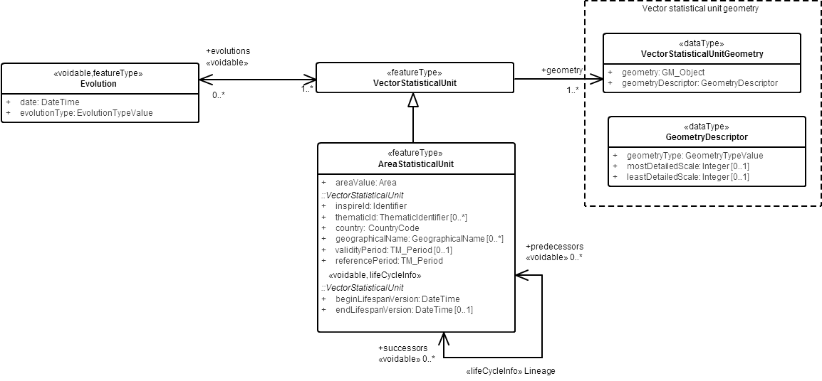

In the INSPIRE SU theme, changes are represented through the elements validityPeriod, beginLifeSpanVersion and endLifeSpanVersion. The validityPeriod in the SU theme can be considered functionally equivalent to the designationPeriod in the AM theme.

Additional information about the lineage is represented using two elements:

* + predecessors,which identifies the object(s) that the current object replaces;
  + successors,which identifies the object(s) that replace the current object.

Finally, the INSPIRE evolutionselement is used to clarify the type of event (aggregation, splitting, etc.) that generated the current object.

In the WISE spatial data sets, these concepts are adopted.

Predecessors are identified through their thematic identifiers, using two elements:

* + **predecessorsIdentifier**,which must contain a comma-separated list of the identifiers of the object(s) that have been deactivated/replaced by the presently reported object;
  + **predecessorsIdentifierScheme**, which must contain the identifiers’ scheme.

These elements are conditional: predecessors must be reported if the current object is replacing something. Predecessors must be identified even if their geometry (or other information) has never been reported.

For example, if surface water body 'ZZ1234' is the aggregation of surface water body 'ZZ12' and surface water body 'ZZ34' previously reported, then 'ZZ12' and 'ZZ34' must be reported as predecessors of 'ZZ1234'.

Successors are also identified through their thematic identifiers, using two elements:

* + **successorsIdentifier**,which must contain a comma-separated list of the identifiers of the object(s) that have replaced the presently reported object;
  + **successorsIdentifierScheme**, which must contain the identifiers’ scheme.

Again, these elements are conditional: successors must be reported if they exist. Successors must be identified even if their geometry (or other information) has never been reported.

The **wiseEvolutionType** element explicitly states what type of event generated the object.

This element is mandatory (even if there are no predecessors or successors to be reported).

The following allowable values have the same meaning defined in the INSPIRE SU theme: 'creation', 'deletion', 'aggregation', 'splitting' and 'change'.

For the purposes of the WISE reporting, the change types required in the WFD reporting were added: 'changeCode', 'changeBothAggregationAndSplitting', 'changeExtendedArea', 'changeExtendedDepth', 'changeExtendedAreaAndDepth', 'changeReducedArea', 'changeReducedDepth', 'changeReducedAreaAndDepth', 'noChange'.

The 'noChange' option must not be used if predecessors or successors are reported for a given spatial object. A typical example for the use of the 'noChange' option is the reporting of a water body that had no changes in the geometry and in the identifier since the 1st RBMP reporting cycle.

The 'deletion' option must be used if an object that is no longer valid is reported. A typical example for the use of the 'deletion' option is the optional reporting of a water body that was valid in the 1st RBMP reporting cycle (but whose geometry was not previously reported) but that is no longer valid in the 2016 reporting cycle. (Note that these objects are not subject to the spatial quality control check applicable to other objects).

### Reporting geographical names

Data Providers are requested to report the geographical name of each object in a national language and to identify the national language used. Optionally, an English language version of the name is also requested, if available.

In any INSPIRE theme, geographical names should be represented using the generic mechanism proposed under the Geographical Names data specification (see INSPIRE Annex I Geographical Names data specifications), which uses the complex data type GeographicalName.Only the data elements represented in were deemed strictly necessary:

Figure . INSPIRE GeographicalName data type (informative only).



In the WISE spatial data sets, the following data elements are used:

* + **nameText**, with the name in a national language (equivalent to the text data element in the INSPIRE SpellingOfName data type);
  + **nameLanguage**, with the ISO 639-2/B code of the national language (equivalent to the language data element of the INSPIRE GeographicalName data type);
  + **nameTextInternational**, an optional element with an English exonym or an understandable English version of the name of the geographical feature or spatial object (in this case, the language element is not requested).

Note that the same mechanism is used for all WISE spatial data sets (e.g. river basin districts, water bodies, etc.).

### Reporting the designationPeriod

The INSPIRE designationPeriod data element has a TM\_Period data type.

The TM\_Period data type has a relatively complex structure.

Figure . TM\_Period data type (informative only).

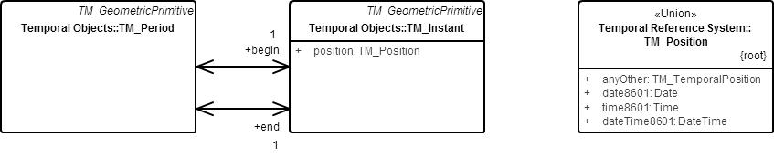

In the current WISE spatial data reporting, this structure was simplified and includes only two data elements:

* + **designationPeriodBegin** with the start date;
  + **designationPeriodEnd** with the end date.

The designationPeriodEnd data element is optional (i.e. has multiplicity 0..1): it does not need to be provided if the end of the time period is indeterminate or currently unknown.

The dates must be reported in the ISO 8601 extended format:

* + YYYY-MM-DD, for days;
  + YYYY-MM, for months;
  + YYYY, for years.

### Reporting zoneType and specialisedZoneType

The INSPIRE zoneType and specialisedZoneType data elements allow users to locate and filter information about different types of AM zones.

In the current WISE spatial data reporting, each type of AM zone is reported in a separate data file.

In theory, the zone type could be inferred from the file name or from its associated schema. However, for quality control purposes, it is important to keep the zoneType and specialisedZoneType elements in the data model, even if all objects in a given data file have the same value (e.g. all river basin districts have the same zone type). details the valid code list values for each type of spatial object.

Important note: It is not necessary to report the spatial data for areas protected under the Habitats Directive or the Birds Directive, since that information is reported via the Natura2000 data flow. Also note that those protected areas are in the scope of the INSPIRE **Protected Sites** (PS) theme, and not in the scope of the INSPIRE AM theme.

Table . Valid zoneType and specialisedZoneType values for each WISE spatial data set.

| Object type | zoneType value | specialisedZoneType value |
| --- | --- | --- |
| RiverBasinDistrict | riverBasinDistrict | -- not applicable -- |
| SubUnit | riverBasinDistrict | riverBasinDistrictSubUnit |
| SurfaceWaterBody | waterBody | riverWaterBody  lakeWaterBody  transitionalWaterBody  coastalWaterBody |
|  |  | territorialWaters |
| GroundWaterBody | waterBody | groundwaterBody |
| ProtectedArea | nitrateVulnerableZone  sensitiveArea  bathingWaters  drinkingWaterProtectionArea | -- not applicable -- |
|  | designatedWaters | shellfishDesignatedWater  freshwaterFishDesignatedWater  otherProtectedArea |

### Reporting the legalBasis information

In the current WISE spatial data reporting, the INSPIRE legalBasis information is only requested for Protected Areas. illustrates the relevant data elements in the INSPIRE AM data model.

Figure . INSPIRE LegislationCitation (informative only).

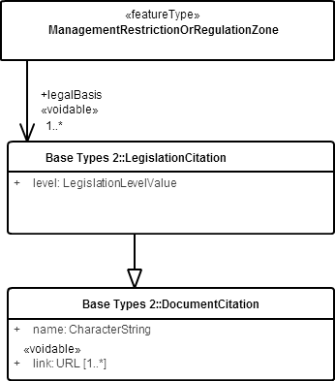

In the current WISE spatial data reporting, the following 3 data elements are used:

* + **legalBasisName** with the official name of the legislative instrument;
  + **legalBasisLink** with a link to an online version of the document;
  + **legalBasisLevel** with the level at which the legislative instrument is adopted (allowable values are 'european', 'international', 'national', or 'sub-national').

### Reporting relatedZone information

In the INSPIRE AM model, the **relatedZone** association allows one ManagementRestrictionOrRegulationZone object to be "linked" to zero or more ManagementRestrictionOrRegulationZone objects. In the current WISE spatial data reporting, the relatedZone association has a more restricted meaning (see Figure 29 in page 53):

* + Each SubUnit is related to one and only one RiverBasinDistrict;
  + Each SurfaceWaterBody is related to one and only one SubUnit;
  + Each GroundWaterBody is related to one and only one RiverBasinDistrict.

Each related zone is identified using its thematic identifier, which requires the following 2 data elements:

* + relatedZoneIdentifier and
  + relatedZoneIdentifierScheme.

Specifically for transboundary water bodies, a common identifier may be reported using:

* relatedZoneTransboundaryIdentifier and
* relatedZoneTransboundaryIdentifierScheme.

Note 1: A centralised registry of transboundary identifiers will not be kept in WISE (because the management of the identifiers is in the scope of each international river basin district, or set of neighbouring countries). Transboundary identifiers are not required to follow the WISE syntax rules.

Note 2: Some water bodies are associated with protected areas: in the WFD reporting, this information is provided via the "non-spatial" thematic reporting. In the scope of WISE SoE, this information is not required.

### Data elements specific to WISE

The following additional WISE data elements are not related to INSPIRE elements: **sizeValue**, **sizeUom**, **meanDepth**, **horizons** and **link**.

## INSPIRE Environmental Monitoring Facilities

### Introduction

This section provides information about the relationship between the WISE spatial data sets and the INSPIRE EF theme (Annex III - Environmental Monitoring Facilities).

This section provides information about the conceptual mapping between the data elements in the WISE spatial data model and the data elements in the INSPIRE EF data model. It also explains the basic differences between the data schemas used in WISE and in INSPIRE.

### Overview

The INSPIRE EF theme covers the “*location and operation of environmental monitoring facilities includes observation and measurement of emissions, of the state of environmental media and of other ecosystem parameters (biodiversity, ecological conditions of vegetation, etc.) by or on behalf of public authorities*”.

The EF theme allows the representation of Environmental Monitoring Facilities, Networks, Activities and Programmes.

In the current WISE spatial data reporting, only the aspects related to Environmental Monitoring Facilities (e.g. monitoring sites) are covered in the spatial data sets.

The following WISE spatial data sets are related to the INSPIRE EF theme:

* + Monitoring Sites

For informative purposes only, the following diagram shows the part of the EF data model which is relevant for the WISE spatial data reporting.

Figure . Class diagram for the INSPIRE EF theme (informative only).

Machine generated alternative text:
+supersedes 
«voidable» Il 
+supersededay 
«voidable» Il 
'featu reT rpe» 
AbstractMonitoringO bject 
+ inspireld: Identifier 
+ mediaMonitored: MediaValue (1 
+ geometry: GM _ Object (Cl_ll 
«voidable» 
+ name: CharacterString (Il 'l 
+ purpose: Purpose OfCollectionValue (Il 
'featu reT rpe» 
Abs tra ctMonitoringFeature 
'featu reT rpe» 
EnvironmentalMonitoringFacility 
«voidable» 
+ measurementRegime: MeasurementRegimeValue 
+ mobile: Boolean 
+re latedTo 
«voidable» 
'feature Type. 
ObsewingCapability 
«v oidable» 
observingTime: TM Object 
processType: ProcessTypeValue 
resultNature: ResuttNatureValue 
-Heature Oflnterest 
«v oidable» 
'F eatureType» 
General Feature Instance::GFl Feature 
'feature Type. 
Op eratio nalActivityPeriod 
activityTime: TM Object 
+0b ability 
«voidable» 
+ope ration alActiv riod 
«v oidable» 

### Required data elements

In the current WISE spatial data reporting, not all elements in the INSPIRE EF data model are requested:

* + The measurementRegime or mobile nature of the environmental monitoring facility is not requested;
  + Only information about the featureOfInterest is requested with regard to the observingCapability;
  + Only a "global" operationalActivityPeriod is requested.

Important notes:

1. Data Providers implementing the INSPIRE Directive are still required include the above data elements in their INSPIRE visualisation and download services. The simplification adopted in WISE merely reflects the fact that not everything is strictly needed in the context of a specific reporting obligation (although it may be needed for other purposes).
2. Data Providers implementing the INSPIRE Directive are still required to use the INSPIRE schemas.   
   The flat schemas presently adopted in WISE are not compliant with INSPIRE requirements.

### Voidable data elements

In the current WISE spatial data reporting, the INSPIRE «voidable» stereotype is not used:

* + WISE data elements with multiplicity 1..1 are required and must be provided.
  + WISE data elements with multiplicity 0..1 are treated as conditional: if the information exists or is applicable, it must be provided.

Requesting further information associated with «voidable» characteristics (such as the VoidReasonValue) was presently deemed unnecessary.

### Multiplicity of the data elements

Some INSPIRE data elements and associations can have many instances (i.e. multiplicity 0..\* or 1..\*).

In the WISE spatial data sets, data elements typically have a maximum of one instance (i.e. multiplicity 0..1 or 1..1).

This change was required by the "flat" structure in the WISE spatial data files.

The restriction in multiplicity was applied to the following INSPIRE elements: name, mediaMonitored, purpose, relatedTo and operationalActivityPeriod.

### Reporting the geometry

The INSPIRE EF theme does not restrict the type of geometry of spatial objects.

However in the WISE MonitoringSite data set, 2D points must be used. If the reference geometry is a path (i.e. for mobile stations) or an area, then a representative point must be provided.

Table . Allowed geometry types for the MonitoringSite spatial data set.

|  |  |  |
| --- | --- | --- |
| Spatial data set | Geometry (GML) | Geometry (shapefile) |
| MonitoringSite | GM\_Point | Point |

### Reporting inspireId and thematicId

The flattened structure of the current WISE spatial data files required the "flattening" of INSPIRE complex data elements or data types.

The INSPIRE inspireId data element has a complex data type: Identifier.

In the WISE spatial data sets, it must be provided using 3 separate data elements:

* + inspireIdLocalId;
  + inspireIdNamespace and
  + inspireIdVersionId.

Figure . INSPIRE Identifier data type (informative only).



Unlike other INSPIRE Annex III themes, the EF data specification does not foresee the need for thematic identifiers. However, monitoring sites can be known by different codes, depending on the context of their use in reporting obligations. For this reason, a thematic identifier is also needed and used in the WISE MonitoringSite data set.

Data Providers reporting under WFD must use the European code of the monitoring site.

Data Providers reporting under WISE SoE must report EIONET monitoring sites that are not WFD monitoring sites: in this situation the EIONET monitoring site code is used as the thematic identifier. Examples are provided in the section on "Identifier management".

The INSPIRE thematicId data element also has a complex data type: ThematicIdentifier.

In the WISE spatial data sets, itmust be provided using 2 separate data elements:

* + thematicIdIdentifier, and
  + thematicIdIdentifierScheme.

Figure . INSPIRE ThematicIdentifier data type (informative only).



For reporting purposes, the thematic identifier is very important: it is required to join the spatial data with other reported thematic information. Please refer to the section on "Identifier management" for further information.

### Life-cycle information

Life-cycle information at spatial object level is reported using the **beginLifespanVersion** and **endLifespanVersion** elements. Dates must be reported using the ISO 8601 extended format:

* + YYYY-MM-DD, for days;
  + YYYY-MM, for months;
  + YYYY, for years.

(If necessary, or convenient, time values can be reported. The ISO 8601 extended format for UTC time should be used.)

### Reporting predecessors and successors

The need to manage life-cycle information in the WISE spatial data sets is identified in Guidance Document No. 22 (2009):

"Depending on the data, the reporting obligations and the intended use of the data, it will be necessary to establish a system that manages temporal changes of non-hydrological features including the identification of predecessors and successors.

Changes will occur from one reporting period to another (submission of datasets according to reporting deadlines) but also in between reporting periods (update/resubmission of datasets)."

In the INSPIRE EF theme, the concept of predecessors and successors is encoded using the associations supersedes and supersededBy, respectively. (Please refer to the section on "Reporting predecessors and successors" for Areas of Management for further information).

Predecessors are identified through their thematic identifiers, using two elements:

* + **supersedesIdentifier**,which must contain a comma-separated list of the identifiers of the object(s) that have been deactivated/replaced by the presently reported object;
  + **supersedesIdentifierScheme**, which must contain the identifiers’ scheme.

These elements are conditional: predecessors must be reported if the current object is replacing something. Predecessors must be identified even if their geometry (or other information) has never been reported.

Successors are also identified through their thematic identifiers, using two elements:

* + **supersededByIdentifier**,which must contain a comma-separated list of the identifier of the object(s) that have replaced the presently reported object;
  + **supersededByIdentifierScheme**, which must contain the identifiers’ scheme.

Again, these elements are conditional: successors must reported if they exist. Successors must be identified even if their geometry (or other information) has never been reported.

The **wiseEvolutionType** element explicitly states what type of event generated the object.

This element is mandatory (even if there are no predecessors or successors to be reported).

### Reporting geographical names

Data Providers are requested to report the geographical name of each object in a national language and to identify the national language used. Optionally, an English language version of the name is also requested, if available.

In any INSPIRE theme, geographical names should be represented using the generic mechanism proposed under the Geographical Names data specification (see INSPIRE Annex I Geographical Names data specifications), which uses the complex data type GeographicalName.Only the data elements represented in were deemed strictly necessary:

Figure . INSPIRE GeographicalName data type (informative only).



In the WISE spatial data sets, the following data elements are used:

* + **nameText**, with the name in a national language (equivalent to the text data element in the INSPIRE SpellingOfName data type);
  + **nameLanguage**, with the ISO 639-2/B code of the national language (equivalent to the language data element of the INSPIRE GeographicalName data type);
  + **nameTextInternational**, an optional element with an English exonym or an understandable English version of the name of the geographical feature or spatial object (in this case, the language element is not requested).

### Reporting the operationalActivityPeriod

The INSPIRE **operationalActivityPeriod** data element has a TM\_Period data type.

The TM\_Period data type has a relatively complex structure.

Figure . TM\_Period data type (informative only).



In the current WISE spatial data reporting, this structure was simplified and includes only two data elements:

* + operationalActivityPeriodBegin with the start date;
  + operationalActivityPeriodEnd with the end date.

The operationalActivityPeriodEnd data element is optional (i.e. has multiplicity 0..1): it does not need to be provided if the end of the time period is indeterminate or currently unknown (meaning that the monitoring site is still operational).

The dates must be reported in the ISO 8601 extended format:

* + YYYY-MM-DD, for days;
  + YYYY-MM, for months;
  + YYYY, for years.

Note that only one "global" operational period is requested. While this simplification does not allow the reporting of inactivity periods (which would be possible under the INSPIRE structure), a decision was taken to keep the structure as simple as possible - and similar to the one used to the designationPeriod applicable to areas of management.

### Reporting the featureOfInterest

Each monitoring site is providing observation data for a given water body: its featureOfInterest.

In the INSPIRE EM theme, monitoring facilities have zero or more observingCapability over a given domain or featureOfInterest. As explained above, in the current WISE spatial data reporting, the featureOfInterest association has a very restricted meaning: it allows the identification of the water body being monitored.

In the WISE spatial data sets, the featureOfInterest association is implemented using the thematic identifier, which requires the following 2 data elements:

* + featureOfInterestIdentifier and
  + featureOfInterestIdentifierScheme.

Please refer to the section on "Identifier management" for further information.

### Reporting relatedTo information

In the INSPIRE EF model, the **relatedTo** association allows one EnvironmentMonitoringFacility object to be "linked" to any other type of spatial object.

In the WISE spatial data sets, the relatedTo association is implemented using the thematic identifier, which requires the following 2 data elements:

* + relatedToIdentifier and
  + relatedToIdentifierScheme.

In the current WISE spatial data reporting, the relatedTo association has a very restricted meaning: it is required only if a WFD monitoring site is also an EIONET monitoring site.

If this happens, then the EIONET monitoring site code must be provided in relatedToIdentifier element, while the relatedToIdentifierScheme takes the value 'eionetMonitoringSiteCode'.

Please refer to the section on "Identifier management" for further information.

### Reporting mediaMonitored information

In the WISE spatial data sets, the mediaMonitored is reported using 3 Boolean elements:

* + mediaMonitoredBiota;
  + mediaMonitoredWater;
  + mediaMonitoredSediment.

In the scope of the WFD reporting, the relevant information is that related to the WFD monitoring programmes (see the relevant elements under the Monitoring schema for the non-spatial data).

### Reporting monitoring purpose information

In the WISE spatial data sets, the **purpose** data element must be reported using a comma-separated list of monitoring purposes, based on the set of allowable values defined for the WFD and WISE SoE reporting. presents the valid 3-letter codes (see column “Notation”) for the different monitoring purposes.

Table . Monitoring purpose of monitoring sites (PurposeOfCollection code list).

|  |  |
| --- | --- |
| Notation | Label |
|  | Monitoring programme |
| SUR | Surveillance monitoring |
| OPE | Operational monitoring |
| INV | Investigative monitoring |
|  | Trend and status assessment |
| ECO | Ecological status |
| CHE | Chemical status |
| QUA | Quantitative status |
| TRE | Chemical trend assessment |
|  | Protected area |
| DWD | Drinking water - WFD Annex IV.1.i |
| SHE | Shellfish designated waters - WFD Annex IV.1.ii |
| BWD | Recreational or bathing water - WFD Annex IV.1.iii |
| UWW | Nutrient sensitive area under the Urban Waste Water Treatment Directive - WFD Annex IV.1.iv |
| NID | Nutrient sensitive area under the Nitrates Directive - WFD Annex IV.1.iv |
| HAB | Protection of habitats or species depending on water - WFD Annex IV.1.v |
|  | Transboundary monitoring |
| RIV | International network of a river convention (including bilateral agreements) |
| SEA | International network of a sea convention |
| INT | International network of other international convention |
| SOE | EIONET State of Environment monitoring |
| QTY | Water quantity |
| LEV | Water quantity - groundwater level |
| FLO | Water quantity - streamflow |
| GWA | Groundwater abstraction site |
| AGR | Groundwater abstraction site for irrigation |
| IND | Groundwater abstraction site for industrial supply |
| DRI | Groundwater abstraction site for human consumption |
| MAR | Transitional, coastal or marine monitoring site |
| SPA | Spatial distribution monitoring |
| TTM | Temporal trend monitoring |
| RIN | Riverine inputs |
|  | Other monitoring purpose or network |
| MSF | Marine Strategy Framework Directive monitoring network |
| REF | Reference network monitoring site |

### Data elements specific to WISE

The following additional WISE data elements are not related to INSPIRE elements: **catchmentArea**, **maximumDepth,** **confidentialityStatus** and **link**.

# Identifier management

## Overview

The requirements for life-cycle information in the WISE spatial data sets are stated in the following excerpt of the CIS Guidance Document No 22 (section 4.4.4):

The management of the identifiers and codes at European level will include:

* + - The publication of the identifiers/codes in WISE and the description of their development;
    - The registration of the namespace used (including entity type codes if used);
    - The description of life-cycle rules of the spatial objects of the WISE Reference GIS datasets;
    - An explanation if identifiers/codes have been changed or new identifiers/codes have been created (e.g. change of RBDs or Sub-units) during an update. […]
    - The description how Member States should use the identifiers/code, including how the referencing of objects provided by Member States to the objects of the WISE Reference GIS datasets will be performed.

This section provides an overview on issues related to identifier management for the spatial objects in the different WISE spatial data sets, namely:

* + The use of thematic identifiers to uniquely identify spatial objects in WISE;
  + The possible relationship between thematic identifiers and INSPIRE identifiers (for countries implementing the INSPIRE Directive).

It also provides practical information and examples on:

* + How to use the thematic identifiers to report the WFD and EIONET code of an object that was reported under different data flows;
  + How to use the thematic identifiers to relate a monitoring site to a water body, a water body to a sub-unit or a river basin district, etc.

Please refer to the section on “” for additional information on:

* + How to report changes in the water bodies (e.g. from the 2010 WFD delineation to the 2016 WFD delineation) and other spatial objects;
  + How to report changes in monitoring sites (e.g. changes in the identifiers, or changes in the monitoring site itself that do not ‘break’ the existing time series).

## Using thematic identifiers

### What is a thematic identifier?

Thematic identifiers are identifiers of real-world phenomena. The concept was introduced in the INSPIRE Annex II/III data models, recognising that a given spatial object may be known under different "codes" depending on the thematic context or the reporting obligation:

"Multiple thematic object identifiers may be assigned to a zone where different data exchange requirements (e.g. national vs European reporting) have defined different lexical rules for thematic object identifiers. Where multiple thematic object identifiers exist all should be provided. This shall allow external datasets that use these thematic object identifiers for referencing to link to the INSPIRE spatial object."

To fulfil this requirement, the INSPIRE Annex II/III data models introduced a new base type named ThematicIdentifier, which is composed of two elements: identifier and identifierScheme.

Figure . INSPIRE ThematicIdentifier data type (informative only).



Identifiers must be unique within each identifier scheme.

Most INSPIRE Annex II/III data models include a thematicID element, with multiplicity 0..\*, and ThematicIdentifier data type.

Furthermore, according to the INSPIRE Generic Conceptual Model (D2.5\_v3.4rc3):

INSPIRE data models should aim at not duplicating information that is already covered by existing reporting data flows in order not to create an additional burden on Member States. Since reporting obligations and the maturity of data flows and reporting sheets differ in the different INSPIRE themes, the following specific principles should be applied:

* Where there are existing and well-established data flows for reporting data from Member States to the Commission / EEA, INSPIRE data models should be limited to providing spatial objects and attributes that allow "joining" the reporting data to the spatial objects (e.g. external object identifiers or thematic identifiers).

In the WISE spatial data models, thematic identifiers are adopted to "join" the non-spatial data (in the different reporting obligations) to the spatial objects.

Given that complex XML data types are avoided in the current WISE spatial data models, two elements are always used to encode the thematic identifier:

* + thematicIdIdentifier and
  + thematicIdIdentifierScheme.

### Using thematic identifiers to identify WISE monitoring sites, water bodies, etc.

Thematic identifiers are used for monitoring sites, water bodies, river basin districts and sub-units, and protected areas. The identifier scheme (i.e. the scope within which a code is valid) varies according to the object type and according to the data flow that establishes the reporting obligation.

Table . Valid identifier schemes in the different WISE spatial object types.

|  |  |  |
| --- | --- | --- |
| Spatial Object | WFD Reporting Identifier Scheme | WISE SoE Reporting Identifier Scheme |
| MonitoringSite | 'euMonitoringSiteCode' | 'eionetMonitoringSiteCode' |
| SurfaceWaterBody | 'euSurfaceWaterBodyCode' | 'eionetSurfaceWaterBodyCode' |
| GroundWaterBody | 'euGroundWaterBodyCode' | 'eionetGroundWaterBodyCode' |
| SubUnit | 'euSubUnitCode' | 'eionetSubUnitCode' |
| RiverBasinDistrict | 'euRBDCode' | 'eionetRBDCode' |

An identifier scheme typically provides a list of the currently valid identifiers, specifies a syntax for any valid identifier, and has defined procedures for maintenance.

In practice, this means that WISE will maintain “lists” of codes for different types of spatial objects. Some objects may have valid identifiers in two different lists. For example, a WFD monitoring that was also reported under the EIONET WISE SoE data flow, may have been reported with different identifiers in the two data flows. In this situation, the WFD identifier is always the preferred identifier (i.e. the code which is valid in the 'euMonitoringSiteCode' scheme). The objective is, at least for EU Member States, to use the 'eionetMonitoringSiteCode' scheme only for very specific situations (see the section “Special case: reporting monitoring sites under WISE SoE”) – and to keep track of time series reported in the past (e.g. monitoring sites that are no longer active, or that where never reported under WFD).

In the 1st RBMP reporting cycle, a structure was set for the identifiers. The 2010 European codes should start with the ISO 3166-1 alpha-2 country code, immediately followed by the national code with a maximum of 22 characters. The following characters were allowed:

• The local identifier shall only use the following set of characters: {“A”…”Z”, “a”…”z”, “0”…”9”, “\_”, “.”, “-“, “,”}, i.e. only letters from the Latin alphabet, digits, underscore, point, comma, and dash are allowed;

• The identifier should contain no spaces;

• Alphabetical characters should always be in UPPER CASE;

• Special characters must be avoided, such as ‘$’, ‘!’, ‘&’, ‘ë’, ‘á’, etc;

[Source: Guidance on reporting of spatial data for the WFD (RBMP). Version 3.0 December 21 2009, Section 7.3.1, page 35.]

**The specification has changed in the current reporting.** The identifiers must:

* + Start with the ISO 3166-1 alpha-2 country code, **except for Greece ('EL') and the United Kingdom ('UK')**;
  + Be followed by the national code, with a maximum of **40 characters**;
  + Use only **upper case letters** [A to Z] and **digits** [0 to 9].   
    The **underscore** character (**'\_'**) or the **hyphen** character (**'-'**) may be used as separators within the code (but not to separate the country code from the national code, and not in the end of the code).   
    This means that the comma character (**','**) and the period character (**'.'**) can no longer be used.

The reason for this change is that each identifier will be associated with a stable URL in the WISE system (e.g. <http://dd.eionet.europa.eu/vocabulary/wise/SpatialUnit/euRBDCode.ES030>).

A regular expression may be used for a preliminary check the syntax of the identifiers. Adapt the following pattern to the specific country: ^[A-Z]{2}[0-9A-Z]{1}([0-9A-Z\_-]{0,38}[0-9A-Z]{1}){0,1}$

### Using thematic identifiers to relate two objects with different types

In WISE, the thematic identifiers are also used to link objects of different types.

and provide an overview of the existing associations.

Figure . Overview of the relationships between different WISE spatial object types.

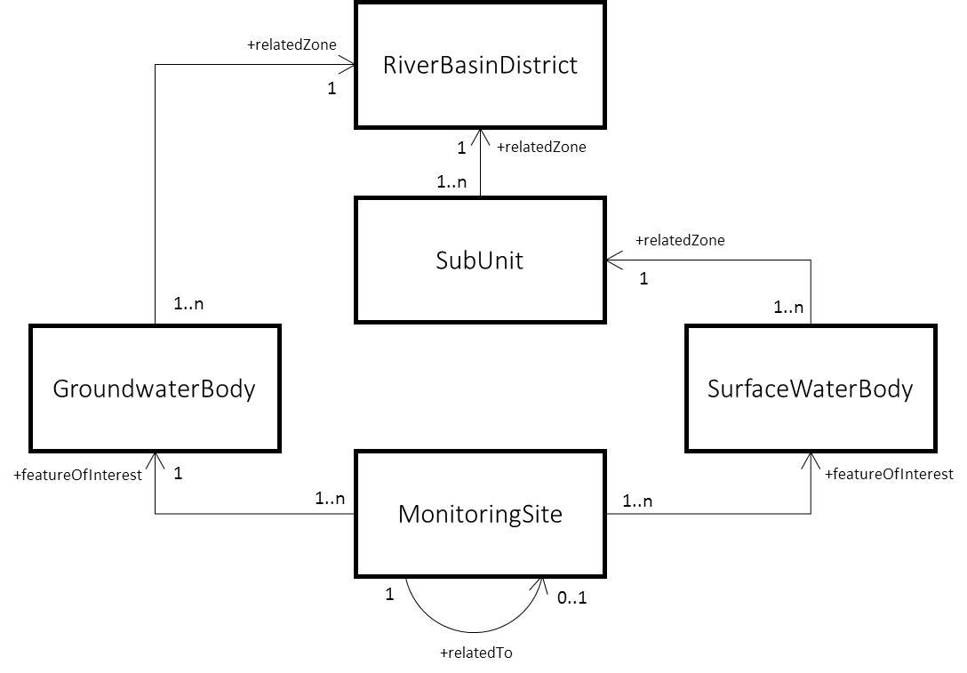

Table . Description of the relationships between different WISE spatial object types.

|  |  |  |  |
| --- | --- | --- | --- |
| Source Spatial Object Type | Association | Definition | Target Spatial Object Type |
| MonitoringSite | featureOfInterest | Identifies the water body being monitored. | SurfaceWaterBody  GroundWaterBody |
| SurfaceWaterBody | relatedZone | Identifies the sub-unit that the surface water body belongs to. | SubUnit |
| GroundWaterBody | relatedZone | Identifies the river basin district that the groundwater body belongs to. | RiverBasinDistrict |
| SubUnit | relatedZone | Identifies the river basin district that the sub-unit belongs to. | RiverBasinDistrict |

Note that all these associations are implemented using thematic identifiers, which always requires the pair identifier and identifier scheme (for example, relatedZoneIdentifier and relatedZoneIdentifierScheme encode the association relatedZone).

The identifier scheme used for the source spatial object must be consistent with identifier scheme used for the target object. Table 19 lists the valid combinations in the WISE spatial data sets.

Table . Using consistent identifier schemes to relate different WISE objects.

|  |  |  |  |  |
| --- | --- | --- | --- | --- |
| Source object | | Target object | | Validity  constraints |
| Object Type | Identifier Scheme | Object Type | Identifier Scheme |
| MonitoringSite | 'euMonitoringSiteCode' | SurfaceWaterBody | 'euSurfaceWaterBodyCode' | 2) |
| " | " | GroundWaterBody | 'euGroundWaterBodyCode' | 2) |
| " | 'eionetMonitoringSiteCode' | SurfaceWaterBody | 'euSurfaceWaterBodyCode' | 3) |
| " | " | " | 'eionetSurfaceWaterBodyCode' | 1) 4) |
| " | " | GroundWaterBody | 'euGroundWaterBodyCode' | 3) |
| " | " | " | 'eionetGroundWaterBodyCode' | 1) 4) |
| SurfaceWaterBody | 'euSurfaceWaterBodyCode' | SubUnit | 'euSubUnitCode' | 2) |
| " | 'eionetSurfaceWaterBodyCode' | SubUnit | 'euSubUnitCode' | 4) |
| " | " | " | 'eionetSubUnitCode' | 1) |
| GroundWaterBody | 'euGroundWaterBodyCode' | RiverBasinDistrict | 'euRBDCode' | 2) |
| " | 'eionetGroundWaterBodyCode' | " | 'eionetRBDCode' | 1) |
| SubUnit | 'euSubUnitCode' | RiverBasinDistrict | 'euRBDCode' | 2) |
| " | 'eionetSubUnitCode' | " | 'eionetRBDCode' | 1) |

1) Mandatory for countries not reporting under WFD.

2) Mandatory for countries reporting under WFD.

3) Valid for countries reporting under WFD.

4) Valid in exceptional cases (e.g. small non-WFD water bodies) for countries reporting under WFD.

### Using thematic identifiers to relate WFD and EIONET monitoring site codes

In the MonitoringSite data set, thematic identifiers are used for one additional purpose: to identify WFD monitoring sites that are also EIONET monitoring sites.

As explained above, the monitoring sites must be identified by their WFD code if they are used in a WFD monitoring programme. Otherwise, they must be identified by their EIONET code.

If a WFD monitoring site is also an EIONET monitoring site (i.e. if historically it has been reported under the EIONET WISE SoE data flows), then the EIONET code is provided via the relatedTo association.

Table . Reporting the WFD and the EIONET identifier for monitoring sites.

|  |  |  |  |  |
| --- | --- | --- | --- | --- |
| Object Type | Identifier Scheme | Association | Object Type | Identifier Scheme |
| MonitoringSite | 'euMonitoringSiteCode' | relatedTo | MonitoringSite | 'eionetMonitoringSiteCode' |

## Using INSPIRE identifiers

The INSPIRE data models use a base type named **Identifier** to uniquely identify spatial objects.

Note that a spatial object is a representation of a real-world object: so the representation may change (e.g. the geometry may be corrected), even if the real-world object remains the same.

The INSPIRE inspireId data element has a complex data type: Identifier.

Figure . INSPIRE Identifier data type (informative only).



In the WISE spatial data sets, it must be provided using 3 separate data elements:

* + inspireIdLocalId;
  + inspireIdNamespace and
  + inspireIdVersionId.

In theory, the INSPIRE identifier might have been used exclusively (i.e. instead of using additional thematic identifiers). In practice, this would have been problematic:

* + Implementation of the INSPIRE directive is only mandatory for EU Member States. Non-EU Data Providers might not have the possibility of providing the mandatory information (i.e. localId and namespace).
  + Implementation of the INSPIRE directive is phased. For Annex III themes, newly collected and extensively restructured spatial data sets shall be conformant to the INSPIRE implementing rules on interoperability of spatial data sets and services by 2015-10-21 and for all data sets by 2020‑10‑21. This includes *Environmental Monitoring Facilities* (applicable to monitoring sites) and *Area Management/Restriction/Regulation Zones and Reporting Units* (applicable to river basin districts and sub-units, surface and groundwater bodies, and protected areas). The current implementation status quo is variable among EU Member States, so it is not possible to assume that all might be able to provide INSPIRE persistent unique identifiers.
  + Specifically in the case of the *Area Management/Restriction/Regulation Zones and Reporting Units* theme, the INSPIRE technical guidelines recommend that the European codes defined for the WFD reporting should be used as the localId in the corresponding INSPIRE data sets and services. However this is only a recommendation. So a thematic identifier is needed to guarantee that the spatial objects can be linked to the thematic information reported under WFD or WISE SoE.
  + Specifically in the case of the *Environmental Monitoring Facilities* - which covers the WFD and EIONET monitoring sites but is a rather abstract data model- two additional problems exist: there is no recommendation with regard to the use of European codes in the localID component of the identifier; and the technical guidelines do not explicitly include a thematic identifier to allow a link to previously reported thematic data. To maintain consistency with the remaining themes, a decision was taken to use thematic identifiers also in the MonitoringSite data model.

Finally, a conceptual difference exists between the thematic identifier and the INSPIRE identifier. The thematic identifier identifies a real-world object, while the INSPIRE identifier identifies the spatial object that represents it in a data set.

For many purposes, this distinction is irrelevant. However, it is important when the temporal aspects of life-cycle information need to be registered both at spatial object level and at real-world object level.

As a result of the issues described above, a number of modelling decisions was taken and the following recommendations are given:

* + The inspireIdLocalId data element is mandatory. Data Providers implementing the INSPIRE directive must provide the INSPIRE localId value using this element. Data Providers not implementing the INSPIRE directive should provide the national persistent unique identifier of the spatial object: the uniqueness constraint applies to all objects of the same type reported by the country.
  + The inspireIdNamespace data element is marked as optional, as requested by some Data Providers. Data Providers implementing the INSPIRE directive are requested to provide the INSPIRE namespace using this element, if already available. Data Providers not implementing the INSPIRE directive are recommended to adopt a similar approach and referred to the document “[Designing URI Sets for Location](http://www.data.gov.uk/sites/default/files/Designing_URI_Sets_for_Location-V1.0.pdf)” for informative purposes.
  + The inspireIdVersionId element is optional. It is recommended that Data Providers report the version of the spatial object.

### Relationship between inspireId and thematicId

The following text was extracted from the INSPIRE Annex III Area Management/Restriction/Regulation Zones and Reporting Units Data Specification:

Many ManagementRestrictionOrRegulationZone spatial objects have been assigned multiple identifiers based on different identifier schemes that have been defined for data exchange for specific requirements (e.g. national versus European reporting. Thematic identifiers have been and shall continue to be the key used to link non-spatial data to the ManagementRestrictionOrRegulationZone spatial object. To ensure that none of these identifiers and links are lost, a thematicId has been added to the ManagementRestrictionOrRegulationZone.

The key difference between the inspireId and thematicId is that the inspireId shall be a persistent, unique identifier that can be used in external datasets to reference to the spatial object by any third party. Whereas the thematicID is a descriptive unique object identifier assigned to the spatial object defined in an information community.

NOTE: A thematic identifier may form part of the inspireId.

Some ManagementRestrictionOrRegulationZone spatial objects may be assigned more than one thematic identifier. These thematic identifiers may have been assigned to meet internal data maintenance requirements or are identification codes assigned at national, European or International level.

### Special case: Using hydrographic identifiers

Hydrographic identifiers are only used in the SurfaceWaterBodyCentreline data set, relating hydrographic centreline segments to surface water bodies.

Hydrographic centrelines are part of the INSPIRE HY theme (Annex I - Hydrography) specification, under the Hydro - Network application schema. The Network application schema presents a network view of hydrographic elements, with real-world features modelled as links (WatercourseLink) and nodes (HydroNode).

The INSPIRE HY theme does not include thematic identifiers (because Annex I data specifications were developed before thematic identifiers were introduced as a base data type in the Annex II and Annex III data specifications).

However, all hydrographic objects in the INSPIRE HY theme have ahydroIdelement with a similar meaning. The INSPIRE hydroId has a complex data type called HydroIdentifier.

Figure . INSPIRE HydroIdentifier data type (informative only).

Machine generated alternative text:
«dataT rpe» 
Hydro - 
classificationScheme: CharacterString (Ill I 
localld: CharacterString 
namespace: CharacterString 

For WISE reporting purposes, this hydrographic identifier will be treated as a thematic identifier:

* + The classificationScheme is not required.
  + The HydroIdentifier localId is a unique identifier in the scope of the corresponding namespace - so in practice it is equivalent to the ThematicIdentifier identifier.
  + Similarly, the HydroIdentifier namespace is equivalent to the ThematicIdentifier IdentifierScheme in the remaining themes (i.e. it identifies the national or international identifier scheme from which the hydrographic identifier was obtained).

Further information is provided on the section “”.

## Using identifiers in the WISE spatial data reporting

In the examples in this sections, two hypothetical countries are used:

* XZ, a country reporting under WFD and WISE SoE;
* ZZ, a country reporting only under WISE SoE.

### Reporting the identifier for spatial objects

#### Monitoring sites

Monitoring sites include:

* + WFD monitoring sites, i.e. monitoring sites included in any of the WFD monitoring programmes (including specific programmes and monitoring sites observed under other EU Directives, such as the Drinking Water Directive, the Bathing Waters Directive or the Urban Waste Water Treatment Directive);
  + EIONET monitoring sites, which include any monitoring site for which time series have been reported under any EIONET WISE SoE data flow.

For countries reporting under WFD, most EIONET monitoring sites are also WFD monitoring sites.

In this case, the WFD monitoring site code is always the preferred identifier. The EIONET identifier must be reported in the relatedTo elements (see Figure 32).

In exceptional cases (e.g. monitoring sites in water bodies not delineated as WFD water bodies, historical monitoring sites no longer operational, etc.), an EIONET monitoring site may exist that was not reported under WFD.

For countries not reporting under the WFD, the EIONET identifier must be used.

Figure . Reporting the identifier of monitoring sites.

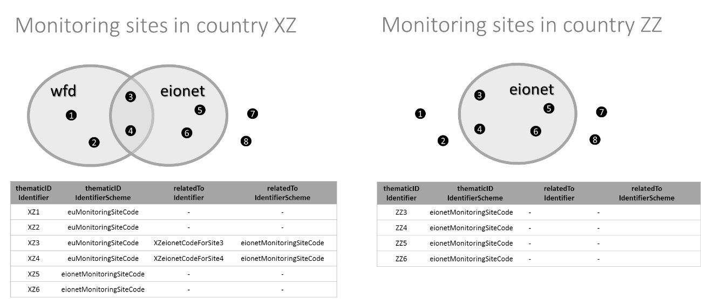

#### Groundwater bodies

The same principle described above applies to groundwater bodies: the WFD groundwater body code will be used as a preferred identifier, where applicable. Figure 33 illustrates the reporting of the identifiers for a hypothetical set of water bodies.

Figure . Reporting the identifier of groundwater bodies.

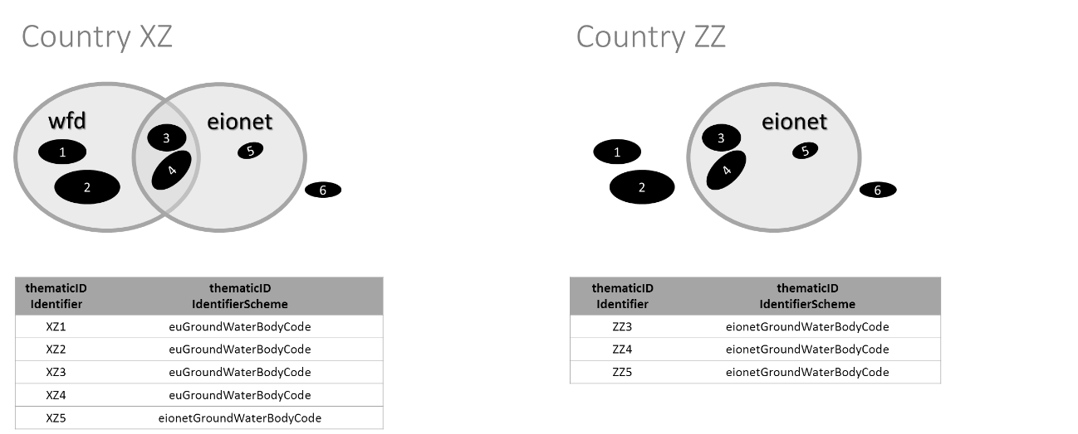

From a thematic point of view, some situations should occur only in exceptional circumstances:

* + Data Providers reporting under WFD must report all WFD groundwater bodies – so, in principle, groundwater bodies XZ5 and XZ6 would typically be smaller aquifers, not delineated as WFD groundwater bodies[[1]](#footnote-2).
  + To allow European-wide assessments, Data Providers not reporting under WFD are requested to provide a comparable coverage of their national groundwater bodies – so, in principle, groundwater bodies ZZ1 and ZZ2 (and their monitoring sites and time series) should also be reported under the EIONET WISE SoE data flows.

Note that the thematic identifier of a monitoring site must be unique, i.e. a groundwater monitoring site and a surface water monitoring site must not have identical identifiers.

#### Surface water bodies

The principle described for groundwater bodies is also applicable to surface water bodies: the WFD surface water body code will be used as a preferred identifier; the EIONET identifier shall be used in exceptional cases, e.g. for small lakes that are not WFD water bodies.

Please refer to the section “Special case: reporting surface water bodies under WISE SoE”.

Note that the thematic identifier of a monitoring site must be unique, i.e. a groundwater monitoring site and a surface water monitoring site must not have identical identifiers.

#### River basin districts and sub-units

For Data Providers reporting under WFD, this information will be provided under the WFD data flow.

Data Providers not reporting under WFD are requested to provide their national delineation of river basins or sub-basins, consistent with the one used for reporting purposes under WISE SoE.

The same principle illustrated in Figure 1 (cf. page 4) applies to the reporting of sub-units (sub basins). For sub-units, the correct thematicIdIdentifierScheme is:

* + 'euSubUnitCode' for WFD subunits and
  + 'eionetSubUnitCode' for sub-basins reported by Data Providers not reporting under WFD.

Refer to the section “Special case: reporting river basins under WISE SoE” for further information.

### Linking spatial objects

#### Linking a monitoring site to a water body

Each monitoring site needs to be linked to the water body being monitored i.e. the sampled feature or "feature of interest". The two featureOfInterest elements are used for this purpose.

(cf. page ) illustrates the reporting of WFD and EIONET monitoring sites, and their relationship to WFD or EIONET surface water bodies. If a WFD identifier exists, it will always be the preferred identifier.

The same principle applies to monitoring sites related to groundwater bodies. The only difference is that the identifier scheme changes for monitoring sires in groundwater bodies:

* + 'euGroundWaterBodyCode' must be used instead of 'euSurfaceWaterBodyCode'; and
  + 'eionetGroundWaterBodyCode' must be used instead of 'eionetSurfaceWaterBodyCode'.

#### Linking a sub-unit to a river basin district

Under WFD, river basin districts can be subdivided in sub-units.

By convention, if a river basin district is not subdivided, it is treated as having only one sub-unit spatially equal to the river basin district itself. This creates a hierarchical relationship similar to the one between NUTS1 and NUTS2 (statistical units).

illustrates a hypothetical River Basin District divided in 3 sub-units, and how to report the relationship between each sub-unit and the corresponding RBD.

Figure . Linking sub-units to River Basin Districts using the relatedZone elements.

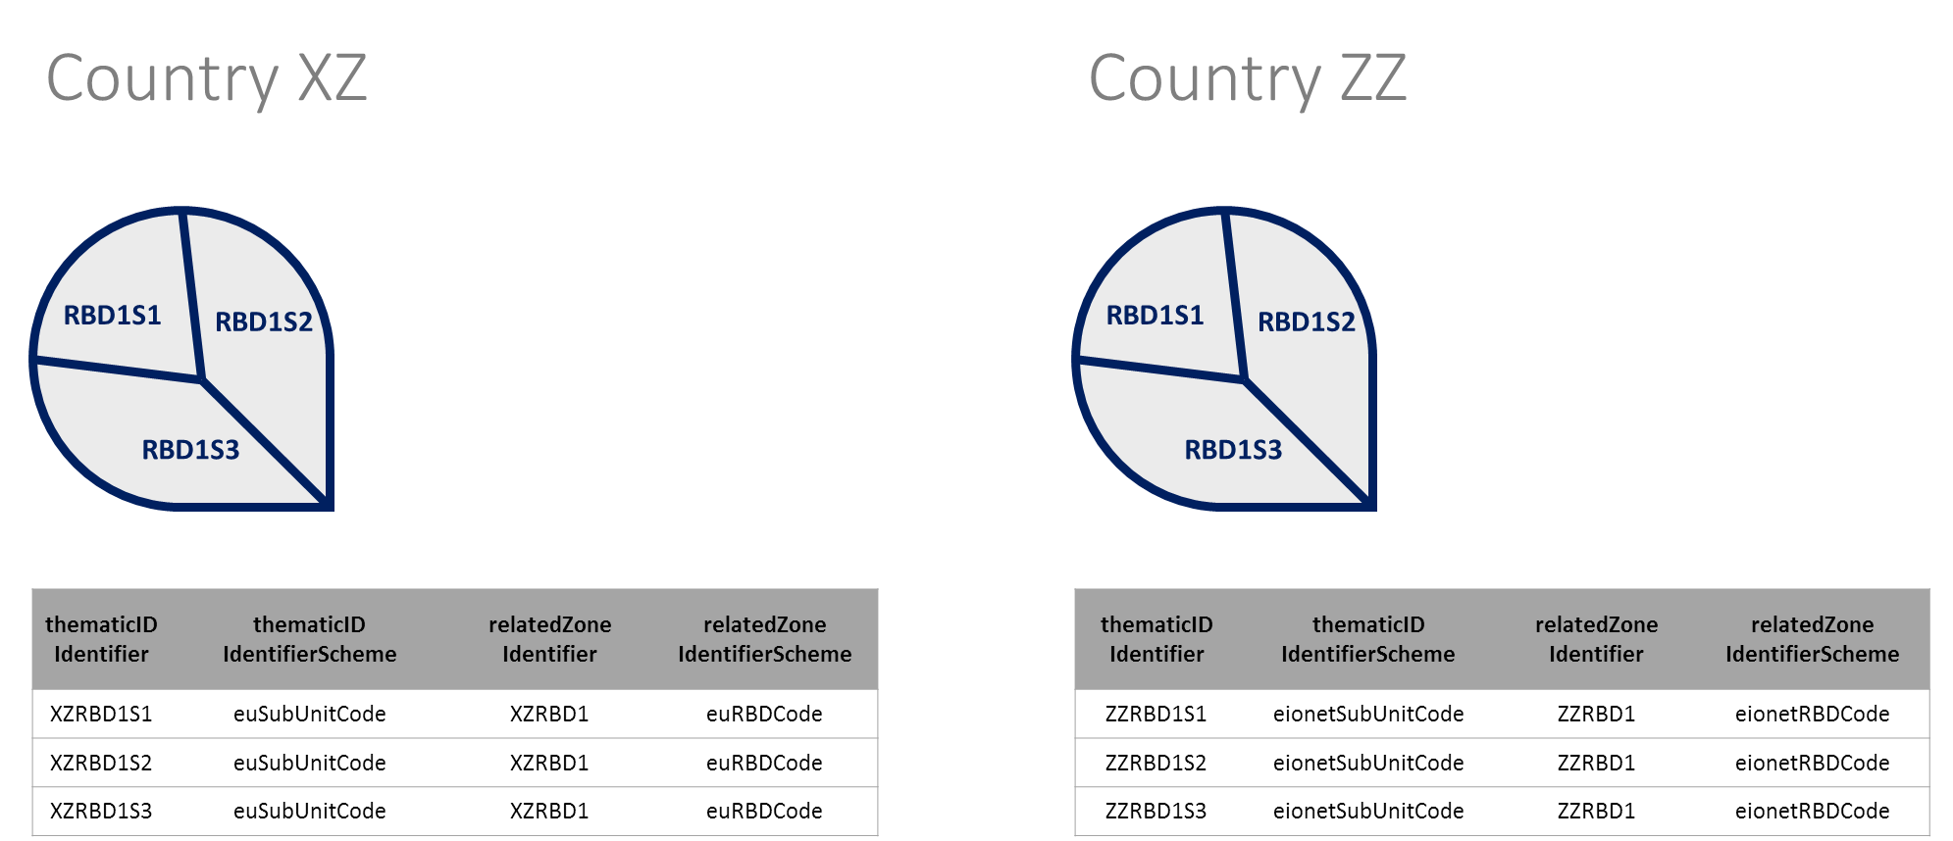

Data Providers not reporting under WFD (for example, non EU countries) must follow the same approach. Note that the correct identifier schemes are 'eionetSubUnitCode' (instead of 'euSubUnitCode') and 'eionetRBDCode' (instead of 'euRBDCode').

Data providers not reporting under WFD are requested to provide the spatial data pertaining river basins and river basin sub-units. Otherwise, the analysis and publication of the country's thematic data at European level may be impaired. RBD should be interpreted as reporting units (e.g. a main river basin or a set of contiguous river basins) and the same applies to sub-units (typically the basin of a tributary, a set of small contiguous coastal watersheds, etc.). The aggregated information reported under WISE SoE Water Quantity or WISE SoE Emissions need to refer to a valid RBD or sub-unit.

#### Linking a groundwater bodies to a river basin district

Following the principle established in the WFD reporting, each groundwater body must be related to one and only one River Basin District.

Data providers not reporting under WFD must follow the same principle, using the appropriate identifier schemes: 'eionetGroundaterBodyCode' (instead of 'euGroundwaterCode') and 'eionetRBDCode' (instead of 'euRBDCode').

provides an example. Groundwater XZB illustrates a special case: if the river basin district delineation follows the surface watershed divides, a groundwater polygon (i.e. the horizontal projection of the groundwater) may extent “beyond” the watershed. In this case, the groundwater body should be assigned to the adequate river basin district (based on the groundwater recharge).

Figure . Linking groundwater bodies to river districts using the relatedZone elements.

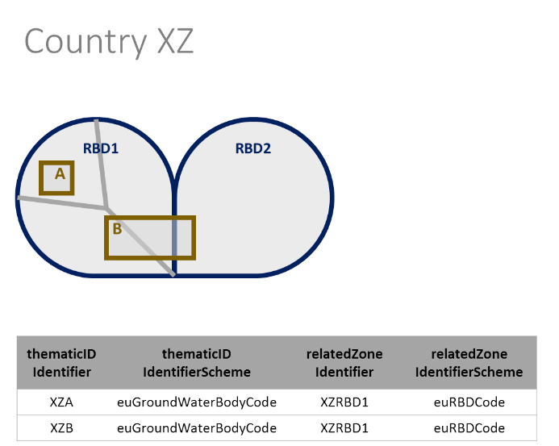

#### Linking surface water bodies to sub-units

Each surface water body is related to one and only one subunit. The principle described for groundwater bodies is applicable (with the necessary adaptations). illustrates an exceptional case where two small water bodies (XZc and XZd) are not WFD surface water bodies.

Figure . Linking surface water bodies to sub-units using the relatedZone elements.

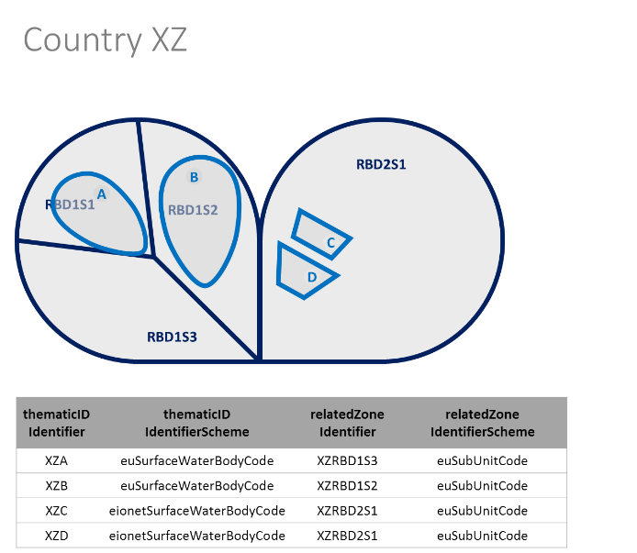

# Life-cycle management

## Overview

The requirements for life-cycle information in the WISE spatial data sets are stated in the following excerpt of the CIS Guidance Document No 22 (section 4.4.5):

“Member States are responsible for the unique identification of spatial objects reported to WISE and to guarantee persistence over time. […] However two major problems arise on implementing these rules:

* + - Objects in the real world change over time. For example a monitoring station is removed from a network, River Basin Districts are restructured (due to changes in administrative boundaries), etc. […]
    - As the objects are changing over time this also means that […] references to other datasets may become obsolete.

Member States will be responsible for:

* + - Maintaining the references between national data submitted to WISE as required by the respective reporting guidelines and described in the WISE data model (e.g. sensitive areas reported under UWWTD linked to water bodies reported under WFD);
    - Referencing their spatial objects to the respective objects of the WISE Reference GIS datasets and maintaining these references;
    - Maintaining correct linkages between datasets where objects have changed or new objects have been created, and updating all related datasets accordingly (e.g. if a new river water body dataset is submitted, the river monitoring stations also have to be updated because the stations are linked to river water bodies).”

This section provides an overview on issues related to life-cycle management for the spatial objects in the different WISE spatial data sets, namely:

* + How to report if a WFD water body was re-delineated since it was reported in the first RBMP in 2010.
  + How to report if the identifier (the code) of a WFD surface water body was changed, without any other relevant change to the surface water body itself.
  + How to report if the identifier (the code) of a monitoring site has changed.
  + How to report if a monitoring site has been superseded by another monitoring site (implicitly meaning that the time series of the two sites are representative of the same conditions in the monitored water body).

It also provides practical information and examples on:

* + How to use the beginLifeSpanVersion, endLifeSpanVerison and versionId to report changes to a spatial object representation;
  + How to use the operationalActivityPeriodBegin and operationalActivityPeriodEnd to report the “validity period” of a monitoring site;
  + How to use the designationPeriodBegin and designationPeriodEnd to report “validity period” of water bodies, river basin districts or protected areas;
  + How to report predecessors and successors to guarantee the comparability and continuity of the data when changes occur; and
  + How to report the type of change using the wiseEvolutionType element.

Please read the section on “” for information on the proper use of thematic identifiers to uniquely identify spatial objects in WISE.

This section builds extensively on the concepts and examples in Annex F on the INSPIRE SU theme (Annex III - Statistical Units) data specification.

## Life-cycle information

Life-cycle management has different complementary aspects:

* + To keep track of the status of real-world entities;
  + To keep track of the status of their representation, as objects in a data set;
  + To keep track of their longitudinal succession in time.

The life-cycle of each real-world entity is registered using the following elements:

* + For monitoring sites:
* **operationalActivityPeriodBegin**;
* **operationalActivityPeriodEnd**.
  + For water bodies, sub-units, river basin districts and protected areas:
* **designationPeriodBegin**;
* **designationPeriodEnd**.

The life-cycle of each spatial object in the data set is registered using the following elements:

* + **beginLifeSpanVersion**;
  + **endLifeSpanVersion**;
  + **versionId** (if the Data Provider chooses to report it explicitly as recommended).

This set of elements allows the creation of snapshots, i.e. data sets that include the spatial objects representing the real-world entities that are valid at a given moment in time.

However, tracking their succession in time requires two additional elements: predecessors and successors. Using these elements, an explicit log can be kept of any longitudinal changes in the data sets. (Note that for monitoring sites, the equivalent elements are supersedes and supersededBy*.*)

One final element is used: **wiseEvolutionType**. It registers the type event that generated the object.

Figure . Valid options for the wiseEvolutionType element.

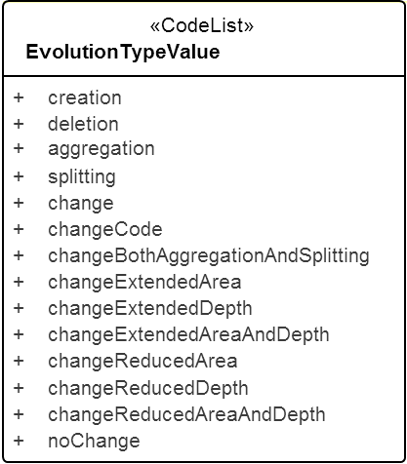

## Creation

If a new spatial object is to be created in the WISE spatial reference data sets (e.g. a new WFD water body not reported in the 1st RBMPs), then:

* + The **wiseEvolutionType** element must have the value 'creation';
  + The **beginLifespanVersion** element must be filled with a valid date;
  + It is strongly recommended to provide a **versionId**: this element is relevant when there are future changes to the object (e.g. minor changes in the geometry, or corrections/updates to other information that does not change the identity of the object itself).

For monitoring sites, the **operationalPeriodBegin** element must be provided, with a valid DateTime value.

For other spatial objects – water bodies, sub-units, RBDs, protected areas – the **designationPeriodBegin** element must be provided, with a valid DateTime value.

The following rules apply:

* + If the new object does not replace an existing object, then it will have no predecessors.
  + If the new object replaces any existing object(s), then it will have 1 (or more) predecessors.
  + If object A identifies object B as a predecessor, then object B must identify object A as a successor.

Typically, a new object is not supposed to have successors (i.e. it is supposed to be valid and operational). However, exceptional situations may require the reporting of a previous unreported object that is no longer operational. If the object was never reported and its identifier is not listed in the WISE register, the recommended procedure is to use the following two steps:

* + Provide the previously unreported object, using wiseEvolutionType ='creation'.
  + Provide an update to that object, using wiseEvolutionType ='deletion' and specifying its successors.

The following exclusions apply:

* + If the object was already reported (but not its geometry) and has not been replaced, then use the option 'noChange'. This option must be used for the WFD water bodies that haven’t changed from the 1st to 2nd RBPM, but that were not previously reported in the spatial data sets.
  + If the object was already reported (but not its geometry) and has been replaced, then use the option 'delete'. This option must be used for the WFD water bodies from the 1st RBPM that were not previously reported in the spatial data sets, and that are no longer in use for the 2nd RBPM. If the object was replaced, then one or more successors should be identified.
  + If the new object is created from an existing object via a splitting operation, then use the option 'splitting'.   
    One and only one predecessor must be identified.
  + If the new object is created from existing objects via an aggregation operation, then use the option 'aggregation'. Two (or more) predecessors must be identified.
  + If the new object is created from existing objects via a hybrid operation involving both aggregation and splitting, then use the option 'changeBothAggregationAndSplitting'. Two (or more) predecessors must be identified.
  + If the object modifies an existing object then use the relevant **wiseEvolutionType** value: 'changeExtendedArea', 'changeExtendedDepth', 'changeExtendedAreaAndDepth', 'changeReducedArea', 'changeReducedDepth', 'changeReducedAreaAndDepth'. Note that the identifier of the object may remain the same (if it is not considered a “new” object): however, it is always a new version of the object, so the beginLifespanVersionand versionIdelements must be provided accordingly. See further information under the section “Changes in the spatial extent”.
  + If there has been a change in the code used at national level, use the option 'changeCode', and report the previous code in the *predecessors* elements (or the *supersedes* elements, if it is a monitoring site).

## Aggregation

If a new spatial object results from the aggregation of previously reported spatial objects (e.g. a new WFD water body resulting from the aggregation of two water bodies reported in the 1st RBMPs), then:

* + The **wiseEvolutionType** element must have the value 'aggregation'.
  + The **beginLifespanVersion** element must be filled with a valid DateTime.
  + It is strongly recommended to provide a **versionId**: this element is relevant when there are future changes to the object (e.g. minor changes in the geometry, or corrections/updates to other information that does not change the identity of the object itself).

Note that aggregation is applicable to real-world surfaces – which are usually represented by polygons. However, the cartographic representation may also be a polyline or even a (representative) point. So, the aggregation operation can also be reported for polyline and point data sets.

For monitoring sites, the **operationalPeriodBegin** element must be provided, with a valid DateTime value. For other spatial objects – water bodies, sub-units, RBDs, protected areas – the **designationPeriodBegin** element must be provided, with a valid DateTime value.

Two (or more) predecessors must be reported.

* + If object A identifies object B as a predecessor, then object B must identify object A as a successor.

The following constraints are applicable (and used to control the validity of the reported data):

* + The new objects must not reuse the thematic identifier of any replaced object.
  + Aggregation of monitoring sites is valid if all are located within the same water body.
  + Aggregation of surface bodies is valid if the resulting water body is located in the same sub-unit. (If the geometry of the original water bodies is available, additional checks are performed).
  + Aggregation of groundwater bodies is valid if the resulting water body are located in the same river basin district.

(If the geometry of the original waterbodies is available, additional checks are performed.)

## Splitting

If a new spatial object results from the splitting of a previously reported spatial object (e.g. a new WFD water body resulting from the splitting of a water body reported in the first RBMPs), then:

* + The **wiseEvolutionType** element must have the value 'splitting'.
  + The **beginLifespanVersion** element must be filled with a valid DateTime.
  + It is strongly recommended to provide a **versionId**: this element is relevant when there are future changes to the object (e.g. minor changes in the geometry, or corrections/updates to other information that does not change the identity of the object itself).

Note that splitting is applicable to real-world surfaces – which are usually represented by polygons. However, the cartographic representation may also be a polyline or even a (representative) point. So, the splitting operation can also be reported for polyline and point data sets.

For monitoring sites, the **operationalPeriodBegin** element must be provided, with a valid DateTime value. For other spatial objects – water bodies, sub-units, RBDs, protected areas – the **designationPeriodBegin** element must be provided, with a valid DateTime value.

One predecessor must be reported.

* + If object A identifies object B as a predecessor, then object B must identify object A as a successor.

The following constraints are applicable (and used to control the validity of the reported data):

* + The new objects must not reuse the thematic identifier of any replaced object.
  + Splitting of monitoring sites is valid if all are located in the same water body.
  + Splitting of a surface body is valid if the resulting water bodies are spatially adjacent and all are located in the same sub-unit.
  + Splitting of a groundwater body is valid if the resulting water bodies are spatially adjacent and all are located in the same river basin district.

(If the geometry of the original waterbodies is available, additional checks are performed.)

## Combined aggregation and splitting

If a new spatial object results from a complex operation involving both the splitting and aggregation of previously reported spatial objects, then:

* + The **wiseEvolutionType** element must have the value 'changeBothAggregationAndSplitting'.
  + The **beginLifespanVersion** element must be filled with a valid DateTime.
  + It is strongly recommended to provide a **versionId**: this element is relevant when there are future changes to the object (e.g. minor changes in the geometry, or corrections/updates to other information that does not change the identity of the object itself).

For monitoring sites, the **operationalPeriodBegin** element must be provided, with a valid DateTime value. For other spatial objects – water bodies, sub-units, RBDs, protected areas – the **designationPeriodBegin** element must be provided, with a valid DateTime value.

Two or more predecessors must be reported.

* + If object A identifies object B as a predecessor, then object B must identify object A as a successor.

The constraints in the sections on “” and “” are applicable in this case.

## Changes in the spatial extent

If the spatial object results from changes to spatial extent of a previously existing object (typically a water body or a protected area), then:

* + The **wiseEvolutionType** value must have the relevant value for the specific situation been reported: 'changeExtendedArea', 'changeReducedArea', 'changeExtendedDepth', 'changeExtendedAreaAndDepth', 'changeReducedDepth', 'changeReducedAreaAndDepth'.
  + The options involving changes in the depth are applicable only to groundwater bodies.
  + The **beginLifespanVersion** element must be filled with a valid DateTime.
  + It is strongly recommended to provide a **versionId**: this element is relevant when there are future changes to the object (e.g. minor changes in the geometry, or corrections/updates to other information that does not change the identity of the object itself).

For monitoring sites, the **operationalPeriodBegin** element must be provided, with a valid DateTime value. For other spatial objects – water bodies, sub-units, RBDs, protected areas – the **designationPeriodBegin** element must be provided, with a valid DateTime value.

With regard to identifiers, two options are possible (depending on the degree of change and on the approach taken by the different national Data Providers):

* + The identifier of the object remains the same (if it is not considered a “new” object): however, it is always a new version of the object, so the **beginLifespanVersion**and **versionId**elements must be provided.
  + Or, the changed object is treated as new object, with a new unique thematic identifier: then the original object must be listed as a **predecessor**.

Data providers are strongly recommended to follow the second approach (i.e. treat the changed object as a new object, with a new unique identifier).

## Changes in the identifier of an object

In special cases, the identifiers used at national level may change although the real-world entities have not changed. Since the European identifiers are derived from the national identifiers (by concatenating the 2‑letter country code as a suffix to the national code), this change needs to be propagated to the WISE spatial data sets.

Conceptually, if the identifier changes, then the object is no longer the same as before, and it replaces the one with the old identifier.

* + The **wiseEvolutionType** element must have the value 'changeCode';
  + The **beginLifespanVersion** element must be filled with a valid DateTime;
  + It is strongly recommended to provide a **versionId**: this element is relevant when there are future changes in the object (e.g. minor changes in the geometry, or corrections/updates to other information that does not change the identity of the object itself).

For monitoring sites, the **operationalPeriodBegin** element must be provided, with a valid DateTime value. For other spatial objects – water bodies, sub-units, RBDs, protected areas – the **designationPeriodBegin** element must be provided, with a valid DateTime value.

One predecessor must be identified: the object bearing the old identifier.

## Changes in the geometry

Some changes do not affect the identity of a previously reported object, but create a new version of an existing object. For example, if the location of a monitoring site can be reported with better accuracy or precision than previously reported. Or if the delineation of a water body has changed only because a new survey is available with better geometric accuracy or precision.

If an update is provided to the geometry of a previously reported object, then:

* + The **wiseEvolutionType** element must have the value 'change';
  + The **beginLifespanVersion** element must be filled with a valid DateTime;
  + The **versionId**element needs to be updated with regard to the value in the original version of the object.

Note also that the original version of the object will be updated (specifically the endLifeSpanVersion value) in the European dataset (there is no need to report that version again).

Note that the object is the same: it’s just a newer version. Note also that the concept of successors and predecessors is applicable at object level, not at version level. So, if the old version of the object had predecessors (and/or successors), then the new version of the object maintains the same predecessors (and/or successors).

## No changes

In other situations, the update does not create a new version of an existing object.   
For example, missing information may be available that was not previously reported.

In these situations:

* + The **wiseEvolutionType** element must have the value 'noChange'.

The remaining values may change as appropriate.

Note that this option must be used for the WFD water bodies that haven’t changed from the 1st to 2nd RBPM, but that were not previously reported in the spatial data sets.

## Deletion

If a WFD spatial object was reported in the 2010 reporting exercise and is not reported in the 2016 reporting exercise because it no longer exists (as opposed to the cases in which it was aggregated or split into new objects), then the object should be reported as 'deleted'. This is to avoid problems of interpretation (if the object is not reported, this could be due to the object not existing but also to an involuntary omission).

If a previously reported spatial object will no longer be valid, then:

* + The **wiseEvolutionType** element must have the value 'deletion';
  + The **endLifespanVersion** element must be filled with a valid DateTime.

Note the **endLifespanVersion** value must be posterior to the **beginLifespanVersion** value.

If a monitoring site will no longer be reported because it is no longer active or monitored in the real world, the **operationalPeriodEnd** element must be provided, with a valid DateTime value.

Note the **operationalPeriodEnd**value must be posterior to the **operationalPeriodBegin**value.

For other spatial objects – water bodies, sub-units, RBDs, protected areas – the **designationPeriodEnd** element must be provided, with a valid DateTime value.

Note the **designationPeriodEnd**value must be posterior to the **designationPeriodBegin**value.

The following principles apply:

* + If the object will not be replaced, then it has no successors.   
    (Note that, for monitoring sites, this will break the time series of reported data.)
  + If other objects will replace it, then 1 (or more) successors must be identified.   
    (A comma-separated list of their identifiers must be provided as the value of the element.)   
    (Note that, for monitoring sites, the time series data previously reported for the deleted site will be considered representative of the conditions at the “new” site, i.e. the time series will be merged.)
  + If object A identifies object B as a predecessor, then object B must identify object A as a successor.

For monitoring sites, successors must be reported using the supersededByelements.

For other spatial object, successors must be reported using the successorselements.

## Special case: constraints and quality control

Spatial objects marked for 'deletion' are excluded from the quality control procedures applicable to the remaining “valid” objects in the data set.

## Special case: invalid objects

Invalid objects are objects reported by mistake. There will be no automated mechanism to purge invalid objects – as this is considered an exceptional situation that shall require human intervention and oversight.

Please contact helpdesk ([wfd.helpdesk@eionet.europa.eu](mailto:wfd.helpdesk@eionet.europa.eu) or [wisesoe.helpdesk@eionet.europa.eu](mailto:wisesoe.helpdesk@eionet.europa.eu), depending on the reporting obligation).

# Quick reference card



# Note on the WISE register

**This note is provided for information only. It does not change or affect the reporting process.**

**register**

set of files containing identifiers assigned to items with descriptions of the associated items [ISO 19135]

**registry**

information system on which a register is maintained [ISO 19135]

Source: http://inspire.ec.europa.eu/documents/Data\_Specifications/D2.5\_v3.4.pdf

As part of the EIONET register at <http://dd.eionet.europa.eu/vocabularies> and to facilitate to reuse of the WISE identifiers across different data flows and reporting obligations, a register is being created for the identifiers of river basin districts, sub-units, water bodies and monitoring sites.

The vocabularies are structured according to the SKOS ([Simple Knowledge Organization System](https://www.w3.org/TR/skos-reference/)) data model.

Currently, the WISE register is mainly a codelist register that contains concepts common to the WFD and the WISE SoE reporting. For example, the [WFD quality elements](http://dd.eionet.europa.eu/vocabulary/wise/WFDQualityElement) or the [WFD intercalibration types](http://dd.eionet.europa.eu/vocabulary/wise/WFDIntercalibrationType).

Registers will be maintained for the identifiers of river basin districts, sub-units, water bodies and monitoring sites. Similar registers already exist for the [Natura 2000 site list](http://dd.eionet.europa.eu/vocabulary/biodiversity/n2000sites) or the [CDDA site list](http://dd.eionet.europa.eu/vocabulary/cdda/cddasites),

The <http://dd.eionet.europa.eu/vocabulary/wise/SpatialUnit> register currently contains 3 types of spatial units: countries, river basin districts and sub-units (Figure 38).

Figure . SpatialUnit register.

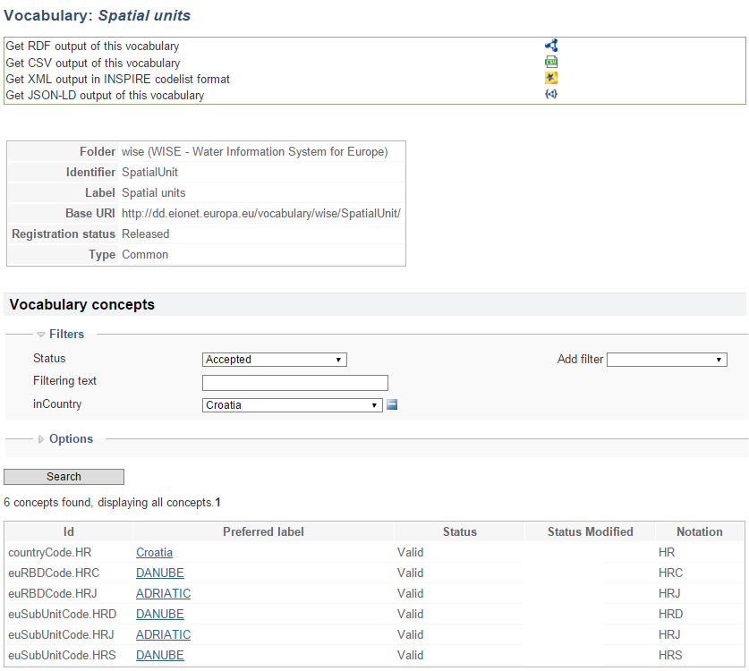

Each concept has an URI, e.g. <http://dd.eionet.europa.eu/vocabulary/wise/SpatialUnit/euRBDCode.AT1000>. The link provides basic information about the spatial unit, which in this case is an Austrian river basin district (Figure 39).

Figure . Information about the identifier of a river basin district.

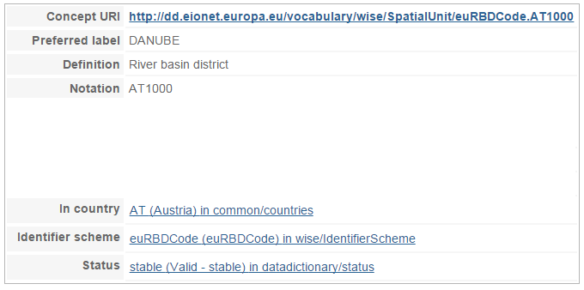

Similarly, each subunit within AT1000 has a unique URI. For example: <http://dd.eionet.europa.eu/vocabularyconcept/wise/SpatialUnit/euSubUnitCode.AT1100>.

Each sub-unit has an additional predicate: the related zone, i.e. the river basin it belongs to (Figure 40).

Figure . Information about the identifier of a river basin district sub-unit.

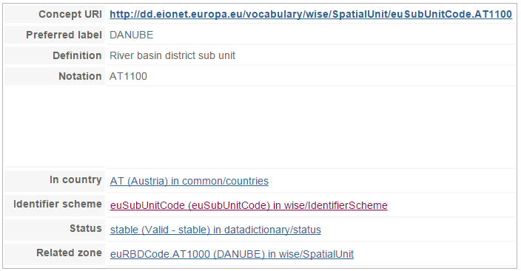

Information about the life-cycle of identifiers is also available. For example, in the 2016 WFD reporting, Ireland will report a single river basin district that replaces the river basin districts reported in the 2010 exercise (Figure 41).

Figure . Information about the identifier of a river basin district that replaces previously reported identifiers.

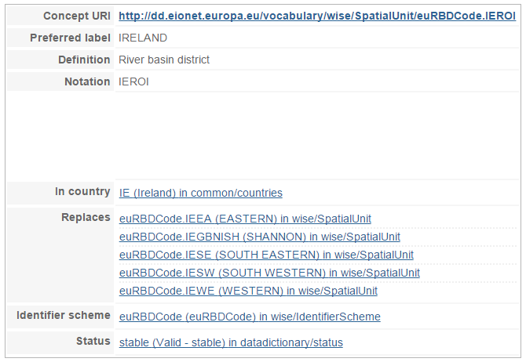

Each of the former river basin districts is kept in the register (Figure 42). Note however that the status is superseded, because the spatial unit has been replaced. The link to the new river basin district is provided.

Figure . Information about the identifier of a river basin district that has been replaced by a new identifier.

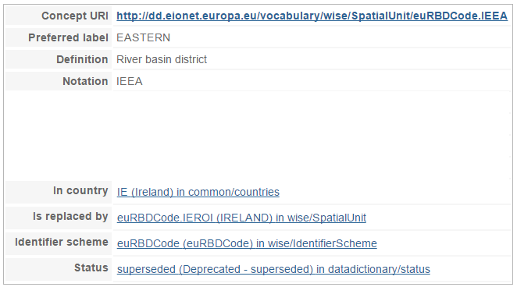

Figure 43 illustrates a different case: EL01 replaces an “invalid.13” identifier, meaning an identifier with an invalid syntax.

Figure . Information about the identifier of a river basin district that replaces an invalid identifier.

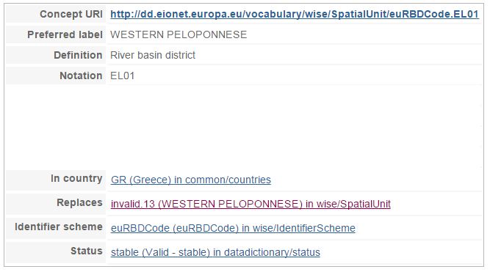

Following the link, clarifies the reason: in the previous WFD reporting the 'GR' country code was used in the beginning of the identifier (Figure 44). In the 2016 reporting, the 'EL' country code must be used in the beginning of the identifier, but the river basin district is the same. So the former identifier is simply marked as invalid and replaced by the new identifier. For the same reason, the URI to an invalid concept is not "human-readable" nor does can it be used to directly obtain the identifier.

Figure . Information about an 'invalid' identifier previously used for a river basin district.

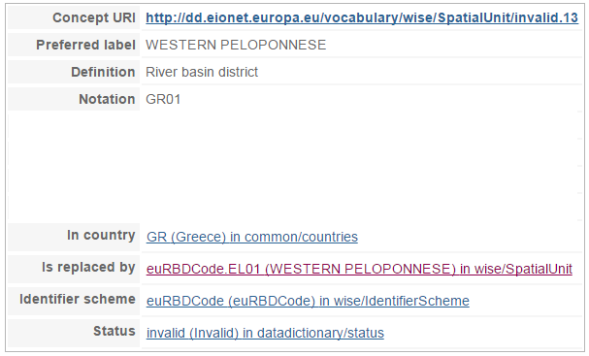

## About the status of a concept

Each concept has an associated status (Figure 45).

The different possible statuses are defined in <http://dd.eionet.europa.eu/vocabulary/datadictionary/status>.

The section provides an overview of the different statuses and of their use in the context of the identifiers register and of the data quality control.

Figure . Status.

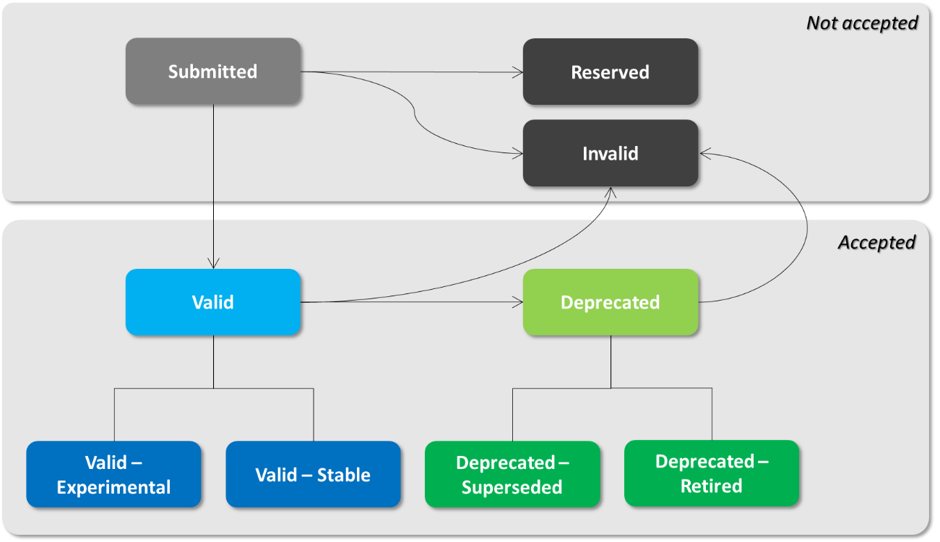

**Not accepted** is an abstract status that includes:

* + **Submitted -** Used for identifiers that haven’t been evaluated (e.g. passed quality control). Can be seen as an internal initial state.
  + **Reserved** - Used for reserved identifiers that cannot be used for real spatial units.
  + **Invalid** - Used for identifiers that cannot not be used in the current reporting.

The invalid state is applied to “wrong” identifiers – e.g. identifiers that were used in the past, but that do not follow the current syntax requirements for identifiers, or identifiers that the Data Provider flagged has being wrong. Invalid spatial identifiers can be replaced by other identifiers.

Not accepted identifiers should not be used in the reporting. Depending on the requirements of each specific data flow or spatial data set, using one of this identifiers in a data delivery can trigger:

* + a BLOCKER, i.e. the data cannot be delivered;
  + an ERROR, i.e. the data can be delivered but a resubmission will probably be requested; or
  + a WARNING, i.e. the data can be delivered but a resubmission may be requested or the data may not be publishable.

**Accepted** is an abstract state that includes valid and deprecated identifiers.

**Valid** identifiers include 'valid – **experimental**' and 'valid – **stable**' identifiers.

**Deprecated** identifiers include 'deprecated – **superseded**' and 'deprecated – **retired**' identifiers.

Depending on the requirements of each specific data flow or spatial data set, the data delivery may include any accepted identifier, or only valid identifiers, or only valid – stable identifiers, etc…

The default approach is that any accepted identifier can be used.

**Valid – stable** identifiers are syntactically correct, no issue has been detected in the spatial object previously reported by the Data Provider, and refer to an active valid real world entity (as far as the Data Requester knows).

**Valid – experimental** identifiers are syntactically correct identifiers that are proposed by the Data Requester (i.e. the EEA or DG ENV) to replace invalid identifiers.

These identifiers were never reported by countries. They are proposed as a replacement for an invalid identifier that was reported by in the past (e.g. an identifier that had special characters). If countries accept the change and use it in the reporting, then the identifier state will be changed to **'valid – stable'**, **'deprecated – superseded'** or **'deprecated – retired'** (depending on what is reported, see definitions below).

**Valid** identifiers are syntactically correct identifiers reported by the Data Provider. However issues have been detected with the spatial object itself (e.g. the name is missing and/or the geometry needs to be checked), so the identifier cannot be marked as 'valid – stable'. Valid identifiers may replace 'deprecated' identifiers or 'invalid' identifiers (the same applies to 'valid – stable' or valid – experimental identifiers).

**Deprecated – superseded** identifiers are syntactically correct identifiers that are known to have been replaced by another identifier (as reported by Data Providers in the normal reporting process, using the life‑cycle information attributes).

**Deprecated – retired** identifiers are syntactically correct identifiers that are no longer used and have not been replaced (e.g. a monitoring site that is no longer operational and has not been replaced by a different one).

**Deprecated** identifiers are syntactically correct identifiers that were valid in the past. This status is only used when there is not enough information to know if the identifier has been superseded or retired.

(In exceptional circumstances, valid or deprecated identifiers may later be found to be invalid.)

# References

* + CIS Guidance Document No 2 “Identification of Water Bodies”. 2003. <https://circabc.europa.eu/sd/a/655e3e31-3b5d-4053-be19-15bd22b15ba9/Guidance%20No%202%20-%20Identification%20of%20water%20bodies.pdf>
  + CIS Guidance Document No 5 “Transitional and Coastal Waters – Typology, Reference Conditions and Classification Systems”. 2003. <https://circabc.europa.eu/sd/a/85912f96-4dca-432e-84d6-a4dded785da5/Guidance%20No%205%20-%20characterisation%20of%20coastal%20waters%20-%20COAST%20%28WG%202.4%29.pdf>
  + CIS Guidance Document No 22 “Updated Guidance on Implementing the Geographical Information System (GIS) Elements of the EU Water policy. 17. November 2008. <https://circabc.europa.eu/sd/a/d5a9cbcd-e693-483f-a76d-5b64b8f80311/WISE%20GIS%20guidance-No22-%202nd%20edition%20Nov__08.pdf>
  + Guidance on reporting of spatial data for the WFD (RBMP). Version 3.0. December 21 2009.   
    <http://icm.eionet.europa.eu/schemas/dir200060ec/resources/WFD%20Guidance%20on%20reporting%20spatial%20data%20v3.0.pdf>
  + Guidance on practical arrangement for electronic reporting to the Water Information System for Europe (WISE). WISE reporting arrangements. Final document (01.03.2007). <https://circabc.europa.eu/w/browse/f4ddd7fc-c508-4830-b26b-819f83984de6>
  + Report on sub-units – version 5, 31 January 2008. Paper prepared for the meeting of the CIS Working Group Reporting. <https://circabc.europa.eu/w/browse/4b0e9c5d-f5b0-410e-a721-7ae90c8ef844>
  + Groundwater summary report – December 2005 <http://ec.europa.eu/environment/water/water-framework/pdf/groundwater_report.pdf>
  + INSPIRE Data Specification on Environmental Monitoring Facilities – Technical Guidelines <http://inspire.jrc.ec.europa.eu/documents/Data_Specifications/INSPIRE_DataSpecification_EF_v3.0.pdf>
  + INSPIRE Data Specification on Area Management/Restriction/Regulation Zones and Reporting Units – Technical Guidelines. <http://inspire.jrc.ec.europa.eu/documents/Data_Specifications/INSPIRE_DataSpecification_AM_v3.0.pdf>
  + INSPIRE Data Specification on Hydrography – Technical Guidelines. <http://inspire.ec.europa.eu/documents/Data_Specifications/INSPIRE_DataSpecification_HY_v3.1.pdf>
  + INSPIRE Data Specification on Statistical Units – Technical Guidelines <http://inspire.jrc.ec.europa.eu/documents/Data_Specifications/INSPIRE_DataSpecification_SU_v3.0.pdf>
  + Drafting Team "Data Specifications" – deliverable D2.6: Methodology for the development of data specifications, <http://inspire.ec.europa.eu/reports/ImplementingRules/DataSpecifications/D2.6_v3.0.pdf>
  + INSPIRE Metadata Implementing Rules: Technical Guidelines based on EN ISO 19115 and EN ISO 19119. <http://inspire.ec.europa.eu/documents/Metadata/MD_IR_and_ISO_20131029.pdf>
  + Directive 2000/60/EC of the European Parliament and of the Council of 23 October 2000 establishing a framework for Community action in the field of water policy. <http://ec.europa.eu/environment/water/water-framework/index_en.html>

1. Generically, WFD groundwater body should be delineated in aquifers that can be used for drinking water abstraction (at least 10 m3/d as an average, or 50 persons) or support the ecological quality of a surface water body or groundwater dependent terrestrial ecosystem. [↑](#footnote-ref-2)