Reporting Manual

for the delivery of Art. 12 data

in Reportnet 3.0

## Table of Contents

Table of Contents 2

1. Introduction 3

2. General reporting procedure 4

3. Access to Reportnet 3.0 5

3.1 Overview 5

3.2 Manage reporters 5

3.3 Access for countries reporting on outermost regions 7

4. Data preparation and delivery in Reportnet 3.0 8

4.1 General data preparation 8

4.1.1 General Resources 8

4.1.2 Extended Excel templates 10

4.1.3 Preparation of the national checklist 11

4.2 General functioning of Reportnet 3.0 12

4.2.1 Data Submission 14

4.2.2 Data Validation 21

4.2.3 Data Correction 26

4.2.4 Re-submission, Re-validation and Re-correction 26

4.2.5 Report Delivery 27

4.3 Checklist 28

4.4 Other tabular data 33

4.4.1 General Report 33

4.4.2 Birds 34

4.5 Spatial Data 36

## Introduction

This manual has been prepared to assist Member States in their submission of Article 12 national reports to Reportnet 3 managed by the European Environment Agency (EEA). These guidelines aim to ensure that the procedure is comprehensible and clear to national reporters involved at any stage along the data preparation, import and delivery process.

The manual has been divided in different sections including i) a general description of the reporting procedure, ii) how to access the Repornet 3.0 reporting platform and the Art. 12 dataflow and iii) the preparation requirements for data delivery using the Reportnet 3.0 platform. This last section includes general information on Art. 12 data preparation and on the functions of Reportnet 3.0. Furthermore, specific instructions for the preparation and delivery of the specific Art. 12 schemas are included. Separate guidelines will be developed for additional reporting tools, e.g. Webforms, when and if these tools are available.

Additional technical guidelines for the use of the Reportnet 3.0 platform may be found in <https://reportnet.europa.eu/> in the section “Supporting documents”.

For specific help and advice, questions regarding the data reports, data standards, QA/QC rules, and functioning of the specific features of the reporting folders may be addressed to [nature.helpdesk@eionet.europa.eu.](mailto:nature.helpdesk@eionet.europa.eu)

## General reporting procedure

For the upcoming 2019-2024 reporting period, the submission of national reports will be through Reportnet 3.0, accessible at <https://reportnet.europa.eu/>. Reporters responsible for data delivery for a Member State must first manage their access to Reportnet 3.0 and organize the different responsibilities among them (see section 3).

The reporting process then takes place in several steps (Fig. 2.1), starting with the preparation of the data, submission and validation. Considering the feedback of the validation process, a correction and re-submission may be necessary. These steps should be repeated until the data has achieved the required quality and the delivery can be finalised (see section 4 of this manual).

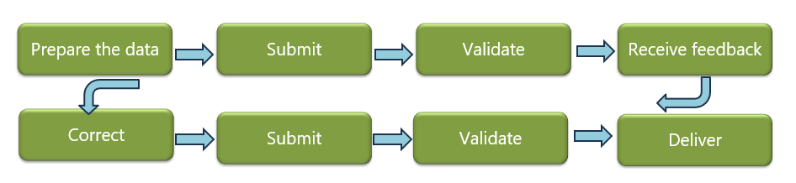

**Fig. 2.1:** General workflow of the reporting process under Reportnet 3.0.

The **validation** is an important function to generate acceptable reporting data. There are four types of error messages with different consequences and priorities for the following steps:

* Blockers: correction necessary, no release possible
* Errors: correction strongly recommended
* Warnings: possible error, data should be checked again
* Info: Information about potential anomalies in the data

**Both Blockers and Errors should be addressed before releasing the delivery!**

After these issues have been solved, the lead reporter can proceed to release the data collection. This will run a new and final validation process. If the delivery is successful (i.e. there are no blockers), a confirmation certificate can be downloaded (see section 4.2).

## Access to Reportnet 3.0

### 3.1 Overview

Member State’s national reports should be delivered via Reportnet 3.0 (<https://reportnet.europa.eu/>).

Each Member State should designate a lead reporter. Lead reporters can internally designate other national reporters on the platform. Lead reporters as well as other reporters need to have access to Reportnet 3.0. For this, please follow the instructions to login to Reportnet 3.0 detailed in the following guidelines available in Reportnet 3.0: <https://www.eionet.europa.eu/reportnet/docs/prod/howto_login_reportnet3.> Importantly, all reporters should have an EU login. Once logged in the reporters will be able to see the dataflows assigned to them.

Lead reporters also act as the primary point of contact for the Commission, the EEA and the ETC BE regarding any question about national data deliveries via Reportnet 3.0.

Additional technical guidelines for the use of the Reportnet 3.0 platform may be found in <https://reportnet.europa.eu/> in the section “Supporting documents”.

### 3.2 Manage reporters

The lead reporter can provide access to a dataflow to other reporters. For this, the lead reporter should access the corresponding dataflow (in this case, the Birds Directive reporting (Art. 12) – 2019-2024 dataflow) and click on the ‘**Manage reporters’** icon, located on the left vertical bar of the platform (see Fig. 3.2.1). A new window will open, where the blue ‘**+Add**’ icon can be used to add a new national reporter. This will open a second window (Fig. 3.2.2), where the email address (i.e. the registered user email address) of the new reporter may be added. If the system cannot find the email as a registered user, then a red box will appear around the email address and an icon indicating the user is not valid. In this case, please verify if the email address is correctly registered in Reportnet 3.0. For each reporter to be added, the access level (‘read’ or ‘write’) should be given. ‘Read’ reporters may only see the dataflow schemas but have no editing rights, whereas ‘write’ reporters have editing rights. This setting may be edited anytime using the ‘**Edit**’ button. To save the entered data, click ‘Save’. A lead reporter may add as many national reporters as needed. Once all reporters have been added, click ’Close’ to finalize and close the main window with the listed reporters.

For further information on the management of reporters, please refer to the “**Reportnet 3 Requester HowTo**” Guidance available in <https://reportnet.europa.eu/>.

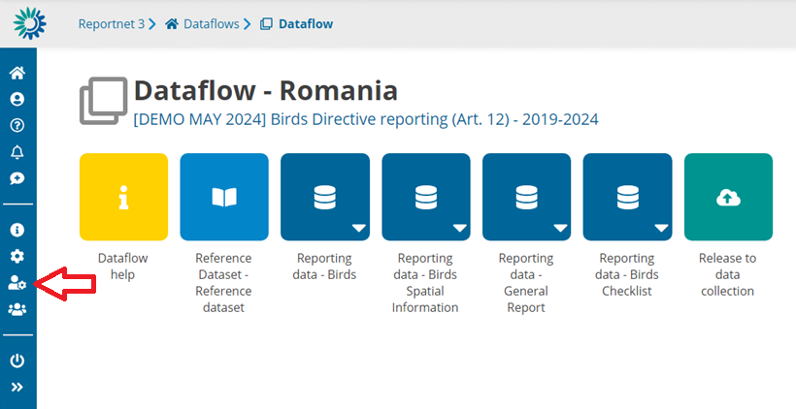**Figure 3.2.1.** After accessing the country folder, the lead reporter may add one or more reporters by clicking on the indicated icon.

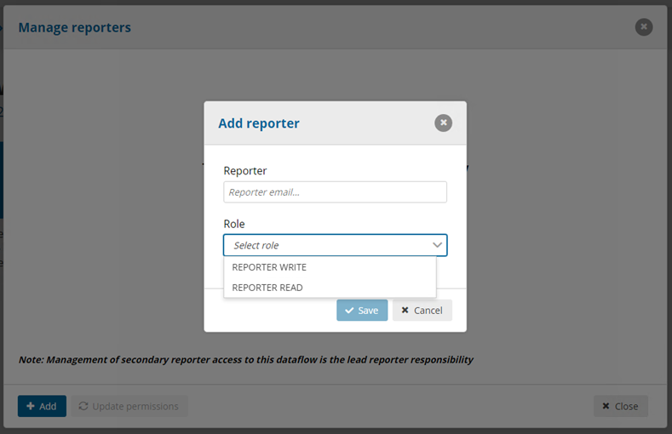**Figure 3.2.2.** When selecting the icon indicated in Fig. 3.2.1, a new window will open where the registered email address and role of the new reporter may be added.

### 3.3 Access for countries reporting on outermost regions

The outermost regions ESIC, PTAC and PTMA will be reported as separate “countries” in the Art. 12 dataflow. The lead reporters for Spain and Portugal will be also assigned to ESIC and PTAC - PTMA, respectively, and they can assign additional reporters to each of these independently, by following the steps mentioned in section 3.2 for each region.

For Article 12, separate reports shall be filled in for each outermost region, except for the General Report schema, that should only be filled in for the main “country” dataflow (i.e. for the ES or PT dataflows). Exception to this rule is the table on success stories that should be filled in in the General Report schema of the specific outermost region folder. All other tables of the General Report and all other schemas (Birds Checklist, Birds Spatial Information, Birds) shall be filled in for all outermost regions individually and be delivered as separate reports (i.e. Spain will deliver two reports, one for ES and one for ESIC. Portugal will deliver three reports, one for PT, one for PTAC and one for PTMA).

## 4. Data preparation and delivery in Reportnet 3.0

### 4.1 General data preparation

#### 4.1.1 General Resources

The Article 12 [Reference Portal](https://cdr.eionet.europa.eu/help/birds_art12) provides all the necessary information for preparing Art. 12 reports, including the reporting format, the [explanatory notes](https://cdr.eionet.europa.eu/help/birds_art12/Reporting%202025/Explanatory%20Notes%20Art%2012%20final.pdf), extended import tables, all schemas and data tables, reference tables and validation rules. Schemas, validation rules and import tables are also available directly in Reportnet 3.0 ('Dataflow help' button, Figs. 4.1.1 and 4.1.2). Additionally, import tables of any schema may be downloaded using the “Export dataset data” function found within the corresponding schema (Fig. 4.1.3). If no data has yet been entered, this function will provide an empty table that may be used by the reporters as template. Note, however, that this downloadable version doesn’t include predefined dropdown menus, in contrast to the “extended” template versions accessible in the Reference Portal.

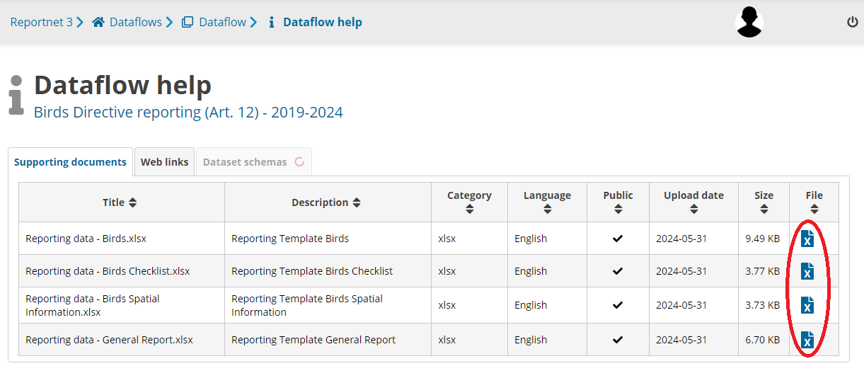**Fig. 4.1.1.** The Dataflow help section contains supporting information and documents relevant for the reports. In the “Supporting documents” section, import tables can be downloaded by clicking on the document icon on the right side of the table.

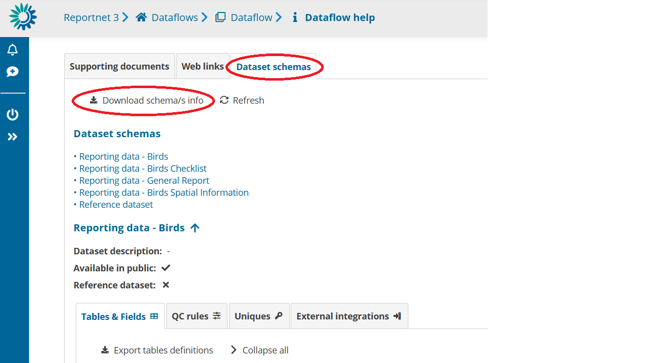

**Figure 4.1.2.** The Dataflow help section contains supporting information and documents relevant for the reports. In the “Dataset schemas” section, the details of each one of the schemas can be seen, including a description of their tables and fields, as well as the specific validation rules. This information can be downloaded by clicking on ‘Download schema/s info’.

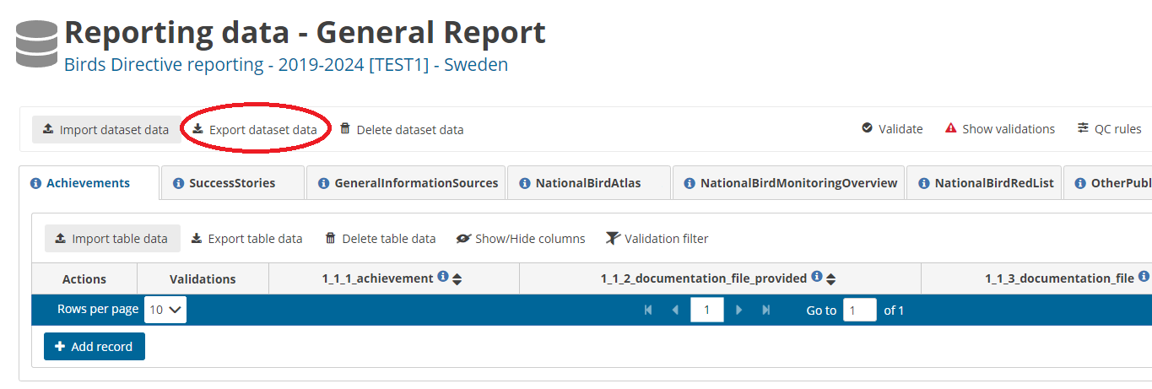 **Figure 4.1.3.** For any schema, the ‘Export dataset data’ function initiates the download of an .xslx table that may be used as import template for the corresponding schema in Reportnet 3.0.

All the schema structures and validation rules must be fully considered when preparing data. Disregarding this can result in mistakes that must be rectified before the data is delivered. The same applies to the reference datasets or code lists (see Fig. 4.1.4): only the values defined there can be used for valid data entry in the respective fields. Using other values will lead to blockers and prevent data delivery. It is therefore particularly important to familiarize in advance with the technical requirements for compiling and editing the data.

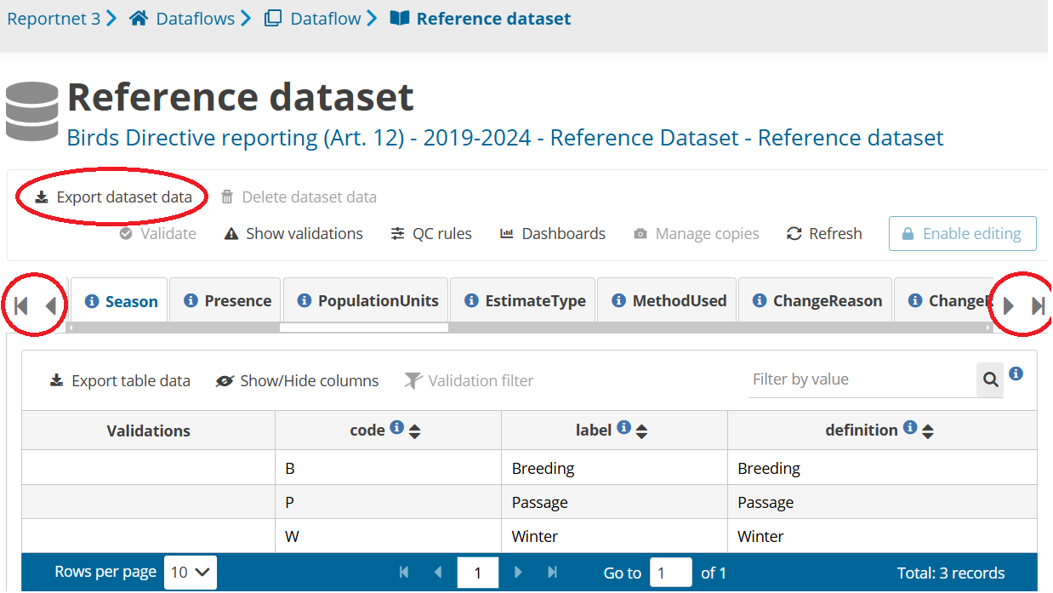**Figure 4.1.4.** The “Reference Dataset” section contains all reference tables or code lists used for the Art. 12 report. Use the lateral arrows to move across tables. The full list of tables can be downloaded using the ‘Export dataset data’ function.

#### 4.1.2 Extended Excel templates

To facilitate the preparation and completion of data tables, extended import tables are available, containing dropdown menus with reference codes. These extended templates can be found in the Reference Portal as well as in the Dataflow Help section in Reportnet 3.0 or be exported from the ‘Export dataset data’ button option ‘Export to EET (experimental)’. With regard to the latter, as it is still in experimental development please check the export thoroughly. You can use this functionality to also export an Extended Excel Template including reported values.

The extended Excel tables contain one extra datasheet called ‘RefLOVs’, that contains the lists of reference codes to be used in the tables of the corresponding schema. Please note that with regard to birds codes, all codes of the codelist appear in the dropdown menu, as the Extended import template is not country specific.

Overall, the columns of extended Excel tables conform with the following colour code:

White columns: Columns to be filled by the Member State, without the use of dropdown menus.

Light-green columns: Columns with dropdown menu option, where only one value from the code list can directly be selected by the user.

Yellow columns: Columns automatically prefilled, given a certain code selected in a light green column. This is the case of labels of bird species codes, pressures and measures codes). This allows the user to visualise the content or value associated to the code used in a certain column. These label columns are denoted with the same column name as the code column + the ending ‘_refLabel’. Importantly, these label columns are automatically deleted when importing the files in Reportnet 3, meaning they are not part of the stored data in Reportnet 3.

Light-blue columns: Columns for fields associated to code lists, but for which more than one value can be indicated (i.e., multiple selection fields). This is the case of, for example, the fields “Change and reason for change”, “Main purpose of the measures taken” or “Type of international plan”. In these cases, since more than one value may be entered, the different values from the reference code list should be copy-pasted in the corresponding field, separated by a semi-colon and no space in between. For a reference, the possible values that can be listed are present in the light-red columns (see next).

Light-red columns: Columns containing the code lists associated to light-blue columns. These should be used to copy the values that will be entered (i.e., pasted) in the corresponding light-blue columns. These columns are denoted with the same column name as the corresponding light-blue column + the ending ‘_mv’. Importantly, these columns with code lists are automatically deleted when importing the files in Reportnet 3, meaning they are not part of the stored data in Reportnet 3.

#### 4.1.3 Preparation of the national checklist

As a basis for the Art. 12 data preparation process, it is necessary to first check, amend (if necessary) and validate the national species checklist (see section 4.3). All open questions to the relevant contents of the checklist, Member States are advised to solve them at this stage, as the content of the Checklist is an important reference for the validations of the next steps of the reporting process.

Once the checklist has been clarified, the actual reporting data should be prepared. Data can be compiled externally and be imported to Reportnet 3.0 using the corresponding import templates. Data can be further edited online in Reportnet 3.0. Alternatively, data can also be added manually in Reportnet 3.0. Particularly when importing data, the relevant technical requirements for the data must be fully observed by the reporters.

### 4.2 General functioning of Reportnet 3.0

Once a (lead) reporter has accessed the Reportnet 3.0 platform, if one or more dataflows have been assigned to them, these will appear in the initial view of the platform (Fig. 4.2.1). To access the dataflow corresponding to the delivery of Art. 12 reports, please click in the “Birds Directive Reporting (Art. 12) – 2019-2024 dataflow”.

Within the dataflow, the reporter will have access to important information associated with the report, including a dataflow help section, the reference dataset (reference tables or code lists), the management of reporters (for lead reporters, see section 3.2 of this manual) and the report schemas for Art. 12 (Fig. 4.2.2).

The report schemas are based on the Art. 12 Reporting Format. Tabular information has been implemented in **three tabular reporting schemas (Birds Checklist, General Report and Birds) and in one spatial schema (Birds Spatial Information)** (Fig. 4.2.2), each of them composed of several tables. Each table represents a group of fields from the Art. 12 Reporting Format that are related to each other and follow similar validation rules. The necessary data must be prepared in these tables, considering basic requirements and quality rules.

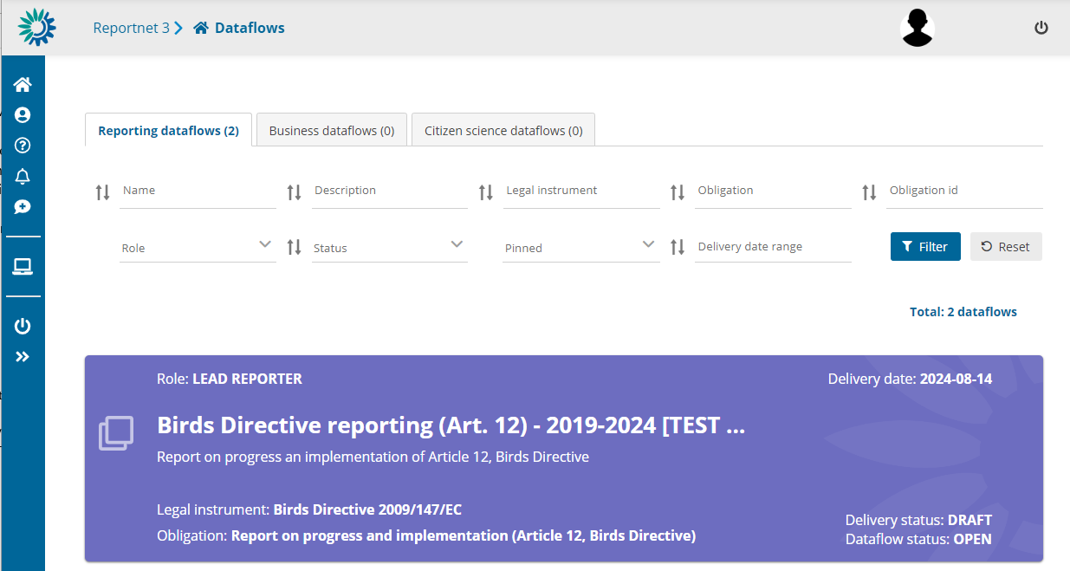**Fig. 4.2.1.** Initial view of available dataflows, in this case, the test dataflow for Art. 12.

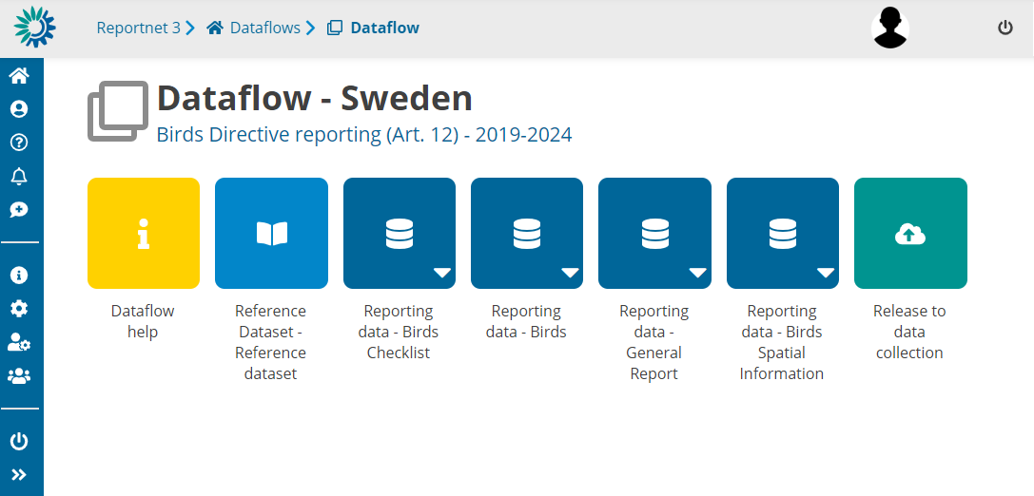**Figure 4.2.2.** View of a country's dataflow, including the Art. 12 schemas, as well as the help section and the reference dataset section.

In Reportnet 3.0, tables can be mandatory (implying that information has to be reported in these tables) or non-mandatory (in principle, optional). Mandatory tables *must* be filled in, and specific quality control rules must always be observed. In contrast, non-mandatory tables, in principle, *can* be filled in, but *if reported*, the full set of validation rules will be applied through the table. Mandatory and non-mandatory tables can contain both required and non-required fields.

Fields can be required (implying that they *must* be filled in, otherwise the report will be blocked) or non-required. Non-required fields can become required under preconditions set with validation rules.

Furthermore, each non-mandatory table and non-required field has specific formal requirements (e.g. text format, associated code lists) to be considered if reported. To illustrate these conditions, consider the following examples:

Example 1: If the Member State decides to provide a success story (General Report, table “SuccessStories” which is non-mandatory),but does not indicate a species code or season (fields 1.3 a or b that are required), the validation process will produce a Blocker.

Example 2: The table “Pressures_GeneralInformation” is a non-mandatory table. However, if reported, information of, for example, field 7.2 “Methods used” (“7_2_Method” in Reportnet 3.0), which is a non-required field, must comply with the codes of the corresponding reference table “MethodUsed”. Invalid codes will produce a Blocker.

Additionally, consider the case when a Member State decides to report on an optional species (e.g., ARR or OPT bird species, considered as optional to report according to the Explanatory Notes). In that case, once the species enters the reporting process, the data for that species must comply with the full validation rules of a mandatory species.

Finally, it is important to note that all species that must be reported according to the Explanatory notes and Guidelines require the respective reporting tables to be filled in, apart from those that are marked for deletion in the country checklist. Not reporting on one of the required species will block a delivery. However, fields can still be left empty if information is not available for a species, under specific conditions (see the specific list of validation rules for more detail).

All validation rules are available in the Dataflow Help in Reportnet 3.0 andalso described in the Reference Portal.

#### 4.2.1 Data Submission

The first step to submit the reports is the confirmation of the national Checklist, meaning that each Member State must decide whether they will continue the reporting process with the checklist offered by the system (official checklist published as Reference Table and available in the Reference Portal) or, in case of last-minute changes, edit the mentioned checklist, and validate it. This process can be done by accessing the “Reporting data – Birds Checklist” schema (see the following section 4.3 Checklists). Once the national checklist is confirmed, the reporter may continue with the submission of the other schemas (section 4.4 including the General Report and Birds schemas, and section 4.5 including the Birds Spatial Information schema).

In general, to import data for all tables of a schema together, the ‘**Import *dataset* data’** function should be used (Fig. 4.2.3). Tabular schemas (Birds Checklist, General Report and Birds) permit the import of a .zip file (containing the individual .csv tables) or a .xlsx file (may import one file with several sheets, i.e. several tables) (Fig. 4.2.4). For the Birds Checklist, the ‘Import dataset data’ function may also be used to import a pre-filled file of the national Checklist. For spatial information, several formats are allowed, depending on whether the Member State reports grid cell codes or gridded polygons (see section 4.5 for more details).

To import tables individually, the ‘**Import *table* data’** function can be used (Fig. 4.2.3). This function only allows to import .csv files.

Whenever one of these two functions is used, a new window will open where files may be selected from the local computer or dragged into the box (Fig. 4.2.5). Within this window, the function ‘**Replace data’** will erase all previous data that have been imported for the corresponding schema (i.e. for all tables of the schema if using the ‘Import dataset data’ function) or for the corresponding table (if using the ‘Import table data’ function). If the function ‘Replace data’ is not selected, data will be added without erasing previous imported data, meaning that new entries will be added to the list together with previous entries. This also means that Member States may import information from several individual files, and data will be collected together in the country folder. These different files must, however, be imported one by one and not simultaneously, since the import functions only allow one (.zip or .xlsx) file at a time.

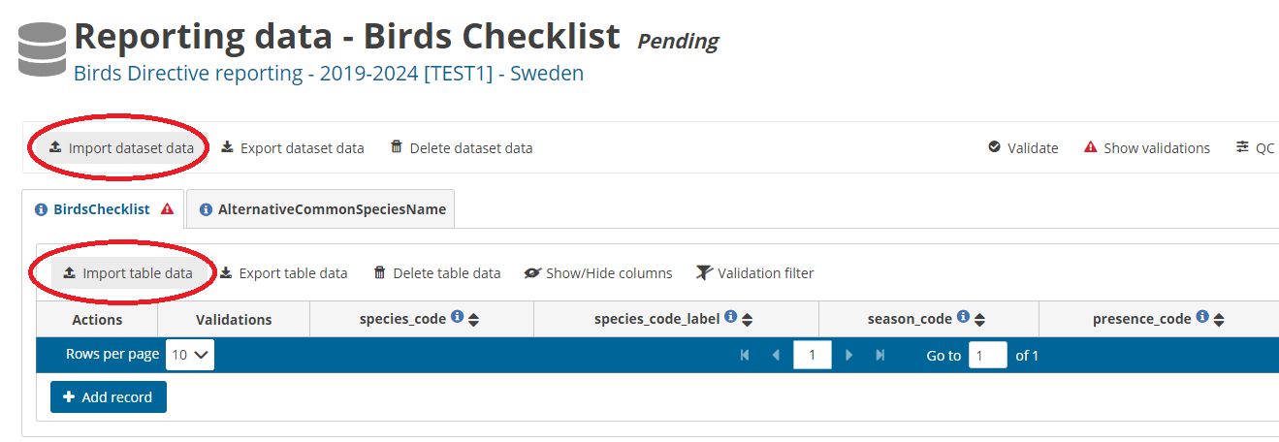**Figure 4.2.3.** Data can be imported to Reportnet 3.0 by using different functions: ‘Import dataset data’ will import data for all tables of a schema, ‘Import table data’ will import one file for a specific table.

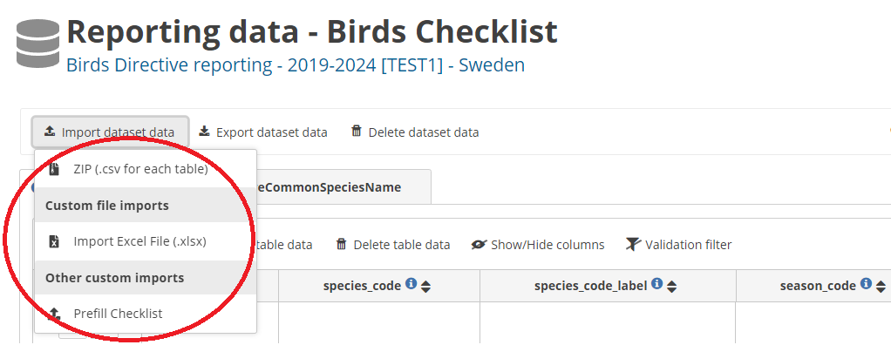**Figure 4.2.4.** The function ‘Import dataset data’ offers different import alternatives, mainly: import one .zip file containing several .csv tables, import one .xlsx file with different sheets, or import a pre-filled table to populate the schema (‘Prefill Checklist’, only available for the Birds Checklist schema).

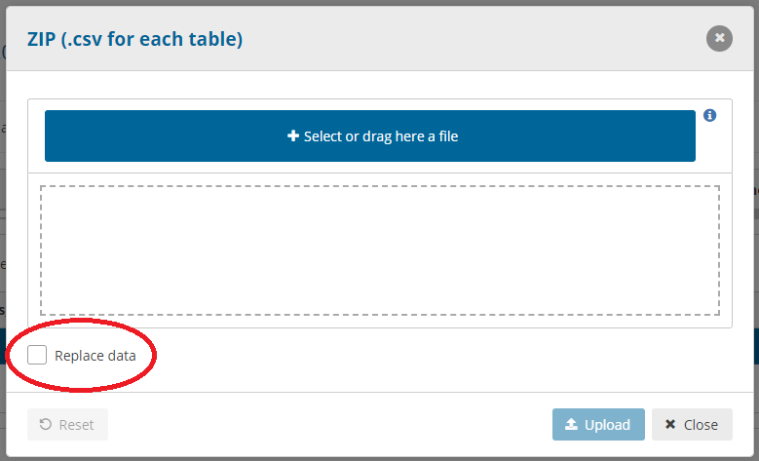**Figure 4.2.5.** When the “Import dataset data” and the “Import table data” are used, a new window will open where the files to be imported must be selected from the local computer or dragged into the box. Clicking “Replace data” will erase previous imported data (for a whole schema or for a table).

After importing datasets or tables with the mentioned functions, several information windows will appear at the top-right side of the screen: first, a blue notice indicating “Importing data”, secondly, a green one indicating “Success, external process ended”, and finally, a green notification indicating “Success, loaded data completed” (Fig. 4.2.6). These notification windows vanish relatively quick; however, it is always possible to revise them by accessing the **notifications board** (accessible by clicking the **bell icon** on the left vertical menu). Please consider that the import of datasets and tables may take a few minutes.

After data have been completely loaded (third notification message), the “**Refresh**” button (top right) should be used to load the imported data (Fig. 4.2.6). With this, the new entries will be added on in the corresponding table(s) below the labels of the fields (Fig. 4.2.7). Without “refreshing”, the imported data will not be shown! By default, the platform shows 10 entries per page, thus, when more than 10 records are entered, these will be displayed in several pages. This setting can be modified by changing the number of “Rows per page” at the bottom of the list of entries. Additionally, to move across pages, the reporter can use the arrows at the bottom of the list of entries (Fig. 4.2.7).

Data may also be entered manually, by using the “**Add record**” function (Fig. 4.2.6). To activate this function, the reporter must first activate the “**Enable editing**” function at the top right of the page. Then the “Add record” icon will appear at the bottom of the page below other entries, if entries have already been added (Fig. 4.2.7). By clicking this function, a new window will open, where data may be entered manually for each field of the corresponding table (Fig. 4.2.8). To add the record, click “Save” and the window will automatically close. The new record will be added at the end of all entered records (after “refreshing”). If the reporter wishes to continue adding records, the function “Add another record” may be clicked before clicking “**Save**”. This will add the record but will keep the window open to continue adding entries.

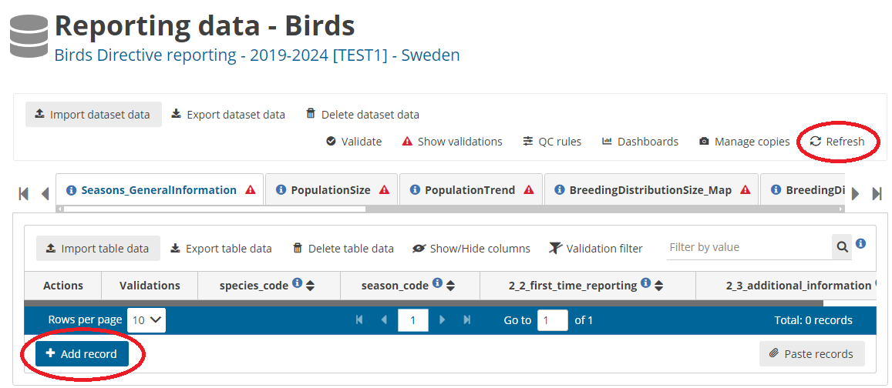**Figure 4.2.6**. After importing datasets or tables, always use the “Refresh” function on the top right. The function “Add record” allows to manually add an entry for a specific table, if the “Enabling editing” function is activated. This action will open a new window, where data may be entered (Fig. 4.2.8).

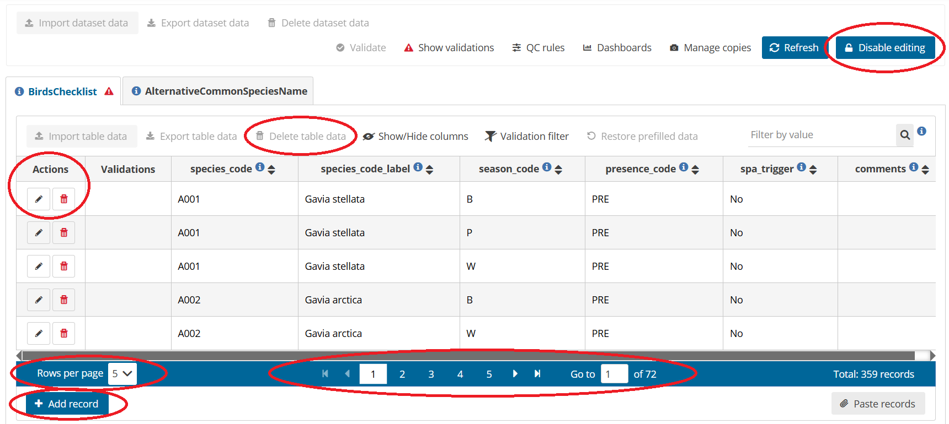**Figure 4.2.7.** List of records/entries after importing data in one table. To see all entries, the reporter may modify the number of entries shown in one page “Rows per page” or move across pages using the arrows at the end of the list of entries. To add one entry, use the “Add record” function. To edit or delete one entry, the action buttons may be used. Additionally, after “disabling editing” (top right), it is possible to delete all data of a table, using the “Delete table data” function.

Each of the entries of a table may also be edited using the Action button “**Edit**” (Fig. 4.2.7) (the “**Enable editing**” function at the top right of the page must be activated). When editing an entry, a new window will open, where data of one or more fields can be modified for that entry. To finish editing the entry, click “**Save**”. However, data can also be edited by simply clicking on the field (see Figs. 4.2.9 and 4.2.10). Entries can also be deleted using the “**Delete**” action button (red trash bin icon, see Fig. 4.2.7). To clear all data of a table, the “**Delete table data**” function may be used after “Disable editing” (Fig. 4.2.7).

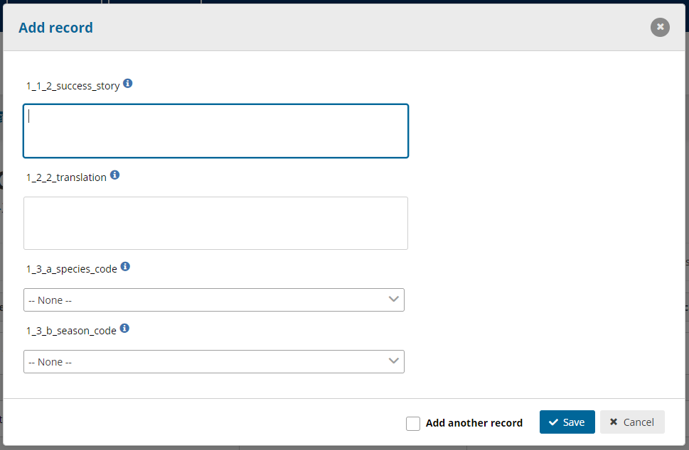**Figure 4.2.8.** When manually entering a record, a new window will open, where data for each one of the fields for one entry (e.g. one species success story) should be entered. This example shows the fields to be completed for one entry of the Table “SuccessStories”, within the General Report schema.

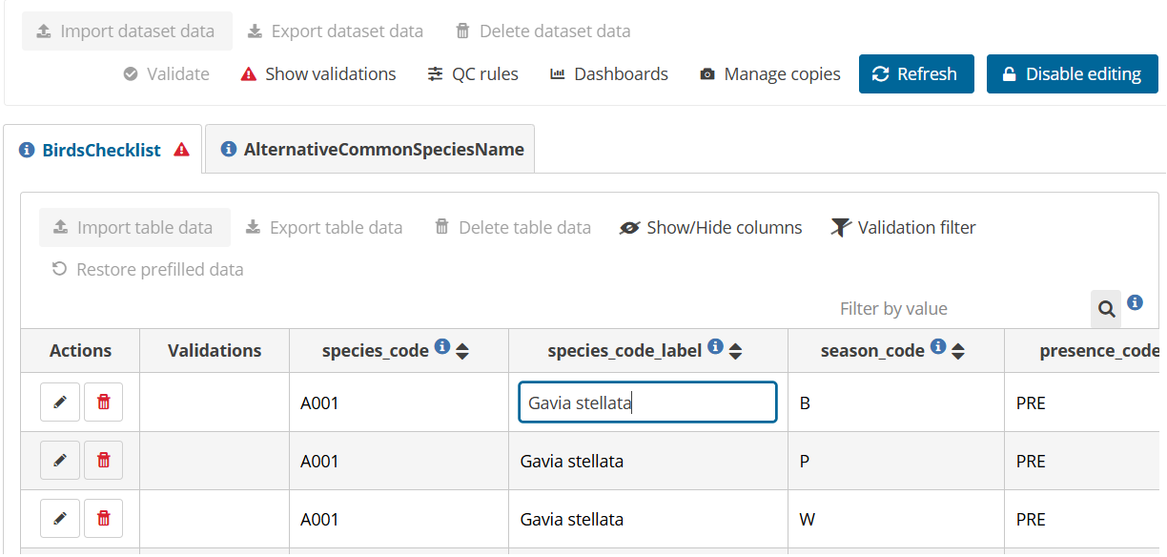**Figure 4.2.9**. Alternatively to the use of the “Edit” action function, to edit any entry of a table, simply click on the field box. The box turns white, and the text can be edited directly.

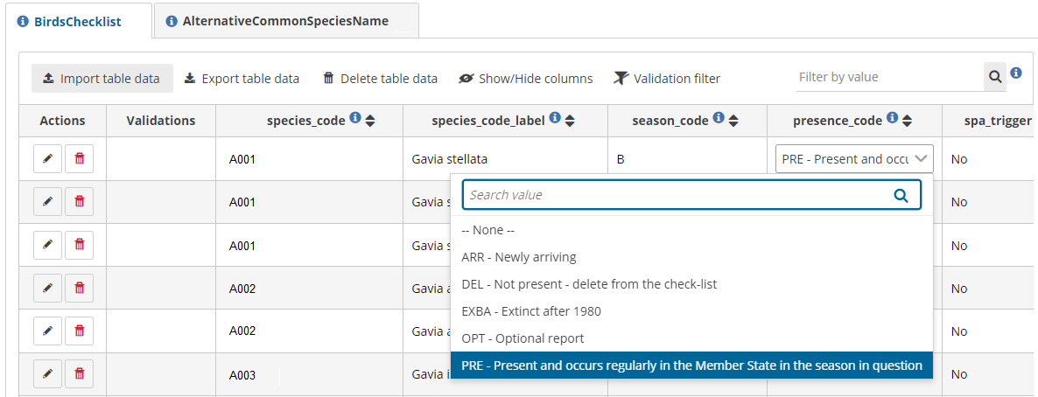**Figure 4.2.10**. To edit fields with dropdown menus, clicking the field box will open the dropdown list of possible values to be entered. Please note that, by default, the search bar contains the current value, which should be erased to find other possible values of the reference table.

For any schema and table, whenever information on a particular field is required, the reporter can place the mouse over the corresponding **blue information icon** and click on it. This will display a small window with details and explanations of the field content (Fig. 4.2.11). To continue with the report, simply click “OK” or close the open window.

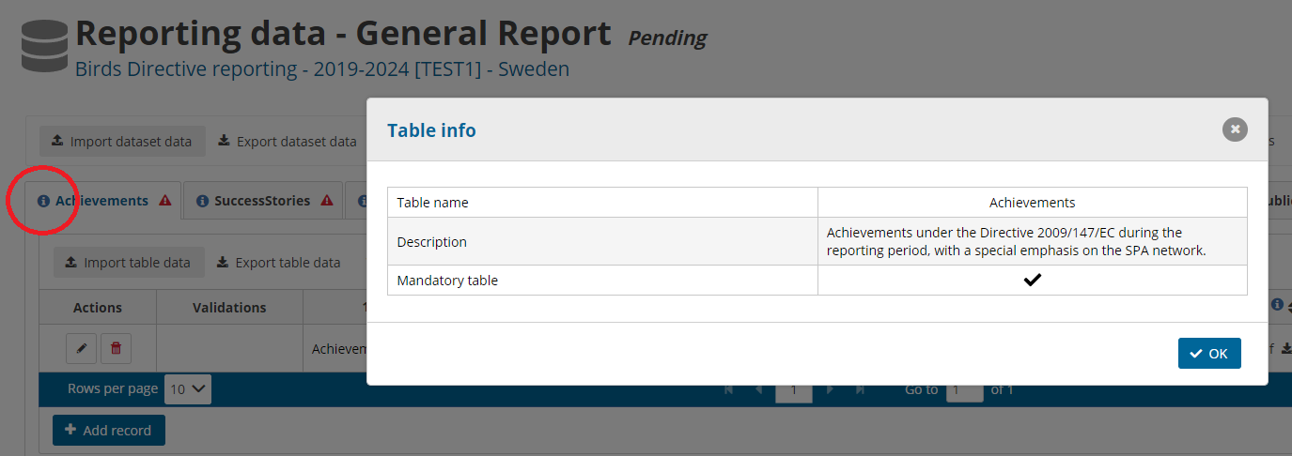**Figure 4.2.11.** Example of information window that opens after clicking on the blue info icon of a field.

**Fields where attachments may or must be uploaded** are indicated by a **grey arrow towards up** (Fig. 4.2.12) for every entry of the corresponding table. To be able to upload a file, first activate the “**Enable editing**” function. By clicking the grey arrow towards up, a new window opens where files can be selected or dragged. Once a file has been selected, click “Upload” to complete the action. Only one item per entry can be uploaded, thus, if the reporter wishes to upload more than one file, it is suggested to use compressed .zip files. To change an attachment, simply click on the arrow towards up once again and select the desired file. Attached files can also be downloaded (by using the arrow towards down icon) or deleted (trash bin icon). **In the import template (.csv or .xlsx file), fields that require attachments must be left empty**, i.e. no data should be written in the corresponding field. It is recommended to first import full datasets and tables and, afterwards, to import the corresponding attachments.

In Reportnet 3.0, tables are visible and accessible as different vignettes (Fig. 4.2.12). Depending on the monitor size, not all tables/vignettes may be visible when opening a schema due to space limitations. To access the last tables situated towards the right, use the grey arrows or the moving bar underneath the tables’ names (see Figure 4.2.12). Similarly, not all fields of a table may be visible at the same time. To visualise other fields, use the grey bar located below the fields’ names (Fig. 4.2.12).

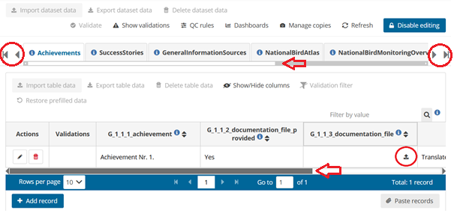

**Figure 4.2.12.** For any field where an attachment may be uploaded, the upload function is indicated by a grey arrow towards up. Grey arrows towards left and right next to the tables’ names/vignettes, as well as the moving bar, allow access to the tables/vignettes that are not visible due to space limitations. Similarly, a moving bar allows access to the different columns to the right or left within a table.

#### 4.2.2 Data Validation

Within each schema, a list of the validation rules that apply to all the corresponding tables may be checked by using the “**QC rules**” function (Fig. 4.2.13). This will display a new window with a table listing general rules of a table, as well as field specific rules (Fig. 4.2.14). This table has a built-in search and filter function, to search for specific functions. For example, rules may be filtered by Table, Field or by Error class (Fig. 4.2.14). This table may be downloaded using the “**Download QCs**” function at the bottom-left corner of this window.

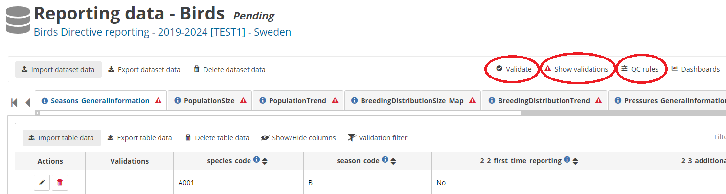**Figure 4.2.13.** For a certain schema, the function “QC rules” may be used to visualize the list of quality control rules that apply for the corresponding tables and fields. This list will open in a separate window (Fig. 4.2.14). To test these rules and validate the data, the “Validate” function should be used. Once the validation process has ended, the outcome may be seen by clicking “Show validations”.

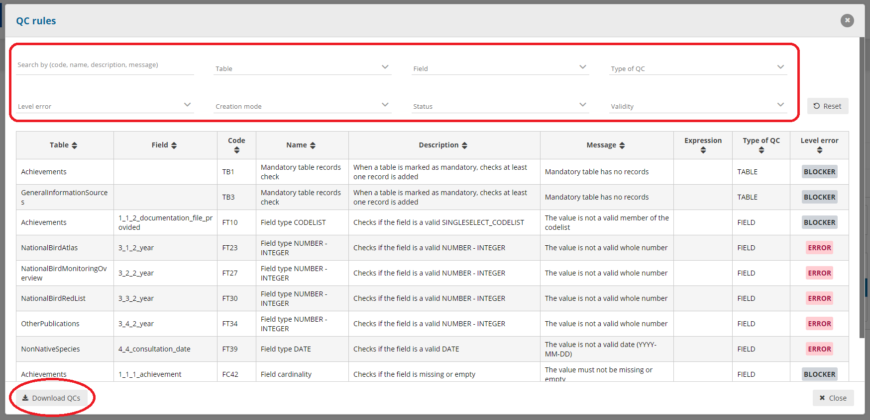**Figure 4.2.14.** Example list of validation rules for a schema. The table has a search and filter function (top search bar), where specific rules may be searched. The list of rules may be downloaded as a table using the “Download QCs” function at the bottom-left of the window.

Once data has been correctly imported or manually entered and edited for all tables of a schema, the reporter must validate the data using the “**Validate**” function (Fig. 4.2.13). This function is available when the “**Enable editing**” is deactivated. By clicking on “Validate”, a new window will open, indicating that the process may take a few minutes (Fig. 4.2.15). After accepting, the validation process will start. During this process, the “Validation” function will indicate in light grey “Validation in progress”. It is suggested that the reporter stops working while validations are in progress.

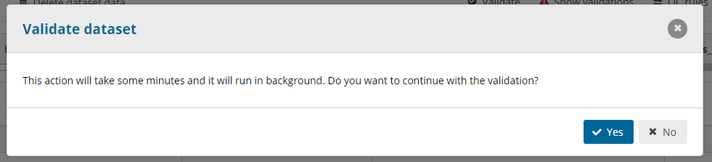**Figure 4.2.15.** When the “Validate” function is used, a window will open requesting to confirm the action.

Once the validation process has finished, a small green notification window on the top right corner of the platform will confirm the completion of the process (Fig. 4.2.16). This small window vanishes relatively soon, however, the action is registered in the “**Notifications**” history, accessible on the left, vertical panel (see Fig. 4.2.16). By clicking on the bell icon, the reporter has access to the record of all actions taken in Reportnet 3.0 (Fig. 4.2.17).

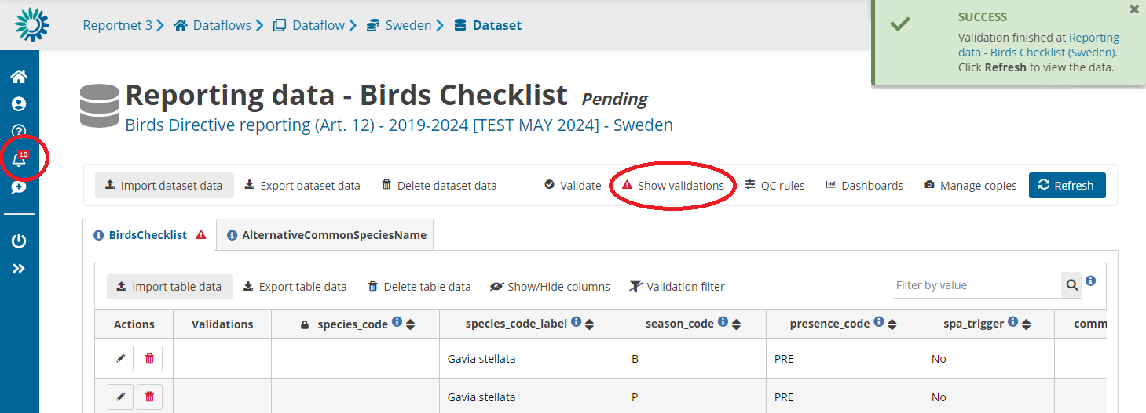**Figure 4.2.16**. After the validation process has finished, a notification appears on the top right corner of the monitor in the form of a small window, and is also tracked in the Notifications history, accessible on the left vertical panel (bell icon, see also Fig. 4.2.17). To see the list of validations, the “Show validations” function may be used.

Once the validation process has finished, click the ‘Refresh’ button. If issues arise during the validation process within the corresponding schema, these will be indicated with alert icons (Fig. 4.2.18). These icons will appear next to each table’s name and, within a table, for every entry, in the summary column “Validations” and in the field column that presents issues (Fig. 4.2.19). Levels of issues (blockers, errors, warnings or information messages) are shown with different icons (Fig. 4.2.18). Placing the mouse over one of these icons will provide further information on the issues encountered (validation message).

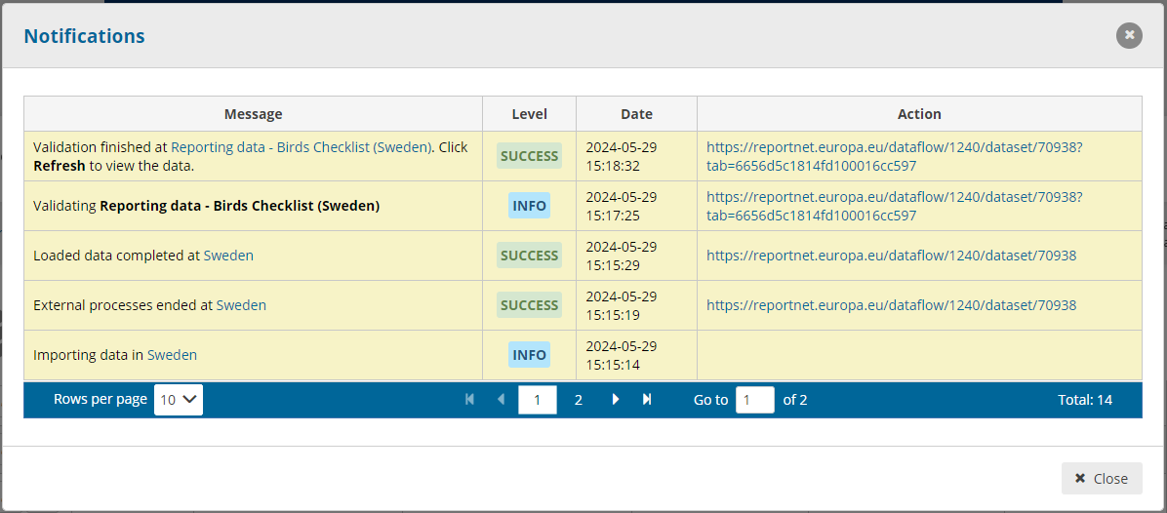**Figure 4.2.17**. Clicking on the bell icon (Fig. 4.2.16) opens a new window where a list of notifications is shown. Every task or action in Reportnet 3.0 is recorded in this list.

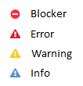

**Figure 4.2.18.** Alert icons corresponding to the four error class codes.

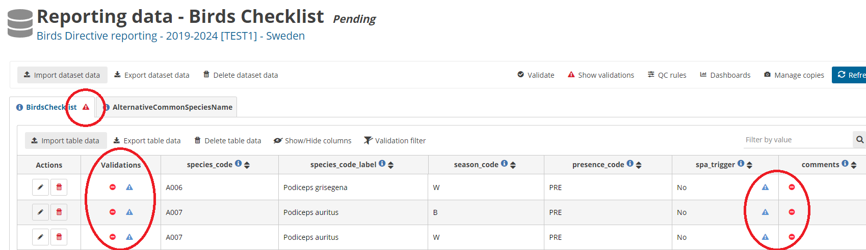**Figure 4.2.19.** After running a validation, if issues have arisen, these will be indicated with different icons (Fig. 4.2.18) at the level of tables, row entries and fields.

To see the issues in detail, it is also possible to use the “**Show validations**” function (Fig. 4.2.16). This will open a new window with a summary of the issues (Fig. 4.2.20), including the level of error (info, warning, error or blocker), an explanation and the number of entries with such error. Clicking on any of the results in this summary will apply a filter based on the clicked error, displaying only the corresponding affected records. The table can be further explored using the “Filter” function, where errors can be filtered by type of QC rule, by table, field or error class/type (Fig. 4.2.18). It is important to note that, by default, only 10 errors/records are shown in one page, thus, if more than 10 errors/records are identified during the validation process, these will show in continuous pages. To move across pages, use the arrows in the blue bar below the list of entries of the table (similar to Fig. 4.2.7). This summary table can be downloaded with the function “**Download validations**” at the bottom left of this window (Fig. 4.2.20). Some validations may not be shown in the schema tables (e.g. table related rules not specific to an entry), thus **the reporter should always pay attention to the indications shown in the validations’ summary window.**

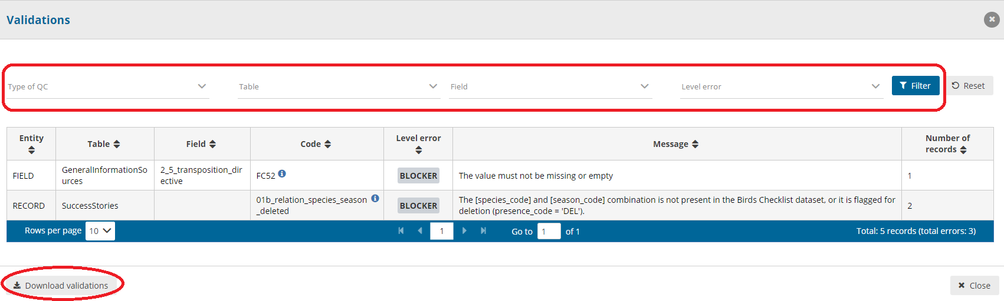**Figure 4.2.20**. Example of a list of validations shown when using the “Show validations” function. To filter validations, use the top filter tools, or simply click on any field within the table. This will display the records that have the selected issue. To download this table, click the function “Download validations”.

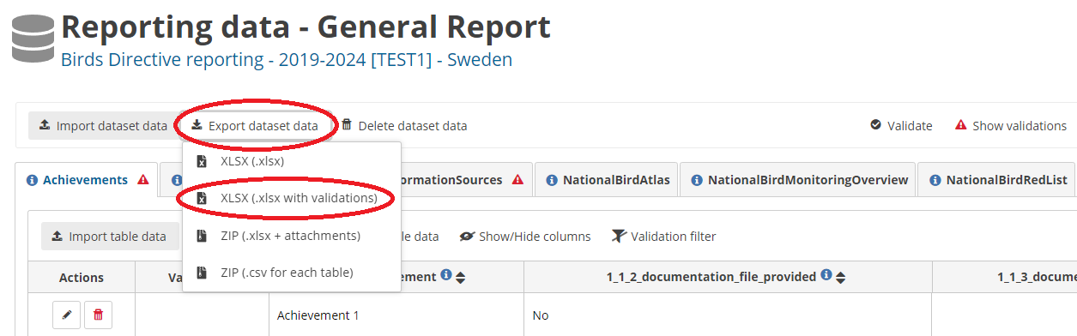**Figure 4.2.21**. The “Export dataset data + XLSX (.xlsx with validations)” function may be used to download the dataset with validations inserted in the table, allowing the reporter to identify the issues per entry and per table.

Please note, that there is one validation rule that works differently. If there are records missing in a table, this is shown in the ‘Show validations’ table with the number of records being always 1. When pressing on this validation result, there is only one record filtered out and it is the first record of the table. The list of missing codes appears when placing the mouse cursor over the blocker sign in the Validations field of the table.

Data may be validated at any stage of completion of a table or schema. Thus, for example, if the reporter has completed one of the tables of a schema, and wishes to check it for validations, this is possible by using the “Validate” function. However, since the validation process analyses the full schema (i.e. all tables of a schema together), the output of the validations will provide information for other mandatory tables of the schema as well.

The validation can run only when the specific dataset schema is not in editing mode, i.e. the ‘Enable Editing’ button is deactivated. Use the ‘Disable editing’ button first if you want to run the validation. Be aware though, that some of the validations involve data from other schemas in their tests (e.g. data from the schema ‘Birds checklist’ is used as a validation reference in the schema ‘Birds’). If those other schemas are currently in an editing mode, any changes that were performed in those schemas after the editing mode was activated, may be used in the validation only after the editing in these schemas is disabled. It is, therefore, particularly important that there is a tight cooperation and coordination among reporters in case more than one reporter is working on the dataflow. This is necessary to avoid disabling editing when another reporter is still editing the same schema, as that can lead to a loss of data.

#### 4.2.3 Data Correction

Ideally, all Blockers, Errors and Warnings should be solved before delivering the data. Blockers will block the delivery of a report, whereas Errors and Warnings won’t.

To correct the data, the reporter has two alternatives: 1) editing the original file offline, to later import it again in Reportnet 3.0, or 2) to manually edit the entries of a table in Reportnet 3.0. For the latter, the reporter can use the “**Add record**”, “**Edit**” and “**Delete**” functions for every entry of a table, or simply click in any entry and edit (see Figs. 4.2.7, 4.2.9 and 4.2.10).

The “**Add record**” and “**Edit**” functions will open a new window where the individual fields of the corresponding entry may be added or edited. Once the editions are complete, the “**Save**” function must be used to store the changes and go back to the general table.

#### 4.2.4 Re-submission, Re-validation and Re-correction

The previous steps (Submission, Validation and Correction of data) may be performed as many times as needed for one or more tables of a schema. During this iterative process, all imported data will be stored on the platform, allowing the reporter to work on specific tables offline, if necessary, before going back to the online platform. If the reporter wishes to import new data and replace the data already stored in the platform, the “**Replace data**” function should be used when importing the new dataset or table (see section “II. Data submission” and Fig. 4.2.5). If not, the newly imported data will be added as additional entries next to already existing ones.

Similarly, data will not be lost when moving from one schema to another, allowing parallel work on different schemas. However, **imported data do not mean that the report of the Member State has been delivered and the platform does not automatically create stored versions of these imports**. To officially deliver a report, please refer to the following section “Report Delivery”. As indicated before, all blockers and errors must be solved before ultimately delivering the report.

Reloading data will invalidate previous validations. Therefore, it is essential to always re-validate the schemas after re-uploading data, even if validations were previously successful.

#### 4.2.5 Report Delivery

Once all blockers and errors have been solved and all schemas are complete, **the lead reporter may deliver the national report by using the green icon** “**Release to data collection**”, located in the main menu of the country dataflow. A new window will open, requiring to confirm the delivery (Fig. 4.2.22). Additionally, the lead reporter may indicate whether the data to be submitted should be restricted from public view. **By default, and independent of this indication, all spatial data will be restricted from public view. After the reports are delivered, the data are checked and the national summaries are approved, the EEA will create maps releasing the spatial information of non-sensitive species.** By clicking the option “**Restrict from public view**”, **the complete national report** (including both tabular and spatial data) **will be restricted from public view**. **Restricting the tabular information is strongly discouraged**.

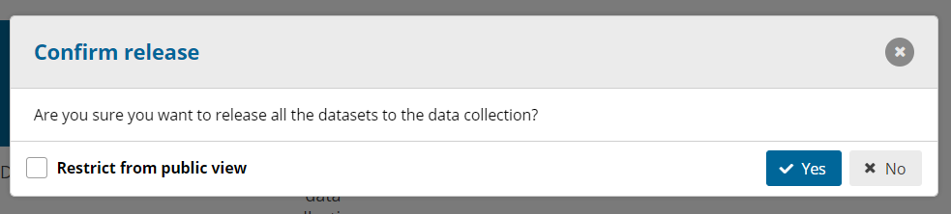**Figure 4.2.22.** Last step of the general reporting process, to confirm the delivery of the national report. By default, maps are restricted from public view. Clicking on “Restrict from public view” will restrict the whole report from public view.

A quality control process on the dataflow will run when confirming the release by clicking ‘Yes’. The list of validations will be refreshed in the background:

* If there are any blockers in the dataflow, the release will stop and a message to the user will inform about that.
* If the quality control is fine, a notification will appear saying the data is being validated and sent to the data collection. An automatic copy will be created. In the main country folder, the reporter will also see a new icon from which a simple “Confirmation Receipt” can be downloaded (Fig. 4.2.23).

The reporter can modify the data and resubmit a new copy of the data as many times as needed. Whenever a new copy is released to the data collection, the previous delivery will be deleted, and a new confirmation receipt will be available for download.

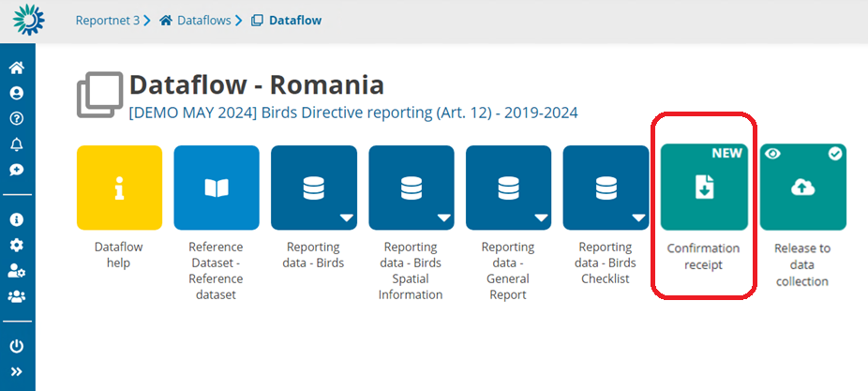**Figure 4.2.23**. After the correct delivery of a report, a new icon in the main country folder will show a confirmation receipt that may be downloaded.

For further information on the data submission, please consult the Reportnet 3.0 Reporter HowTo Guidance:

<https://www.eionet.europa.eu/reportnet/docs/prod/reporter_howto_reportnet3>

The following sections provide details of the data preparation and delivery of the specific schemas of the Art. 12 report. For each of these schemas, the general rules explained in section 4.2 apply.

### 4.3 Checklist

The first step to prepare the data submission is to confirm the national Art. 12 species Checklist, meaning that each Member State must decide whether they will continue the reporting process with the checklist offered by the system (official checklist published as Reference Table and available in the Reference Portal) or, in case of last-minute changes, edit the mentioned checklist and validate it. The Birds Checklist can be filled in based on the template “Reporting data - Birds Checklist.xlsx”, for which the technical details are described in "Art. 12 schema and validation rules" (all available in the Reference Portal). The template may also be downloaded from the Reportnet 3.0 Dataflow help button (see Fig. 4.1.1).

The schema for the Birds Checklist contains two tables, “BirdsChecklist” and “AlternativeCommonSpeciesName” (Fig. 4.3.1). The extended import template contains the same two tables too as separate datasheets, in addition of one extra datasheet containing the reference values or code lists. The first table should be used to confirm the national checklist to be used for reporting. The second one may be used to add an alternative scientific name used at the national level (if different to name from the reference list) and/or a common name in the national language. It is important to note that the second table may only be filled out for species (i.e. for species codes) that are present on the first table.

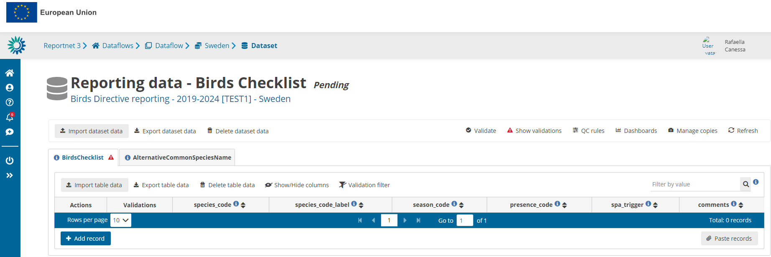**Figure 4.3.1.** General view of the schema “Reporting data – Birds Checklist”, including two tables, shown as two vignettes.

The “BirdsChecklist” table is a mandatory table and contains the following fields:

* species_code: individual species code
* species_code_label: species label, i.e. species scientific name, including subspecific population if appropriate. This field is filled automatically based on the species code, if the ’prefill checklist’ option is used (see below). These values are editable by the reporters but are not validated.
* season_code: season (breeding, passage or wintering)
* presence_code: occurrence
* spa_trigger: information on whether the species belongs to a taxon not listed in Annex I of the Birds Directive but triggers SPA classifications nationally under Art. 4(2) of the Directive. **Therefore, Annex I species should be indicated as ‘spa_trigger’ = ‘NO’ as this field corresponds to Non-Annex I spa trigger’ species.**
* comments: comments should be given in cases where any of the previous fields, with regard to the already published national checklist, are modified by the Member State, or new species-season combinations are added.

The “AlternativeCommonSpeciesName” table is a non-mandatory table, contains the following fields:

* species_code: individual species code
* alternative_name: optional alternative species name (field 1.6 from Part B of the Art. 12 Reporting Format)
* common_name: optional common local or national species name (field 1.7 from Part B of the Art. 12 Reporting Format)

To work on the ‘BirdsChecklist’ and the ‘AlternativeCommonSpeciesName’ tables, the reporter may use the “**Import dataset data**” function (Fig. 4.3.2) to import an .xlsx (importing one file with two sheets, i.e. two tables) or a .zip file (importing two .csv tables simultaneously).

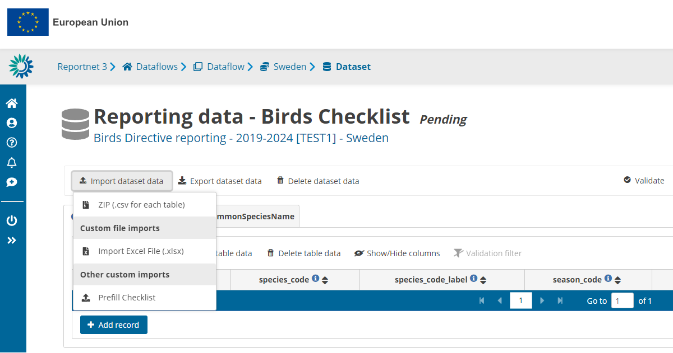**Figure 4.3.2.** Alternatives to import dataset data for the Birds Checklist schema: an Excel file or a ZIP file may be imported from a local computer. Alternatively, a pre-filled checklist can be imported.

Reportnet 3.0 also offers a function to directly prefill the national Checklist for each Member State (Fig. 4.3.2). The fields of Table “BirdsChecklist” will then automatically be pre-filled (including the ‘AlternativeCommonSpeciesName’ table which will then need to be updated), based on the Art. 12 Checklist version published in the Reference dataset. If the Member State envisions to report under Art. 12 using this pre-filled checklist (i.e. without any changes), the Member State may simply use this pre-filled Checklist import function (Fig. 4.3.2), and validate it, without any extra steps. Please note that the option ‘Prefill checklist’ always replaces the data in the Checklist tables. The checkbox ‘Replace’ is still visible (it can not technically be removed) but the import will still replace the data even if not ticked.

Afterwards, the Member State is ready to proceed with the data preparations of other schemas and further delivery.

Alternatively, the reporter may import the ‘BirdsChecklist’ or the ‘AlternativeCommonSpeciesName’ table individually by using the “**Import table data**” function (see Fig. 4.2.3). This function only supports .csv files.

If the Member State requires to modify an entry in the Art. 12 national Checklist, including the table “AlternativeCommonSpeciesName”, they may edit it directly in the Reportnet 3.0 platform (see Figs. 4.3.3, 4.3.4 and 4.3.5) or import an edited table and validate it. The permitted modifications include:

* **Addition/ modification of alternative and/or common species names** for any bird species.
* **Addition of species-season combinations**, based on a species present in the codelist (e.g. ARR species). In this case, information on the corresponding species_code, season_code, presence_code and spa_trigger must be provided, in addition to a comment explaining the addition of the entry to the national checklist (blocker).
* **Modification of the occurrence of species-season combinations**, **or the information on spa_trigger**, where a comment explaining the modification of the entry in the national checklist should be provided in the field ‘comment’ (blocker).
* **Flagging of a bird species–season combination for deletion,** by selecting the presence code ‘DEL’. Please note that, in the case a species-season combination needs to be deleted, this should be only flagged (by selecting ‘DEL’) and the record itself should not be deleted from the checklist, otherwise the delivery will be blocked.

**All modifications on species–season code combinations, occurrence or ‘spa trigger’ require a comment explaining the modification of the type of occurrence (otherwise the delivery is blocked).**

If the season of a species needs to be modified, the existing species-season combination should first be flagged for deletion (i.e. use presence code ‘DEL’), and a new species-season combination should be added.

Additions of new species-season combinations to the checklist may be done by using the “**Add record**” function (see Fig. 4.2.6), after “Enable editing” is activated. By clicking this function, a new window will open where for each entry (i.e. for each species-season combination) the individual fields ‘species_code’, ‘species_code_label’, ‘season_code’, ‘presence_code’ and ‘spa_trigger’ (information on whether the species belongs to a taxon not listed in Annex I of the Birds Directive but triggers SPA classifications nationally under Art. 4(2) of the Directive) must be provided, in addition to a comment explaining the addition of the entry to the national checklist (blocker).

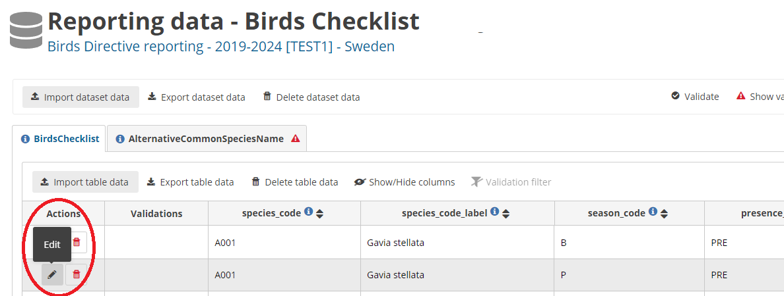**Figure 4.3.3.** To edit a species-season combination, use the ’Edit’ function in the Actions column. Remember to ‘Enable editing’

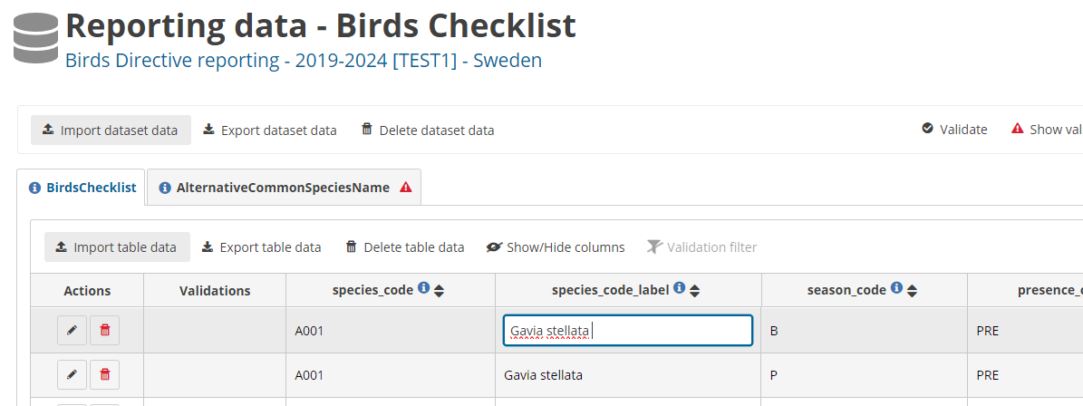**Figure 4.3.4**. Alternatively to the step shown in Fig. 4.3.3, to edit any entry of a species-season combination, simply click on the text box. The box turns white, and the text can be edited directly.

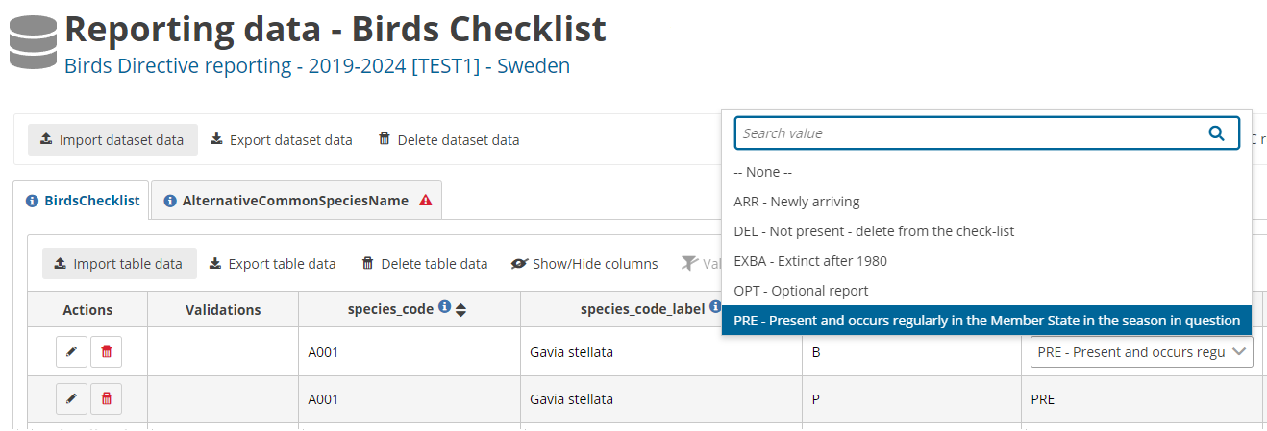**Figure 4.3.5**. In the case of fields with dropdown menus, clicking the text box will open the dropdown list of possible values to be entered. Please note that, by default, the search bar contains the current value, which should be erased to find other possible values.

After checking and adapting the lists, a validation must be run to ensure the necessary data quality (see “Data validation” in section 4.2.2). Afterwards, the Member State may proceed with the data preparations and further delivery.

Once a dataset or a table has been correctly imported, use the “Refresh” function to see all entries in the table of the schema and visually check them. Once both tables of the “Birds Checklist” schema are completed, click “**Validate**” to run the validations (see Fig. 4.2.13).

### 4.4 Other tabular data

This section contains information on preparing and delivering tabular data related to two schemas, “Reporting data – General Report” and “Reporting data – Birds". Each of these schemas is subdivided into several tables. Similar to the Checklist schema, data may be imported using the “**Import dataset data**” or “**Import table data**” functions, or manually entered using the “**Add record**” function. Furthermore, within a table, entries may be edited online using the editing functions (see also “Data Submission” in section 4.2.1).

#### 4.4.1 General Report

The schema “Reporting data – General Report” covers **Part A (General Report)** of the Art. 12 Reporting Format, and is divided into eight tables, listed below. The tables of the General Report should not be filled in for the territories of ESIC, PTAC and PTMA. Each field of a table of the General Report is denoted with a ‘G’ before the field number.

* Achievements: This table corresponds to fields within section 1 “Main achievements under Directive 2009/147/EC”, point Main Achievements. Only one entry (i.e. one row) should be reported, thus, if the reporter envisions reporting multiple achievements, these must all be included in one single row. This is not a mandatory table but it is ensured through validations that the table is filled out for all MS except for ESIC, PTAC and PTMA.
* SuccessStories: This table corresponds to fields within section 1 “Main achievements under Directive 1009/147/EC”, point *Success stories*. This is a non-mandatory table, and multiple success stories (i.e. multiple entries or rows) may be submitted for one species, splitting a success story per season, or for several species.
* GeneralInformationSources: This table covers fields within section 2 “General information sources on the implementation of Directive 2009/147/EC”. It’s a non-mandatory table, but it is ensured through validations that every sub-point (2.1 to 2.5) of the table is filled out for all MS except for ESIC, PTAC and PTMA. If more than one information source needs to be provided, these should be added within one single entry (i.e. within one row), separated by semicolons.
* NationalBirdAtlas: This table covers fields within 3.1 “National bird atlas”. It’s a non-mandatory table, and multiple entries are allowed.
* NationalBirdMonitorinOverview: This table covers fields within 3.2 “National bird monitoring overview”. It’s a non-mandatory table, and several entries are allowed.
* NationalBirdRedList: This table covers fields within 3.3 “National bird red list”. It’s a non-mandatory table and several entries are allowed.
* OtherPublications: This table covers fields within 3.4 “Other publications of EU-wide interest (e.g. national overview of action for threatened species)”. It’s a non-mandatory table and several entries are allowed.
* NonNativeSpecies: This table covers fields within 4 “Non-native bird species (Art. 11 of Directive 2009/147/EC)”. It’s a non-mandatory table, and several entries are allowed.

In Reportnet 3.0, these tables are visible and accessible as different vignettes (Fig. 4.4.1). Depending on the monitor size, not all tables/vignettes may be visible when opening the schema due to space limitations. To access the last tables situated towards the right, use the grey arrows or the moving bar underneath the tables’ names (see Figure 4.4.1). In the import table “General Report”, these tables are represented as different spread sheets.

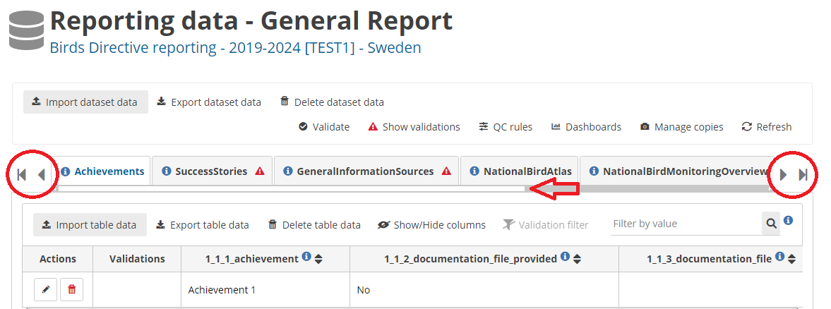

**Figure 4.4.1.** General view of the schema “Reporting data – General Report”. The grey arrows and the white moving bar allow access to the tables/vignettes that are not visible due to space limitations.

#### 4.4.2 Birds

The schema “Reporting data – Birds” covers **Part B (Bird species status and trends report format)** of the Art. 12 Reporting Format, and it’s divided into 12 tables, listed below. Each field of a table of the Birds schema is denoted with a ‘B’ before the field number.

* Seasons_GeneralInformation: This table corresponds to fields within section 2 “Season”. This is a mandatory table.
* PopulationSize: This table corresponds to fields within section 3 “Population size”. This is a mandatory table.
* PopulationTrend: This table corresponds to fields within section 4 “Population trend”. This is a mandatory table.
* BreedingDistributionSize_Map: This table corresponds to fields within section 5 “Breeding distribtion map and size”. This is a mandatory table.
* BreedingDistributionTrend: This table corresponds to fields within section 6 “Breeding distribution trend”. This is a mandatory table.
* Pressures_GeneralInformation: This table corresponds to fields within section 7 “Main pressures and threats”, particularly, fields 7.2, 7.3 and 7.4. This is a non-mandatory table.
* Pressures_List: This table corresponds to fields within section 7 “Main pressures and threats”, particularly, fields 7.1 a) to g). Each pressure should be reported on a separate row. This is a mandatory table.
* Measures_GeneralInformation: This table corresponds to fields within section 8 “Conservation measures”, particularly, fields 8.1, 8.2, 8.3, 8.4, 8.5 and 8.7. This is a mandatory table.
* Measures_List: This table corresponds to field 8.6 “List of main conservation measures”. Each measure should be reported on a separate row. This is a mandatory table.
* Natura2000Coverage: This table corresponds to fields within section 9 “Natura 2000 (Special Protection Areas (SPAs)) coverage”. This is a mandatory table.
* PlansProgress: This table corresponds to fields within section 10 “Progress in work related to International Species Action Plans (SAPs), Management Plans (MPs) and Brief Management Statements (BMMs)”. This is a mandatory table.
* HuntingBags: This table corresponds to fields within section 11 “Information related to Annex II species of Directive 2009/147/EC”. This is a mandatory table.

These tables are found as different spread sheets in the “Import template Birds” file. For most of these tables, each row/entry represents data of one species-season combination. For this reason, the first two fields of each table correspond to “species_code” and “season_code”. The exceptions are tables “PlansProgress” (Progress in work related to International Species Action Plans (SAPS), Management Plans (MPS) and Brief Management Statements (BMSS)) and “HuntingBags” (Information related to Annex II species of Directive 2009/147/EC), for which each row/entry represents a species (no season information).

For table “BreedingDistributionSize_Map”, only the *tabular data* associated to this table should be submitted here, whereas all associated *spatial data* (or maps) should be submitted via the schema “Birds Spatial Information”, available in the main menu of the Art. 12 dataflow (see also section 4.5). The reporter must ensure to mention in this table whether the Breeding distribution map (field 5.3) and Additional maps (field 5.6) are going to be submitted by indicating ‘yes’ or ‘no’ for each of these fields. The reporter must ensure to mention in this table also if the species is sensitive or not (field 5.1) as this information will not be provided again in the Spatial Information schema.

Similar to the General Report, in Reportnet 3.0, all tables are visible and accessible as different vignettes (Fig. 4.4.2). To access the last tables situated towards the right, use the grey arrows or the moving bar underneath the tables’ names (similar as in Fig. 4.4.1).

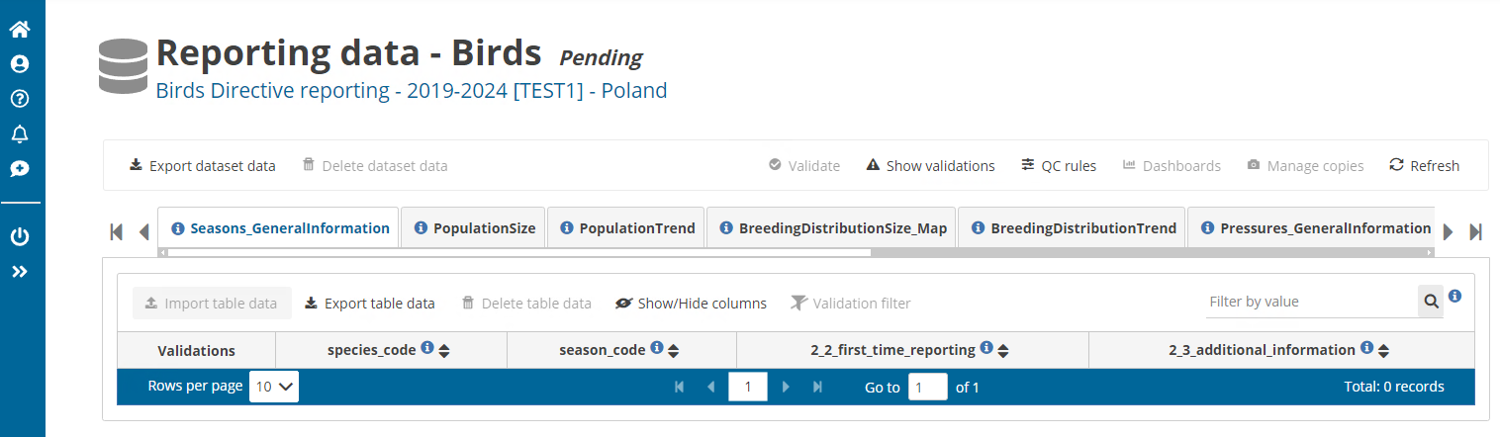**Figure 4.4.2**. General view of the schema ”Reporting data – Birds”.

### 4.5 Spatial Data

The submission of distribution maps for breeding birds present in a Member State is a basic requirement of Article 12 reports. Maps should provide information about where breeding is recorded according to the categories defined in the new European Breeding Bird Atlas.

Distribution maps must be submitted using the “Reporting data – Birds Spatial Information” dataflow, found within the country folder. This dataflow contains two tables, “Birds_Distribution_GridCells” and “Birds_AdditionalMaps”. The first table shall be used for the submission of distribution maps according to field 5.3 of Part B of the Art. 12 Reporting Format and is a mandatory table. The second table shall be used for field 5.6 ‘Additional maps’ and is a non-mandatory table.

Similar as for other schemas, the function “Export dataset data” à “XLSX” can be used to download the tables that should be used as import template (Fig. 4.5.1). This template is also available in the Reference Portal and in the Dataflow Help section (as extended template with embedded dropdown menus) and in the Dataflow Help section (simple template, Fig. 4.1.1).

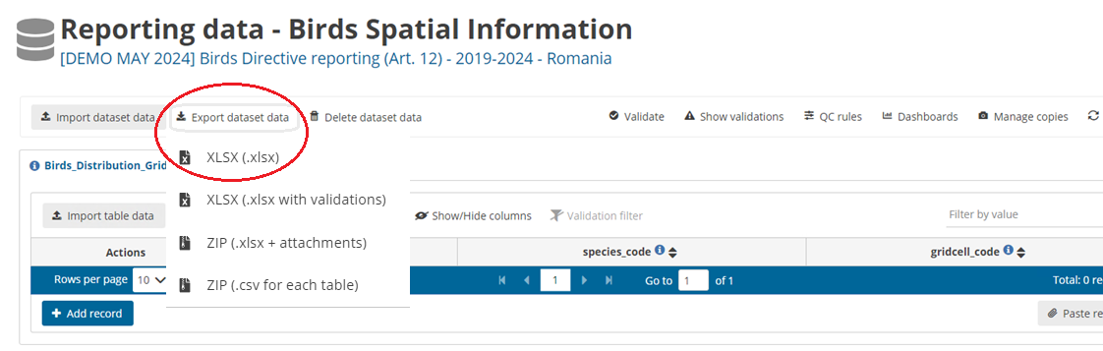 **Figure 4.5.1**. The function “Export dataset data” allows for the download of the schema tables. The downloaded table can be used as a template for reporting tabular information related to the two tables within the Birds Spatial Information schema.

Member States can submit the birds’ distribution data (for the table “Birds_Distribution_GridCells”) in two ways, as tabular information or as gridded polygons:

**Submission of maps as tabular information**

Mas can now be submitted using simple tabular information instead of more complex geospatial data. This new method, implemented in the Reportnet 3.0 platform, facilitates the submission of essential geospatial information. Previously, Member States had to submit geometry information (e.g. shapefiles) consisting of multiple files, which increased the possibility of errors in the geometry of the files. With this new tabular approach, we limit these errors by simplifying the information to be submitted to a simple tabular file (.csv or .xlsx) that includes no more information than the species code and the occupied grid cell codes (EEA reference grids) by the species. Thus, Member States should prepare the information in the form of a .csv or .xlsx table, simply indicating the species code and the reference code to the EU standard grid (at 10x10 km or 1x1 km) where the species is recorded breeding, as described in the Explanatory Notes. This format, in contrast to maps or geometry files, contains the most basic information used for the creation of distribution maps and will be used for the re-creation of the maps from EEA and ETC BE.

The table to be used for this is the “Birds_Distribution_GridCells” table, containing two fields/columns: “species_code” (bird species code) and “gridcell_code” (standard EU grid code, see the reference tables “GridCell10” for details). Member State can submit, in one single table, grid cell codes of different grid sizes (1x1 km, 10x10 km grids), i.e. some species may use one grid size and others a different grid size. However, each species should be reported using only one grid size.

Understanding that some Member States maintain their workflows and systems around the legacy geospatial format, the old format of submitting the spatial data is maintained. Member States may thus import a geometry file (shapefile, geopackage) that conforms with the following requirements:

**Use of gridded polygons**

Alternative to the submission of tabular spatial information, Member States may also submit gridded polygons, as long as they adhere to the following conditions:

* Single Shapefile:Zipped shapefiles may be submitted, containing all the necessary associated files (e.g., .shp, .shx, .dbf, .prj). Alternatively, unzipped geopackage files (.gpkg) may be imported.
* Grid Cell Polygons: The gridded polygons, or individual grid cell polygons must precisely match the specific EEA reference grid
* Spatial Reference: The SRID (Spatial Reference System Identifier) should be EPSG:3035
* Multiple layers: The shapefiles can include multiple layers, and it is acceptable for multiple layers to exist for the same species
* Files can contain dissolved or undissolved grid cell polygons at the proper European projection.

It is important to note that, if the Member State decides to import geometric files, these files will not be stored in Reportnet 3.0, and only the tabular information of these files will be extracted and stored. Thus, geometric files will be converted into a table containing the species code and the grid cell codes. This table will be visible to the reporter after importing and using the “Refresh” function.

To submit, edit and validate data, the general functions and rules described in section 4.1 apply. However, the following particular aspects should be considered for the “Birds Spatial Information” schema:

The “**Import dataset data**” function can import tabular files as one ZIP file (with .csv files for each table), Excel files (following the import template format) and geometry files (zipped shapefiles or one geopackage file) (Fig. 4.5.2).

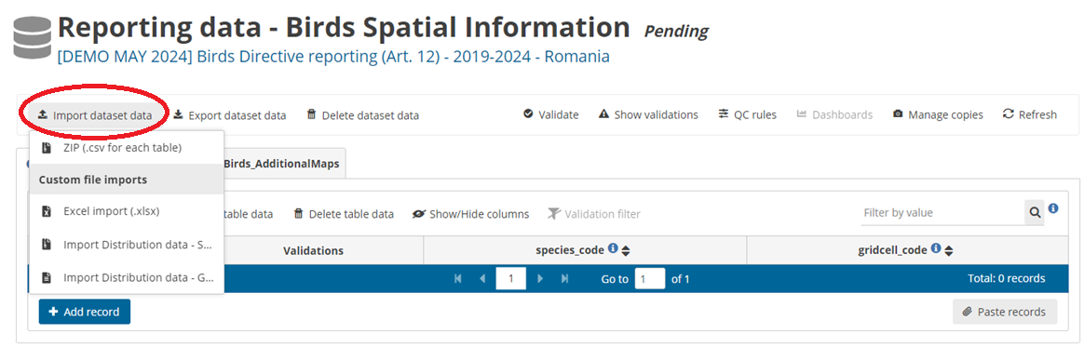 **Figure 4.5.2**. The function “Import dataset data” provides several alternatives for importing tabular and/or geometric files.

Similar as for other schemas, only one file can be imported at a time:

* One ZIP file, containing one or two .csv tables, each one corresponding to the tables “Birds_Distribution_GridCells” and “Birds_AdditionalMaps”. Table names and column names must follow the import template format.
* One .xlsx table that must comply with the format of the import table (i.e. contain two sheets, one for “Birds_Distribution_GridCells” and one for “Birds_AdditionalMaps”)
* One zipped file containing the necessary shapefiles (e.g., .shp, .shx, .dbf, .prj). Geometry files need to have the following column names: ‘CODE’ for the species code and ‘REFGRID’ for the grid cell code.
* One geometry file in the form of geopackage (unzipped). Column names must be ‘CODE’ for the species code and ‘REFGRID’ for the grid cell code. Additionally, .gpkg files have another column called ‘fid’ (feature ID) created by default.

The “**Import table data**” function, on the other hand, can only import one .csv file, and the column names must follow the corresponding table of the import template.

Similar as for other schemas, data can also be added manually using the “**Add record**” function.

Both the “Import dataset data” and “Import table data” functions will open a new window where files may be selected from the local computer or dragged into the box (Fig. 4.5.3). Within this window, the function **“Replace data”** will erase all previous data that have been imported in the schema (i.e. for all tables of the schema if using the “Import dataset data” function) or for the corresponding table (if using the “Import table data” function). If the function “Replace data” is not selected, data will be added without erasing previous imported data, meaning that new entries will be added on to the list together with previous entries. This also means that Member States may import several individual files, and data will be collected in the country folder. These different files must, however, be imported one by one and not simultaneously.

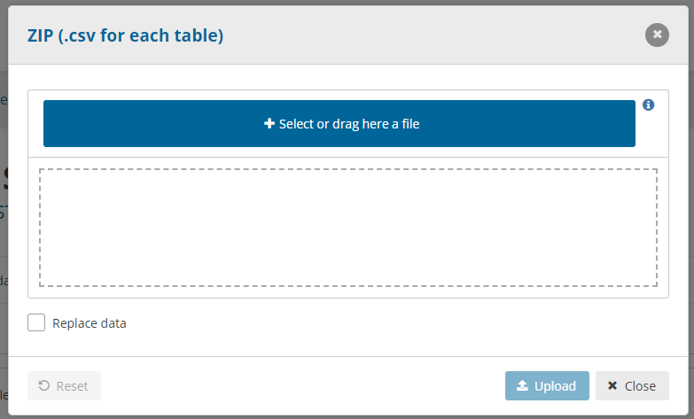**Figure 4.5.3**. When using the “Import dataset data” or “Import table data” functions, a window will open where the file (ZIP, .xlsx, or .gpkg depending on the function) can be selected or dragged.

Once datafiles or tables have been imported, the “**Refresh**” button should be used (Fig. 4.5.4) to display the data for the corresponding table(s) (Fig. 4.5.5). Note that if geospatial files were imported, Reportnet 3.0 extracts selected information that takes the form of tabular data, containing only the species code and the grid cell code (Fig. 4.5.5).

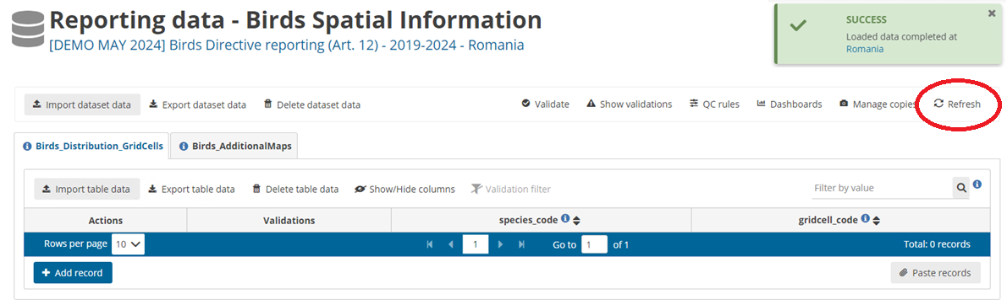**Figure 4.5.4**. After importing files, the ”Refresh” button should be used. This will display the imported data as in Fig. 4.5.5.

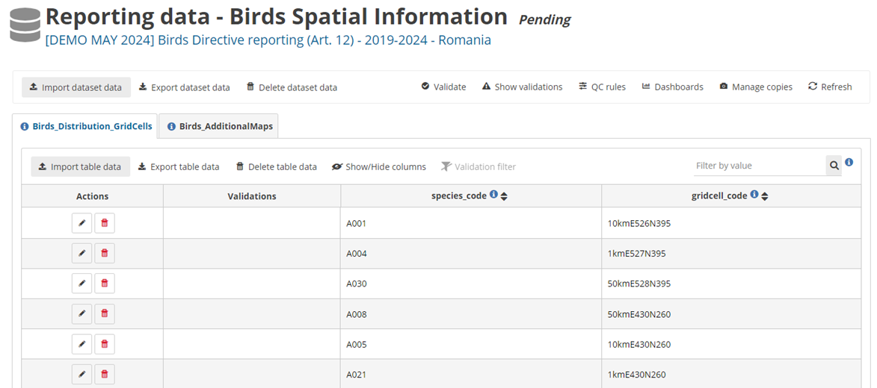**Figure 4.5.5**. After importing files (either tabular or geospatial) and refreshing the dataflow, the data (species code and grid cell code) will be displayed as a table.

The “**Export dataset data**” (and similarly, the “**Export table data**”) function allows for the download of already imported (or manually added) tables (Fig. 4.5.6). Importantly, custom exports may be done, to download the (now tabular) data as either tabular (.xlsx) or geometry (shapefiles or geopackage files, zipped or unzipped) files. This allows the reporter to revise the submitted data. For example, if data were submitted as tabular data, they can be visualized as geometry files, and if data were submitted as geometry files, the table with gridded cell codes produced by Reportnet 3.0 can also be checked.

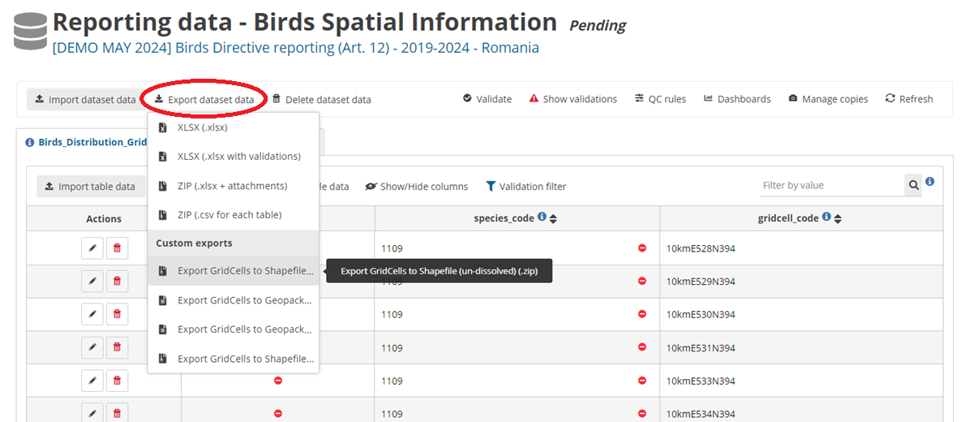**Figure 4.5.6**. The “Export dataset data” function allows the reporter to download the imported data in several formats, including both tabular and geometry files.

To submit additional maps, the table “**Birds_AdditionalMaps”** should be used. Data may be imported (via the “Import dataset data” or “Import table data” functions) from the import template, either as .xlsx (original format of the import template) or as a zipped .csv file. In both cases, the fields ‘spatial_file_description’ and ‘species_code’ should be filled in, whereas the field ‘spatial_file’ should not be filled in. After importing the table to Reportnet and refreshing, attachments corresponding to the field “spatial_file” should be uploaded by using the “**Add attachment**” function (grey arrow, see Fig. 4.5.7). Clicking the arrow will open a new window, where documents may be selected or dragged. Only one attachment per entry is possible. There are no format restrictions or quality control rules applied to an attachment.

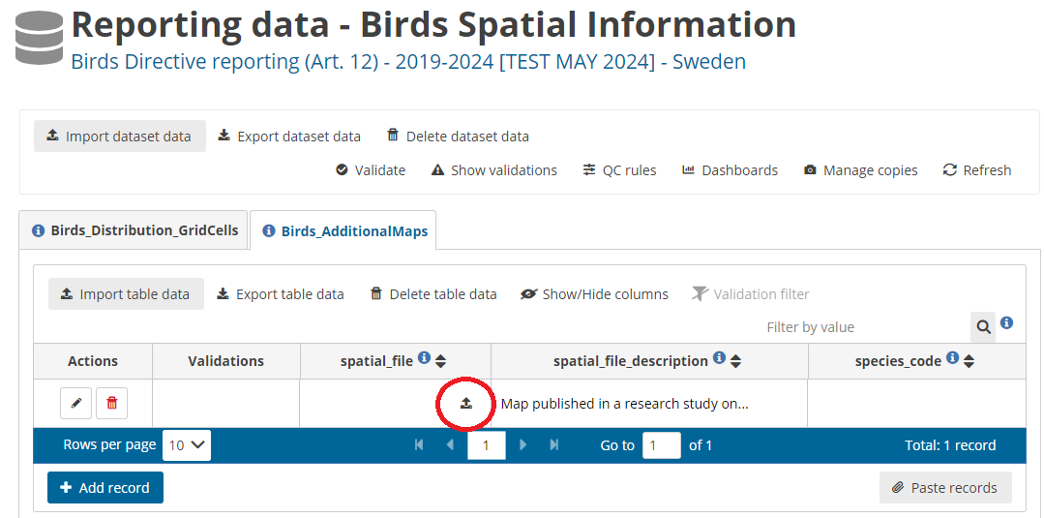**Figure 4.5.7**. To upload an attachment, use the grey arrow in the corresponding entry.

If the Member State decides to submit “birds additional maps” (related to field 5.6) in addition to gridded polygons of “bird distribution maps” (related to field 5.3), the reporters must prepare 1) the table designed for “Birds_AdditionalMaps” (a zipped .csv or an .xlsx file following the import template), where the ‘spatial file description’ should be provided, and 2) a separated zipped shapefile with the species code and grid cell codes (or an unzipped geopackage file with the species code and grid cell codes) corresponding to the “spatial_file” to be uploaded in the relevant field as attachment. This means that two upload actions must be performed (the table and the map itself). The reporter must ensure that spatial attachments in ZIP format are under 100 MB to allow the upload of additional maps.