How to use Reportnet 3 for Nationally Designated Areas inventory (NatDA) reporting

Version 1.1

Content
Content 2
Overview 3
1 Nationally designated areas inventory (NatDA) 4
1.1 Step 1: Log on to Reportnet 3 4
1.2 Step 2: Open the NatDA dataflow 5
1.3 Step 3: Find the needed files 6
1.4 Step 4: Upload the NatDA data 7
1.4.1 Type 1 – Spatial Data 7
1.4.2 Type 1 – Spatial Data – Import from file 8
1.4.3 Type 2 – Descriptive Data 9
1.5 Step 5: Run quality control check (QA/QC) tests on the data 11
1.6 Step 6: Review quality control check (QA/QC) results 11
1.7 Step 7: Release the data to the data collection 13
2 More help is available 14
Annex 1 – Adding supporting reporters 15
Annex 2 – Using dataset copies 16

Overview
These guidelines explain how to use Reportnet 3 (the European Environment Agency's new digital infrastructure for data collection) for reporting information to the nationally designated protected areas (NatDA) annual data collection, which is one of the agreed EIONET core data flows.

The reporting takes place in Reportnet 3 under ROD obligation 32 – Nationally designated areas inventory (NatDA) - https://rod.eionet.europa.eu/obligations/32. The reporting flow is described in the sections below.

User accounts and access permissions

In order to report in Reportnet 3 platform, an EU login with the same email as is used for reporting is required as well as permission to upload and release the national delivery in the platform. Each country nominates national lead reporters and optionally supporting reporters responsible for the NatDA reporting. The nominations go through the Eionet National Dataflow Coordinator (NDFC) or the Eionet National Focal Point (NFP).

Nationally designated areas inventory (NatDA)

Step 1: Log on to Reportnet 3
https://reportnet.europa.eu/

The login process, the creation of an EU login and logging in for the first time is explained in the “How to login to Reportnet 3”, which is available from the Supporting documents at the right hand side of the Reportnet 3 landing page https://reportnet.europa.eu/
https://www.eionet.europa.eu/reportnet/docs/test/howto_login_reportnet3

Multi factor authentication (MFA) for EU login is explained in
https://www.eionet.europa.eu/reportnet/docs/test/mfa-for-eu-login.pdf
This document is also available for the Reportnet 3 landing page.

Step 2: Open the NatDA dataflow
- Find the dataflow in the list. The 2026 dataflow is used as example in this document: ‘Nationally designated areas (NatDA) - 2026 reporting’.

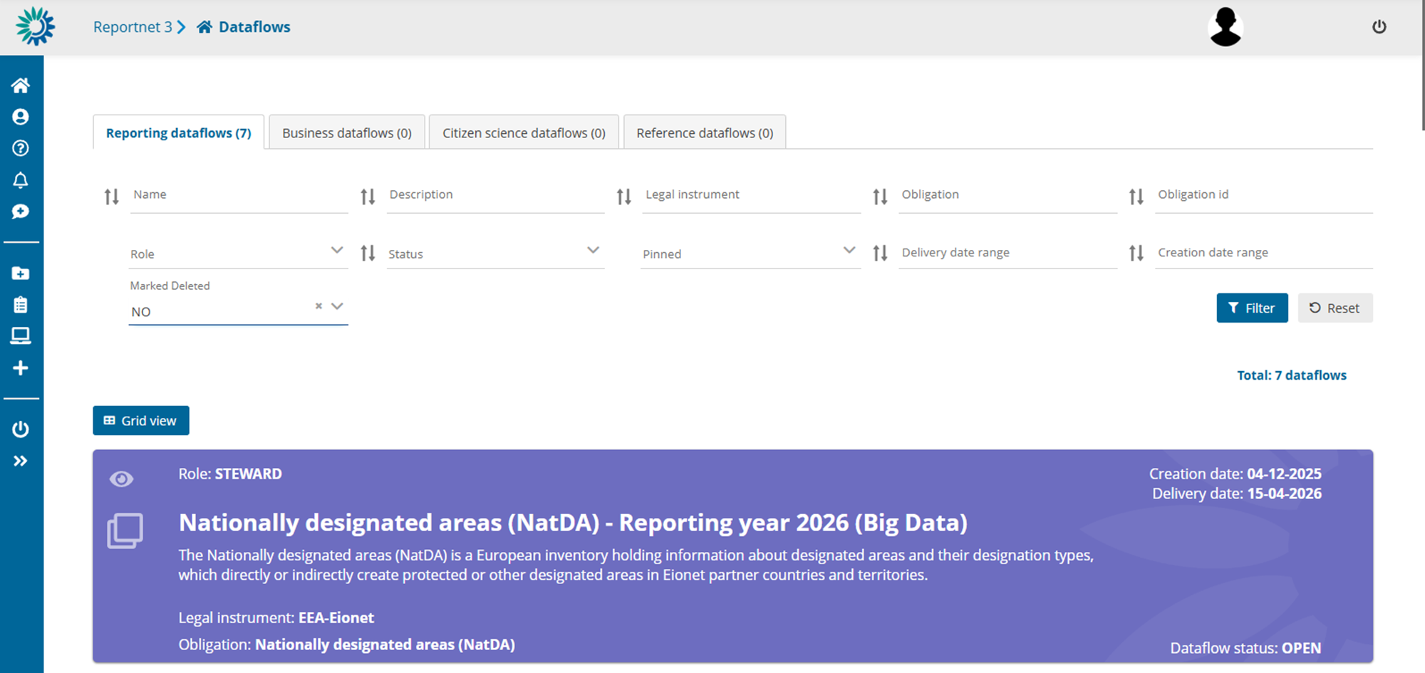

- Go into the dataflow by clicking on it

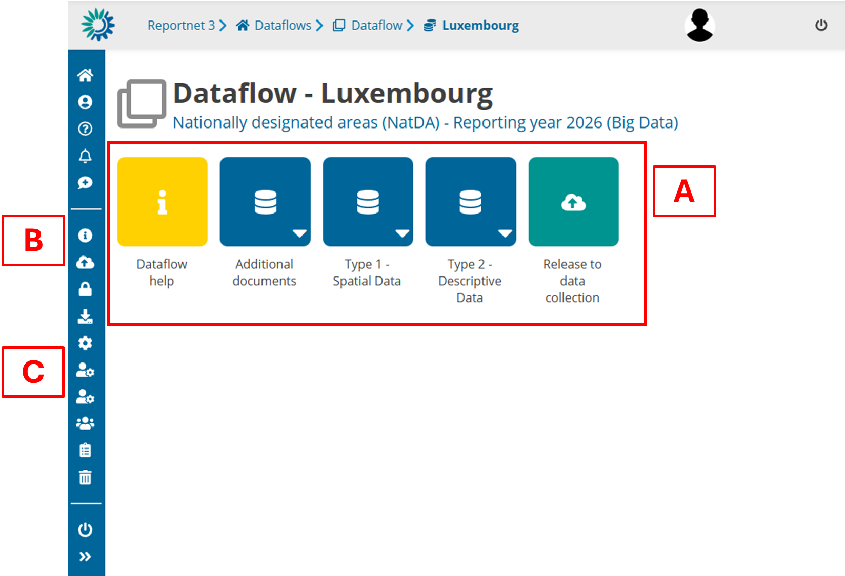

The dataflow overview page provides the most relevant functions to delivering Nationally designated areas inventory (NatDA)
- [A] – The main part of the page are icons which take you to the components of the dataflow:
  - Dataflow help – in here you will find three tabs showing documents, links and technical overview of the reporting schema.
  - Reference data contains data which is used to validate the quality of the reporting checking vocabularies for all elements where a predefined dictionary exists (e.g., previously reported site codes or country codes) and evaluating the position of reported sites against reference country borders.
  - Type 1 – Spatial data schema is where the spatial data as GML file or Shapefile is uploaded and validated.
  - Type 2 – Descriptive data schema is where the tabular data in Excel format is uploaded and validated.
  - Confirmation receipt is only visible after a reporting has been released informing of the successful reception of the data by Reportnet 3 platform.
  - Release to data collection is for submitting the reported data once you have uploaded and validated it.
- [B] – Properties displays the information regarding the dataflow, reporting obligation and legal instrument (extracted from ROD).
- [C] – Manage reporters displays a dialog where a lead reporter can provide access to the dataflow for supporting reporters – PLEASE REFER TO ANNEX 1

Step 3: Find the needed files
- Click on the Dataflow help button. Under supporting documents, you will find the supporting files
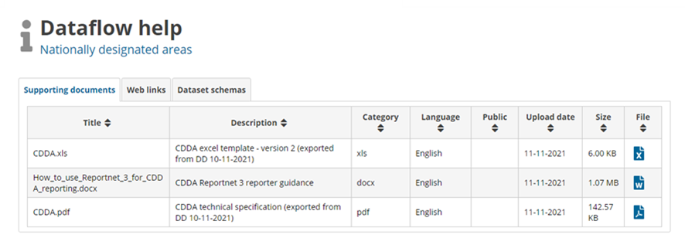

- Alternatively, go to the EEA Data Dictionary website at http://dd.eionet.europa.eu/datasets/latest/CDDA. Click the “Exports” section and download the latest version of the Excel template where the data should be inserted before upload.

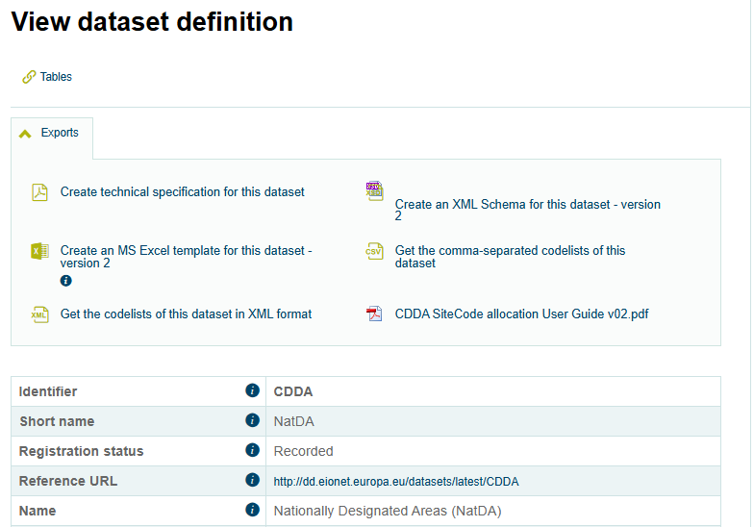

Click the “Create an MS Excel template for this dataset – version 2” link.

By clicking the “Create technical specification for this dataset”, NatDA data dictionary pdf can be opened and downloaded.

Step 4: Upload the NatDA data

Type 1 – Spatial Data
The dataflow allows for two formats to import spatial data. The ‘Import dataset data’ offers to import the spatial data as Shapefile (zipped into one .zip file) or as GML (as unpacked GML, or – to reduce file size – as zip file).

Type 1 – Spatial Data – Import from file
- Go into the Type 1 - Spatial data schema
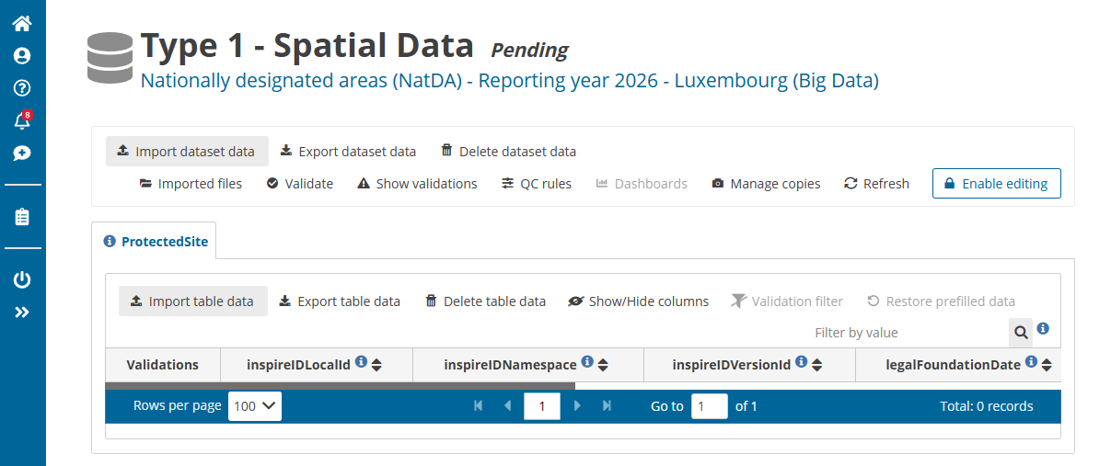

- If you want to start from an empty ProtectedSite table and you find data from a previous import in the table, clear the ProtectedSite table using the Delete table data button available for the ProtectedSite table.

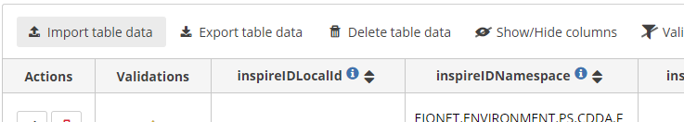

Be aware that this deletes all data in the table. In you upload data from several files, please be aware that it is not possible to delete records from a specific import. All data is deleted and all files must be uploaded again.

- Click on the Import dataset data button on the top left of the menu, either choose ‘Import GML (.gml, .zip)’ or ‘Import Shapefile (.zip)’ and select the file to upload in the dialog.

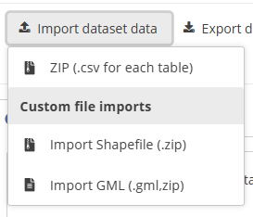

- It is advised not to check Replace data. See step 2 if you want a clean start and import all data again.
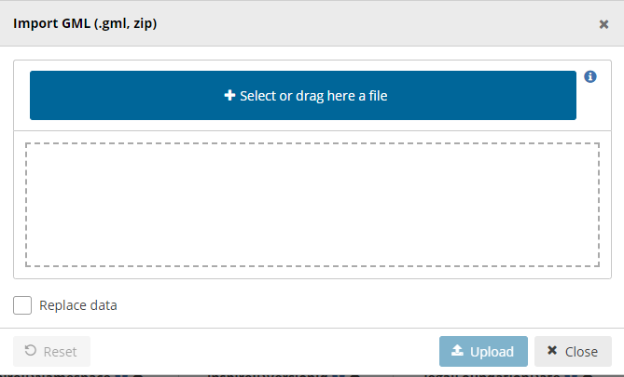
- The application will automatically extract the data from a zip-file and import it to the dataset in the platform. Note: When uploading a Shapefile all associated files (*.shp, *.dbf, *.shx, *.prj) must be packed into the zip file and uploaded.
- After import the validation will be automatically run.
- Notifications in the top right corner will inform you that the import has started and when the validation has finished.
- Once the validation is finished the ‘Refresh’ button will be highlighted and after clicking you will see the results of the validation. The validation can also be run manually – see next section.
- If you want to upload additional files, repeat the process starting from step 3.

Type 2 – Descriptive Data
- Go into the Type 2 - Descriptive Data schema
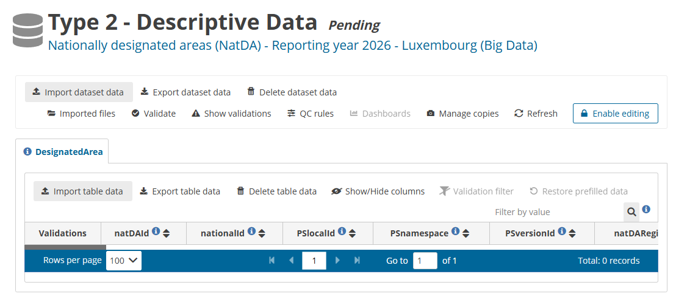

- Click on the Import dataset data button on the top left of the menu, choose ‘Import Excel (generic) (.xls, .xlsx)’ and select the file to upload in the dialog.

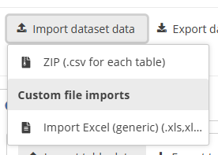

- You may import several files, and the records will be appended to the already uploaded data. If you are importing a file again with all the data, then make sure Replace data is checked.
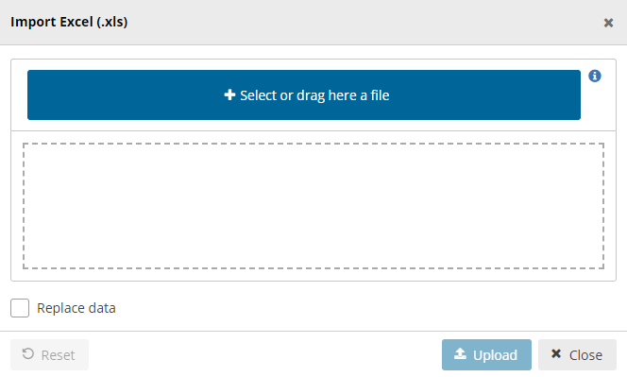
- The application will automatically extract the data from the xml/excel and input into the dataset. Note: the excel file is not stored on the platform.
- After import the validation will be automatically run.
- Notifications in the top right will inform you the import has started and when the validation has finished
- Once the validation is finished the ‘Refresh’ button will be highlighted and after clicking you will see the results of the validation. The validation can also be run manually – see next section.
- To delete the whole dataset and reupload the descriptive data, e.g., after correcting an issue in the data, click ‘Delete dataset data’ in the top row next to the import button. The system will ask for a confirmation to delete the data and propose to create a copy before deleting (PLEASE REFER TO ANNEX 2).

Step 5: Run quality control check (QA/QC) tests on the data
- In the reporting dataset you will find several menu buttons for quality control:

    - Validate – Runs validations for the whole dataset
    - Show validations – Shows a table of all the validation issues found across the whole dataset after a validation has been run.
    - QC rules – shows a list of all the validations which have been created for the dataset.
    - Dashboards – Provides a visualisation of the validation feedback.
    - Manage copies – Functionality to save copies of the data (snapshots or restore points) – PLEASE REFER TO ANNEX 2
    - Refresh – After import, validation and restore copy, you need to refresh the tables.
- Click on Validate.
- A notification in the top right will indicate the validation has started and when it has been completed.
- Refresh the table once the validations are complete.

Step 6: Review quality control check (QA/QC) results
- Validation feedback is displayed by the record, the field, the table or the dataset entity (see further down). Validation feedback may have four different levels.
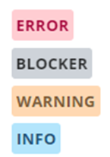
While ‘INFO’ and ‘WARNING’ highlight points which could be correct but should be checked by the reporter, an ‘ERROR’ indicates a more crucial issue which ought to be solved before release of the dataset. A ‘BLOCKER’ message is returned for critical errors found and such errors prevent the reporting from being released.
- The column ‘Validations’ in a table shows for each record which level of errors has been found.
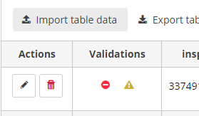
- Field level errors have icons next to value in the field. Hover over it to see the error message.
- Click on Show validations button (dataset menu) to view the list of all errors in the dataset.

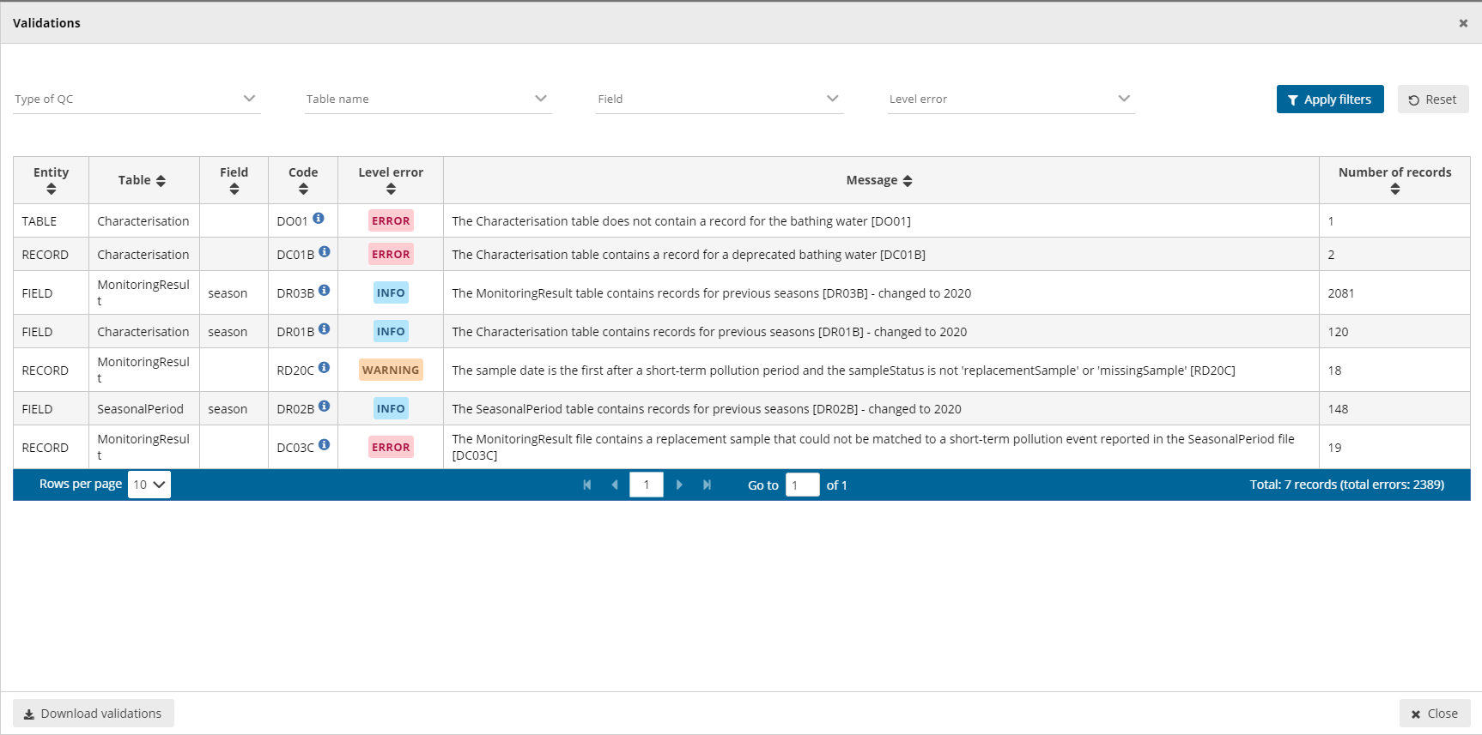

- This table has four columns:
    - Entity – One of FIELD/RECORD/TABLE/DATASET.
    - Table – table name
    - Field – field name (if applicable)
    - Code – short code
    - Level error – One of INFO/WARNING/ERROR/BLOCKER.
    - Error message – What the issue is.
    - Number of records – the number of records which have triggered the error (the table is grouped by error)
- Page through it and sort it to understand errors in data. It is also possible to filter records in the validation table to make it easier to work with.
- Double-click on an error in the list to go to group of records in the reporting table.
- Click on Dashboards to get a visual overview of the number of errors in the data by table.
- Corrections to the data should be made in your source data and then import again the excel/xml file. Remember when importing again your excel, to either Delete dataset data first, or check the Replace data in the excel import dialog. Once imported validate again the data.
- Only BLOCKERS will stop the data from being released to the data collection.

Step 7: Release the data to the data collection
Once you are satisfied with the uploaded data, complete your delivery by releasing to the data collection.
- Go to the Dataflow overview.
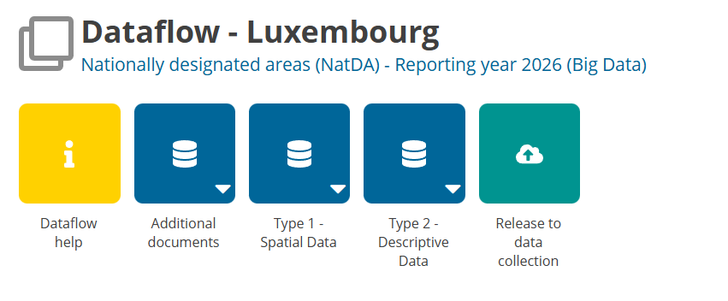
- Click on the button Release to data collection. You will be asked again if the data is ready to be released into the data collection.
- In the background, the QC is run again on each dataset and the ‘Show validations’ list refreshed in the dataset.
- If there are blockers in any dataset, the release is stopped and there will be a message to inform about that.
- If the QCs run fine, a notification will appear saying the data has been ‘released successfully’. An automatic copy will be created.
- You will also see a new icon from which you can download a Confirmation receipt. If you change the data and resubmit a new copy to the data collection, then a new confirmation receipt is available for download.
- To look at your submission history, on the dropdown menu for the Reporting data, you will find Historic releases which opens a dialog showing the releases metadata.
Once the data is released, it is marked as an official delivery. The delivery must be inspected and accepted. Before it is inspected by an EEA or delegated ETC data manager, the status of the delivery is “Final feedback”.

The final feedback is given by the EEA or ETC. Once the the delivery is approved, the status changes to “Envelope is complete”. The delivery is then marked as an official delivery. Data updates, corrections and re-submissions can always be delivered via making a new release to the data collection. The tracking of delivery versions is enabled through ‘Historic releases’. If EEA or ETC has technically rejected the delivery due to incompleteness, you will be contacted and asked for clarifications. In such case, inconsistencies in the data will have to be corrected by reporter and submitted under a new release to the data collection as described above (Steps 1-8). If EEA or ETC has technically accepted the delivery, no further actions are necessary.

More help is available
More help on Reportnet 3 is available at: https://www.eionet.europa.eu/reportnet/docs/prod/reporter_howto_reportnet3/@@download/file/HowTo_Reporter.(Reportnet3.0).(v3.10).pdf

In case of login or platform problems, please contact Eionet Helpdesk: helpdesk@reportnet.europa.eu.

NatDA additional reporting resources page: https://cdr.eionet.europa.eu/help/cdda

In case of data problems, please contact the NatDA helpdesk: natda.helpdesk@eionet.europa.eu.

Annex 1 – Adding supporting reporters
Note: Only a lead reporter can use this functionality

Pre-requisite: Supporting reporters can only be added if they have registered on Reportnet 3 – See Step 1 (page 4).

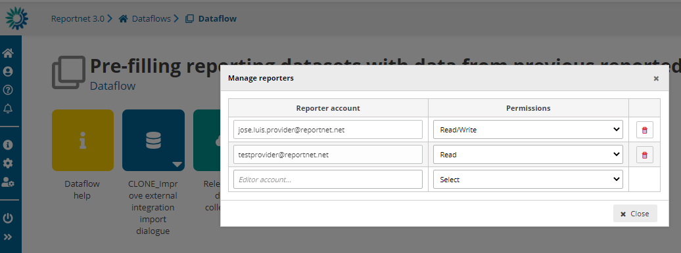

- Go to the dataflow page
- Click on the double arrow at bottom left to expand the left menu, and click on the button ‘Manage reporters’
- A pop-up will appear where you can add supporting reporters
- Add the reporter accounts using the email. Under the account field, add the registered users email address and select an access level of ‘read’ or ‘read-write’. Click on the dialogue away from the input fields.
Note: ‘read-write’ can add data to the schema and run the validations. ‘read’ can only see the dataflow schema through the ‘Dataflow help’ -> ‘Dataset schemas’ page

- If the system cannot find the email as a registered user, then a red box will appear around the email address. If not found, then the reporter to be added has not registered on the platform – see Step 1 (page 4)
- If it is accepted, then you will be able to add another editor (the account field is automatically generated after a successful entry) and so on.
- Once you have added all your reporters click ‘Close’

Annex 2 – Using dataset copies
As you upload and edit data, you may wish to create a save point in your data which you can later restore from. This is possible from the dataset menu.

How to save a copy of the dataset

- On the table menu bar, click on Manage copies.
- In the dialogue, give your copy a description in the text field at the top and press the ‘+’ button.
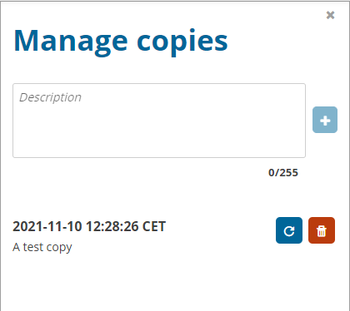
- Click Yes to confirm in the popup.
- The platform will create the copy and when finished will now be listed.
- Close the right panel and continue working.

How to restore a copy of the dataset

- On the table menu bar, click on Manage copies.
- In the list, press the Restore copy button next to the copy you wish to revert to (WARNING: the current data will be overwritten – consider taking a copy of the current dataset before reverting to an older one).
- Confirm in the dialogue you wish to continue.
- Wait for the green notification to appear in the top right, confirming the copy has been successfully restored.
- Close the right panel, refresh the dataset and continue working.

