Calculation of Favourable Reference Population for European Ground Squirrel (1335 Spermophilus citellus) in Austria – Continental biogeograpical region
Thomas Ellmauer
Environment Agency Austria; correspondence to: Thomas.ellmauer@umweltbundesamt.at

- Biology of the species
The European Ground Squirrel is a rodent, preferably living in open steppic and dry grassland habitats, including the “cultural” steppe of short-stalked grasslands, airports, golf courses, fallow land, pastures and vineyards (Janak et al. 2013, Enzinger 2018). In Austria, European Ground Squirrels mainly occur in the pannonic zone of the continental biogeographical region, trespassing marginally to the alpine biogeographical region at the eastern steep slopes of the alps (see Fig). The species lives in burrows where it also hibernates from autumn (around September/October) to late winter/early spring (February/March). Reproduction takes place in early spring. The female gives birth to a number of 2-8 young individuals.

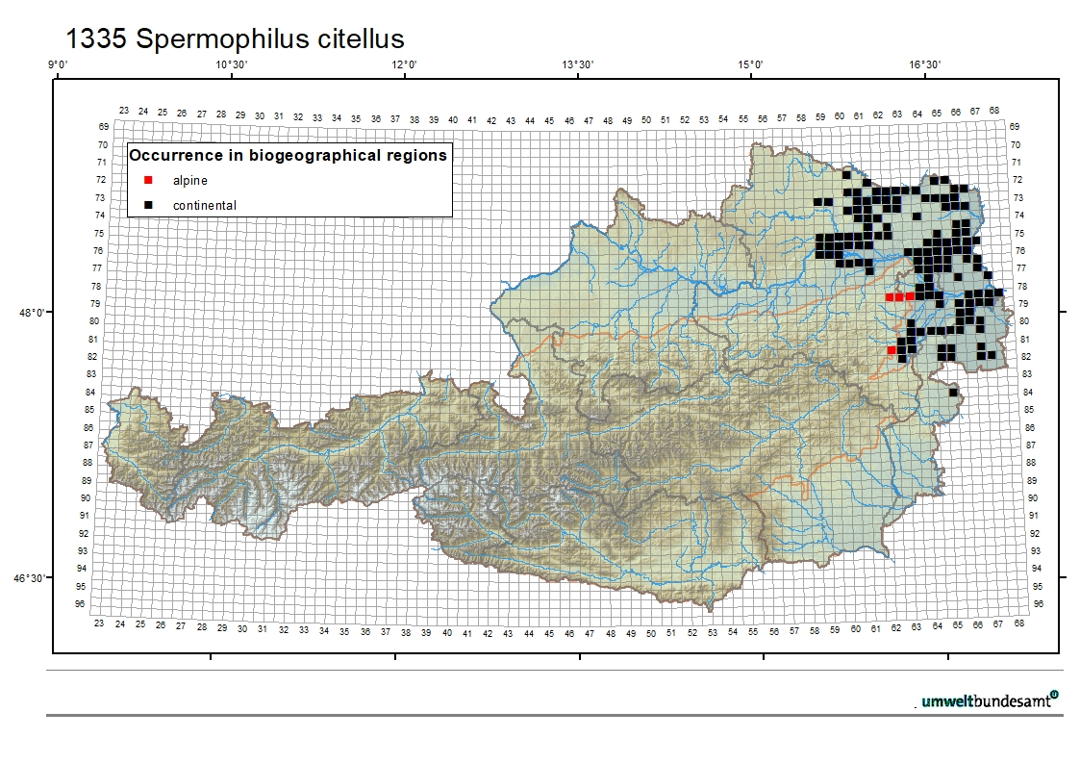Figure 1 1: Current distribution from the reporting periods 2007-2012 and 2013-2018 of 1335 Spermophilus citellus in Austria.
Due to a monitoring and citizen science project of the NGO “Naturschutzbund Niederösterreich” which was started in 2005 (Enzinger et al. 2006), data on the distribution and status of European Ground Squirrel are quite well in Austria.
Favourable Reference Population
For a prospering population of European Ground Squirrel, it is necessary that the single populations are interconnected with each other. According to studies by Koshev (2009), active colonies have a distance to other colonies of about 3,25 km +/- 1,44km. By buffering polygons of the known Ground squirrel occurrences by 1.600 m, which is the half distance of active colonies, populations which build together a metapopulation can be identified. By considering the fragmentation of the habitats, a total of 67 metapopulations could be identified within the range of the species. On the other hand 34 isolated populations, which are in danger of extinction, have been identified.
For a long-term survival of a metapopulation the existence of at least one big core population (mainland population) within the metapopulation is of paramount importance. For a modeled metapopulation of 1.800-2.5000 individuals, consisting of a mainland population of 1.000 individuals and an area of habitat with a carrying capacity of 2.000 individuals, an extinction risk of less than 10 % within 100 years was calculated (Enzinger 2017). According to Mateju et al (2010) metapopulations of about 2.5000 individuals have a low extinction risk.
Metapopulations, which meet the above mentioned criteria (mainland population of about 1.000 individuals and habitat area for 2.000 individuals of carrying capacity) in average occupy an area of about 4.400 ha. The potential dispersal area, calculated by the potential habitats (e.g. grassland, fallow land, vineyards) within the migration distance of Ground squirrel (5 km) accounts to 3.650 km² in Lower Austria. Consequently, the potential dispersal area should host about 83 metapopulations in Lower Austria for a sustainable population within the current (and favourable) range. The Federal State of Burgenland hosts about 15% of the species range and Vienna approximately 5%. Therefore, Burgenland should host additionally 13 metapopulations and Vienna 4, which makes in total for whole Austria 100 metapopulations.
For the calculation of the favourable reference population 100 metapopulations are multiplied by 2.000 individuals for the carrying capacity of each metapopulation. Consequently, the favourable reference population accounts to 200.000 individuals.

Janak, M.; Marhoul, P. & Mateju, J. 2013: Action Plan for the Conservation of the European Ground Squirrel Spermophilus citellus in the European Union. European Commission.
Enzinger, K. 2018: Das Ziesel in Niederösterreich. Ergebnisse der Schwerpunktkartierung 2017. Bericht mit Unterstützung des Landes Niederösterreich und der Europäischen Union.
Enzinger, K., Walder, C., Moser, D. & Herzig, B. 2006: Vorkommen und Schutz des Ziesels (Spermophilus citellus) in Niederösterreich. Naturschutzbund NÖ.
Koshev, Y. 2009: Distribution, isolation and recent status of European ground squirrel (Spermophilus citellus L.) in Pazardzhik district, Bulgaria. - Annual of Shumen University "Konstantin Preslavsky", Faculty of Natural Sciences, Vol. XIX B6: pp. 97-109. ISSN: 1311-834X [In English with Bulgarian summary].
Enzinger, K. 2017: Ziesel im Zieselschutz. Wie verbessern wir den Erhaltungszustand des Ziesels in NÖ? Zieselpopulationen, Gefährdungen, Schutzmaßnahmen und das Lebensraumpotenzial des Ziesels in Niederösterreich. Energie- und Umweltagentur NÖ (E.N.U.) & Amt der NÖ Landesregierung.
Mateju, J., Hulova, Š., Nova, P., Cepakova, E., Marhoul, P. & Uhlikova J., 2010: Záchranný program sysla, obecného (Spermophilus citellus) v České republice, Action plan for the European Ground Squirrel (Spermophilus citellus) in the Czech Republic. Department of Zoology, Faculty of Sciences, Univerzita Karlova v Prze, ISBN 978-80-7444-001-4, Prag, 2010.

