How to update the list of typical species

Reporting period 2019-2024

## Introduction

The compilation of typical species used by Member States to assess the parameter 'Specific structure and functions (including typical species)' for the reporting periods 2007-2012 and 2013-2018 is provided on the Reference portal:

(<https://cdr.eionet.europa.eu/help/habitats_art17/Reporting2019/typical_species_2013-2018.xlsx>)

If the list of 'typical species' used for the period 2019-2024 has changed in comparison with the previous reporting period, then an updated list should be provided together with the Member State Article 17 report delivery. This note gives short instructions on how to update the national lists of typical species.

## Updating the list of typical species

If an update of the list of typical species is needed, the Member State should fill in the ‘Template for listing the typical species’ (Fig. 1), available on the reference portal: <https://cdr.eionet.europa.eu/help/habitats_art17/Reporting2025/Template%20typical%20species%202019-2024.xlsx/>

The updated list of typical species should contain the following information for each of the typical species listed:

* **country** - the two-digit code for your Member State in accordance with the list to be found on the Reference Portal;
* **region** - biogeographical region or marine region concerned within the Member State using the list to be found on the Reference Portal;
* **habitat code** - the habitat code given in the Habitats checklist;
* **update (yes/no**) - indicate whether the entry (a typical species for a habitat in a biogeographical region) has been updated compared to the previous reporting period (e.g. new species added, species name change, etc.). *Yes/No* = the Member State *indicates/doesn’t indicate* a change in the typical species for the corresponding habitat and biogeographical region;
* **species scientific name** - provide the scientific name of the typical species;
* **taxonomic group (optional)** - information on taxonomic group can be provided in this field;
* **method (optional)** - method used for assessing typical species, if available;
* **MS note (optional) -** any additional information related to a particular habitat or species that the MS wishes to provide. Habitats for which no typical species has been established should be noted in this field**.**

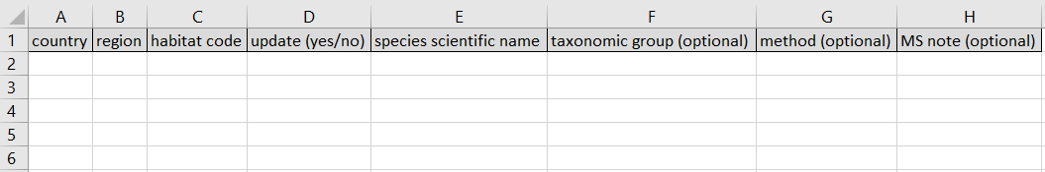

**Figure 1.** Template for listing typical species, to be submitted if an updated version is required for the 2019-2024 reporting period.

To fill in the template, please consider the following points when indicating the ‘scientific species name’ of a typical species:

* Provide one single scientific name per cell in the ‘species scientific name’ column. One habitat can have several entries if more than one typical species is listed for the mentioned habitat;
* Do not list species synonyms;
* Use the full genus name (avoid notations such as “*A. monspessulanum”);*
* Do not include other information, such as vernacular name, taxonomic group or threat status in the ‘species scientific name’ cells;
* Subspecies can be mentioned using “subsp.”, “spp.” or the direct subspecies name (e.g., *Persicaria lapathifolia* subsp. *brittingeri*, *Persicaria lapathifolia* ssp. *brittingeri*, *Abramis brama lahna*).

Member States should submit the **complete list** of typical species for all habitats with their national Article 17 report (also **including habitats without any changes** in their typical species for the current reporting period). The updated list of typical species will replace the existing compilation of typical species (from 20013-2018 reporting) (see Fig. 2).

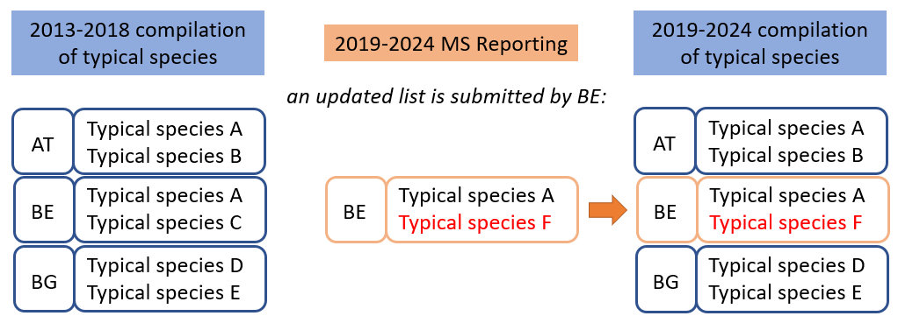

**Figure 2.** Graphical representation of the process of preparing an updated list of typical species. Updated lists must be complete, including both information for habitats with changes in typical species as well those without changes.

For habitats for which **no typical species has been established** this should be noted in the field **‘MS note’.**

The excel file with the updated list of typical species (using the template found on the reference portal) should be uploaded in Reportnet 3.0 in the relevant field “6_6_b_typical_species_list”.

The naming convention for the file is:

XX_typical_species_update_currentyear.xls or xlsx

(where ‘XX’ is the two-digit code for the corresponding Member State)