Customer | DG ENV
Document | MSFD 2018 Web Forms User Manual
About | This document contains the User Manual for the  MSFD web forms.

Ver. | DATE | AUTHOR | DESCRIPTION
V1 | 06/11/2017 | Jose Asensio | Generation of the document

Table of Contents

1 Introduction 3
1.1 Purpose 3
1.2 Definitions, acronyms and abbreviation 3
1.3 Overview 3
2 Web forms 4
2.1 Access to web forms 4
2.2 Web forms structure 5
2.3 Web forms validation 6
2.4 Web forms HTML view 6
2.5 Web forms merge tool 7

Introduction

Purpose
The purpose of this document is to provide a user guide for the end users of the Marine Strategy Framework Directive (MSFD) web forms.

Definitions, acronyms and abbreviation
This section provides the reader of the document with an overview of terms used throughout this document and will help to properly understand the MSFD web forms.

EEA | European Environment Agency
EIONET | European Environment Information and Observation Network
HTML | Hypertext Markup Language
MSFD | Marine Strategy Framework Directive
XML | Extensible Mark-up Language

Overview
This document is aimed at providing support for the reporting of the MSFD. The EEA provides us the EIONET platform where the web forms will be allocated. By now they are deployed in the testing environment (http://webq2test.eionet.europa.eu), there we can find the five web forms (one per each schema).

Web forms

Access to web forms
Accessing the web forms URL (http://webq2test.eionet.europa.eu) we have two options:
- Create new session file
- Upload session file
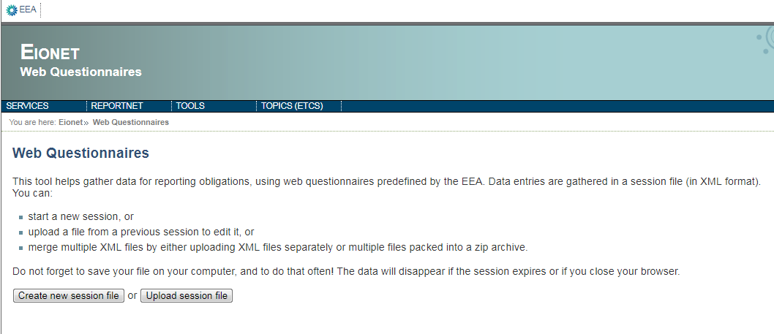
Clicking in the button Create new session file we have to choose one of the five web forms that we need to fill for the reporting of the MSFD;
- MSFD Indicators
- MSFD Article 8 ESA
- MSFD Article 8 GES
- MSFD Article 9 GES
- MSFD Article 10 Targets
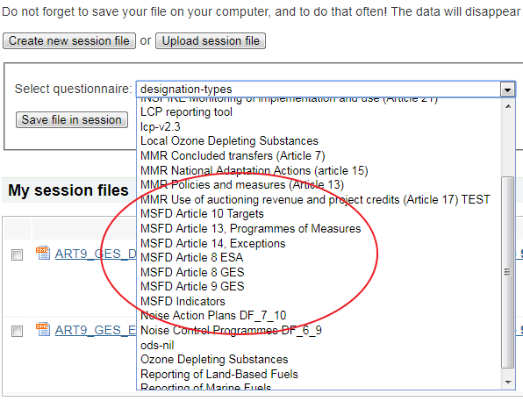
With the option Upload session file, we can upload a XML file to work with it. This XML file could be a prefilled file provide by us or a file that we downloaded and we want to follow the work with it.
Both options will allow us to open the web form clicking in the action provided by the file.
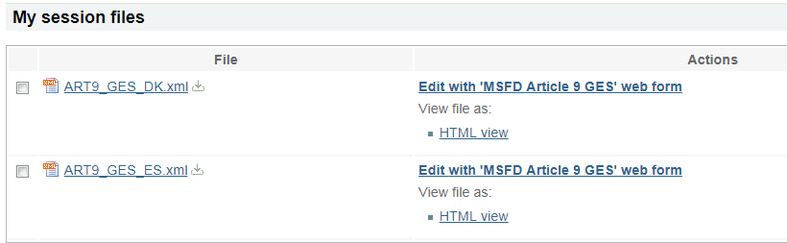

Web forms structure
The web forms have a common section called Reporter Information where we have to insert the data of the reporter.
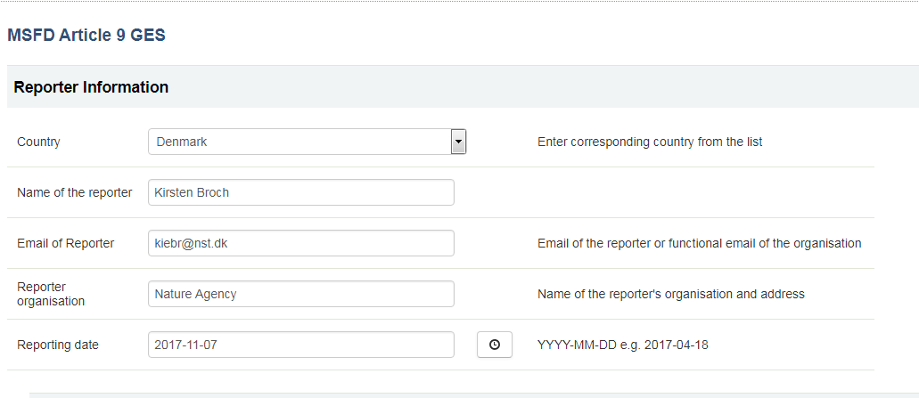
Below this section there is another section common to all web forms called Marine Units, this is the main class of all the schema models. In this section we can add, delete and copy each Marine Unit, if we delete or copy a Marine Unit we will copy and delete also their child elements.
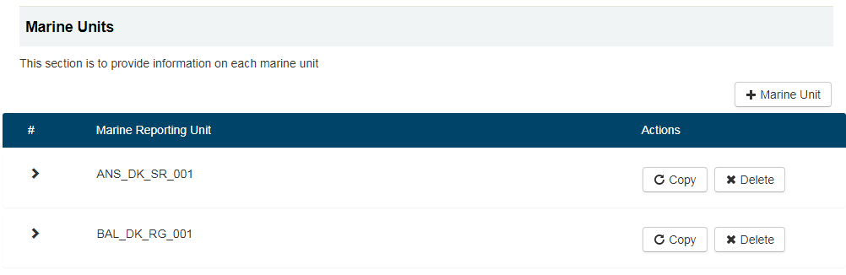
The other sections depend on the selected we form, but their behaviour is the same.

Web forms validation
To facilitate the full fill of the web forms we have implemented a validation. This validation allows the user to check if the mandatory fields are properly filled. The validation can be enabled and disabled using the button at the bottom of the page.
When the validation is enabled, we can check where the error is.
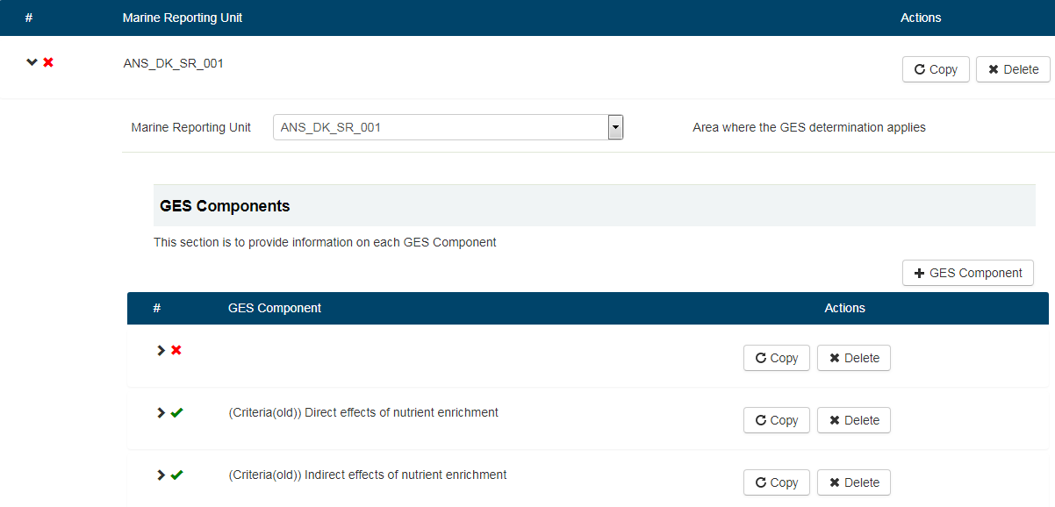
Knowing it we can navigate to the class that give us the error and solve it.
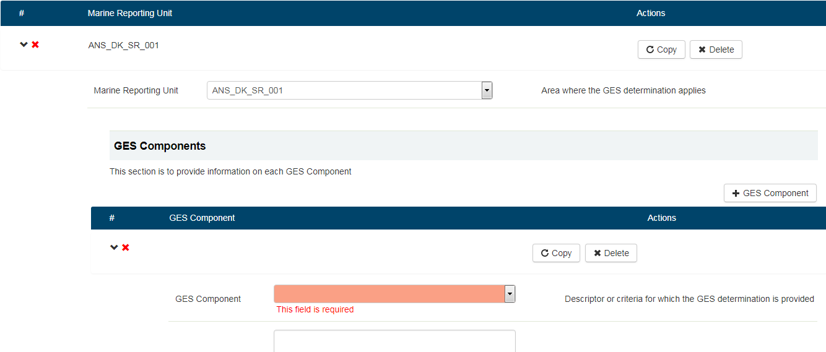

Web forms HTML view
To make the web forms more readable, we have developed a HTML view that can be printed, the option is in the main page of the web forms platform.
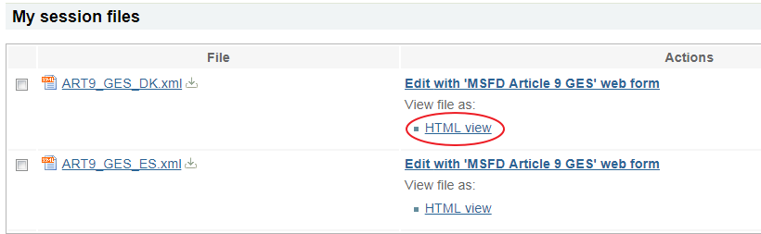
This link will open a new page with the data filled in the web form.
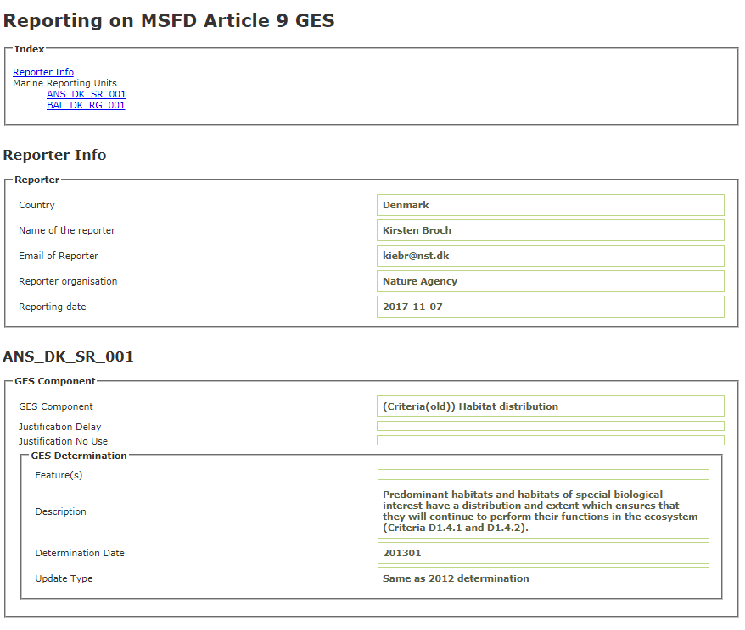

Web forms merge tool
Taking into account that the reporting task could be done for more than one user, we have implemented the merge tool. This tool can be find in the main page of the web forms platform, the button is enabled when we select two files.
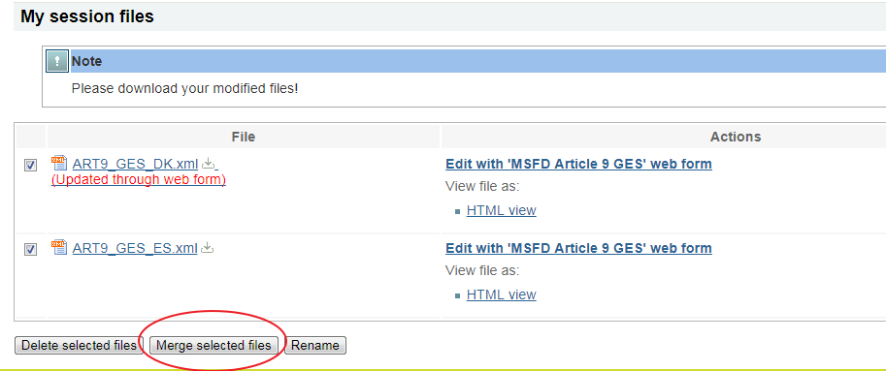
The tool is configured to merge two files and the merge is done at Marine Unit level, which means that the marine units will be joined in a new file that will be automatically downloaded.

